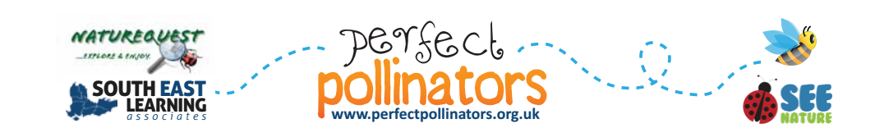**Perfect Pollinators 2016**

**A super science based project about bees for Key Stages 1 and 2 pupils!**

**Registration Form**

**We wish to register our interest in taking part in Perfect Pollinators.**

|  |  |
| --- | --- |
| **Name of School:** |  |
| **Full Postal Address to include postcode:** |  |
| **Staff Contact:** |  |
| **Contact E-mail:** |  |
| **Contact Phone Number:** |  |

**The deadline for registering interest in taking part in this project is Friday 24th July 2015. Please complete and return this form to:**

**E-mail:** [**info@perfectpollinators.org.uk**](mailto:info@perfectpollinators.org.uk) **Post:**

Perfect Pollinators

South East Learning Associates

51 Wiston Avenue,

Worthing,

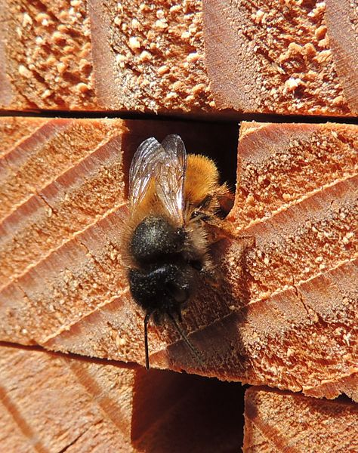West Susse

BN14 7QX

**Schools will be contacted about taking part in the project on or before Friday 16th October 2015.**



**Perfect Pollinators is managed by Nature Quest and The South East Learning Associates**