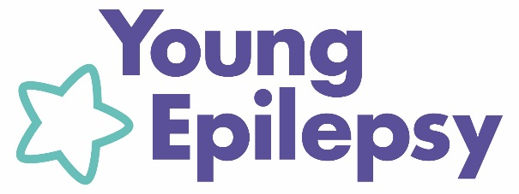
Better futures for young lives with epilepsy and associated conditions

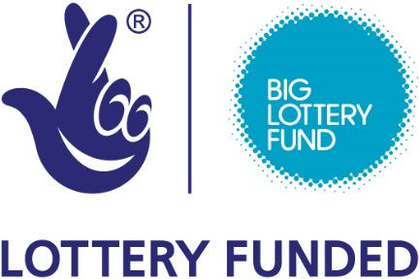

Connect Project - Kent

What is Connect?
Connect is a project being delivered by Young Epilepsy, funded by Big Lottery for the next 3 years and provides emotional and social support centred around young people with epilepsy and their families. A Regional Connect Worker is working full time in Kent.

How will it provide support?
- 1 to 1 sessions for children and young people with epilepsy aged 0-25 – to identify fears and anxieties and to develop personal development plans
- Bringing groups of young people with epilepsy together to share experiences – followed up by online groups to continue contact
- Support for parents through 1 to 1 meetings, events for them to meet other parents of children with epilepsy and training to develop their coping skills

What outcomes are we working towards?
- Young people will be empowered to set more ambitious goals, better manage and reduce anxiety around their condition.
- Young people will be more socially integrated, reducing isolation and loneliness, increasing in engagement and participation at school
- Young people will be less depressed and more independent as parents are better able to cope with the condition
- Young people will have better access to services and experience less exclusions and discrimination due to awareness raising and training

Where and why are we doing this?
Young people with epilepsy face a vicious cycle of discrimination, social isolation, psychological problems, low self-esteem and underachievement.

For more information about Connect and details of how to make referrals please contact Sameera Abu-alia, Regional Connect worker, Kent.
M: 07825 188875, E: sabualia@youngepilepsy.org.uk

Young Epilepsy is the operating name of The National Centre for Young People with Epilepsy. Registered Charity No 311877 (England and Wales).

© Young Epilepsy 2015
youngepilepsy.org.uk

