**The BirdBox Project – Free drop-in session for Kent schools**



**Are you interested in installing a webcam birdbox in your school grounds, and streaming live video of life inside the box to all classes, parents and the wider community? If it's a resounding “yes!” please read on!**

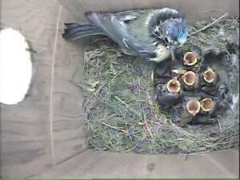

This past spring / summer, 30 Kent and Sussex schools took part in our very successful trial of the BirdBox Project.

To share the outcomes from this project, and to explain how easy it is to join and take part, we are holding free, open drop-in sessions at schools across the county in October and November 2015.

If you are interested in learning more about this project then please come along to see us. You will have the opportunity to see the birdbox equipment used by our project schools, watch live feed from a birdbox (no nest yet, of course!) and feeder station, and take a look at our project website ([http://birdbox.seenature.org.uk](http://birdbox.seenature.org.uk/)). We'll be there to answer any questions you might have.

Installing a birdbox webcam and streaming live video is not difficult, and is not costly. A webcam birdbox, with all the required accessories, is just **£125+VAT**. Membership to our project website, including live online streaming, is just **£199+VAT** per year.

If you plan to attend a session, please let us know in advance by completing the form below and emailing it back to us at [bookings@seeg.org.uk](mailto:bookings@seeg.org.uk). Alternatively, you can post it back to use at: **See Nature – 28 Sweetbay Crescent, Ashford, Kent, TN23 3QA**

**Dates and Venues (All meetings are from 4.00 to 5.00 p.m.)**

**Thursday 22nd October 2015 Bysing Wood Primary School, Lower Road, Faversham, ME13 7NU**

**Tuesday 3rd November 2015** **St Eanswythes Primary School Folkestone, Church St, Folkestone, Kent CT20**

**Wednesday 4th November 2015 St Teresas Catholic Primary School, Quantock Dr, Ashford TN24 8QN**

**Thursday 19th November 2015 Deal Parochial Primary School, Gladstone Road, Deal, CT14 7ER**

Kind regards

**Phil Bracegirdle & Tim Hall** (See Nature – South East Education Group)

E-mail: **phil.bracegirdle@seeg.org.uk** or Tel: **07801709409**

|  |  |
| --- | --- |
| **Name** |  |
| **School** |  |
| **Which session?** |  |
| **Email Address** |  |
| **Phone Number** |  |