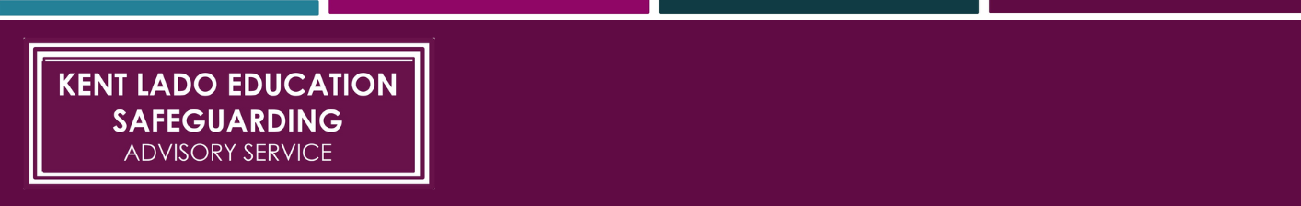
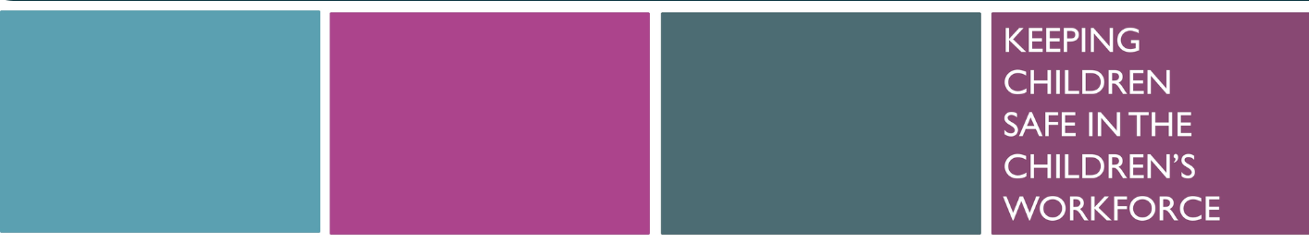

Safeguarding Record Keeping Templates


Safeguarding Record Keeping Templates

Contents

Disclaimer 2
Guidance Notes 3
Access, Storage and Transfer of Child Protection Files 3
Welfare Incident/Concern Form 4
Sample Safeguarding Record Front Sheet 5
Sample Chronology Form 6
Record of DSL Meetings 7

Guidance Notes

‘All concerns, discussions and decisions made, and the reasons for those decisions, should be recorded in writing. This will also help if/when responding to any complaints about the way a case has been handled by the school or college. Information should be kept confidential and stored securely. It is good practice to keep concerns and referrals in a separate child protection file for each child.

Records should include:
- a clear and comprehensive summary of the concern
- details of how the concern was followed up and resolved, and
- a note of any action taken, decisions reached and the outcome.’

Keeping Children Safe in Education’ (KCSIE)

Records should be factual, accurate and contemporaneous. They should include the child’s wishes, feelings, views, lived experience and presentation where appropriate, alongside a clear and comprehensive summary of concerns, actions taken, decisions reached and outcomes. For children who communicate non-verbally, practitioners should record relevant observations, behaviours and other indicators of concern.

The Designated Safeguarding Lead (DSL) is responsible for ensuring that child protection files are kept up to date. These templates are provided to support DSLs working within education settings to implement robust record-keeping arrangements.

Leaders and DSLs should adapt the content to include specific information such as named points of contact and local procedures. These decisions and details will vary from setting to setting, so this template should be used as a starting framework. It may not be appropriate for schools, colleges or early years settings to adopt the templates in their entirety; DSLs and leaders should ensure that unnecessary or irrelevant content is removed and that any adaptations reflect local processes and statutory requirements.

- [Blue font] indicates that the setting should insert relevant information
- Red italic font highlights suggestions to assist DSLs

Access, Storage and Transfer of Child Protection Files

It is recommended practice to keep safeguarding concerns and referrals in a separate child protection file for each child. Child protection files should only be accessed by those who need to see them. Where a file, or information within it, is shared, this should be done in accordance with the information-sharing guidance set out in KCSIE and the DfE's ‘Information sharing advice for safeguarding practitioners’ guidance.

Where children leave the setting (including through an in-year transfer), DSLs should ensure that child protection files are transferred to the new setting as soon as possible; within five days for an in-year transfer, or within the first five days of the start of a new term. Files should be transferred separately from the child's main file using secure methods, and confirmation of receipt should be obtained. Receiving settings should ensure that relevant staff, including the DSL and SENCO where appropriate, are aware of relevant information. A lack of information about a child's circumstances can have a significant impact on their safety, welfare and educational outcomes.

In addition to the formal transfer of the child protection file, DSLs should consider whether it is appropriate to share information with the new setting in advance of the child moving. This can help the receiving setting put appropriate support in place and help the child to thrive. For example, where a child has a social worker or has experienced abuse, sharing relevant information appropriately can help ensure suitable support is available from the outset.

Disclaimer and Copyright

This document was last reviewed in August 2026.

The Kent County Council LADO Education Safeguarding Advisory Service makes every effort to ensure that the information contained within these templates is accurate and up to date. However, ultimate responsibility for ensuring that safeguarding record-keeping systems are appropriate and comply with relevant statutory requirements rests with the school, college or setting leadership team. If any errors are brought to our attention, we will correct them as soon as reasonably practicable.

The copyright of these materials is held by Kent County Council. However, schools, colleges, early years settings and other organisations working with children are granted permission to use all or part of these materials for non-profit purposes.

Safeguarding Incident / Concern Form

[SCHOOL/SETTING NAME] [SCHOOL/SETTING LOGO]

Pupil Name: | Date of Birth and Year Group/Class
Name and position of person completing form (please print)

Date of incident /concern: (DD MM YY)
Incident / concern (who what where when) *

Any other relevant information (witnesses, immediate action taken) *

Signature:  Role: | Date and time form completed:
DSL actions, rationale, decision-making and outcome (To be completed by the DSL): *

Signature of DSL |  | Date (DD MM YY)
Signature of Lead DSL (if appropriate) |  | Date (DD MM YY)
*Continue on a separate sheet if necessary

Sample Safeguarding Record Front Sheet

[SCHOOL/SETTING NAME] [SCHOOL/SETTING LOGO]

SAFEGUARDING RECORD FRONT SHEET

Pupil/Child name: |  |  | Date of birth:
Any other name by which child is known:

Home address:  Telephone no: |  |  | Current address (if different)
Family members i.e. parents / carers / siblings:

Name | Relationship |  | Address |  | School/Setting details
Date file started: (DD MM YY)

Are records held in school/setting relating to other connected children?

Contact details of any professionals involved
It is advisable for DSLs to ensure they have specific contact information for any named workers, but also to include details of any admin/managers/local offices in case of emergency
Name |  | Agency |  | Address/Contacts

Sample Chronology Form

[SCHOOL/SETTING NAME] [SCHOOL/SETTING LOGO]

CHRONOLOGY
CHILD NAME: |  | DATE OF BIRTH:
DATE  (DD MM YY) | INCIDENT / EVENT  (including actions taken) |  | NAME  SIGNATURE

Record of DSL Meetings

[SCHOOL/SETTING NAME] [SCHOOL/SETTING LOGO]

Official Record of DSL Meetings

This record should be kept by Lead DSL - discussions about individual children should be included in their safeguarding file

Date of meeting:

Present:

Review of previous actions:

Child | What are we worried about? | What’s going well? | Actions  (who will complete and by what date)
Other issues discussed:
Date of next meeting: (DD MM YY)

