

**Key hypothesis**

**Foci -Significant characteristics that impact on teaching outcomes (see directional questions)** 

**Essential**

**Enquiries- lead to key themes**

**(see suggested activities)** 

**Thinking of the links will help decide on a set of priorities.** 

**Possible links** 

**Multi -layered plan, which is** 

**reviewed using this process**

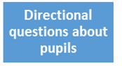 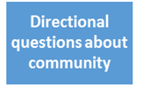 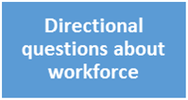 

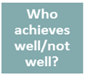  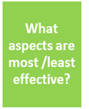 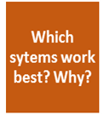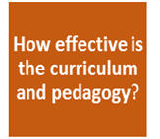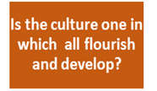

**What key themes emerge from the essential enquiries?**

**Can the key themes be linked in any way(s)?**

**What are those links and how do they work?**

**Link 3:**

**Link 2:**

**Link 1:**

**Eg prof development linked to workforce and school**

**Plans are multi-layered, time limited, include what needs to be further embedded and what needs to change or stop.**