subject: | General Schools Budget Update

authorS: | Karen Stone, Interim Finance Business Partner (Children’s, Young People and Education)
date: | July 2020

summary OF REPORT:
General updates on the Dedicated Schools Grant (DSG): 2019-20 outturn, 2020-21 Budget, and 2021-22 Budget.

FOR: | For Information

- Dedicated Schools Grant: 2019-20 Outturn, DSG Deficit Recovery Plan and 2020-21 initial forecast

1.1 Table 1 below provides an update on the cumulative DSG reserve position for 2019-20. Figures in brackets indicate a deficit balance.

 | £’ms
Balance b/fwd as at 1 April 2019 | (6.5)
Academy conversion/closing school deficits write offs
High Needs overspend
School Growth | 3.2
Balance c/fwd as at 31 March 2020 | (21.5)

1.2 The cumulative deficit of £21.5m as at 31 March 2020 is equivalent to 1.8% of our total DSG allocation. At the November 2019 Schools Funding Forum meeting it was highlighted the estimated cumulative deficit by the end of March 2021 could reach approximately £50m. The initial forecast for 2020-21 supports this position with the expected pressure on High Needs to continue in 2020-21. The presentation on high needs (item 2) gives further information on the position on high needs and the currently work being undertaken to address both the SEND Written Statement of Action and the use of the 1% school block transfer to support mainstream schools with the inclusion strategy. However, it is unlikely there will be an immediate impact on the 2020-21 forecast.

1.3 In January 2020, the Government issued it response to its consultation on clarifying the specific grant and ring-fenced status of the Dedicated Schools Grant (DSG) and has subsequently updated the terms and conditions of the DSG for both 2019-20 and 2020-21. These included the following key changes:
- with effect from the end of the 2019-2020 financial year, a new requirement that a deficit must be carried forward to be dealt with from future DSG income, unless the Secretary of State authorises the local authority not to do this. Local authorities no longer have the option to meet this deficit from general reserves (KCC has never supported this view).
- The automatic requirement to produce and submit a deficit recovery plan to the DFE once the accumulated deficit is in excess of 1% of the total DSG allocation has been replaced with a more general requirement that a local authority with an overall deficit on its DSG account at the end of the 2019 to 2020 financial year, or whose DSG surplus has substantially reduced during the year, must co-operate with the Department for Education (DfE) in handling that situation including:
1.Provide information as and when requested by the department about its plans for managing its DSG account in the 2020 to 2021 financial year and subsequently.
2.Provide information as and when requested by the department about pressures and potential savings on its high needs budget.
3.Meet with officials of the department as and when they request to discuss the local authority’s plans and financial situation.
4.Keep the schools forum regularly updated about the local authority’s DSG account and plans for handling it, including high needs pressures and potential savings.

1.4 In addition, the consultation also recognises there may be some LAs which, even if they can stabilise their in-year expenditure on high needs, will still not be able to pay off their historic deficit within a reasonable time. Where that is the case the DFE will work with LAs on a plan of action to enable the LA to pay off its deficit over time. The consultation was silent on exactly how this might be achieved.

1.5 The DFE are continuing to review the recovery plan process and are expected to provide updated guidance in the coming months.

2. 2020-21 Budget Update: Dedicated Schools Grant

2.1 Appendix 1 provides a summary of the 2020-21 Budget update for school budgets.

3. 2021-22 Budget Update: Dedicated Schools Grant

Draft Budget 2021-22
3.1 The draft 2021-22 school budget allocations and operational guidance is expected to be published at the end of July 2020. We continue to expect the Government to honour the three-year funding settlement for schools announced last year (please see table below) but there are no indications at this stage on how this will be split across schools, high needs and early years. The DFE have repeatedly said “High Needs is top of the agenda” although exactly what this means is still unclear and how this may impact high needs funded institutions or top up funding to mainstream schools and colleges. The Government has remained silent on the future funding proposals for early years. We are expecting the historic commitment element of the central schools services block (CSSB) to be reduced by a further 20% in 2021-22 (see paragraph 3.7).

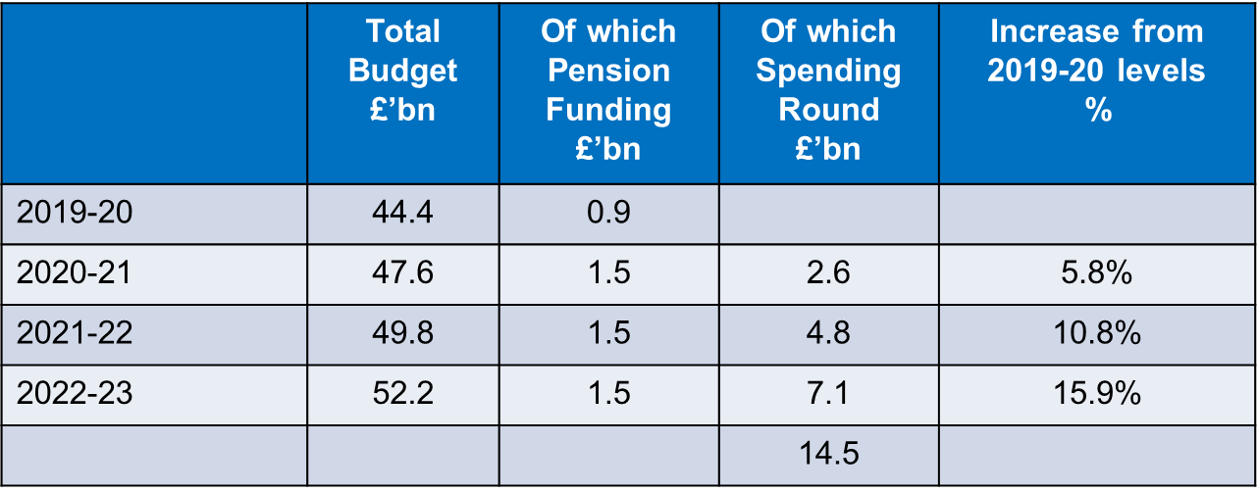

Expected changes to Schools National Funding Formula (NFF) in 2021-22
3.2 In 2021-22, local authorities will remain responsible for determining final allocations to schools, in consultation with the Schools Forum. There has been limited formal communication from the DFE on the expected changes to the NFF in 2021-22. We are assuming the Government will honour its commitment given in 2019 to increase the minimum per pupil level for primary schools from £3,750 to £4,000 in 2021-22. The DFE have also indicated their intention to provide a consistent rate increase for other factors in the NFF.

3.3 Based on information gathered from LA/DFE events the DFE are suggesting the following extra changes to the NFF in 2021-22: the updating of the IDACI data used in the deprivation factors of the NFF; the rolling of the current Teachers’ Pay Grant (TPG) and the Teachers’ Pension Employer Contribution Grant (TPECG) into the NFF; recognising small schools within the NFF. Further details of possible changes are given below. It is important to note none of these changes have been confirmed and the impact on individual schools of any NFF change will not be known until the detailed school data is published in the Autumn term.

3.4 The NFF uses the Income Deprivation Affecting Children Index (IDACI) to allocate deprivation funding. This index was updated in 2019 for the first time since 2015 and it is expected the NFF will be updated in 2021-22 to use the 2019 scorings (in 2020-21, the 2015 scorings continued to be used). In doing this they are also expected to change the banding structure so that the proportion of pupils attracting funding through each band will remain broadly unchanged. However, schools should expect a distributional impact: areas which have become relatively more deprived over time benefit from more pupils attracting deprivation funding, and areas which have become relatively less deprived will attract less. The minimum funding guarantee in the local formula is expected to protect schools with particularly large changes in IDACI deprivation funding. In the past Kent schools have experienced significant changes to their funding as a consequence of similar changes therefore the impact of this will need to considered as part of setting the local formula in 2021-22.

3.5 The TPG was introduced in September 2018 to support schools to implement the 2018 teachers’ pay award. In September 2019 the grant was increased to help schools implement the 2019 teachers’ pay award, as well as the ongoing cost of the 2018 award. From September 2019, the employer contribution rate in the Teachers’ Pension Scheme increased from 16.4% to 23.6%. To fully funding the increased costs to schools of this change the TPECG and supplementary fund were introduced. As with the TPG, this is paid on the basis of pupil or place numbers to all state-funded schools. It has been suggested to roll the grants into the NFF so the additional funding schools are allocated through the NFF is as close as possible to the funding they would have received if the grants were continuing as separate entities. The proposal is to do this by:
- Adding the amount that schools receive per pupil through the TPG and TPECG onto the basic per pupil amount (AWPU)
- Adding the amount that schools receive per pupil through the TPG and TPECG onto the minimum per pupil funding levels (MPPL),
- Adding the total amount of funding schools receive through the TPG, TPECG and supplementary fund in respect of their reception to Year 11 pupils onto their baselines, used to calculate any funding protection for the schools through the minimum funding guarantee.

For schools funded through the high needs budget i.e. special schools, proposals have yet been finalised but could include increasing the core funding level of £10,000.

3.6 The DFE are starting to recognise the need to provide more support for small schools through the NFF however the initial proposals were focused on remote small primary schools rather than all small primary schools. There was a suggestion the sparsity factor rate for primaries could be increased in 2021-22 with further proposals in 2022-23 to expand the number of small schools that would benefit from this factor. Although this is welcome, in Kent there are 455 primaries of which 85 could be categorised as small (under 150 pupils) and only 16 of these schools would currently meet the criteria to receive sparsity funding under the NFF. General feedback from local authorities has been the need to do more.

3.7 The DFE have also recognised the lack of 2020 data for both the Early Years foundation stage profile and KS2 assessments will have implications for the Low Prior Attainment (LPA) factor in the local formulae for 2021-22. There is no indication as to how this will be resolved at this stage.

Other Grant Changes in 2021-22
3.5 In the 2020 Budget statement the Government committed to the following:
“providing £29 million per year by 2023-24 to support primary school PE teaching and help schools make the best use of their sports facilities, as well as £90 million per year to introduce an Arts Premium from September 2021 to help schools provide high-quality arts programmes and extracurricular activities for pupils”. The Primary PE sports grant is given on an academic year basis and it has recently been confirmation it will continue at its current level in 2020-21.

3.6 You will already be aware of the ending of the Year 7 catch up funding from August 2020. Grant announcements are normally made later in the year and we are not expecting to hear any further information until the Autumn term (or beyond).

Central Schools Services Block 2021-22
3.7 The CSSB includes an element of funding termed “historic commitments”. The historic commitments funding is based on previously agreed expenditure by Schools Funding Forum on Council services. The DFE set out its intention to start to wind down the funding for the historic commitments of element of the CSSB in 2019. This grant was cut by 20% as part of the 2021-22 budget (£1.4m) and is expected to be cut by a further 20% each year after. In the short-term this has been addressed through the Council’s 2020-23 Medium Term Financial Plan without any direct impact to schools. During this year the Council will be reviewing the options available in line with Government policy and funding to minimise the impact of these cuts.

IDACI is an area-based index measuring the relative deprivation of different areas, and ascribes a score as well as a rank to each Lower-level Super Output Area (LSOA).

