**QUICK GUIDE**

1. GO TO [WWW.KENTCHOICES.CO.UK](http://WWW.KENTCHOICES.CO.UK) AND CLICK ON THE **‘SEARCH & APPLY’** BOX

1. THEN CLICK THE PURPLE **‘SEARCH FOR COURSES’** BUTTON

1. **‘SIGN IN’** USING THE USERNAME AND PASSWORD PROVIDED BY YOUR SCHOOL

1. COMPLETE ALL SECTIONS OF YOUR **‘PROFILE TEMPLATE’**

1. **SEARCH FOR COURSES** EITHER BY PROVIDER, SECTOR, QUALIFICATION OR KEYWORDS

1. ADD COURSES TO YOUR **‘FAVOURITES’**

1. WHEN YOU HAVE MADE YOUR CHOICE(S) GO TO **‘MY APPLICATIONS’** AND **‘APPLY’**

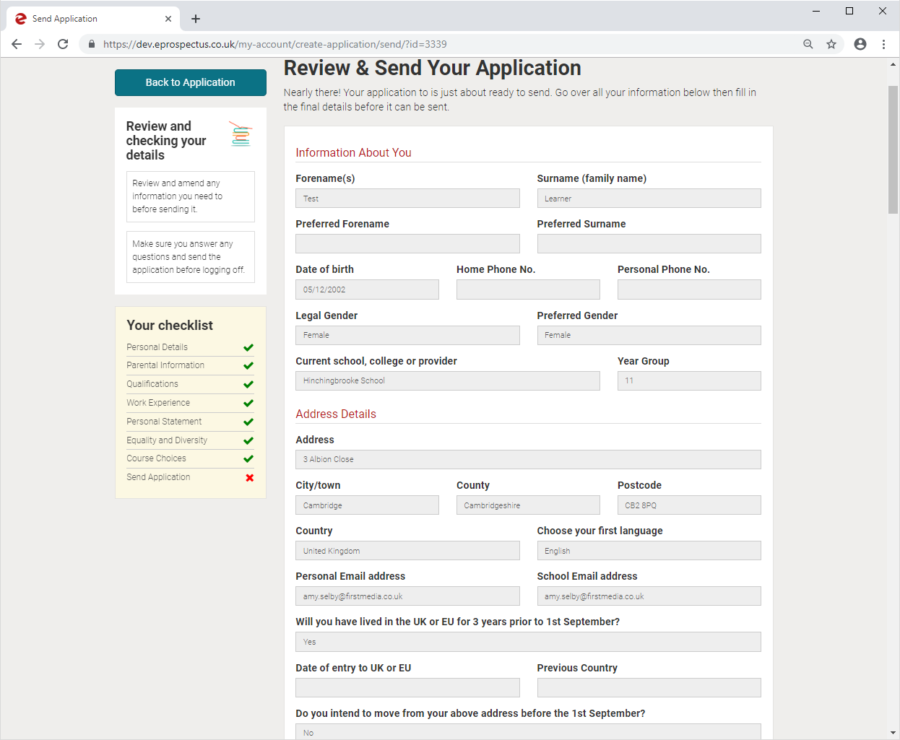

1. CHECK BACK REGULARLY TO SEE HOW YOUR APPLICATION IS PROGRESSING IN THE **‘MY APPLICATIONS’** TAB OF **‘MY ACCOUNT’**

1. REMEMBER TO ACCEPT OR DECLINE YOUR OFFERS

**HELP & GUIDANCE**

