
Keith Abbott – Director Education Planning and Access

All Schools
Children, Young People and Education
Sessions House
County Hall
MAIDSTONE
Kent
ME14 1XQ
Your Ref:
Direct Dial: 03000 417008
e-mail:keith.abbott@kent.gov.uk
Ask For: Keith Abbott
Date: 23 March 2018

Dear Headteachers/SENCOs

As you will be aware Kent, like many other Local Authorities, is facing a significant increase in requests for statutory assessment and Education Health and Care plans. When these are agreed there is a requirement that advice must be sought from specific professionals including Educational Psychologists. This growth in demand, combined with the recruitment challenges that most Local Authorities are facing because of a national shortage of Educational Psychologists, is putting the service under considerable pressure at the current time.

This position is not sustainable, and we need to secure some additional, temporary capacity to help meet this sharp increase in demand. We are putting a range of measures in place to do this. I am writing to let you know that one of the measures affects the LIFTs and I have written to the LIFT Chairs to let them know that I have reluctantly decided to remove Educational Psychologists from the LIFT process until September 2018. This is not a decision I have taken lightly as I am aware that it removes a significant contribution to the LIFT process.

As you will know from recent Head Teacher briefings work is underway to more fully understand why there has been such a significant increase in demand for statutory assessment and what we can do to address it. Over the next few months we will continue with the work that was started at those recent briefings, working with Headteachers to find a solution to this difficult issue.

If you have any queries or concerns about this, please do not hesitate to contact me.

Yours sincerely
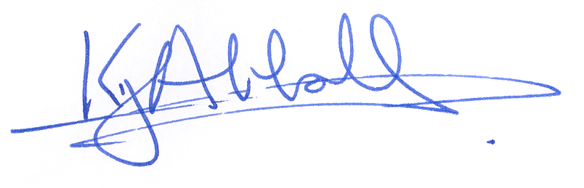

Keith Abbott
Director of Education Planning and Access
Children, Young People and Education

