UNIVERSAL
PRECAUTIONS – HAND HYGIENE

ALWAYS WASH YOUR HANDS
- Before and after using protective gloves (Gloves should always be worn when in contact with blood or other body fluids)
- After sneezing or blowing your nose
- After handling bed linen or laundry
- After using the toilet
- After providing physical care for a service user
- Before preparing or serving meals or drinks
- At any time when the hands are visibly soiled.
Note: Alcohol gel is only to be used in support of hand washing.

TAKE SIMPLE PROTECTIVE MEASURES
- Appropriate gloves and plastic apron must be used to prevent contamination from bodily fluids and blood stained products. (Refer to KASS Glove Policy). Avoid contaminating yourself or your clothing with blood. Always wear gloves appropriate to the task and a plastic apron when delivering all personal care and when dealing with body fluids and dispose of as instructed below. Household rubber gloves should be used for general cleaning. Afterwards wash them and then remove.

ALWAYS COVER CUTS OR ABRASIONS ON YOUR SKIN
- Clean the wound with water and paper towels or tissues. Use clean waterproof plasters. Take every care to avoid damaging your skin with cuts or abrasions in the presence of blood.

CLEAR UP SPILLAGES OF BODY FLUIDS PROMPTLY
- Where blood is evident on hard surfaces cover with chlorine releasing granules [e.g. Titan Sanitizer powder or chlorclean] and leave for 3 minutes. Then clean up with paper towels and dispose of then as instructed below. All other spillages of body fluids and blood stained spillages on soft fabrics should be cleaned up with paper towels and the area washed thoroughly with detergent or shampoo solution. Refer to hazard data sheets and COSHH assessments.

TAKE CARE WITH CHLORINE BASED PRODUCTS
- These are corrosive and can damage fabrics. Always use at the strength directed and never use on skin. Never mix with anything other than water as they can liberate chlorine gas in contact with acids like toilet cleaners and urine.

DISPOSE OF WASTE SAFELY
- Waste such as soiled incontinence pads, dressings and disposable gloves, aprons and paper towels contaminated with body fluids should be disposed of in the appropriate clinical waste collection bin, where provided. Where such bins are not provided, unless you are told otherwise, you may place small quantities of clinical waste in a plastic bag, tie it securely then place in another plastic bag and dispose of it with the normal waste. Sharps must always be placed in a ‘Sharps’ container for collection and must never be disposed of with normal waste.

THE SIMPLE PRECAUTIONS DESCRIBED ABOVE MUST BE ADOPTED AT ALL TIMES

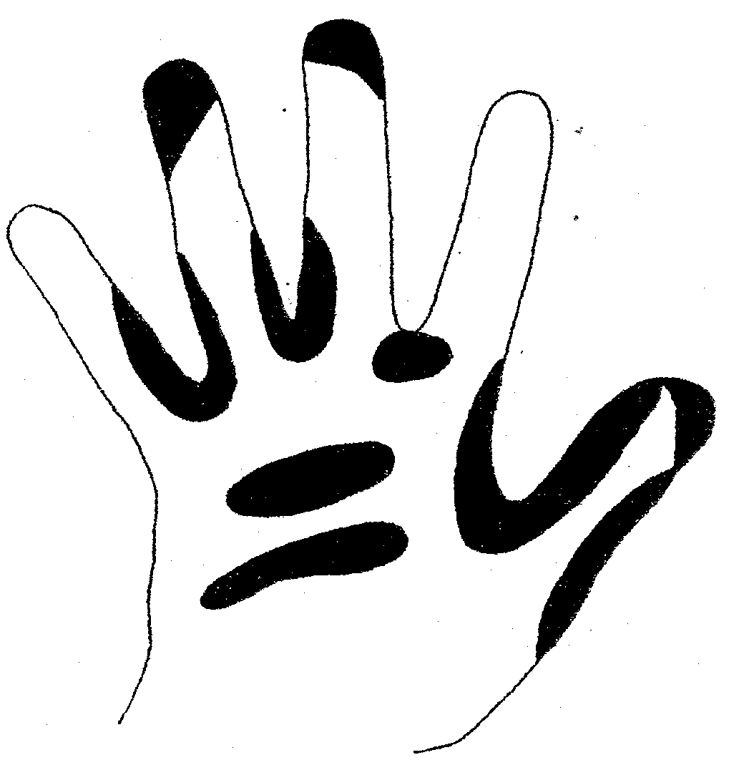
If you have damaged skin and believe yourself to have been exposed to bodily fluids from a client at risk then immediately wash the cut or abrasion liberally with soap and water but without scrubbing. Splashes of blood into the eyes or mouth should be washed out immediately with copious amounts of water. If the skin has been punctured, free bleeding should be encouraged but the wound should not be sucked.

Any incident must be reported immediately to the Line Manager and dealt with exactly as an accident. Where necessary, seek emergency advice from your GP or nearest accident and emergency centre.

PROPER HAND WASHING

Remember that effective hand washing is the single most fundamental means of preventing and controlling the spread of infection. In certain circumstances your local Infection Control Team may advise the use of alcohol based hand rub solution to follow a hand wash with soap and water.

Note: The use of alcohol gel is not on it’s own sufficient to reduce infection. It is essential to use soap and water for hand washing.

Remember to use the following technique
with soap and water:

between fingers - around finger tips
around the wrist and thumbs (refer to
dark areas in diagram)

both the front and back of palms.

Then rinse soap off thoroughly and dry
your hands using disposable paper
towels.

This diagram shows the areas that it is easy
to miss.

For further information on infection control refer to the
Public Health England

