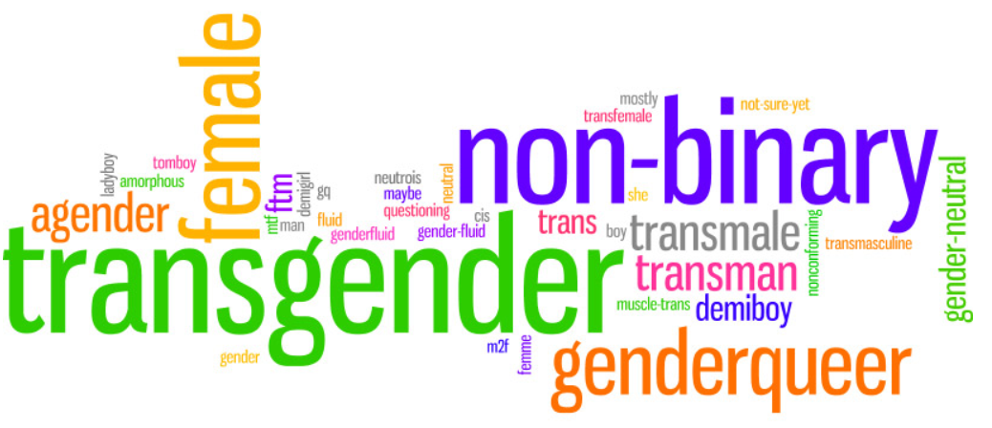

**Supporting Trans Young People**

**in Schools**



**Lenham Community Centre, Groom Way, Lenham,**

**Maidstone, Kent, ME17 2QT**

**Friday 12th February**

**EYFS and Primary 9.00 – 12.00, Secondary 1.00 – 4.00**

In a 2014 survey Trans pupils stated that:

* 40% thought they were trans aged 11 or under
* 75% experienced transphobic name calling at school
* 28% experienced physical abuse
* 67% said their time at school was affected by discrimination or fear of discrimination about their gender identity
* 97% learnt nothing about trans issues at school

*The Metro Youth Chances: The experiences of LGBTQ in England 2014*

**This training will enable delegates to**

**develop their understanding of what it means to be a young Trans person**

**in Britain today,**

**ensure that their policies and practice are inclusive and supportive of Trans pupils,**

**staff and parents,**

**learn to support trans pupils to be confident in who they are,**

**improve attendance and achievement of Trans children and young people,**

**eliminate transphobic bullying within their school.**

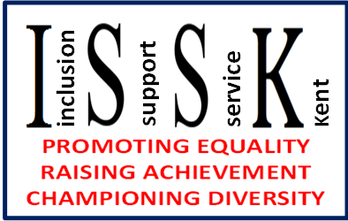

**For More Information please contact:**

**Gillie Heath on 03000 417 093** [**gillie.heath@kent.gov.uk**](mailto:gillie.heath@kent.gov.uk)

**Mandy Maloney on 03000 417 320** [**amanda.maloney@kent.gov.uk**](mailto:amanda.maloney@kent.gov.uk)

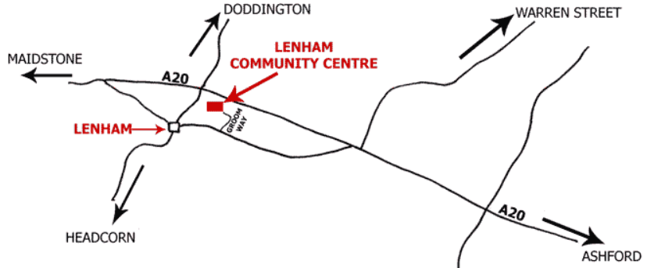

**[Register through](https://www.kentcpdonline.org.uk/cpd/default.asp?sid=)**

**[CPD online](https://www.kentcpdonline.org.uk/cpd/default.asp?sid=)**

**[Here](https://www.kentcpdonline.org.uk/cpd/default.asp?sid=)**