# KCC Logo

The Kent Locality Model

# Communities of Schools

Code of Conduct

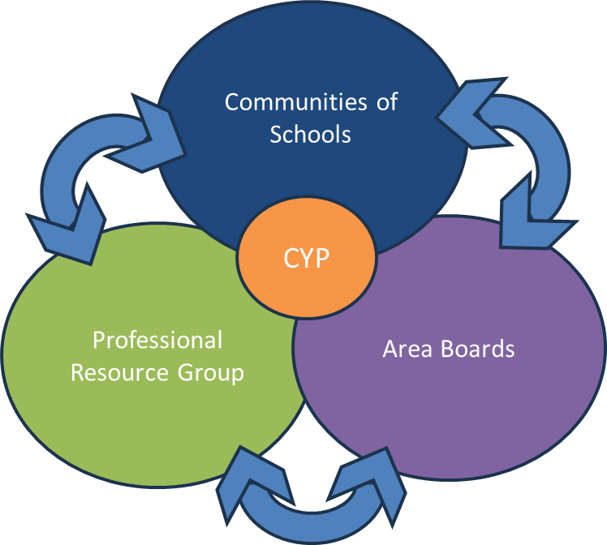

Version 1: April 2025

# **Communities of Schools -** [**Code of Conduct**](https://forms.office.com/e/n5ss9DBe66)

This code outlines the principles and expectations for professional conduct and ethical behaviour for all CoS members.

**Principles of Conduct**

By adhering to this code, members commit to:

**Seven Nolan Principles of Public Life**

1. **Selflessness** - act solely in the public interest
2. **Integrity** - avoid obligations that may influence work; declare interests
3. **Objectivity** – make decisions impartially and fairly
4. **Accountability** – be accountable to the public and open to scrutiny
5. **Openness** – act transparently, withholding information only for lawful reasons
6. **Honesty** - be truthful
7. **Leadership** – promote and support these principles, challenging poor behaviour

## **Member Commitment**

As CoS members, we agree to:

* **Fulfil roles and responsibilities**: Treat everyone with respect, work collaboratively, and uphold CoS values
* **Conduct business with integrity**: Comply with laws, act candidly yet respectfully, and support collective decisions
* **Provide a safe environment**: Ensure a discrimination-free environment and uphold our responsibilities under The Equality Act
* **Engage actively**: Participate in CoS activities, attend meetings, and prepare for contributions
* **Develop relationships**: Collaborate with school leaders and stakeholders, respect authorities, and foster an inclusive environment
* **Maintain confidentiality**: Keep all confidential matters private and handle sensitive documents appropriately
* **Declare conflicts of interest**: Transparently declare any conflicts, leaving discussions if necessary

## **Enforcement and Review**

* Breaches of this code may result in sanctions
* The Code of Conduct will be reviewed annually

By signing this declaration, you confirm that you have made your members aware of the code and have their agreement they will also abide by the CoS Code of Conduct.

**Adopted by:** [CoS] on [date]

**Signed:** [CoS chair]