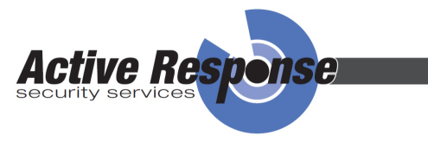

Bee Safe Video

- This Video is entirely Free and has been created for Teaching Staff to engage young Children to learn an Important Message.
- It is one minute long but combines a visual picture with song to help the message be remembered.
- It is founded on the fact that Death or Injury of Children on Building sites needs to be reduced.
- The Bee Character behaves as a Child would, being drawn to a Building Site as if it seems like a perfect “playground”.
- The lesson that follows needs to be drawn out for a Young Audience to understand that the Bee is clear that they should avoid Building Sites.
- The song discourages the Bee from “going in” but his bad Judgement leads him into trouble.
- Staff may wish to watch the Video twice with Children to emphasise what they see. It may encourage them to sing part of the Song.
- A Colouring Template is provided to give to each Child.
- The Bee can be coloured in.
- The background space should be used for each Child to draw a scene they remember.
- When the picture is complete they should sign it and place a name for the Bee on the Sheet.
- We would Love to receive them at this address:

Active Response Security Services Limited
Berneslai Close
Off Churchfield
Barnsley
S70 2FL

Together We Can Make a Difference
Thank You for Participating in this Initiative

