# KCC Logo

The Kent Locality Model

# Communities of Schools

Declaration of Interests

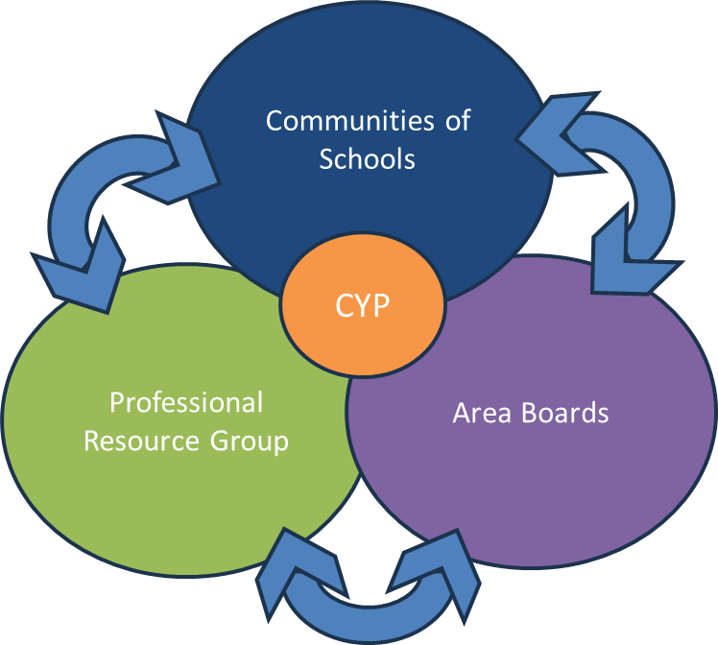

Version 1: April 2025

# **Communities of Schools –** [**Declaration of Interests**](https://forms.office.com/e/SP011AwBKD) **\***

* *Please refer to the guidance notes overleaf before completing this form.*

**[Print name in full]** chair of **[add community name]** CoS

I do not have any interests to declare

I wish the following interests to be registered: -

1 Business (for example: employment / former employment at, governor for, another advisory role within, Trust or other links to, a school in the community)

2 Personal (for example: family attends, or partner is a SENCo / bursar / head / teacher at, a school in the community)

3 Any other interests I wish to declare

Signed ___________________________________ date ___________________________

*If there are no changes this form can be updated and signed again*

Signed ___________________________________ updated ___________________________

Signed ___________________________________ updated ___________________________

Signed ___________________________________ updated ___________________________

# **Communities of Schools – Declaration of interests**

**Guidance to Chairs** ([Declaration of Interests Form](https://forms.office.com/e/SP011AwBKD))

**1. Introduction**

1.1 Under the County Council’s Financial Scheme, every governing body is required to establish and update a register of governors’ business interests, this means that governors and headteachers must register and declare business interests that might relate to their duties.

1.2 The principle behind this arrangement is that neither governors, headteachers, or their

spouses, partners, businesses or employers, should benefit financially from the involvement of governors or headteachers in decisions taken by a governing body or one of its committees.

1.3 The register ensures that a system exists for governors to declare and register interests to ensure that decisions are always taken in the best interests of the school or the public funds that finance it.

**To ensure that CoS conduct is regarded the same propriety, CoS chairs are asked to follow similar processes to school governing bodies.**

**2. What CoS Chairs should register and declare**

2.1 As a general principle you should register and declare anything which a member of the public might reasonably think puts you at risk of being biased by putting private considerations above the public interest or seeking preferential treatment for yourself or people/bodies with whom you are connected. A form is attached for this purpose which you are asked to complete even if you have no business interests to declare.

2.2 You should register all interests and personal circumstances which could give rise to an interest in a request for resource or other matter coming before the CoS.

2.3 An interest is anything that might influence a CoS chair to consider some factor other than the interests of the CoS or an individual school within the community and can be divided into pecuniary and non-pecuniary.

2.4 Pecuniary interests are those where an item under discussion may have a financial benefit to the individual chair or their spouse or partner, family, or friends. An example could be the discussion of a request for resource for an individual school or the CoS, which might profit that chair (or their spouse, partner, family, or friends). Chairs must be able to fulfil their role as CoS lead but must not have a personal interest that is different from the CoS as a whole.

2.5 Non-pecuniary interest can be defined as any factor, which would cause an intelligent observer to think that the judgement of a CoS chair is biased. This might be a case of knowing someone who has a financial interest in the decision being made or being related to or knowing someone who will benefit more from the request for resource being granted.