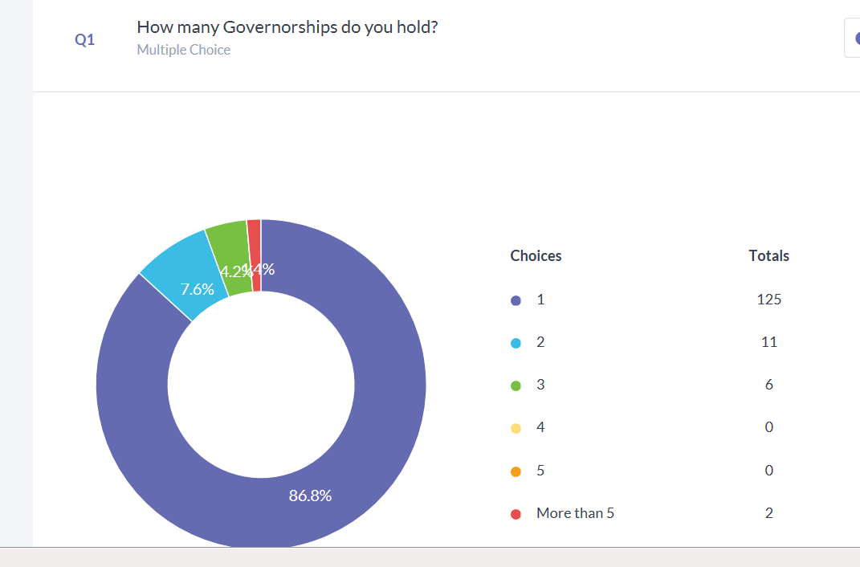
Medway, Merton, West Sussex

Examples of Bespoke Training Commissioned:

Monitoring Visits Finance
Ofsted Real Secrets
Prevent Academy Conversion
Safeguarding Induction
Challenge & Impact HR
RAISE online Exclusion
SIAMS
Early Years
SEN
Self Review for Good Governance
Pupil Premium
Data
Finance for Academies
Journey to Outstanding

ASP Training Pupil Premium
Sports Premium How to get best practice as Safeguarding Governor
Budgeting in Challenging Times Mental Health Issues for Young People
Changes to role in a MAT Early Years
SDP Training Chairs/Heads together Curriculum Topics & Balanced Curriculum
Vision & Ethos Recruiting New Teachers
Monitoring Health and Safety
Good to Outstanding Challenge & Impact
Special Schools Training Training and Development Governor
Safer Recruitment Governor Self Evaluation
Sessions that develop the basic Complaints
Expectations & role of pay committee Succession Planning
Support for Staff Governors Compliance

Improvements you raised:
More on line courses and webinars Handouts – really valued
To continue and ensure well-staffed Better trained clerks
Look at venues and locations Test the market
Full time staff Quality Assure
Increase number of Area Governance Officers Networking opportunities
Daytime Courses
A selection of our positive comments I very much appreciate the support received
Keep doing what you’re doing I think you are doing an excellent job, keep up the good work
All good information given
I have found the support to be of a high standard and comprehensive. I also subscribe to the NGA and can see the sense in avoiding duplication of work by referring to NGA resources when appropriate.

