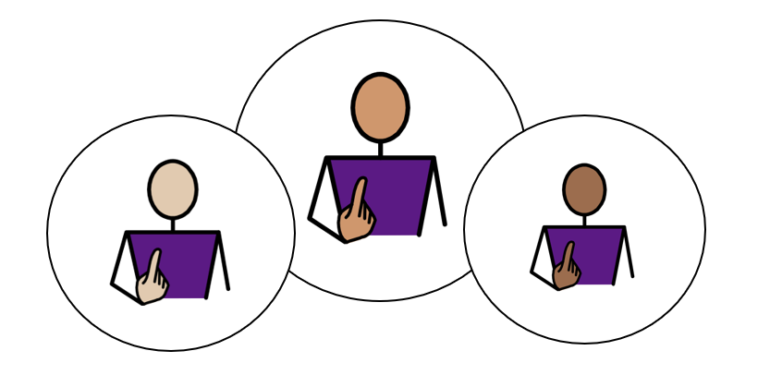
All About Me

All About Me

Appendix 1A: Pathway 2

Voice of the Child / Young Person

This form is all about you. It helps the people who support you understand:
- what you are good at
- what you enjoy
- how you like to communicate
- what helps you learn and feel happy
- anything that could be better for you
You can complete this form on a computer, or you can print it out and write on it.
If you would like help, an adult can read the questions, write or type your answers, or help you complete a little bit at a time.
The examples on each page are just ideas to help you think about your answers. You do not have to choose them. Use the grey boxes to tell us what you think.
✅ Tick any boxes that sound like you.
✍️ Use the grey spaces to add your own comments, ideas, and feelings.
My views should be used to inform my Annual Review Meeting, Outcomes, and Provision.

1. About Me
My Name is:  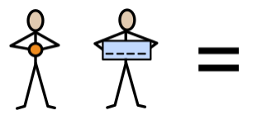 | Tap or click here and type my name
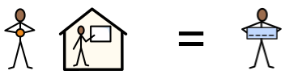  My school or setting is called: | Tap or click here and type my school or setting
Date this form was completed: Click or tap to enter a date.

The name of the person helping me complete this form is: | Tap or click here and type their name
They know me because: | Tap or click here and type how they know me

2. How my views were gathered
☐ My views were captured by completing this form and through observations and discussions with me, my parent(s)/carer(s), and relevant professionals.

☐ I was able to take part in developing my Education, Health and Care Plan by sharing my wishes and aspirations with my parent(s)/carer(s) and the professionals working with me.

☐ I am not able to express my views directly at this time. My views have been shared by adults who know me well, including my teacher and parent/carer.

3. Picture, drawing, or photo of me

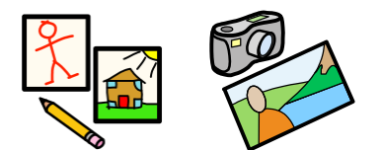
Add a picture, drawing, or photo here if you would like.



4. My aspirations and next steps

This year, I want to get better at: 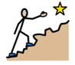

When I grow up, I would like to be: 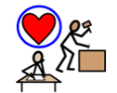

My Independence: I am working towards independence, by:
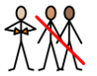
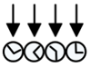 | 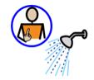 |  | 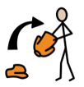 | 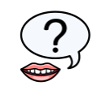 | 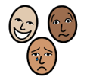 | 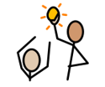
Knowing my routine  ☐ | Doing self-care tasks  ☐ | Managing my own toilet hygiene  ☐ | Dressing independently  ☐ | Asking for help  ☐ | Telling people how I feel  ☐ | Telling people what I want or need  ☐

My Community: Outside of my school, or setting, I like:
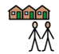
 | 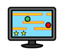 | 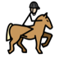 | 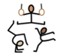 | 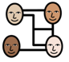 |  | 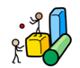
Football  ☐ | Gaming  ☐ | Horse riding  ☐ | Gymnastics  ☐ | Socialising  ☐ | Reading  ☐ | Soft play  ☐

Tap or click here and type any comments

My Community: Outside of my school, or setting, I like:
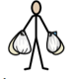 | 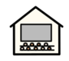 | 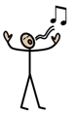 | 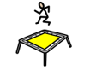 | 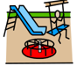
Shopping  ☐ | Cinema  ☐ | Singing  ☐ | Trampolining  ☐ | Going to the park  ☐

Tap or click here and type any comments

My Quality of Life: At school, I feel good, when:
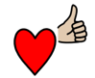
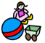 | 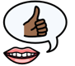 |  | 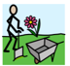 | 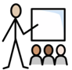
I played with my favourite toy  ☐ | Somebody said: “Well done!”  ☐ | I had computer time  ☐ | It was Forest School  ☐ | It was my favourite lesson  ☐

Tap or click here and type any comments

My Quality of Life: At home, I am happy when I am with:
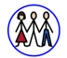 | 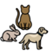 | 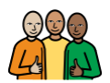
My family  ☐ | My pets  ☐ | My close friends  ☐

Tap or click here and type any comments

My Voice: How I communicate best:
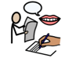
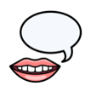 | 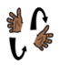 | 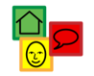 | 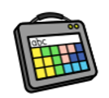 | 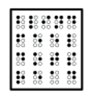
Talking  ☐ | Signing  ☐ | Using Symbols  ☐ | Augmentative Communication Aid  ☐ | Reading Braille  ☐

Tap or click here and type any comments

My Voice: How I communicate best:
Who listens to me, at home?  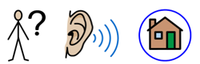 | Tap or click here and type any comments
Who listens to me, at my school, or in my setting?  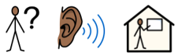 | Tap or click here and type any comments

My Support: Adults can help me, by giving me:
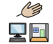
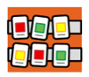 | 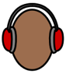 | 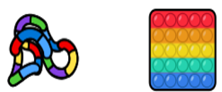 | 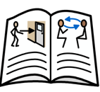 | 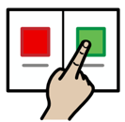 | 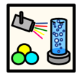 | 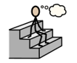
Visual timetables / checklists  ☐ | Ear defenders  ☐ | Fiddle toys  ☐ | Social Stories  ☐ | Choices  ☐ | A safe space  ☐ | Thinking time  ☐

Tap or click here and type any comments

My Learning: The best way for me to learn, is:
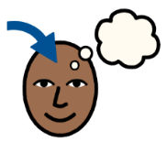
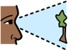 | 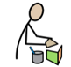 | 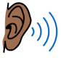 | 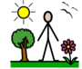 |  |  | 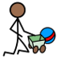
Visual  ☐ | Kinaesthetic  (practical, hands-on)  ☐ | Auditory  ☐ | Outdoor  ☐ | Life Skills-based  ☐ | Watching Videos  ☐ | Play-based/ Child- Initiated  ☐

Tap or click here and type any comments

My Health: To keep myself healthy, I:
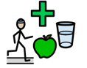

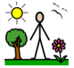 | 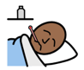 | 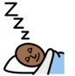
Spend time outside each day  ☐ | Tell someone when I feel unwell  ☐ | Get enough sleep  ☐
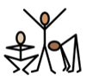 | 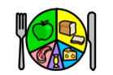 | 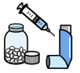
Exercise  ☐ | Try to eat a variety of foods  ☐ | Take my prescribed medication  ☐

My Safety: Adults can teach me to keep safe, by helping me to:
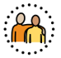
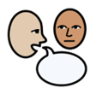 | 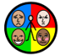 | 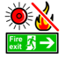 | 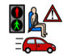 | 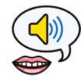 | 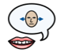 | 
Follow adult direction to keep me safe  ☐ | Practise Self-Regulation  ☐ | Understand what to do in a fire drill  ☐ | Understand Road Safety  ☐ | Understand Consent:  My body; My choice  ☐ | Understand Boundaries: My right to say No, and change my mind  ☐ | Practise  Online Safety  ☐

Tap or click here and type any comments

I have been included in my Annual Review meeting:

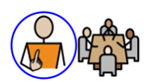

Please select Not Applicable if their annual review meeting has not been held yet meeting (the annual review meeting is held within a year after the EHCP of its first issue or from the date of the last review).

Not Applicable  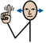 | Yes   | No  
☐ | ☐ | ☐

