All about Me
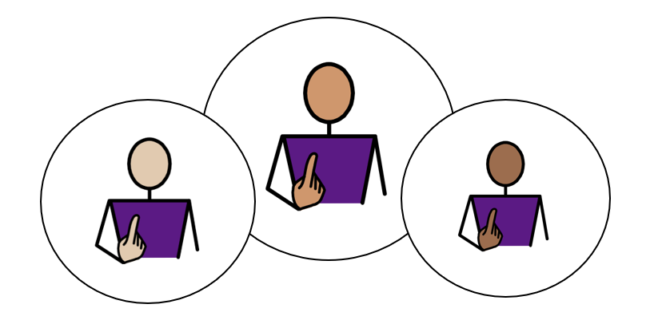

Appendix 1A: Pathway 2-Primary
Voice of the Child / Young Person
We use our Children’s and Young People’s Outcome Framework, below, to make sure that the support provided for you is having a positive impact on your life.
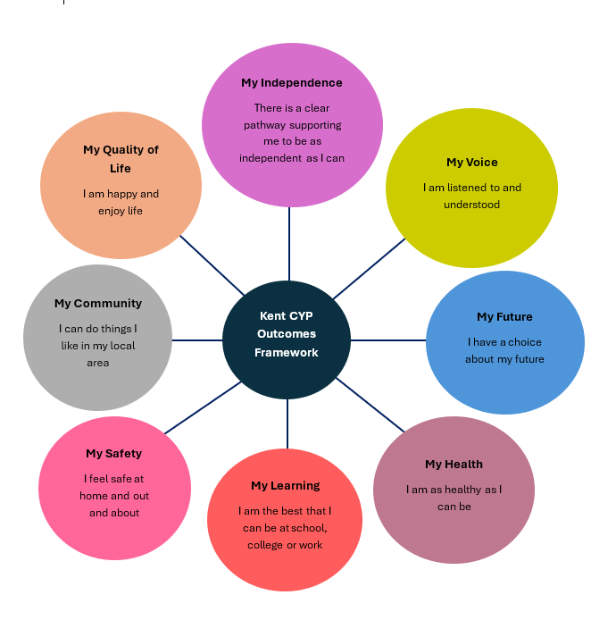

This is your chance to tell everyone supporting you what is going well, and what needs to change, in order to help you reach your full potential. The following questions will help us to understand more about you, and your views about your life.

This form can be printed off, to add your own ideas and thoughts in the blank grey boxes, if you would like. An adult can read for you, and /or write your answers for you, if you would like help; and you can break it down into smaller parts, if you don’t want to complete it all at once. Alternatively, this form can be completed electronically, using the text boxes to add typed comments and /or selecting thoughts and views using the tick boxes provided.

Please use the information gathered through Pupil Voice to inform the Annual Review Meeting in terms of Outcomes and Provision.

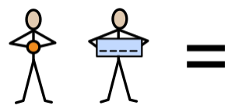
My name is:
Click or tap here to enter text.

Click or tap here to enter text.

My school/setting is called:
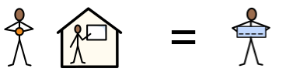

This information was provided by:
Please select the relevant statement below to represent how the child’s views were gathered to complete Appendix 1A:

Child/ Young Person’s views were captured by completion of this form and through observations and discussions with the child, their parent(s), carer(s) and relevant professionals. | ☐
The Child/Young Person’s was able to take part in developing their Education, Health and Care Plan (EHCP) by contributing their wishes and aspirations with their parents (s) and the professionals working with them. | ☐
Due to their severe and complex needs, the child/young person is unable to express their views directly. Therefore, their views have been provided by the child’s teacher and parent/carer. | ☐

Date of completed form:
Click or tap to enter a date.

Picture, drawing, or photo of me (optional):

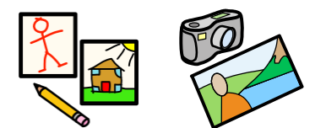

My aspirations (goals) for the future:
My
Future

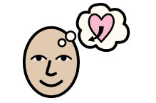

This year, I want to get better at: |  | Please use this box to draw / type / write any of your ideas:
When I grow up, I would like to be: | 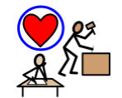 | Please use this box to draw / type / write any of your ideas:
I am working towards Independence, by:
My Independence

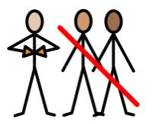

Comments:

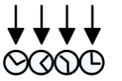 | 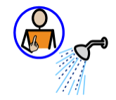 |  | 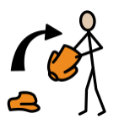 | 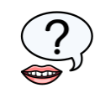 | 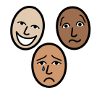 | 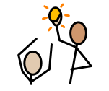
Knowing my routine  ☐ | Doing self-care tasks  ☐ | Managing my own toilet hygiene  ☐ | Dressing independently  ☐ | Asking for help  ☐ | Telling people how I feel  ☐ | Telling people what I want or need  ☐
How I communicate best:
My
Voice

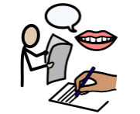

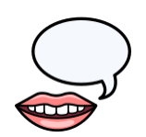 | 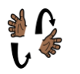 | 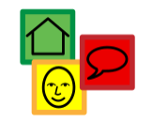 | 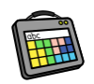 | 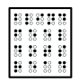
Talking  ☐ | Signing  ☐ | Using Symbols  ☐ | Augmentative Communication Aid  ☐ | Reading Braille  ☐

Comments:

How I communicate best:
My
Voice

Who listens to me, at home?  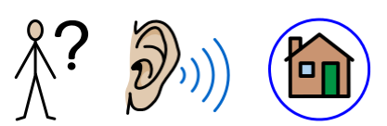 | Please use this box to draw / type / write any of your ideas:
Who listens to me, at my school, or in my setting?  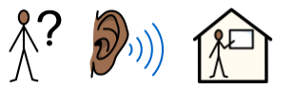 | Please use this box to draw / type / write any of your ideas:

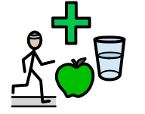
To keep myself healthy, I:
My
Health

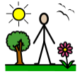 | 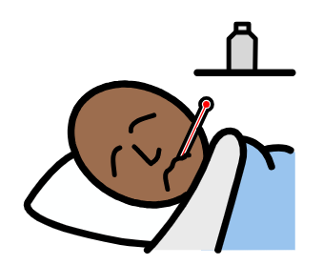 | 
Spend time outside each day  ☐ | Tell someone when I feel unwell  ☐ | Keep my screen-time within healthy limits  ☐
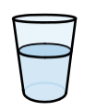 | 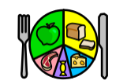 | 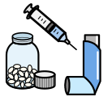
Stay hydrated  ☐ | Try to eat a variety of foods  ☐ | Take my prescribed medication  ☐
To keep myself healthy, I:
My
Health

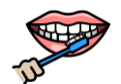 | 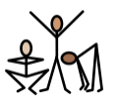 | 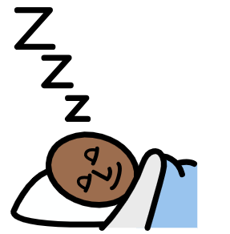 | 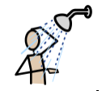 | 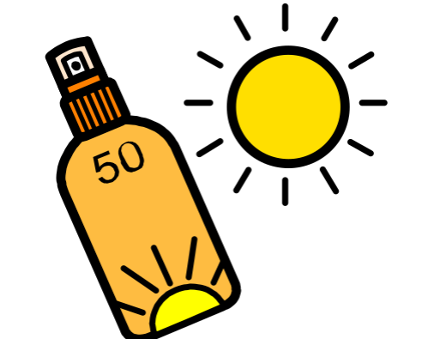
Brush my teeth daily  ☐ | Exercise  ☐ | Get enough sleep  ☐ | Shower, or wash, daily  ☐ | Wear suncream and /or protective clothing  ☐
Please use this box to draw / type / write any of your ideas:

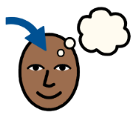
The best way for me to learn, is:
My Learning

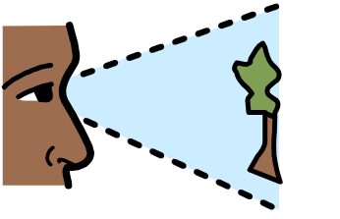 | 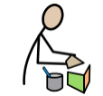 | 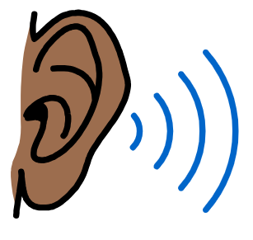 | 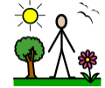 | 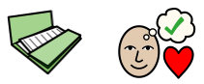
Visual  ☐ | Kinaesthetic (practical, hands-on, doing things)  ☐ | Auditory  ☐ | Out-door  ☐ | Project-based  ☐
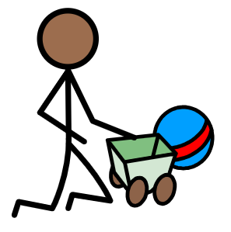 | 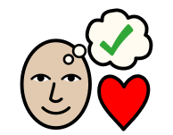 |  |  | 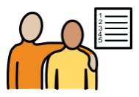
Play-based/ Child- Initiated  ☐ | Special interest-based  ☐ | Watching Videos  ☐ | Life Skills-based  ☐ | Working towards and achieving my EHCP outcomes  ☐

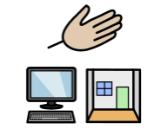
Adults can help me, by giving me:
My Support

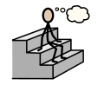 | 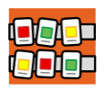 | 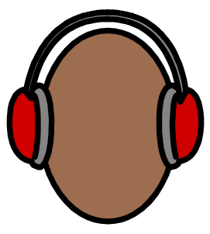 | 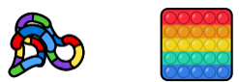 | 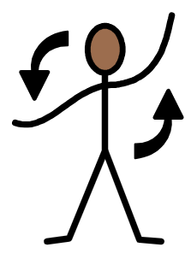
Thinking time  ☐ | Visual timetables / check-lists  ☐ | Ear defenders  ☐ | Fiddle toys  ☐ | Movement breaks  ☐
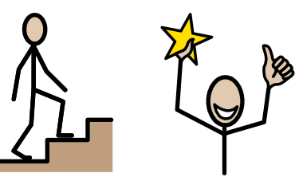 | 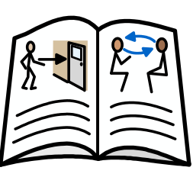 | 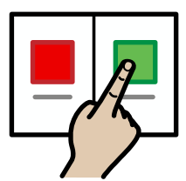 | 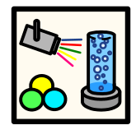 | 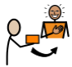
Small steps to success (‘chunked’ tasks)  ☐ | Social Stories  ☐ | Choices  ☐ | A safe space  ☐ | Motivators / Rewards  ☐

I feel safe at school:
My
Safety

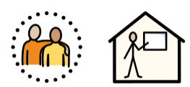

 |  | 
Yes  ☐ | No  ☐ | Unsure  ☐

Please use this box to draw / type / write any of your ideas:

Keeping myself safe:
My
Safety

Who can help me at home?   | Who can help me at school?  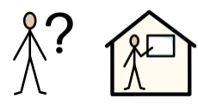
Please use this box to draw / type / write any of your ideas: | Please use this box to draw / type / write any of your ideas:
Adults can teach me to keep safe, by helping me to:
My
Safety

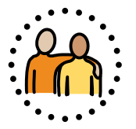

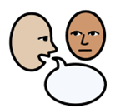 |  | 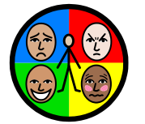 | 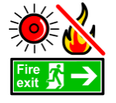 | 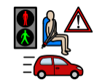
Follow adult direction to keep me safe  ☐ | Recognise Danger  ☐ | Practise Self-Regulation  ☐ | Understand what to do in a fire drill  ☐ | Understand Road Safety  ☐
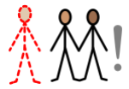 |  | 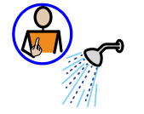 | 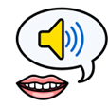 | 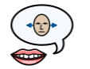
Be aware of Stranger Danger  ☐ | Practise  Online Safety  ☐ | Keep healthy and look after my body  ☐ | Understand Consent:  My body; My choice  ☐ | Understand Boundaries: My right to say No, and change my mind  ☐
Outside of my school, or setting, I like:
My Community

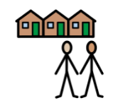

 | 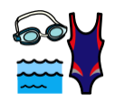 | 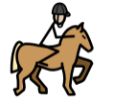 | 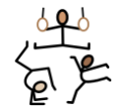 | 
Football  ☐ | Swimming  ☐ | Horse riding  ☐ | Gymnastics  ☐ | Gaming  ☐
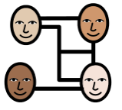 |  | 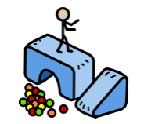 | 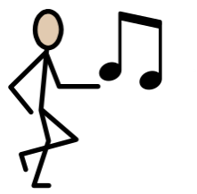 | 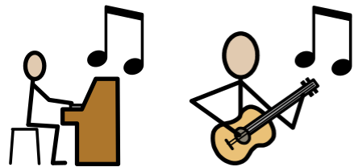
Socialising  ☐ | Reading  ☐ | Soft play  ☐ | Dancing  ☐ | Playing Music  ☐

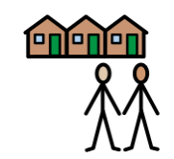
Outside of my school, or setting, I like:
My Community

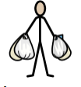 | 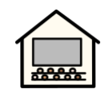 | 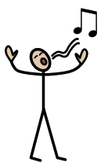 | 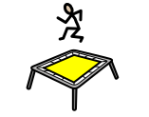 | 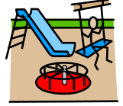
Shopping  ☐ | Cinema  ☐ | Singing  ☐ | Trampolining  ☐ | Going to the park  ☐

Please use this box to draw / type / write any of your ideas:


My quality of Life: At school, I feel good, when:
My Quality of Life

 | 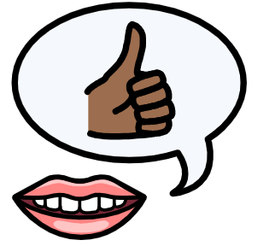 |  | 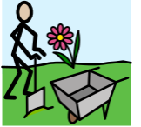 | 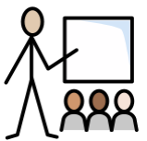
I played with my favourite toy  ☐ | Somebody said: “Well done!”  ☐ | I had computer time  ☐ | It was Forest School  ☐ | It was my favourite lesson  ☐

Please use this box to draw / type / write any of your ideas:

My quality of Life- At home, I am happy when I am with:
My Quality of Life

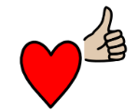

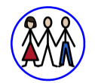 | 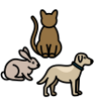 | 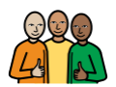
My family  ☐ | My pets  ☐ | My close friends  ☐
Please use this box to draw / type / write any of your ideas:

At my school or setting, overall:


My Setting: |   Yes  Yes |   No  No |   I don’t know
My Future – I have a choice about my future.  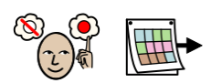 | ☐ | ☐ | ☐
My Independence - I have the right support to enable me to be as independent as I can be.  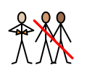 | ☐ | ☐ | ☐
My Voice - I feel listened to.  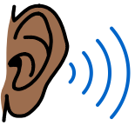 | ☐ | ☐ | ☐
My Health – I have the right health support to enable me to be as healthy as I can be.  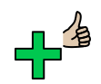 | ☐ | ☐ | ☐
My Learning/Support - I feel I have the right amount of support in my setting.  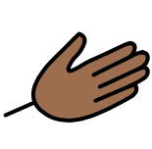 | ☐ | ☐ | ☐
My Safety - I feel safe.  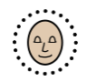 | ☐ | ☐ | ☐
My Quality of Life- I am happy and enjoy life. | ☐ | ☐ | ☐
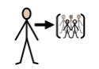  My Community - I have a sense of belonging. | ☐ | ☐ | ☐

I have been included in my Annual Review meeting:
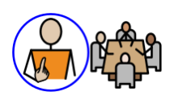

Please select Not Applicable if their annual review meeting has not been held yet meeting (the annual review meeting is held within a year after the EHCP of its first issue or from the date of the last review).

Not Applicable  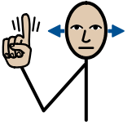 | Yes   | No   | Not Sure
☐ | ☐ | ☐ | ☐
Anything else:
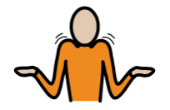

Comments:

