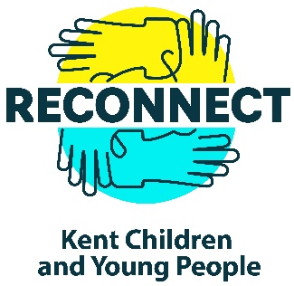
Dear Parents,

Re: Home Study Support for years 10 & 11

We are delighted to inform you that Kent County Council’s “Reconnect: Kent Children and Young People” programme is providing an exciting, free, Home Study Support initiative starting on 1st March 2022.

Delivered by Kent based Invicta National Academy these free voluntary Zoom sessions are available for your child to drop in to and ask their maths, science, and English homework questions or to stay and get support for the whole hour. Sessions are run by qualified teachers with experienced teaching assistants on hand to help. There will be a focus topic for each session and students are encouraged to come with the subject based questions.

During the sessions cameras are switched off and communication is via the Q&A function, which is only visible to your child and the teacher and lesson facilitator. Where possible, students may communicate via the microphone if they would like to; this is controlled by the lesson facilitator.

There is no commitment to attend, students can join as many sessions as they wish using the zoom link provided and can join, leave, and re-join as many times as they wish using the same link.

To register and receive your free virtual Home Study Support link please click on the link below. It takes less than a minute!

Click here to register
https://www.invictaacademy.com/home-study-support

Home Study Support timetable for years 10 & 11 starting 1st March 2022

Tuesdays: Maths 5-6pm & Science 6-7pm
Thursdays: Maths 5-6pm & English 6-7pm

We hope you will encourage your children to take advantage of this exciting new opportunity,

Kind regards,

Head Teacher

About Invicta National Academy
Invicta National Academy is committed to ensuring children learning is not adversely affected by covid-19. With two teaching professionals in every class, Invicta National Academy, provides one of the best, virtual teaching models currently available and we are delighted to be able to offer this extra “state of the art” support. For more information do visit their website at www.invictaacademy.com.

What other parents have said about Invicta National Academy:

“He was looking forward to attending these lessons & it was really enjoyable. He learnt well as it was live Zoom... not Google classroom. It was like being with a teacher in a classroom much better and easier to understand and learn.”

“My child enjoyed these lessons and found she could keep up (a challenge for her - she has dyslexia). This gave her a confidence boost and helped her. Something similar over a longer time span would be very beneficial.”

“Having a ‘live’ lesson has engaged my child far more than I, as a parent, could do. The classes are engaging, and it has helped retain some of the knowledge lost throughout this period [COVID].”

