Dear Colleague,

School Budgets

I am pleased to inform you that the 2013/14 Delegated Formula and Pupil Premium budget templates are now available on KentTrustWeb via the following link: Basic Budget Templates. Devolved Formula Capital allocations have not yet been announced, these are not expected from the DfE until mid-March
For those schools that have purchased the Financial Planning Tool (FPT), the basic budget templates should not be used as they are fully integrated into the FPT. The Financial Planning Tool will be e-mailed to schools or it will be available at the beginning of the chosen training session.
This is the third consecutive year of the Government’s “flat cash per pupil” DSG settlement and the key headlines this year are:

- The Kent formula budget for Primary and Secondary schools has been simplified to reflect the National School Funding Reforms, which you were consulted on in September 2012. One important change is that this is the first year school budgets are based on the previous October census data.
- The Government’s Minimum Funding Guarantee (MFG) for 2013/14 and 2014/15 is -1.5%. This has been applied to ensure no school has a cut in its budget of more than 1.5% per pupil (excluding exempt items and high needs funding) before any pupil premium is allocated.
- The delegated formula budgets include further delegation of services previously managed by the Local Authority (LA), as directed through the school funding reforms. This new delegated funding has been included in the formula budget and also added into the MFG calculation after the -1.5% adjustment has been applied, to ensure that each school receives the full further delegation allocation.
- There are some significant changes to the funding of High Needs SEN pupils. The DfE’s national methodology, known as "Place Plus" is being fully complied with, whilst at the same time ensuring that the current levels of funding for SEN pupils is maintained as far as possible in school budget allocations for the coming year.
- This is the third year of the Government’s Pupil Premium and estimated allocations have been based on the assumed number of eligible pupils. Schools are able to amend the LA assumptions with their own figures. Assumptions about a further increase to the funding rates in 2014/15 have also been reflected.
- On 14 February 2013, the County Council agreed a 1% cost of living pay award for Kent Scheme Staff, effective from 1 April 2013. With regards to Kent Range TCP assessment percentages, we do not yet know what they are but we will inform you via an e-bulletin as soon as they are available. Schools are able to vary these percentages if they have their own pay policy for support staff already in place.

A more detailed note explaining the significant changes can be accessed through the above link.

For 2014/15 and 2015/16, the second and third years of the new three-year planning period, the DfE has confirmed that the MFG will be -1.5%, and that the MFG will continue to apply in 2015/16. However, as this is in the next spending review period past the next election they are unable to confirm the rate at this stage. To provide schools with some initial basis for planning we have assumed that the rate for 2015/16 will be set at -1.5%

The longer term changes in school budgets are very significant and the early analysis we shared with all schools in September 2012 showed budget changes ranging from an increase of 16% to a reduction of 12%. This is very challenging. It is important that schools start planning for the longer term implications now as decisions on how to manage such turbulence will require serious consideration of staffing and curriculum needs for the future. We do not yet know what decisions will be made about school funding after the next general election, when these underlying effects of the funding reforms may become more of a reality.

Your three year financial plan submission due to the LA by the end of May should be based on the LA assumptions. We know that our assumptions may need adjusting, but for now we want Kent schools to be able to plan on a consistent basis. As soon as we receive any information from the Department for Education about future years school funding we will let you know, but we are not anticipating anything until later this year.

This budget ensures that there is sufficient funding to meet the year on year cost increases that schools are likely to face. But if you experience difficulties when setting the budget for your school please contact Yvonne King on 0845 365 5368 or email via schoolsfinancialservices@kent.gov.uk.

The detailed budget guidance notes accessible on KentTrustWeb include a list of contact names dependent on the nature of your query. Please contact me if you have any questions on overall policy issues.

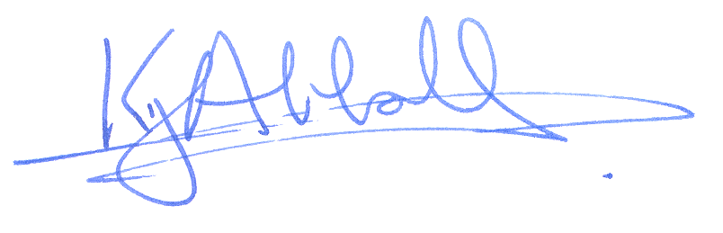
Yours sincerely

Keith Abbott
Director of School Resources

