All About Me
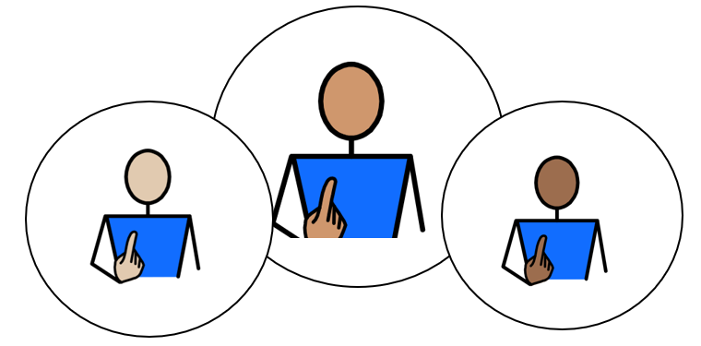

Appendix 1A: Pathway 1

Voice of the Child / Young Person

This form is all about you. It helps the people who support you understand:
- what you are good at
- what you enjoy
- how you like to communicate
- what helps you learn and feel happy
- anything that could be better for you
You can complete this form on a computer, or you can print it out and write on it.
If you would like help, an adult can read the questions, write or type your answers, or help you complete a little bit at a time.
The examples on each page are just ideas to help you think about your answers. You do not have to choose them. Use the grey boxes to tell us what you think.
✅ Tick any boxes that sound like you.
✍️ Use the grey spaces to add your own comments, ideas, and feelings.
My views should be used to inform my Annual Review Meeting, Outcomes, and Provision.

1. About Me
My Name is:  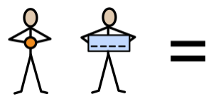 | Tap or click here and type my name
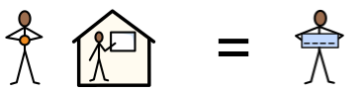  My school or setting is called: | Tap or click here and type my school or setting
Date this form was completed: Click or tap to enter a date.

The name of the person helping me complete this form is: | Tap or click here and type their name
They know me because: | Tap or click here and type how they know me

2. How my views were gathered
☐ My views were captured by completing this form and through observations and discussions with me, my parent(s)/carer(s), and relevant professionals.

☐ I was able to take part in developing my Education, Health and Care Plan by sharing my wishes and aspirations with my parent(s)/carer(s) and the professionals working with me.

☐ I am not able to express my views directly at this time. My views have been shared by adults who know me well, including my teacher and parent/carer.
3. Picture, drawing, or photo of me

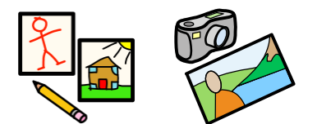
Add a picture, drawing, or photo here if you would like.



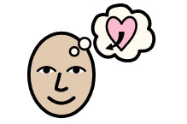
4. My aspirations and next steps
My aspirations or goals for the future are:

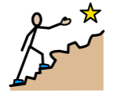
The next steps for me would be to:

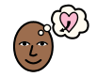
I want to be able to:

My Independence: I am working towards independence, by:
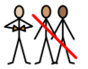
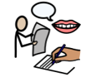 | 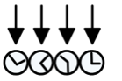 | 
Having my own voice / preferred method of communication  ☐ | Knowing my routine  ☐ | Showing my likes to something by smiling or reaching for it  ☐
  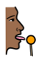 |  | 
Anticipating food routines with interest  ☐ | Accepting an ‘intervention’ feed (e.g. peg-feed)  ☐ | Starting to co-operate with dressing, holding out my  arms/legs  ☐
My Community: Outside of my school, or setting, I like:
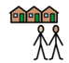
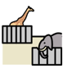 | 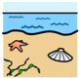 | 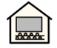
Going to the zoo  ☐ | Going to the beach  ☐ | Going to the cinema  ☐
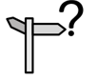 | 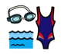 | 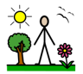
Going out with my Personal Assistant  ☐ | Swimming  ☐ | Going outside  ☐

My Community: Outside of my school, or setting, I like:
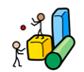 | 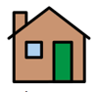 | 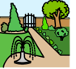 | 
Going to soft play  ☐ | Visiting a family member’s house  ☐ | Going to the park  ☐ | Going on outings  ☐

Tap or click here and type any comments

My Quality of Life: At school, I feel good, when:

 |  | 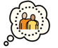 |  | 
I can express when I like something  ☐ | I can express when I do not like something  ☐ | I have a trusted adult who can interpret my needs and wants  ☐ | I can show pleasure derived from an activity  ☐ | Adults protect my dignity and show respect, when hoisting or changing me  ☐
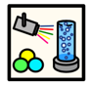 | 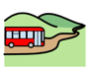 | 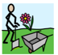 | 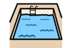 | 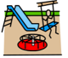
I enjoy using the Sensory Room  ☐ | I enjoy going on school trips  ☐ | I enjoy Forest School  ☐ | I enjoy Hydrotherapy time  ☐ | I enjoy using the Sensory Playground  ☐
My Quality of Life: At home I am happy with:
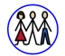 | 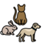 | 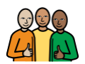
My family  ☐ | My pets  ☐ | My close friends  ☐

Tap or click here and type any comments

My Voice: How I communicate best:

Who listens to me, at home?  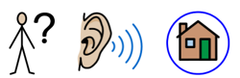 | Tap or click here and type any comments
Who listens to me, at my school, or in my setting?  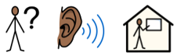 | Tap or click here and type any comments

My Voice: I can communicate best, by:
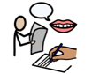
 | 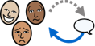 |  | 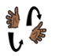 | 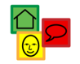 |  | 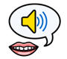 |  | 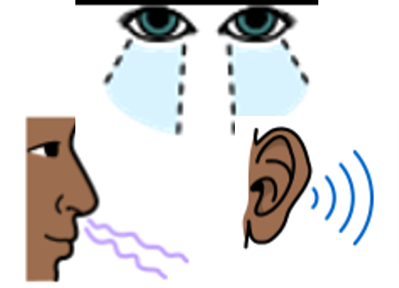
 | Reacting and responding to adults  ☐ |  | Signing  ☐ | Using Symbols  ☐ |  | Vocalisation  ☐ |  | Sensory Cues  ☐
 | 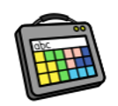 |  | 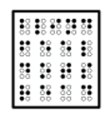 | 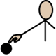 |  | 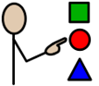 |  | 
 | Using my Augmentative Communication Aid  ☐ |  | Reading Braille  ☐ | Using Touch Cues  ☐ |  | Objects of Reference  ☐ |  | Photo Cues  ☐
My Support: Adults can help by giving me:
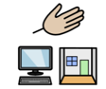

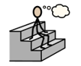 |  |  |  |  |  |  | 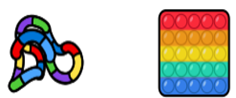
Thinking Time  ☐ |  | Repetition  ☐ |  |  | Ear Defenders  ☐ |  | Fiddle Toys  ☐
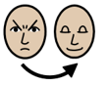 |  | 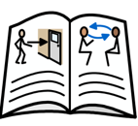 |  |  | 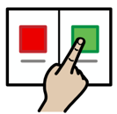 |  | 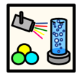
Relaxation  ☐ |  | Social Stories  ☐ |  |  | Choices  ☐ |  | Safe Space  ☐
My Support: Adults can help by giving me:

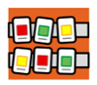 |  | 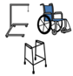 | 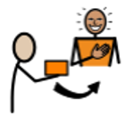
Visual Timetable / Objects of Reference  ☐ | Sensory Room Time  ☐ | Equipment which is appropriate and comfortable  ☐ | External Motivators (Rewards)  ☐

Tap or click here and type any comments

My Learning: I can show engagement, through:

*This page is to be completed by the Education Setting/Team around the Child/Young Person

I show exploration, by…  (e.g., showing interest and curiosity about an activity by noticing it or reaching out to it) | 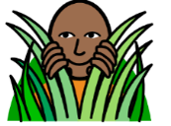 | Tap or click here and type any comments
I show realisation, by…  (e.g., displaying behaviours which show I want more control of the stimulus or activity; by stopping it or trying to make changes to it) | 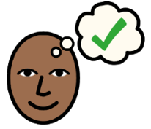 | Tap or click here and type any comments
I show anticipation, by…  (e.g., anticipating that a familiar activity is about to start or finish by interpreting such as auditory (what I hear), tactile (what I feel) and visual (what I see) cues or prompts) | 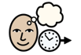 | Tap or click here and type any comments
I show persistence, by…  (e.g., sustaining my attention in a stimulus or activity for long enough to actively try to find out more, and interact with it) |  | Tap or click here and type any comments
I show initiation, by…  (e.g., investigating a stimulus or activity to bring about a desired outcome / acting spontaneously and independently during a familiar activity without waiting for direction) |  | Tap or click here and type any comments
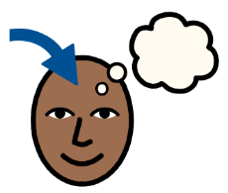
My Learning: The best way for me to learn is:

 | 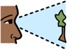 |  |  |  |  | 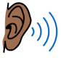 |  | 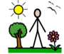 |  | 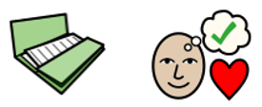
 | Visual  ☐ |  | Kinaesthetic (practical, hands-on, doing things)  ☐ |  |  | Auditory  ☐ |  | Outdoor  ☐ |  | Project-based  ☐
 | 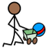 |  | 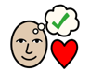 |  |  |  |  |  |  | 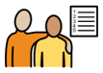
 | Play-based  ☐ |  | Special interest-based  ☐ |  |  | Screen / video-based  ☐ |  | Life Skills-based  ☐ |  | Working towards and achieving my EHCP outcomes  ☐
My Health: I can keep healthy, by:
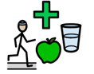
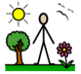 |  |  |  |  |  |  |  |  | 
Spending time outside each day  ☐ |  |  |  | Eating food, bottle, PEG feed, or other agreed support  ☐ |  |  |  |  | Staying regulated without a screen for increasing amounts of time  ☐
 |  |  |  |  |  |  |  |  | 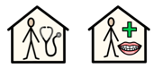
Accepting nappy, pad, or catheter changes  ☐ |  |  |  | Accepting medicine  ☐ |  |  |  |  | Attending medical appointments, such as doctor or dentist appointments  ☐
My Safety: Adults can help to keep me safe, by teaching me to:

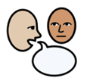 |  |  |  |  | 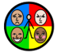 |  | 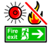 |  |  |  | 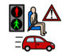
Follow adult direction to keep me safe  ☐ |  | Recognise Danger  ☐ |  |  | Practise Self-Regulation  ☐ |  | Understand what to do in a fire drill  ☐ |  |  |  | Understand Road Safety  ☐
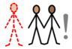 |  |  |  |  | 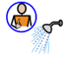 |  | 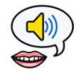
Be aware of Stranger Danger  ☐ |  | Practise Online Safety  ☐ |  |  | Keep healthy and look after my body  ☐ |  | Understand Consent: My body; My choice  ☐ |  |  |  | Understand Boundaries: My right to say No, and change my mind  ☐

Not Applicable  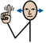 | Yes   | No   | Not Sure  
☐ | ☐ | ☐ | ☐
I have been included in my Annual Review meeting:



Please select Not Applicable if their annual review meeting has not been held yet meeting (the annual review meeting is held within a year after the EHCP of its first issue or from the date of the last review).

