All about Me
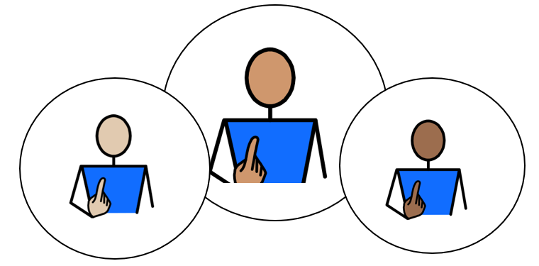

Appendix 1A: Pathway 1
Voice of the Child / Young Person

We use our Children’s and Young People’s Outcome Framework, below, to make sure that the support provided for you is having a positive impact on your life.
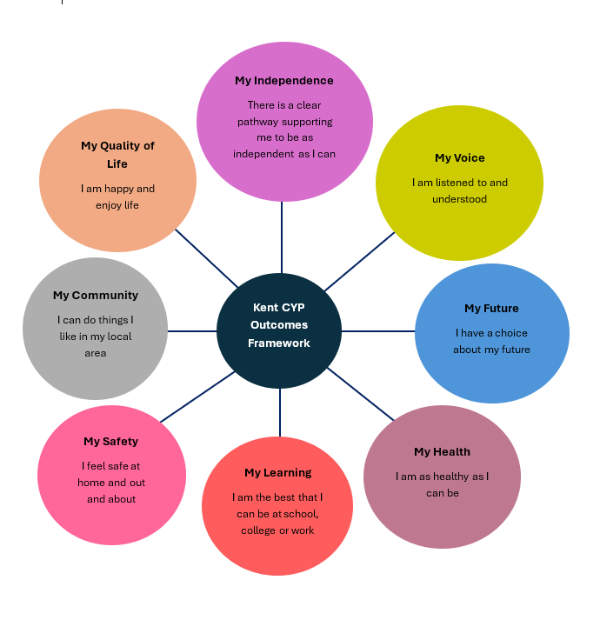

This is your chance to tell everyone supporting you what is going well, and what needs to change, in order to help you reach your full potential. The following questions will help us to understand more about you, and your views about your life.

This form can be printed off, to add your own ideas and thoughts in the blank grey boxes, if you would like. An adult can read for you, and /or write your answers for you, if you would like help; and you can break it down into smaller parts, if you don’t want to complete it all at once. Alternatively, this form can be completed electronically, using the text boxes to add typed comments and /or selecting thoughts and views using the tick boxes provided.

Please use the information gathered through Pupil Voice to inform the Annual Review Meeting in terms of Outcomes and Provision.

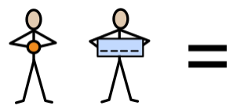
My name is:
Click or tap here to enter text.

Click or tap here to enter text.

My school/setting is called:
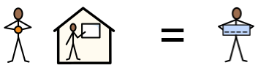

This information was provided by:
Please select the relevant statement below to represent how the child’s views were gathered to complete Appendix 1A:

Child/ Young Person’s views were captured by completion of this form and through observations and discussions with the child, their parent(s), carer(s) and relevant professionals. | ☐
The Child/Young Person’s was able to take part in developing their Education, Health and Care Plan (EHCP) by contributing their wishes and aspirations with their parents (s) and the professionals working with them. | ☐
Due to their severe and complex needs, the child/young person is unable to express their views directly. Therefore, their views have been provided by the child’s teacher and parent/carer. | ☐

Date of completed form:
Click or tap to enter a date.

Picture, drawing, or photo of me (optional):

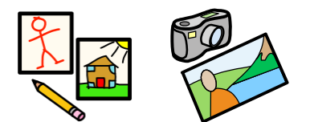

My aspirations (goals) for the future:
My
Future

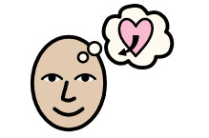

The next steps for me would be to: | 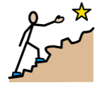 | Comments:
I want to be able to: | 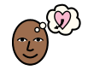 | Comments:

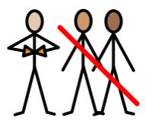
I am working towards independence, by:
My Independence

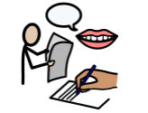 | 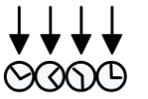 | 
Having my own voice / preferred method of communication  ☐ | Knowing my routine  ☐ | Showing my likes to something by smiling or reaching for it  ☐
  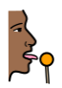 |  | 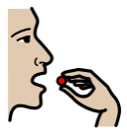
Anticipating food routines with interest  ☐ | Accepting an ‘intervention’ feed (e.g. peg-feed)  ☐ | Biting finger food  ☐

I am working towards independence, by:
My Independence

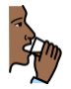 |  |  | 
Holding my own cup  ☐ | Starting to co-operate with dressing, holding out my  arms/legs  ☐ | Co-operating with nappy/pad changes  ☐ | Expressing my dislike for something by crying or pushing it away  ☐
Comments:

I can communicate best, by:
My
Voice

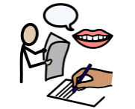

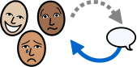 | 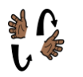 | 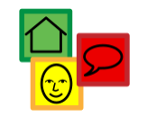 | 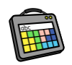 | 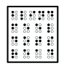 | 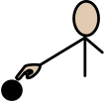
Reacting and responding to adults  ☐ | Signing  ☐ | Using Symbols  ☐ | Using my Augmentative Communication Aid  ☐ | Reading Braille  ☐ | Using Touch Cues  ☐
Comments:

I can communicate best, with:
My
Voice

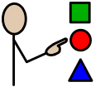 |  | 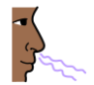  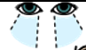  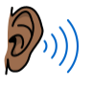 | 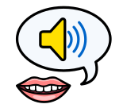
Objects of Reference  ☐ | Photo Cues  ☐ | Sensory Cues  ☐ | Vocalisation  ☐
Comments:

My
Voice

I can communicate my basic needs and wants, when:

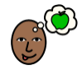 | 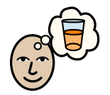 | 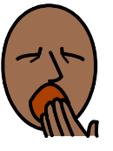 | 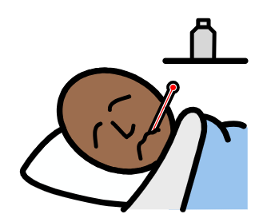 | 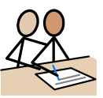
I am hungry  ☐ | I am thirsty  ☐ | I am tired  ☐ | I feel unwell  ☐ | I need help  ☐
 | 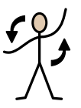 | 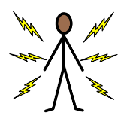 | 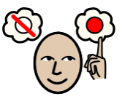 | 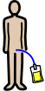
I need suction  ☐ | I need repositioning  ☐ | I am in pain  ☐ | I want to choose between a prefered and non-prefered object  ☐ | I need a nappy/pad/ catheter change  ☐

I can keep healthy, by:
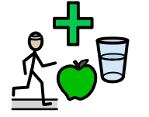
My
Health

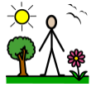 | 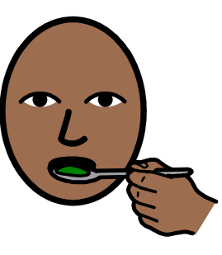 | 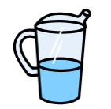 | 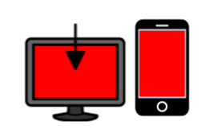
Spending time outside each day  ☐ | Eating (food, bottle, peg-feed, etc)  ☐ | Drinking  ☐ | Staying regulated without a screen for increasing amounts of time  ☐
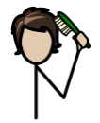 | 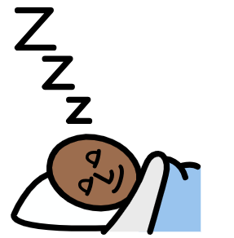 |  | 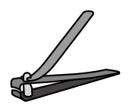
Tolerating my  hair being brushed  ☐ | Getting enough sleep  ☐ | Accepting medicine  ☐ | Tolerating having my fingernails and toenails cut  ☐
I can keep healthy, by:
My
Health

 |  | 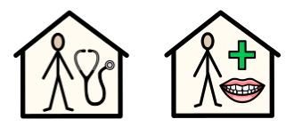 | 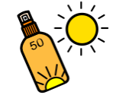
Accepting  Nappy /pad /catheter changes  ☐ | Tolerating having  my teeth brushed  ☐ | Attending medical appointments (doctor / dentist, etc.)  ☐ | Having sun cream applied  ☐
Comments:

I can show engagement, through:
My Learning

*This page is to be completed by the Education Setting/Team around the Child/Young Person.

I show exploration, by…  (e.g., showing interest and curiosity about an activity by noticing it or reaching out to it) | 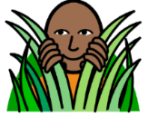 | Comments:
I show realisation, by…  (e.g., displaying behaviours which show I want more control of the stimulus or activity; by stopping it or trying to make changes to it) | 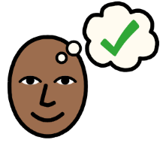 | Comments:
I show anticipation, by…  (e.g., anticipating that a familiar activity is about to start or finish by interpreting such as auditory (what I hear), tactile (what I feel) and visual (what I see) cues or prompts) | 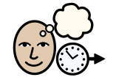 | Comments:
I show persistence, by…  (e.g., sustaining my attention in a stimulus or activity for long enough to actively try to find out more, and interact with it) |  | Comments:
I show initiation, by…  (e.g., investigating a stimulus or activity to bring about a desired outcome / acting spontaneously and independently during a familiar activity without waiting for direction) | 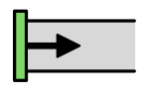 | Comments:
The best way for me to learn, is:
My Learning

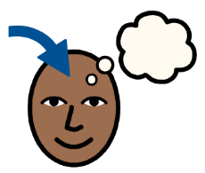

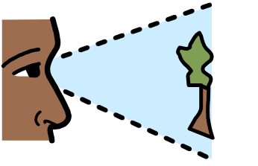 | 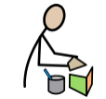 | 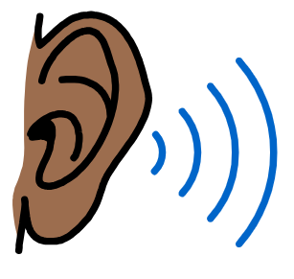 | 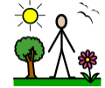 | 
Visual  ☐ | Kinaesthetic (practical, hands-on, doing things)  ☐ | Auditory  ☐ | Out-door  ☐ | Project-based  ☐
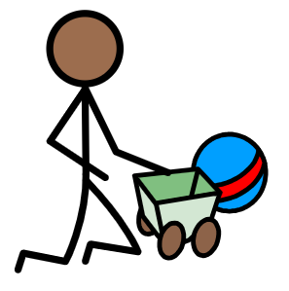 | 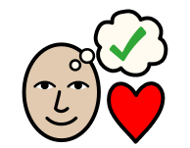 |  |  | 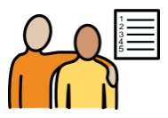
Play-based  ☐ | Special interest-based  ☐ | Screen / video-based  ☐ | Life Skills-based  ☐ | Working towards and achieving my EHCP outcomes  ☐

Adults can help by giving me:
My Support

My Support

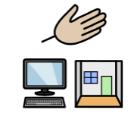

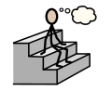 | 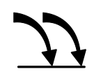 | 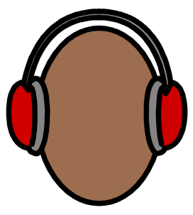 | 
Thinking Time  ☐ | Repetition  ☐ | Ear Defenders  ☐ | Fiddle Toys  ☐
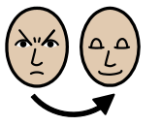 | 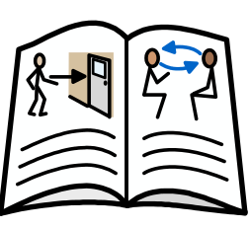 | 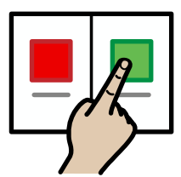 | 
Relaxation  ☐ | Social Stories  ☐ | Choices  ☐ | Safe Space  ☐

Adults can help by giving me:
My Support

My Support

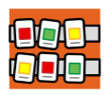 | 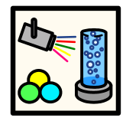 | 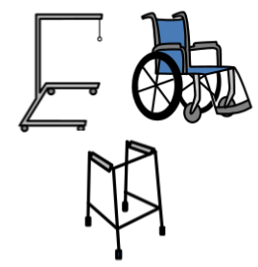 | 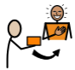
Visual Timetable / Objects of Reference  ☐ | Sensory Room Time  ☐ | Equipment which is appropriate and comfortable  ☐ | External Motivators (Rewards)  ☐
Comments:

Adults can help to keep me safe, by teaching me to:
My
Safety

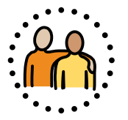

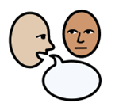 |  | 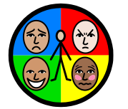 | 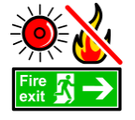 | 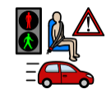
Follow adult direction to keep me safe  ☐ | Recognise Danger  ☐ | Practise Self-Regulation  ☐ | Understand what to do in a fire drill  ☐ | Understand Road Safety  ☐
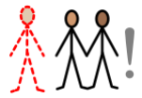 |  | 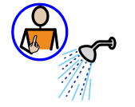 | 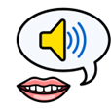 | 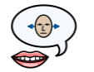
Be aware of Stranger Danger  ☐ | Practise  Online Safety  ☐ | Keep healthy and look after my body  ☐ | Understand Consent:  My body;  My choice  ☐ | Understand Boundaries: My right to say No, and change my mind  ☐

Outside of my school, or setting, I like:
My Community

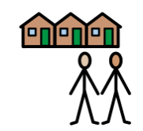

 | 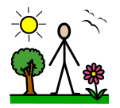 | 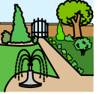 | 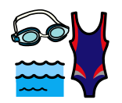
Technology  ☐ | Going outside  ☐ | Going to the park  ☐ | Swimming  ☐
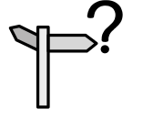 |  | 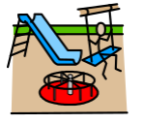 | 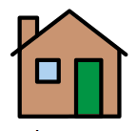
Going out with my Personal Assistant  ☐ | Going on outings  ☐ | Going to the playground  ☐ | Visiting a family member’s house  ☐

Outside of my school, or setting, I like:
My Community

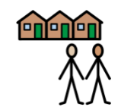

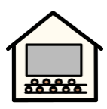 | 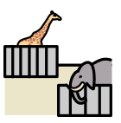 | 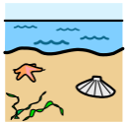 | 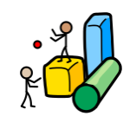 | 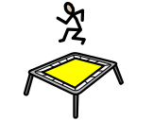
Going to the cinema  ☐ | Going to the zoo  ☐ | Going to the beach  ☐ | Going to soft play  ☐ | Going to a trampoline park  ☐

Comments:
My quality of Life:
My Quality of Life



 |  | 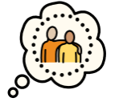 |  | 
I can express when I like something  ☐ | I can express when I do not like something  ☐ | I have a trusted adult who can interpret my needs and wants  ☐ | I can show pleasure derived from an activity  ☐ | Adults protect my dignity and show respect, when hoisting or changing me  ☐
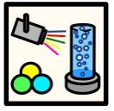 | 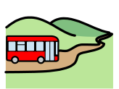 | 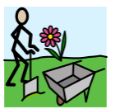 | 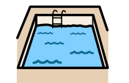 | 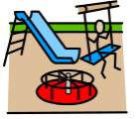
I enjoy using the Sensory Room  ☐ | I enjoy going on school trips  ☐ | I enjoy Forest School  ☐ | I enjoy Hydrotherapy time  ☐ | I enjoy using the Sensory Playground  ☐

My quality of Life:
My Quality of Life

At home, I am happy, with:
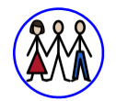 | 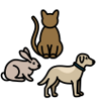 | 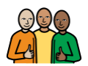
My family  ☐ | My pets  ☐ | My close friends  ☐
Comments:


At my school or setting, overall:

My Setting: |   Yes |   No |   I don’t know
My Future – I have a choice about my future.  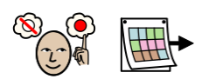 | ☐ | ☐ | ☐
My Independence - I have the right support to enable me to be as independent as I can be.  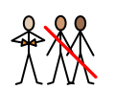 | ☐ | ☐ | ☐
My Voice - I feel listened to.  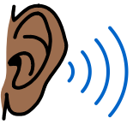 | ☐ | ☐ | ☐
My Health – I have the right health support to enable me to be as healthy as I can be.  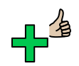 | ☐ | ☐ | ☐
My Learning/Support - I feel I have the right amount of support in my setting.  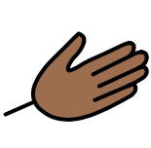 | ☐ | ☐ | ☐
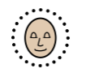  My Safety - I feel safe. | ☐ | ☐ | ☐
My Quality of Life- I am happy and enjoy life. | ☐ | ☐ | ☐
My Community - I have a sense of belonging.  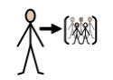 | ☐ | ☐ | ☐

Not Applicable  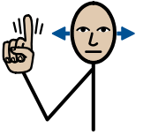 | Yes   | No   | Not Sure
☐ | ☐ | ☐ | ☐
I have been included in my Annual Review meeting:
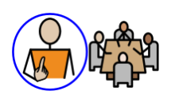

Please select Not Applicable if their annual review meeting has not been held yet meeting (the annual review meeting is held within a year after the EHCP of its first issue or from the date of the last review).

Anything else:
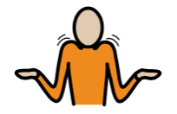

Comments:

