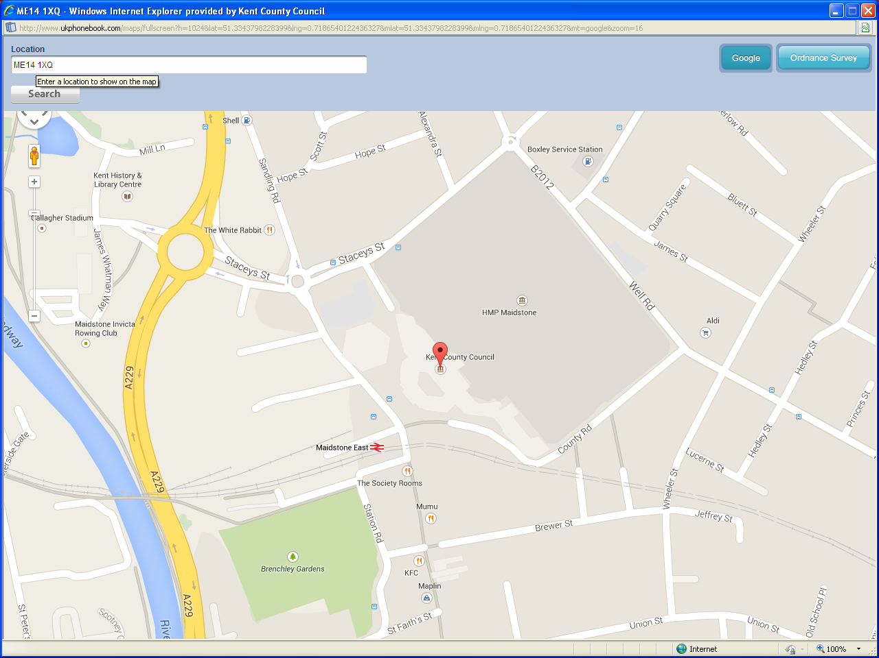
Map:
This is for your reference when travelling to this site and parking your vehicles.
Address: KCC, Sessions House,
County Hall, Maidstone ME14 1XQ

Refreshments:
Please be aware that there will be no refreshments available on the day, therefore you must make your own provisions for lunch.
There are various sites in and around Week Street, Maidstone as well as The Crown Restaurant in County Hall (open on week days until 3pm).

Parking: There is no visitors parking on site- but there are plenty of local car parks nearby.

County Hall Car Parking:
Car parking for County Hall HQ is limited (also short stay parking - 2 hours only). Some meter parking is available outside Sessions House in County Road.

Maidstone East Railway Station Car Park: This is a few minutes walk away

Old royal mail car park: This is a few minutes walk away

Fremlin Walk Car Park:
This is a few minutes walk away

All Other Car Parks:
For other car parking areas with Maidstone, please look at the following link for Maidstone Borough Council:

http://www.maidstone.gov.uk/residents/parking-and-streets/car-parks

(Cost to use Park & Ride – approximately £2.60 per day.)
Local Travel:
Trains:
Maidstone Barracks, Maidstone West and Maidstone East Stations are also within walking distance.

For train times phone National Rail on 08457 484950 or visit National Rail enquiries.

Buses:
For bus timetable call Traveline 0871 200 22 33.

Park & Ride:
There are four bus routes with a frequent service to the town centre.
Further information can be found on the link below.
http://www.maidstone.gov.uk/residents/parking-and-streets/park-and-ride

Coach:
A coach service from London Victoria to Maidstone. For timetable call National Express visit National Express.

Sessions House / County Hall:
County Hall offices are opposite Maidstone East Station. Maidstone Barracks and Maidstone West Stations are also within walking distance.

Reception will able to assist you on how to get to the Lecture Theatre.

Map of Maidstone Town Centre:
‘P’ (blue boxes) indicates some of the car parking adjacent to County Hall.
Please see below.

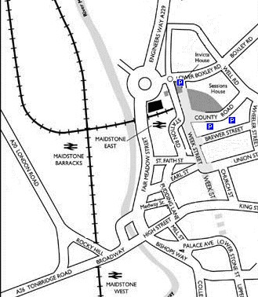
Contact Details:
For further information – please contact the following:

Kent County Council, Sessions House reception on Tel: 03000 41414

