Education Health and Care Plan

Appendix 1

Parent/Carer Views

This form represents your views as parents/carers of your child/young person who may have Special Educational Needs

Please refer to the guidance provided. This form is designed to help you contribute information and your views on the needs of [Name]. Your views are an important part of the statutory assessment process.

Please note that all the information on this form will be copied to all agencies directly involved in the education of your child.

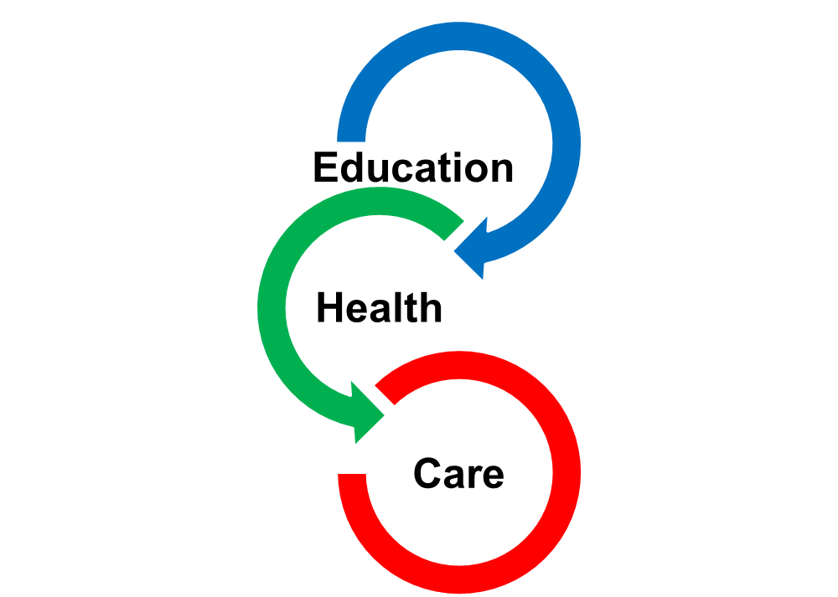

Child or Young Person’s details
Surname
First Name
D.O.B |  |  | Year group
Gender: | Male/Female
Address
Home Language |  | Religion
Education setting |  | NHS number

Person(s) with Parental Responsibility
Name
Relationship:
Address:
Postcode:
Home Tel: |  | Daytime Tel:
Mobile Tel: |  | Email:
Preferred Contact Method:
Name
Relationship:
Address:
Postcode:
Home Tel: |  | Daytime Tel:
Mobile Tel: |  | Email:
Preferred Contact Method:
- Please tell us about [Name]. Include a summary of
[Name’s] history of Special Education Needs

2. What do you feel are [Name]’s main strengths

3. What do you feel are [Name]’s main difficulties

4. What long-term hopes and aspirations do you have for [Name] ?

Education

5. SEN Support currently in Place
Pre-school
Please tell us what support the early years setting have put in place for your child.

Please tell us how many meetings you have had with the early years setting to discuss your child’s provision and progress

Please tell us if a SCARF package is in place for your per-school child – Yes/No

School age
If a child is recorded on the SEN register in school, your child’s provision and progress should be reviewed and discussed with you at least 3 times per year.

Please tell us if your child is recorded on the SEN register at their school - Yes/No

Please tell us about meetings you have had with the school to discuss your child’s SEND, the provision the school has put in place and the setting’s views on the progress your child is making towards achieving their outcomes.

Please tell us what additional support you believe your child requires at their school in addition to that already in place

If you child is in a school setting please tell us if you are aware of the cost of the support in place to support your child.

6. Tell us about what [Name] enjoys at the setting/school/college?

7. Do you feel [Name] is currently making educational progress?

8. More specifically, is [Name] making progress in:
Reading?
Yes |  |  | No

Comment:
Writing?
Yes |  |  | No

Comment:
Communication?
Yes |  |  | No

Comment:
Numeracy?
Yes |  |  | No

Comment:
Personal, Social and Emotional Development?
Yes |  |  | No

Comment:

9. What Outcomes would you like for [Name] in the short term?

10. Are there any specific barriers to achieving these Outcomes?

11. How do you think they can be best overcome?

Social Care (including Voluntary Organisations and Charities)

Are Social Services, Disabled Children’s and /or Adult Social Services currently involved with your family?

Yes |  |  | No
(If yes, please specify)

Comment:

Our family is/has been subject to a Child Protection Plan.

Have they been involved in the past?
Yes |  |  | No
(If yes, please give details below)

Comment:

Do any voluntary organisations or Charities currently or in the past support
your family? E.g. Direct Payment Support Service
Yes |  |  | No
If yes, please give details below

Comment:

Health
- Is [Name] known to any Health professionals? (please tick all that apply)
G.P
Speech and Language Therapist
Occupational Therapist
Physiotherapist
Child and Adolescent Mental Health Service (CAMHS)
Audiologist (Hearing)
Ophthalmologist (vision/sight)
Community Paediatrician
Any other professionals – including specialists (please specify)?

Does [Name] have any health conditions and/or any medical diagnoses, or is he/she on the pathway to potential diagnosis?
Yes |  |  | No
If yes, please give details below

My child is diagnosed with
Condition | Name of Doctor | Date

(Please include copies of reports)

- Is [Name] on any medication?

 | Yes |  |  | No
What is it for?
This was prescribed by (medical professional)
It was last reviewed on |  |  |  |  | Date:
 |  |  |  |  | By:

12. General
Has anything happened in [Name]’s life which you feel may have contribute to his/her current difficulties?

How do the needs of [Name] impact on everyday family life?

Is [Name]:
 | Yes | No | Assistance  required?
Able to dress/undress by him/herself?
Toilet trained?
Able to feed him/herself?
Able to co-operate with family routines?
Able to manage with changes to routines?
Able to use his/her voice to communicate?
Reliant upon gestures, signs or symbols?
Able to show and receive affection?
Does [Name] have difficulty with:
 | Yes | No | Assistance  required?
Making and maintaining friendships?
Coping with the company of other children?
Managing and expressing his/her emotions?
Managing his/her behaviour?

Would you like to make any comments on the questions above?

- Do you notice any patterns or triggers that affect [Name]’s behaviour? Please comment.
At school/college:
At home:
In the community:

Is there any other information or suggestions that you feel would be helpful?

Do you have additional reports received within the last 18 months to add?
Please attach copies of these to this Appendix 1a
 | Yes |  |  |  | No
Signed:
Designation: |  |  | Parent/Guardian/Carer ( Please indicate by circling )
Date:

