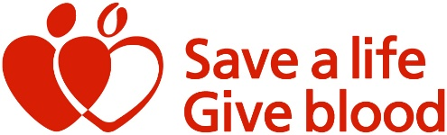
Dear parent/guardian,

On XXXX we will be holding an assembly for our post 16 students to share with them about blood donation and their eligibility to donate from the age of seventeen.
The assembly will involve a video created by a former Deputy Head teacher who lost her husband aged 46 to leukaemia but who is also grateful for the extra time he was given because of over 100 pints of blood products donated by strangers.
The NHS urgently needs blood donations. Each pint of blood saves on average 3 people’s lives. The NHS needs three blood donations every minute to handle emergencies, childbirths and critical treatments.
The assembly is designed to inform students of the option to book to donate blood if they would like to and to show them how quick and easy it is to donate but what a huge impact it has.
We would welcome the support of parents who would also like to donate blood. Please use this QR code to visit blood.co.uk to book your appointment to donate.
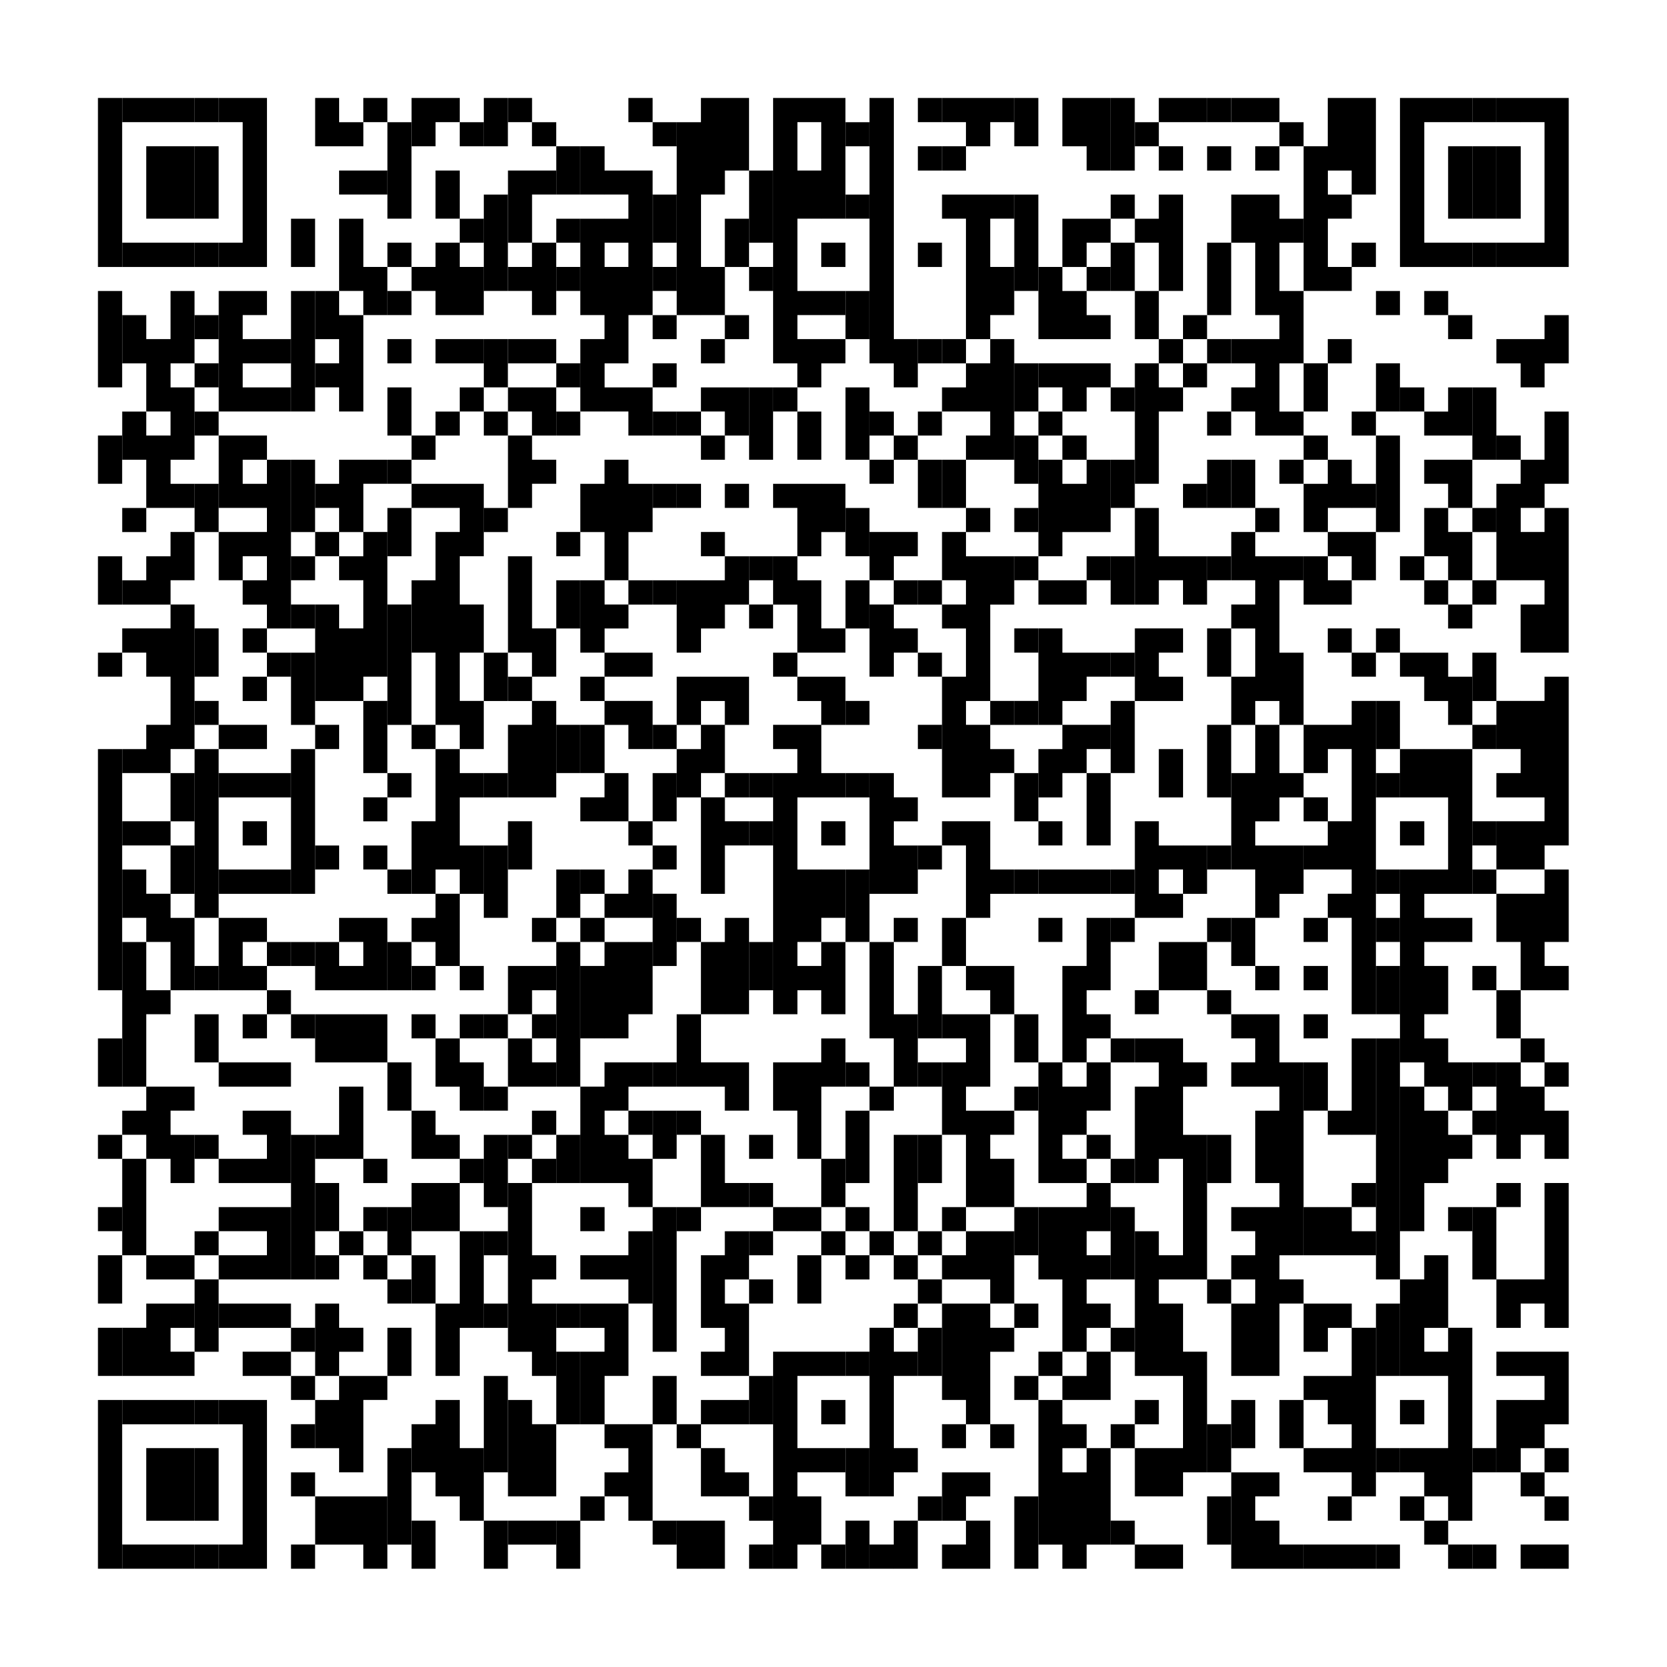
Kind regards,

