Education Health and Care Plan

Guidance for completing
Appendix 2

Guidance Notes for Settings/Schools/FE Colleges

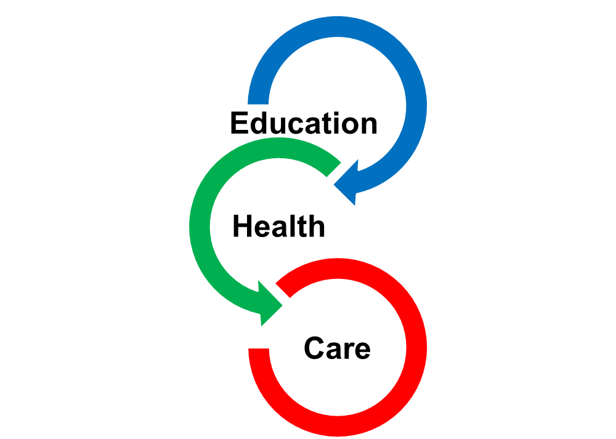

The SENCo or equivalent has responsibility for ensuring this form is completed and submitted to Kent Local Authority within 4-6 weeks of our request to you
See KELSI for SEND specific documentation.

Section:- | Guidance Notes
1 | It is important to ensure we have the correct information in this section including the NHS number where you know this for the Child/Young Person. Where there are sharing restrictions, you will need to provide supporting evidence of this such as a court order.
2 | Where the Child/Young Person is in alternative curriculum, it remains your school’s responsibility to provide us with up-to-date information outlined in this form during their time there.  Record information about the setting attended by the CYP.  FE, please enter Number on roll and % SEN for the course and not for the college.
3 | – Please outline the factors which relate to the Child/Young Person’s educational needs and only provide relevant family background information which is factual. You must outline referrals you have already made and support the Child/Young Person is already receiving from the services outlined.  It is crucial that you outline the Child/Young person’s level of attendance as this will directly impact on their ability to receive provision and make progress. All children and young people are entitled to receive a minimum of 25 hours of education a week, so where they are on a reduced timetable, you will need to outline what plans are in place to re-integrate them back to the required minimum.  If a pupil is dual rolled or has a joint placement, please state name of additional setting. If EY pupil attends more than one setting, please record all known. If pupil is attending Alternative Curriculum placement, please give details and say how long this arrangement has been in place.  When commenting on attendance – EYFS, please comment on whether all sessions are attended regularly, schools please include % attendance over the previous year if known.  Indicate how the child/young person and their family have been involved – for instance, whether they have attended meetings, how they have contributed their views – or, if they have not engaged despite requests from setting.  If a pupil is on a part-time timetable please record reason for this, length of time the arrangement has been in place, the plans and timescales for reintegration from part time to full time and attach the PSP that is in place to monitor the arrangements.  Please record all health/medical conditions that impact on SEN, including those for which diagnosis is awaited.
4 | All Schools/settings have a legal duty to ensure they are doing all they can to support the Children or Young Person in their settings. This is your `best endeavours’ duty. This means you will need to demonstrate that you are adhering to the mainstream core standards including a graduated approach of intervention with appropriate referral for support through the Local Inclusion Forum Team (LIFT). You should be able to demonstrate a minimum of 3 cycles of Assess, Plan, Do, Review, with evaluated and updated provision plans across those 3 cycles. We would expect each cycle to last a minimum of 8 weeks and where you have been given advice from LIFT, you will need to demonstrate that you have implemented and evaluated the impact of that advice.  If you believe your school is unable to make additional provision via reasonable adjustments, Special Educational Needs Inclusion Fund (SENIF) or High Needs Funding (HNF); you will need to tell us why.
5 | It is important that you tell us about all external agency involvement including recommendations made by those agencies, how these have been implemented and what the impact has been.
6 | Because every setting has their own measures of progress, it is important that you explain the measurement that your setting uses. You will need to describe the Child/Young Person’s progress since joining you and how this compares to peers with similar starting points. It is important to tell us the attainment achieved rather than give predictions which are not measurable.
7 | Please tell us about strengths and weaknesses the Child/Young Person has under each category of need only where they have difficulty. If they do not have difficulties in any category please just mark this with not applicable N/A
8 | The strengths and difficulties of the child/young person must be detailed and specific and can be drawn from a range of source material. The information may come from reports/diagnoses received. The description should be listed under the titles of the four areas of need but ONLY IF THE CHILD/YOUNG PERSON HAS A DIFFICULTY IN THAT AREA OF NEED.  You will need to rank each area of need from 1 – 4. (I being the area of greatest need)
9 | Outcomes – As soon as a setting/school/college identifies a child/young person as SEN, Outcomes should be agreed with them/their parents/carers. These Outcomes should guide the provision that the setting makes for a CYP and progress towards achieving them should be reviewed as part of each in-year meeting. These Outcomes will have been requested at LIFT.  All Outcomes currently in place should be listed on this Appendix (usually 3 or 4) – all other professionals involved with the Statutory Assessment will refer to these Outcomes and their recommendations for strategies and interventions will support the child/young person to achieve them.  There must be a transition outcome whenever a CYP is preparing to go to the next phase of education (e.g. from infant to primary). From year 9 onwards these must focus on preparing the CYP for adulthood and the next phase of their education or independent living.
10 | Please provide other information you believe to be relevant and attach any corresponding documentation.

How to write an outcome

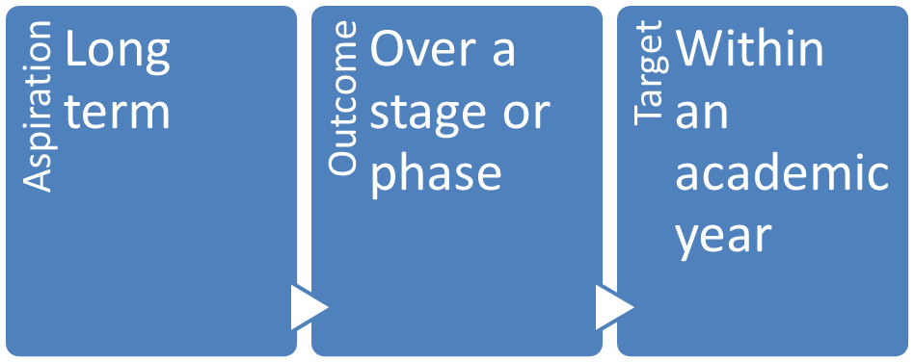

- An Aspiration is something that the child or young person (and/or their parents/carers) aspires to in adulthood. For instance, to be able to live and work independently.
- An Outcome should be something that will be achieved over a phase or stage of education and is a step along the way to the Aspiration. For instance, to be able to travel independently on a bus.
- Short term targets will be used regularly to track that the child/young person is on track to achieving their Outcomes and Aspirations. For instance, to be able to give change from a pound.

An Outcome should be something that the child/young person, their families and those working with them all understand and can feel ownership of. It is more personalised if written in the first person.

