Hazard pictograms alert us to the presence of a hazardous chemical. The pictograms help us to know that the chemicals we are using might cause harm to people or the environment.
These symbols help us to know that the chemicals we are using might be explosive, oxidising, flammable, toxic, harmful, irritant, corrosive or dangerous for the environment. One or more might appear on a single chemical.

(Pictogram) symbol | Illustration
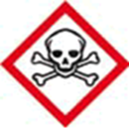 | Toxic
 | Harmful
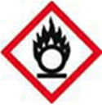 | Oxidising
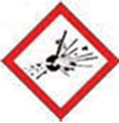 | Explosive
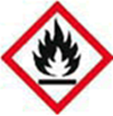 | Flammable
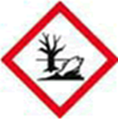 | Environmentally damaging
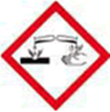 | Corrosive
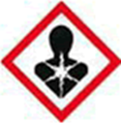 | Serious longer term health hazard, carcinogenicity & respiratory sensitisation
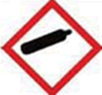 | Contains gas under pressure

