Biting: Understanding why?
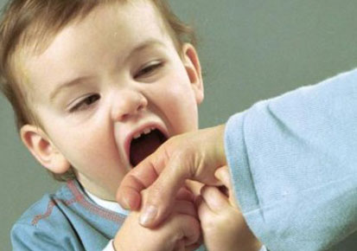

Understanding why a child bites is key to addressing the problem.
Not all children bite, most biting will occur between the ages of two and three. Biting is usually a phase which will pass, not usual beyond the age of four. Not all children bite out of anger or to hurt another child; most children will not understand how much pain they are causing.
Biting is most often a way of communicating – once you understand what children are communicating you can make a choice in how you should respond.
Some children can bite as a way of showing love. Toddlers can have really intense feelings but don’t know how to express them. Biting can be a way of expressing their feelings.

Expressing emotion

Toddlers are learning how their body works – they put things in their mouths to explore. It can be impulsive. Often, a baby will bite on someone when they’re teething. Sometimes toddlers bite when they’re over-excited.

Experimenting

Defending

Some children know biting is a way of getting other children – or their parents – to do what they want.
They don’t always do this consciously. It may happen when a group of children are jostling to be leader.

Young children learn to bite as a defence, especially if they can’t talk. Sometimes a child will bite others when they feel anxious or threatened. Sometimes changes or upsets at home can bring on this type of biting. These children are trying to establish a safety zone. When they bite, their victim moves away – it’s a great defence.

• Controlling:
Controlling

Observe carefully. Notice triggers and identify anxieties
Notice what the child is communicating through their behaviour
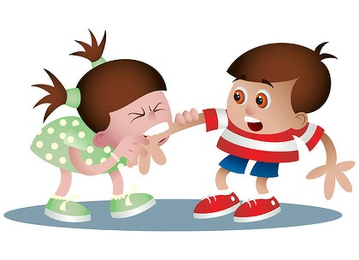
AN APPROACH TO BITING
Share the book
“Teeth are not for Biting”
Provide alternative items to chew/ bite e.g. raw veg and chewelry
Supervise children more closely at key times
Use a consistent, short but firm response
“Stop, biting hurts”
Give most attention to the injured child
Support understanding of social rules during play

