

**Schools Financial Services**

*It all adds up to a great service, flexibility and peace of mind*



**Schools Financial Services**

**Special School Funding Template 2017-18**

**Input Guidance**

**Special School Funding Template 2017-18 - Input Guidance**

Contents

‘Contents’ Tab 3

Initial Set-up 3

‘Year 1’ Tab 3

‘Pupils’ Tab 3

‘Year 1’ Tab 5

Place Plus Funding 2017/18 5

Estimated Pupil Premium (PP) (Based on Jan 2017 census figures) 6

Universal Infant Free School Meals (UIFSM) 7

Pooled Funding Arrangement 8

‘Excess E1 & E2’ Tab 9

‘Year 2 & 3 Pupils’ Tab 10

‘Year 2’ Tab 11

Place Plus Funding 2018/19 11

Estimated Pupil Premium (PP) 13

UIFSM (ESTIMATE) 13

Pooled Funding Arrangement 14

‘Year 3’ Tab 15

Place Plus Funding 2019/20 15

Estimated Pupil Premium 16

UIFSM (ESTIMATE) 17

Pooled Funding Arrangement 18

‘Monthly Statement’ Tab 19

‘Reconciliation’ tab 22

‘BPS Summary’ Tab 25

**Special School Funding Template 2017-18 – Input Guidance**

At the bottom of the spreadsheet there are a number of tabs.



# ‘Contents’ Tab

This tab is for information only and provides details about the purpose of each of the other tabs within the template and hyperlinks to them.

# Initial Set-up

## ‘Year 1’ Tab

On the ‘Year 1’ Tab select the school DfE number in cell I2 at the top of the sheet. The number can either be typed in directly or selected using the drop-down menu.

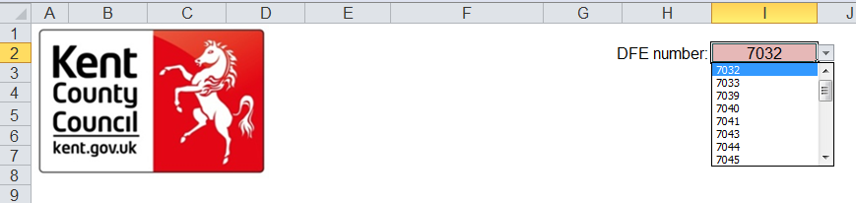

‘Pupils’ Tab

On the ‘Pupils’ Tab, enter pupil details under the pink shaded columns (Columns A, D, E, F, G and H).

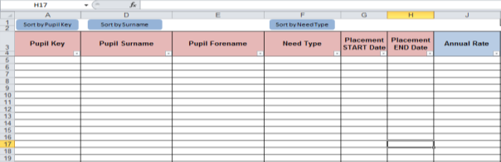

Pupil Keys will be generated by the Schools & PVI Team and sent out with Monthly Statements in the new financial year. They are a combination of a DfE number followed by an underscore and an individual 3 digit identifying number for each pupil on roll (e.g. 7070_001).

They are only necessary for the operation of the ‘Reconciliation’ Tab and can be left blank until receipt of the first monthly statement of the new financial year in April.

Pupil Surnames need to be entered in Column D, Forenames in Column E, Need Types in Column F, and start and end dates in Columns G and H respectively.

The cells left empty in Column A will turn **Yellow**  as data is entered in other columns.

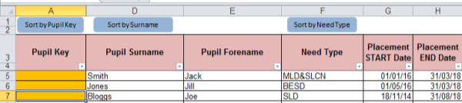

This is because the column has been formatted so that template users can spot issues within pupil data at a glance (explained in more detail in the ‘Reconciliation’ Tab section).

The yellow highlight means that pupil data has been entered without a pupil key and, as already stated, will be resolved when the first monthly statement of the new financial year is received.

The data entered onto this sheet generates forecasts in columns L to X and feeds into a number of other tabs and calculations within the template, so it will be worthwhile double-checking the details to ensure their accuracy.

There are 3 buttons at the top of this sheet that can be used to sort pupil data, either by Pupil Key, by Surname or by Need Type.

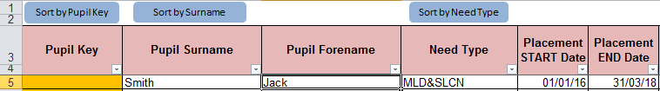

Using the ‘Sort by Need Type’ button and local knowledge will assist in the identification of pupil numbers for each month when entering data on the ‘Year 2 & 3 Pupils’ Tab.

# ‘Year 1’ Tab

## Place Plus Funding 2017/18

On the ‘Year 1’ Tab, Place Plus Funding for Element 1 and Element 2, split between Pre and Post 16 will be shown at the top of the sheet. Within the Element 1 and 2 data, funding for the April to July/August period and the August/September to March period will be shown.

1) The total for Pre-16 Element 1 will be shown in cell I18 and Element 2 in I22.

2) A Pre-16 Total shows in cell I24.

3) The total for Post-16 Element 1 will be shown in cell I29 and Element 2 in cell I33.

4) A Post-16 Total shows in cell I35.

5) Excess Element 1 & 2 Funding will be driven by the pupil data entered onto the pupil tab and will be shown in cell I37.

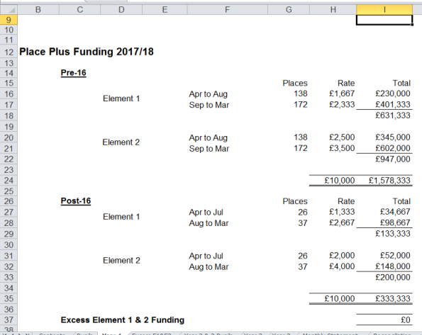

6) Element 3 funding is shown split out on a monthly basis, with an annual total in cell I52.

7) Total Place Plus Funding for 2017/18 will then be shown in cell I54.

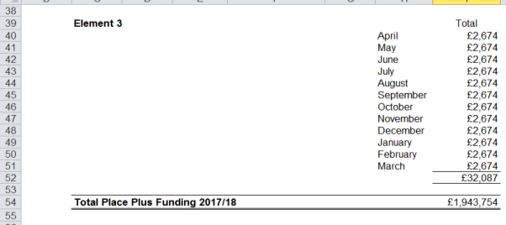

## Estimated Pupil Premium (PP) (Based on Jan 2017 census figures)

1) In cell G59 the estimated number of units for Free School Meals Ever 6 Primary is entered.

2) In cell G60 the estimated number of units for Free School Meals Ever 6 Secondary needs to be entered.

3) Estimated Adopted (Post-LAC) pupil numbers should be entered in cell G61.

4) In cell I62 a total figure for Children in Care (CiC) should be entered.

5) The estimated number of Service Children Ever 6 should then be entered in cell G63.

6) A Total Pupil Premium figure based on these estimates will now appear in cell I65.

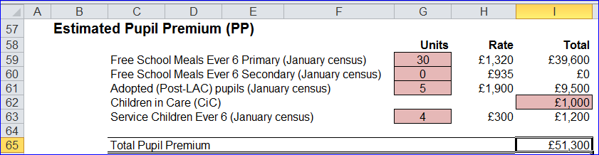

## Universal Infant Free School Meals (UIFSM)

This is split into two sections, with the top section providing a figure for the remaining allocation for the 2016/17 **academic** **year** (April 2017 to August 2017) and the bottom section giving an estimated allocation for the first 7 months of the 2017/18 **academic** **year** (September 2017 to March 2018).

These two figures together will give an Estimated total funding for the 2017/18 **financial year**.

*April to August 2017 Payment*

*Qualifying Pupils: Calculate this by using the number of pupils recorded as taking a meal and then* ***subtracting*** *those pupils taking a meal known to be eligible for FSM in the same censuses. (Refer to census data).*

1) In cell I71, enter the number of qualifying pupils in years 1 & 2 as per the October 2016 census.

2) In cell I72, enter the number of qualifying pupils in years 1 & 2 as per the January 2017 census.

3) In cell I73, enter the number of qualifying pupils in year R as per the October 2016 census.

4) In cell I74, enter the number of qualifying pupils in year R as per the January 2017 census.

5) The remaining allocation for the period April to August 2017 will then show in cell I80, based on the total number of qualifying pupils calculated in the cells above.

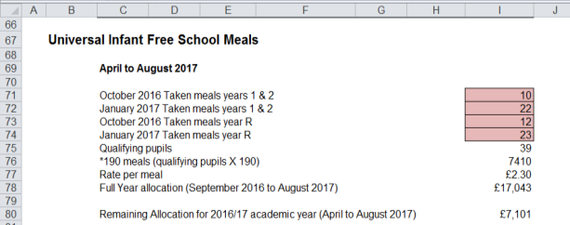

*Estimated September 2017 to March 2018 allocation*

1) In cell I85 enter the estimated number of qualifying pupils in years 1 & 2 for the October 2017 census.

2) In cell I86 enter the estimated number of qualifying pupils in years 1 & 2 that are expected to be on the January 2018 census.

3) In cell I87 enter the estimated number of qualifying pupils in year R as per expectations for the October 2017 census.

4) In cell I88 enter the estimated number of qualifying pupils that will be in year R for the January 2018 census.

5) Once all cells have been populated, an Estimated UIFSM allocation for the 2017/18 academic year (September 2017 to March 2018) will generate in cell I94.

6) An Estimated Total UIFSM funding figure for the 2017/18 financial year (the sum of the April to August payment and the estimated September to March allocation) will be shown in cell I96.

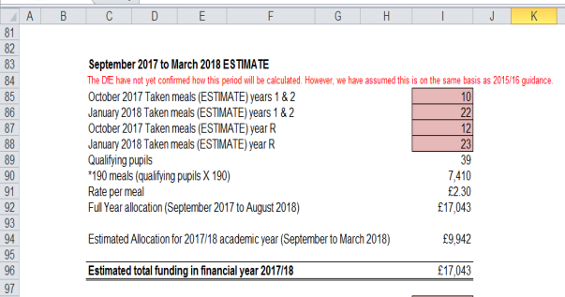

7) Just below this section there is an additional line for any Special Nursery Funding to be entered in cell I98. Schools will have already received notification of this funding from the School Budget & PVI Team.

8) An overall total estimated funding figure will show in cell I100.

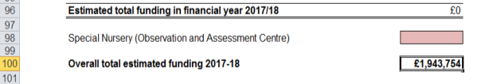

## Pooled Funding Arrangement

*(Funding delegated to schools which is recovered via the advances)*

Details of Pooled Funding Arrangements will appear below the UIFSM section, with a total expenditure figure in cell I111.

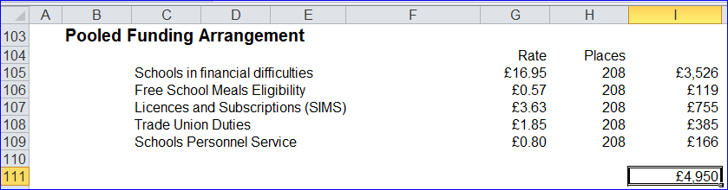

# ‘Excess E1 & E2’ Tab

At the top of this sheet, a Protected Cash Advance figure will be shown in cell C4, based on the figure as at February 2017.

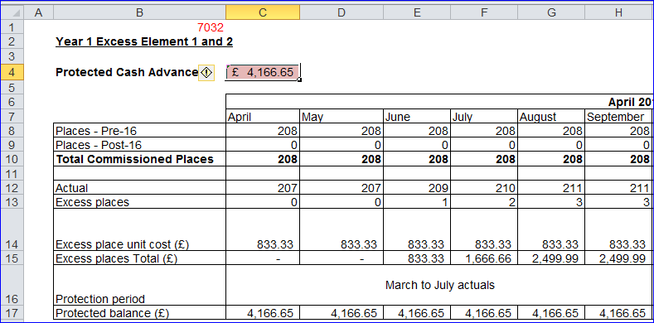

In March 2017, a member of the Schools & PVI team will be contacting Special Schools to notify them if their Protected Cash Advance figure needs to be updated. Any updated figure needs to be entered into cell C4 by overtyping the figure that is already there.

This tab is used to illustrate how Year 1 Excess Element 1 and 2 funding is calculated. It shows the total commissioned place numbers for each month (row 10) against the actual place numbers (row 12), with the difference shown against excess places (row 13).

This number is then multiplied by the excess place unit cost shown in row 14 to give a total for each month in row 15.

Below the excess place totals, the Protection periods are listed and a protected monthly balance is shown in row 17. The total annual protected balance is then shown in cell O17.

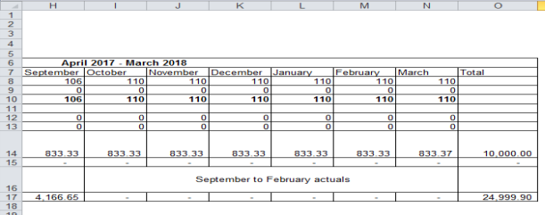

# ‘Year 2 & 3 Pupils’ Tab

In the pink-shaded cells in the *Year 2 Element 3 pupil data table* at the top of the sheet, enter estimated Year 2 pupil numbers for each need type against each month from March to July and September to February.

Figures do not need to be entered for August as these will be based on July figures. Each month’s pupil numbers will generate funding in the following month, so March numbers will dictate the first month’s funding in April 2018 and February numbers will dictate the last month’s funding in March 2019.

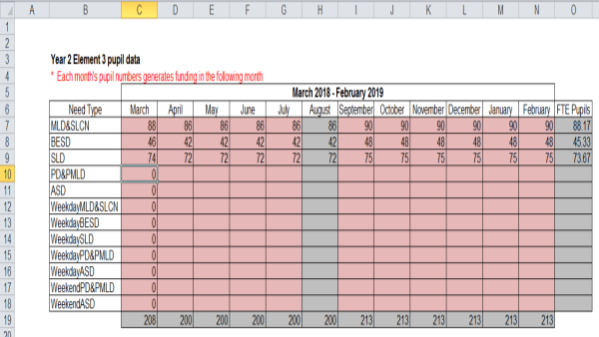

The table just below is for *Year 3 Element 3 pupil data*. As before, enter estimated pupil numbers against each month and need type in the pink-shaded cells.

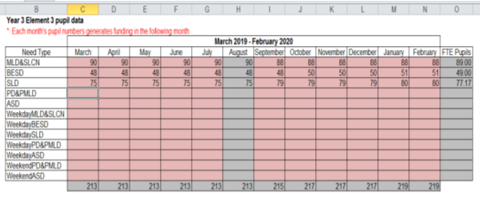

The information entered in these tables will feed into the future years budget calculations on the ‘Year 2’ Tab and the ‘Year 3’ Tab, so ensure best estimates are used and double-checked for accuracy.

# ‘Year 2’ Tab

The ‘Year 2’ Tab provides a budget projection for 2018/19 and relies on the pupil number estimates provided in ‘Year 2 & 3 Pupils’ tab.

## Place Plus Funding 2018/19

1) Enter the estimated number of April to August Pre-16 places on October 2017 in cell G16, and September to March Pre-16 places in cell G17.

2) Enter the estimated number of April to July Post-16 places on October 2017 in cell G28, and August to March Post-16 places in cell G29.

3) The total for Pre-16 Element 1 will be shown in cell I18 and Element 2 in cell I22.

4) The total for Post-16 Element 1 will be shown in cell I30 and Element 2 in cell I34.

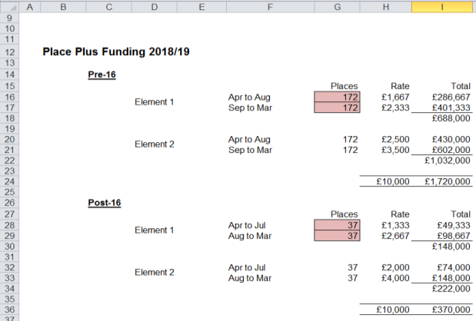

5) Element 3 funding will be shown further down the sheet, with the number of pupils for each need type and their associated funding rates shown separately.

6) Total Element 3 funding is shown in cell I52.

7) Total Place Plus Funding for 2018/19 will then be shown in cell I54.

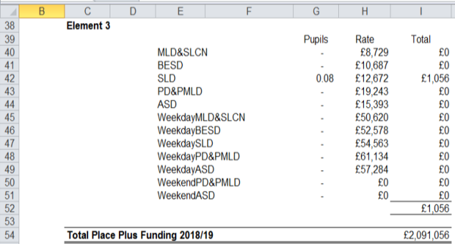

## Estimated Pupil Premium (PP)

1) In cell G59 enter the estimated number of units for Free School Meals Ever 6 Primary,

2) In cell G60 enter the estimated number of units for Free School Meals Ever 6 Secondary needs to be entered.

3) Estimated Adopted (Post-LAC) pupil numbers should be entered in cell G61.

4) In cell I62 a total figure for Children in Care (CiC) should be entered.

5) The estimated number of Service Children Ever 6 should then be entered in cell G63.

6) A Total Year 2 Pupil Premium figure based on the estimates provided will show in cell I65.

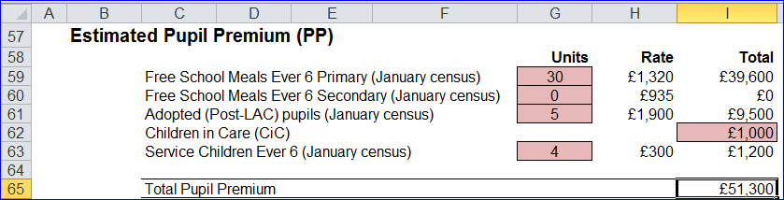

## UIFSM (ESTIMATE)

*Qualifying Pupils: Calculate this by using the number of pupils recorded as taking a meal and then* ***subtracting*** *those pupils taking a meal known to be eligible for FSM in the same censuses. (Refer to census data).*

1) In cell I71, the remaining payment for the period April to August 2018 is shown, based on the difference between the Full Year Allocation (shown in cell I92 on the ‘Year 1’ Tab) and the Estimated Allocation for 2017/18 academic year (shown in cell I94 on the ‘Year 1’ Tab).

2) In cell I75 enter the number of qualifying pupils in years 1 & 2 estimated to be on roll in the October 2018 census.

3) In cell I76 enter the number of qualifying pupils in years 1 & 2 estimated to be on the January 2019 census.

4) In cell I77 enter the estimated number of qualifying pupils in year R for the October 2018 census.

5) In cell I78 enter the estimated number of qualifying pupils in year R for the January 2019 census.

6) An Estimated Allocation for September 2018 to March 2019 will show in cell I84.

7) Estimated total UIFSM funding for the 2018/19 financial year will be displayed in cell I86.

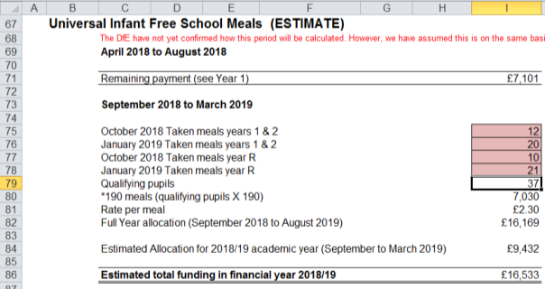

8) Just below this section there is an additional line for any Special Nursery Funding to be entered in cell I88. Schools should use the same figure as used for Year 1.

9) An overall total estimated funding figure will show in cell I90.

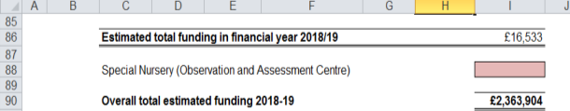

## Pooled Funding Arrangement

*(Funding delegated to schools which is recovered via the advances)*

Pooled Funding Arrangement details will appear below the UIFSM Estimate, with a total expenditure figure in cell I101.

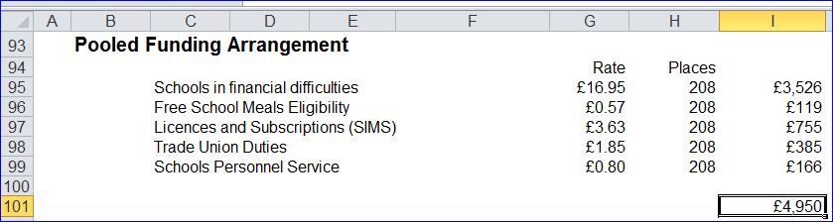

# ‘Year 3’ Tab

The ‘Year 3’ Tab provides a budget projection for 2019/20 and relies on the pupil number estimates entered in the ‘Year 2 & 3 Pupils’ Tab.

It is set up in the same way as the ‘Year 2’ Tab with the Place Plus funding section for 2019/20 at the top of the sheet, then an Estimated Pupil Premium section, a UIFSM section and finally details of Pooled Funding Arrangements at the bottom of the sheet

The information required for this tab is very similar to the ‘Year 2’ Tab, but estimates should be updated to reflect Year 3 expectations.

## Place Plus Funding 2019/20

1) Enter the estimated number of Pre-16 places as at the October 2018 census in cell G17.

2) Enter the estimated number of Post-16 places as at October 2018 in cell G29.

3) The total for Pre-16 Element 1 will be shown in cell I18 and Element 2 in cell I22.

4) The total for Post-16 Element 1 will be shown in cell I30 and Element 2 in cell I34.

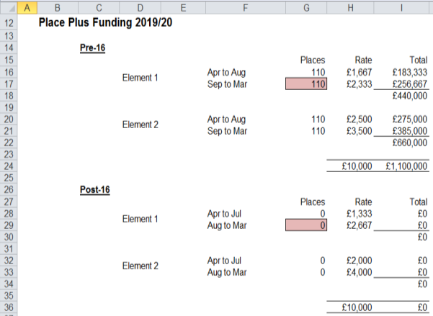

5) Element 3 funding will be shown below, with the number of pupils for each need type and their associated funding rates shown separately.

6) Total Element 3 funding is shown in cell I52.

7) Total Place Plus Funding for 2019/20 will then be shown in cell I54.

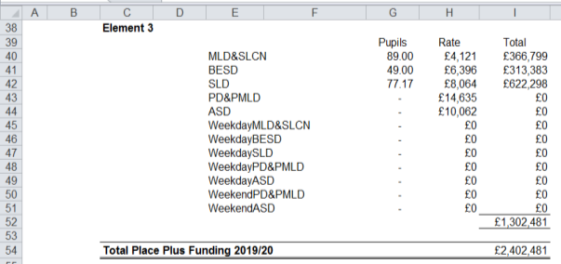

## Estimated Pupil Premium

1) In cell G59 enter the estimated number of units for Free School Meals Ever 6 Primary.

2) In cell G60 enter the estimated number of units for Free School Meals Ever 6 Secondary.

3) Estimated Adopted (Post-LAC) pupil numbers should be entered in cell G61.

4) In cell I62 a total figure for Children in Care (CiC) should be entered.

5) The estimated number of Service Children Ever 6 should then be entered in cell G63.

7) A Total Year 3 Pupil Premium figure based on the estimates provided will show in cell I65.

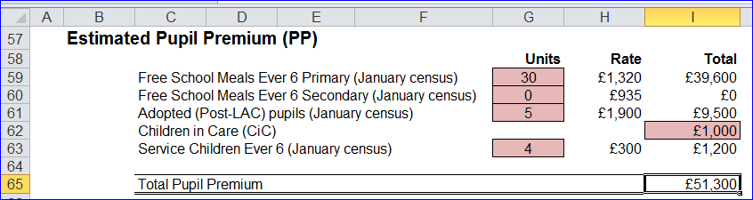

## UIFSM (ESTIMATE)

*Qualifying Pupils: Calculate this by using the number of pupils recorded as taking a meal and then* ***subtracting*** *those pupils taking a meal known to be eligible for FSM in the same censuses. (Refer to census data).*

1) In cell I71, the remaining payment for the period April to August 2019 is shown, based on the difference between the Full Year allocation for September 2018 to August 2019 (shown in cell I82 on the ‘Year 2’ Tab) and the Estimated Allocation for September 2018 to March 2019 period (shown in cell I84 on the ‘Year 2’ Tab).

2) In cell I75 enter the estimated number of qualifying pupils in years 1 & 2 on roll for the October 2019 census.

3) In cell I76 enter the estimated number of qualifying pupils in years 1 & 2 for the January 2020 census.

4) In cell I77 enter the estimated number of qualifying pupils in year R for the October 2019 census.

5) In cell I78 enter the estimated number of qualifying pupils in year R for the January 2020 census.

6) An Estimated Allocation for 2019/20 academic year (September 2019 to March 2020) will appear in cell I84.

7) An estimated total UIFSM funding figure for the 2019/20 financial year will now show in cell I86.

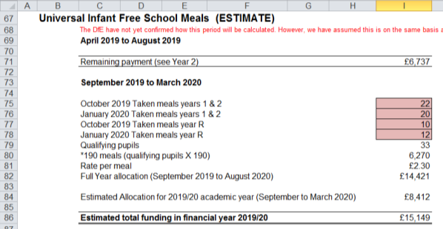

8) Just below this section there is an additional line for any Special Nursery Funding to be entered in cell I88. Schools should use the same figure as used for Year 1.

9) An overall total estimated funding figure will show in cell I90.

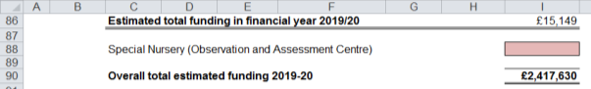

## Pooled Funding Arrangement

*(Funding delegated to schools which is recovered via the advances)*

Details of Pooled Funding Arrangements will appear below your UIFSM Estimate, with a total expenditure figure in cell I101.

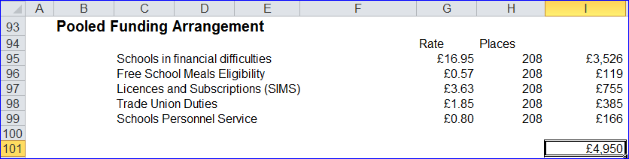

# ‘Monthly Statement’ Tab

Each month, shortly after the advances have run, the School Budget Team send out Monthly Element 3 Statements via email which look similar to the screenshot below:

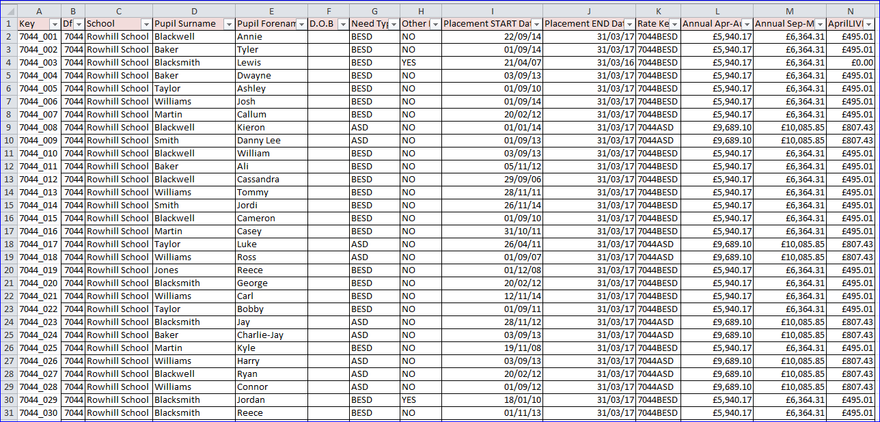

These statements can be imported in to the monthly statement tab. Click the import button on the monthly statement tab and this will ask you to select your monthly statement, click ok and select the file that needs uploading.

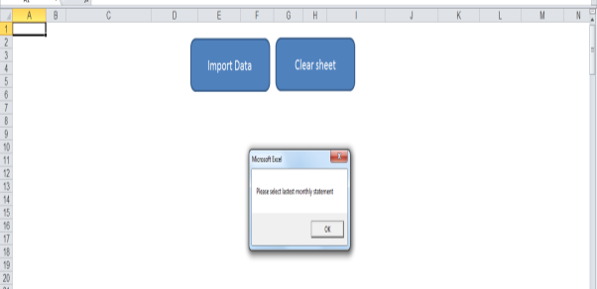

For the first statement in April, after pasting it into the ‘Monthly Statement’ Tab, all cells will turn red, as per the screenshot on page 20:

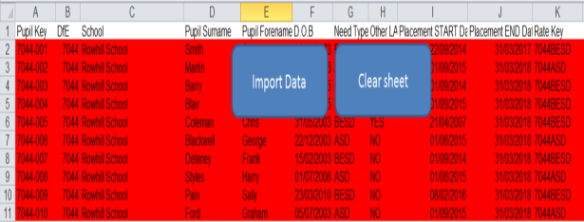

This means that the pupil keys on the ‘Monthly Reconciliation’ Tab are not matched on the ‘Pupils’ Tab. Initially, this will be because there will be no pupil keys on the ‘Pupils’ Tab. However, this will be resolved when the first monthly statement of the new financial year is received.

Going back to the ‘Pupils’ Tab, the pupil keys should now be added, as per the monthly statement. In order for the reconciliation process to function correctly, it is crucial to ensure pupil keys are matched up to the correct pupils.

As pupil keys are entered on the ‘Pupils’ Tab, the yellow formatting in Row A will begin to disappear:

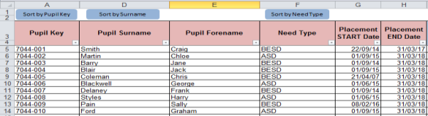

Additionally, on the ‘Monthly Statement’ Tab the red formatting will also disappear as pupil keys are added to the pupil data:

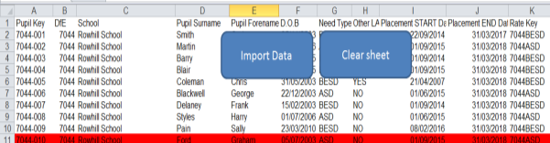

If a pupil key cell turns **BLUE** then this means that the pupil key is a duplicate. On the ‘Pupils’ Tab the cell for the matching pupil key number will also turn blue.

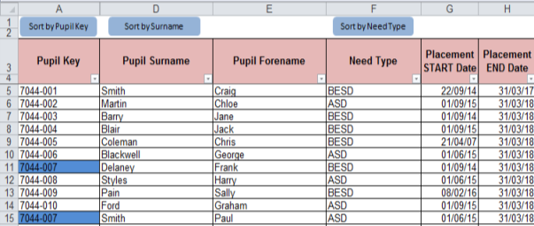

This is very unlikely to happen but if it does then schools should contact Ashley Martin or another member of the Schools & PVI Team, either by email ([ashley.martin@kent.gov.uk](mailto:ashley.martin@kent.gov.uk)) or telephone (03000 416 436), to get a new pupil key generated.

In some instances, schools may have pupils on roll that qualify for funding but have not yet been picked up and included in the monthly statement. In these cases, schools should contact the SEN Resources Team to notify them of any discrepancies ([specialpupiltracking@kent.gov.uk](mailto:specialpupiltracking@kent.gov.uk)).

These pupils should be left on the ‘Pupils’ Tab where their pupil key will remain yellow in Column A. They will not appear on the ‘Reconciliation’ Tab until they have a pupil key which should be generated the following month and included in the monthly statement.

Once the ‘Pupils’ Tab has been updated, any coloured cells (red, yellow or blue) should now be white (unless there are pupils awaiting pupil keys on the ‘Pupils tab’) and the ‘Reconciliation’ Tab should be checked for any variances.

# ‘Reconciliation’ tab

The ‘Reconciliation’ Tab picks up the pupils and their associated payments from the ‘Monthly Statement’ Tab and then compares those pupils’ payments to the forecasts from the ‘Pupils’ Tab. Any differences are then shown in the Variance columns.

Only those pupils on the monthly statement are picked up on the ‘Reconciliation’ Tab. So schools awaiting pupils to be included in monthly statements won’t see the excess pupils from their ‘Pupils’ Tab appearing in the reconciliation and will need to make a separate note of any of these variances

Ensure the correct statement month is selected using the drop down menu in cell A3.

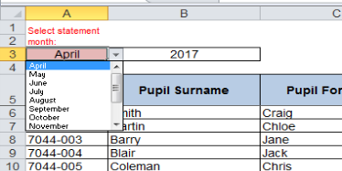

To the right of the drop down menu, cells G1 and G2 perform another check to reconcile the number of pupils on the ‘Pupils’ Tab to the number of pupils on the ‘Reconciliation’ Tab. If there is a difference between the two figures then the cells will turn **RED**.



This maybe because the school has intentionally left pupils on the ‘Pupils’ Tab that are expected to be included in the next monthly statement. If this is the case then no further investigation is needed and cells G1 and G2 will remain red until an updated monthly statement is received the following month. Once the pupil numbers match the red highlights will disappear

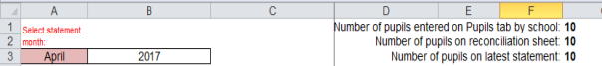

. However, there could be a situation whereby a school is incorrectly funded for an additional pupil (and therefore has an extra pupil on the ‘Monthly Statement’ Tab and ‘Reconciliation’ Tab) but also has a pupil for which they are awaiting funding (and have left the pupil on the ‘Pupils’ Tab). In this situation, the red highlights on cells G1 and G2 would disappear as the discrepancies cancel each other out. However, the extra pupil on the ‘Monthly Statement’ Tab would be highlighted in red and the additional pupil on the ‘Pupils’ Tab would have an yellow highlight in Column A so the users eye should still be drawn to these discrepancies.

Check the ‘Variance to date’ column (Column G) and the variance column for the month to which you are reconciling.

In the example below there is a variance of £532.97 against one of the pupils (pupil Key 7044_007) and this is shown in both column G (variance to date) and column J (April variance column).

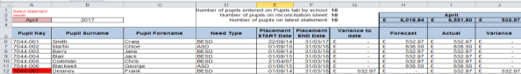

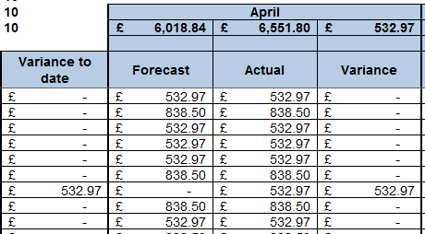

To investigate any differences, check the data for the relevant pupil on the ‘Reconciliation’ Tab and compare it to the data on the ‘Pupils’ Tab.

In this example there is a variance due to a mismatch between the placement start date on the ‘Monthly Statement’ Tab (01/09/14) and the date on the ‘Pupils’ Tab (01/05/17).

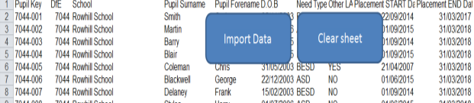

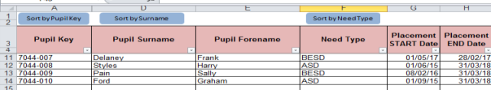

If the monthly statement is correct, once the date is amended on the ‘Pupils’ Tab, the variance disappears.

If the monthly statement is incorrect, then no changes need to be made and schools should contact The SEN Resources Team team to notify them of any discrepancies ([specialpupiltracking@kent.gov.uk](mailto:specialpupiltracking@kent.gov.uk)). The variance will remain on the ‘Reconciliation’ Tab until the following month when any errors on the monthly statement will have been corrected.

It should be noted that the payments shown on the monthly statement are backdated to show how the payments *should have been received* and may not therefore match the actual monthly funding received through the advances.

For example, a pupil who is accidently missed off the monthly statement in April should then receive a double payment in May through the advances (May’s funding and April’s backdated funding). However, the monthly statement will actually show two separate payments in April and May, as this is how the funding should have been received. So the monthly funding shown on the monthly statements may not exactly match the cash payments received but the overall cumulative total will be the same.

This reconciliation is a process that will be repeated every month. A separate copy of the template should be saved after the reconciliation and given an appropriate name, so that at the end of the year there is a copy of the reconciliation for each month (in addition to a master copy of the template saved for budget setting at the start of the year).

To save a separate monthly copy, select ‘Save As’ rather than ‘Save’. This can be done by clicking ‘File’ in the top left of the spreadsheet

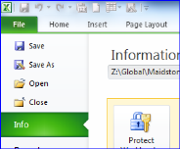

Then select ‘Save As’ and give the file an appropriate name e.g. *April Reconciliation, May Reconciliation etc.*

The following month, open up the last reconciliation and hit the ‘clear sheet’ button on the ‘Monthly Statement’ Tab before pasting the next statement in and repeating the process.

# ‘BPS Summary’ Tab

Once all the other tabs have been completed, this tab will summarise your funding by Ledger Code (I01, I02, I03, I05 and I18) for Years 1, 2 and 3, with totals for each year in cells C23, D23 and E23.

Pooled funding totals for each year will be shown in the cells below (C25, D25 and E25).

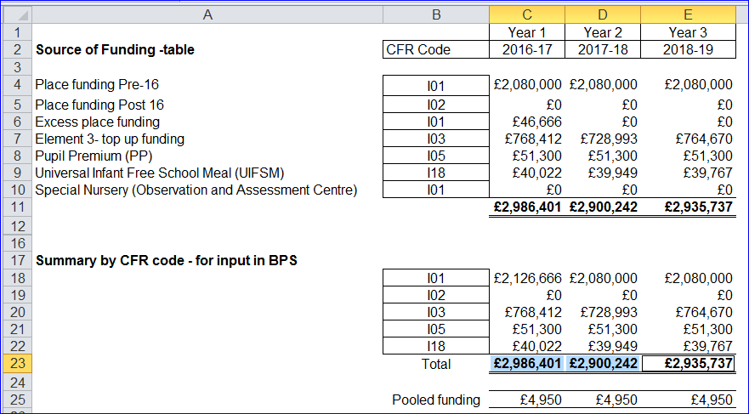

These figures can then be used to complete the first 3 years of the *5 Years Data tab* on the Budget Planning Software (BPS). Refer to the BPS guidance notes for further instructions on how to enter these figures on BPS.

**N.B.**

* The PE & Sports Grant will need to be accounted for within the I&E section on BPS as it is not included within the funding templates
* On the accounts package, a UIFSM year-end adjustment may need to be included in I18 (refer to closedown instructions on KELSI).