Education, Health and Care Plan

Appendix 1a

Young Person Views

This form represents your views as a young person who may have Special Educational Needs

Please refer to the guidance provided. This form is designed to help you contribute information in relation to your views, wishes and feelings about your needs. Your views are an important part of the statutory assessment process.

Please note that all the information on this form will be copied to all agencies directly involved in your education.

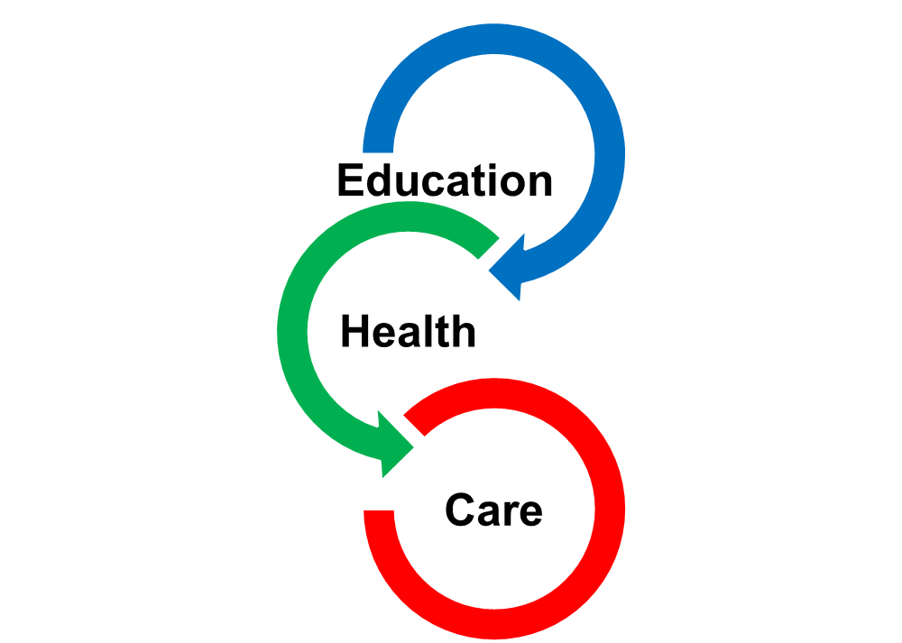

Young Person’s details
Surname
First Name
D.O.B |  |  | Year group
Gender: | Male/Female
Address
Home Language |  | Religion
Education setting |  | NHS number

Please provide contact details for the adults you live with
if you are happy for us to contact them.
Name
Relationship:
Address:
Postcode:
Home Tel: |  | Daytime Tel:
Mobile Tel: |  | Email:
Preferred Contact Method:

- Please tell us about yourself, including some of the
history of your Special Education Needs

2. What do you feel your main strengths are (what you are good at)?

3. What do you feel your main difficulties are
(what do you need help with)?

4. What long-term hopes and aspirations do you have
for your future? Supported Living? Supported Employment? Employment? University?

Education

5. SEN Support currently in Place
Please tell us what support your school or Post 16 provider has put in place for you.

Please tell us how many meetings you have had with your school or post 16 provider to discuss your provision and progress.

Please tell us what additional support you need, above that already in place, to help you make progress towards your outcomes.

If you are aware of the cost of the support you receive please tell us.

6. Tell us what you enjoy at school/college?

7. Do you feel you are making good progress at school or college?

8. More specifically, are you making progress in:
English?
Yes |  |  | No

Comment:
Maths?
Yes |  |  | No

Comment:
Personal, Social and Emotional Development?
Yes |  |  | No

Comment:

9. Please tell us those outcomes which are most
important to you to achieve by the end of this
phase of education ?

10. Are there any specific barriers to achieving
these Outcomes?

11. How do you think they can be best overcome?

12. Social Care (including Voluntary Organisations and Charities)

Are Social Services, Disabled Children’s and /or Adult Social Services currently involved with your family?
Yes |  |  | No
(If yes, please specify)

Comment:

Our family is/has been subject to a Child Protection Plan.

Have they been involved in the past?
Yes |  |  | No
(If yes, please give details below)

Comment:

Do any voluntary organisations or Charities currently or in the past support
your family? E.g. Direct Payment Support Service
Yes |  |  | No
If yes, please give details below
Comment:

13. Health

Are you currently seeing any Health professionals? (Please tick all that apply)
G.P
Speech and Language Therapist
Occupational Therapist
Physiotherapist
Child and Adolescent Mental Health Service (CAMHS)
Audiologist (Hearing)
Ophthalmologist (vision/sight)
Community Paediatrician
Any other professionals – including specialists (please specify)?

Do you have any health conditions and/or any medical diagnoses, or are you awaiting a potential diagnosis?

Yes |  |  | No
If yes, please give details below

I am diagnosed with
Condition | Name of Doctor | Date

(Please include copies of reports)

Are you on any medication?
Yes |  |  | No

What is it for?
This was prescribed by (medical professional)
It was last reviewed on | Date:
It was last reviewed on | By:

14. General
Has anything happened in your life which you feel may have contributed to your current difficulties?

Comments:

How do your needs impact on everyday life?

Are you:
 | Yes | No | Assistance  required?
Able to dress/undress yourself?
Able to use the toilet by yourself?
Able to feed yourself?
Able to co-operate with family routines?
Able to manage with changes to routines?
Able to use your voice to communicate?
Reliant upon gestures, signs or symbols?
Able to show and receive affection?
Do you have difficulty with:
 | Yes | No | Assistance  required?
Making and maintaining friendships?
Coping with the company of other people?
Managing and expressing emotions?
Managing your behaviour?
Would you like to make any comments on the questions above?

Do you notice any patterns or triggers that affect your behaviour?

Please comment:
At school/college:
At home:
In the community:

Is there any other information or suggestions that you feel would be helpful?

Do you have additional reports received within the last 18 months to add?
Please attach copies of these to this Appendix 1a
 | Yes |  |  |  | No

15. Completed by
My name:
Signature:
Date I completed this Form:
Support to complete this form was given by (give names and their role (e.g. parent or teacher).
Name: | Role:

