Name: | Location:
Directorate: | Phone number:
Date of assessment: | Line manager:

Figure 1 - Picture showing the correct workstation setup required for safe working

Figure 2 – Picture of a basic office chair with the various adjustment levers
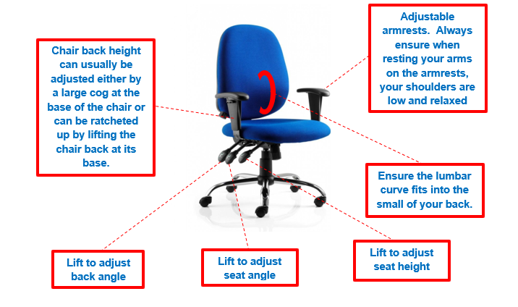
DSE risk factors to be assessed | Response to risk factor question (insert Yes/No) | Recommended guidance to follow to reduce the risk factor | Actions undertaken by user/line manager to address identified issues from the risk factor
Are you working using a laptop only? |  | Follow the laptop safety guidance and the DSE temporary working guidance which is available on KNET
Chair set up  Is the chair suitable and stable? |  | The chair may need replacing if it is broken or does not have sufficient adjustment mechanisms to be able to adjust the chair to the correct sitting position for the user.  The chair must be appropriate for the users size and stature, e.g. larger proportioned staff use larger chairs and smaller proportioned staff use smaller chairs.  Consider swapping chairs to ensure they are fit for purpose for individual users. If you think you require a specialist chair because of complex medical requirements, contact your directorate link health and safety adviser for further advice. Your named contact can be found on the health and safety page on KNET.
Are you sitting correctly?  Are the users forearms in the correct alignment to the desk? |  | Look at the positioning of your arms when you are sitting to see whether or not they are level with the top of the desk/work surface. The foreams should be in a horizontal level alignment just above your desk height when your hands are positioned on the keyboard to type. If the forearms are not in this position, you will need to either raise or lower the chair height setting using the appropriate adjustment mechanism to achieve the correct forearm position.
Is there enough room to ensure that your legs are not impeded by the underside of your desk once you have adjusted the height of the chair correctly? |  | If your legs are touching the underside of your desk then the desk is not tall enough for your leg height. Your desk height will need to be raised by placing desk risers underneath the feet of the desk.
Are your back and shoulders adequately supported by your chair back? |  | To get full support throughout the length of the spine you need to adjust the chair back height by either raising or lowering it so that the lumbar curve fits into the small of the back to give the appropriate support. If the back height of your chair is not tall enough to support the full length of the spine then you may need to replace the chair with an alternative chair which has a taller back height.  Check to see that the chair back angle has been adjusted to an upright position.  Check to see that the back of the knees are not touching the base of your chair as this will cause undue pressure and restrict blood circulation. Consider the use of a footrest to help take pressure off of the back of the knees.
Are you able to slide your chair close into your desk?  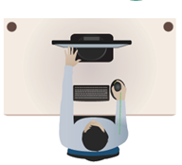 |  | If the chair has arms, check that the arms are not restricting the user from being able to position the chair close into the desk. Remove static arms from the chair if required to enable correct positioning.  Please note that chair arms are not a necessary requirement and it is preferable to use a chair without arms.  If the user requires arms as a support mechanism to be able to get in and out of the chair, then ensure that the chair has either adjustable or retractable arms.
Can you place your feet flat on the floor once you have adjusted your chair to the correct height setting?  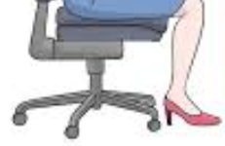 |  | Feet should be placed flat on the floor once the chair height has been adjusted to the correct setting.  You must never place your feet on the wheel base as this will encourage the user to lean forward in the chair which will affect the support required for the spine in addition to restricting blood flow in the legs.  A footrest must be provided if the user is unable to rest their feet flat on the floor.  Please note that a footrest may also be useful if the user tends to slouch forward as the use of a footrest encourages the user to sit back into the chair correctly.
Desk height setup  Is the desk height appropriate to ensure that there is sufficient room to comfortably move the legs and feet? |  | A standard office desk will be suitable for most users, however particularly tall people may need to raise their desk height to accommodate a long leg length to allow for postural changes. Desk risers/wooden blocks can be used to raise the desk. Contact healthandsafety@kent.gov.uk for further advice if required.
Screen setup  Is the screen placed directly in front of the user?  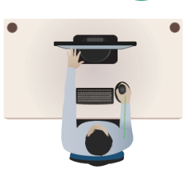 |  | All screens should always be placed directly in front of the user, preferably in the centre of the desk when using a standard straight edge desk.  If you are using a curved edge desk then the screen can be placed into the centre of the curve if it is not practical to place the screen in the centre on the straight edge of the desk. If placing the screen into the curve, then the user must ensure that the chair is positioned into the curve in direct alignment to the screen and keyboard.
Is the screen set at the correct viewing distance from the user?  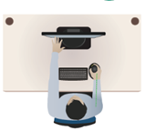 |  | The screen should be placed at an arms length away from the edge of the desk. Please note that the user must slide their chair close into the edge of the desk and ensure that their back is in contact with the chair back whilst holding out their arm length to check the screen distance.
Is the screen height and angle set correctly?  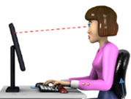 |  | To ensure that the screen is at the correct height and angle, either raise or lower the screen height so that the users eyes rest within the top third of the screen and slightly tilt the screen backwards. To adjust the screen height, push the bottom of the screen up or down as required or press the release button at the back of the stem attached to the screen.  If the screen is still too low after adjustment, you may require the use of a screen riser to achieve the correct height.  Please note that varifocal users will need to have their screen set at a slightly lower height in order to accommodate their prescription to ensure that they are not not working with an upward head posture which can cause issues with neck pain.
If using dual screens have you positioned the screens adjacent to each other?  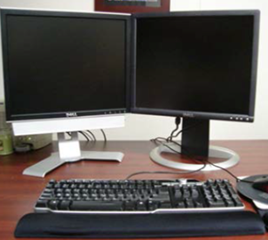 |  | Dual screens should be placed next to each other so that they are butted together at a 90˚ angle to each other and be placed in the centre of the desk directly in front of the user. If you predominately use one of the screens for 80% of the time then place the dominant screen in front of you and butt the second screen slightly to the side of your main screen  Both screens must be adjusted to the same height as each other regardless to what type of screen you are using e.g. a standard screen and a laptop screen. You may need to use a screen raiser to ensure that both screens are the same height as each other.
Is the display screen easy to read with minimal reflection, glare from lights, windows, shining walls and surfaces? |  | Position the monitor away from the source of glare where possible. You may need to consider repositioning the screen on your desk to resolve glare issues. If this does not resolve the issue then consider the installation of blinds or black out film coverings on windows or removing any overhead lighting tubes which are directly above your screen and replace with a desk lamp if required.  You may need to consider repositioning the layout of your desk within the working environment to eliminate or reduce glare issues.
Do you clean your screen regularly? |  | Clean the computer screen with appropriate screen wipes to allow greater clarity of characters.
Is the screen image stable and free from flicker? |  | Contact ICT for support if the screen image is unstable.
Do you know how to adjust the contrast and brightness controls to reduce glare to read the screen more easily? |  | Adjust the Eco Mode button which is on the bottom right hand side of the monitor to adjust screen brightness or adjust your brightness settings within the control panel ON your PC.
Can the characters displayed on the screen be clearly seen? |  | Check font and icon size is sufficient and alter using the display settings on your computer if required or contact ICT for further advice.
Are you suffering with headaches? |  | In the first instance the user must check that the screen distance and screen height setup are correct and that there is no glare on the screen.  Undertake regular screen breaks throughout the day so that your focus is somewhere other than the screen all of the time to enable your eyes to have a rest.  Ensure that you drink plenty of fluids to rehydrate.  If the user is still experiencing headaches then they should consider undertaking an eye test or visiting the GP as appropriate.
Have you had a recent eye test?  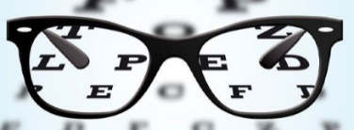 |  | Display screen equipment users should have an eye test every 2 years or more frequently if advised by their optician.  For guidance on claiming for an eye test and contribution towards glasses for display screen use, please see H&S Guidance page on KNet.
Keyboard setup  Is the keyboard placed close to the edge of the desk?  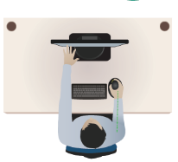 |  | The keyboard should be placed approximately 10cm from the edge of the desk and be placed directly in front of the user and be in direct alignment to the computer screen.  To guage the correct distance, place the beginning of your longest finger where it joins your knuckle on the edge of your desk and then place the keyboard on the desk where your fingertips end.  Please note that If you are using dual screens, place your keyboard centrally between both screens close to the edge of the desk in the same way that you would when using a single screen or place in front of the screen that you predominantly use.
Is the keyboard placed in a horizontal alignment to the edge of your desk? |  | The keyboard should always be placed in a horizontal alignment to the edge of the desk. Do not tilt the keyboard at a sideways angle as this will cause undue twisting of the arms, shoulder and neck.
Can the angle/tilt of the keyboard be adjusted? |  | If your keyboard has a set of pull out stands at the back of it, use them to tilt the keyboard at a slightly downwards angle from the back of the keyboard. Please note that not all keyboards have this functionality.
Are all the characters on the keyboard clear and readable? |  | Clean your keyboard with cleaning wipes so that the keys are readable. If the characters still cannot be read, the keyboard my need replacing. Please note that a matt finish keyboard can help to reduce glare.
Are your wrists in a neutral position when typing?  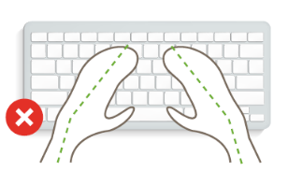  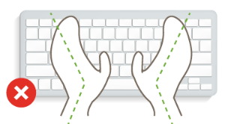  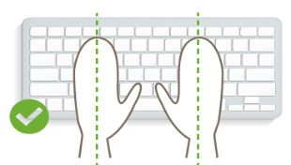 |  | Your hands should be in a relaxed parallel position with each other when you are keying and should not be angled either inwards or outwards.  Check to see that the arms are also in a relaxed position close into your body so that your elbows are not in a splayed outwards position as this can cause upper limb disorders.
Mouse setup  Is the mouse positioned close to the keyboard to avoid overreaching?  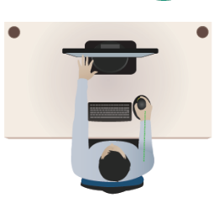 |  | Ensure that the mouse is kept close into the side of the keyboard so that your arm is not stretching out sideways or forwards in an extended position as this will put undue pressure on your arm and shoulders causing over extension.  If there is limited space on the desk which restricts the user from placing the mouse close to the keyboard, consider using a shorter keyboard. Speak to healthandsafety@kent.gov.uk for further advice.
Is the mouse the correct size for your hand size? |  | Check to see that your fingers and thumb are in a nice relaxed natural positon over the curve of the mouse when using it. Ensure that all the functions of the mouse can easily be reached.  If you are using the mouse with a tight claw like hand posture it is quite likely that the mouse is the incorrect size for your hand and should be replaced with a larger mouse.
Are you experiencing discomfort when using the mouse?  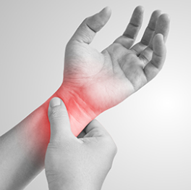 |  | Ensure that you are not flexing your wrists in either a sideways or tilted upwards position when using the mouse. Your wrist, hand and forearm should remain in a natural straight alignment when using the mouse.  Do not put undue pressure on your wrist by pressing down onto a hard surface such as the desk as this can cause a variety of wrist/hand issues. Place the mouse on a soft surface such as a mousemat.  If you continue to suffer with issues in your wrist or hand, then consider replacing the mouse a vertical ergonomic mouse. Speak to healthandsafety@kent.gov.uk for further advice.
Document holder set up  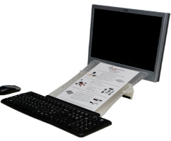  If a document holder is used, can it be positioned close to the screen? |  | The document holder should be placed directly in front of the user and be placed between the keyboard and the screen to ensure any undue twisting of the head and neck.  Speak to healthandsafety@kent.gov.uk for further advice.
Telephone setup  Do you use a telephone without the use of a headset? |  | You should use a headset when taking calls. If you do not have a headset then you should place the receiver on the desk if you need to type information onto the computer and then pick up the receiver again when you need to talk.  If you are using an old style desk telephone ensure that it is placed within easy reaching distance so that you do not overstretch to reach the receiver. Ensure that the user is not holding the telephone receiver under the chin and are craning the neck as this will put undue stress and strain on the neck and across the shoulders.  Ideally the telephone should be placed on the desk and picked up with the hand that is not your writing hand if you need to take messages.  It should be noted that the same precautions to reduce twisting of your neck when taking calls on a mobile telephone should be followed.
Desk space and workplace environment  Is the work surface of the desk large enough for all the necessary equipment? |  | Create more room by moving non-essential items on the desk to somewhere else such as a cupboard or drawers.  There should be some scope for flexible rearrangement of items on the desk.
Can the user comfortably reach all the equipment and papers they need to use?  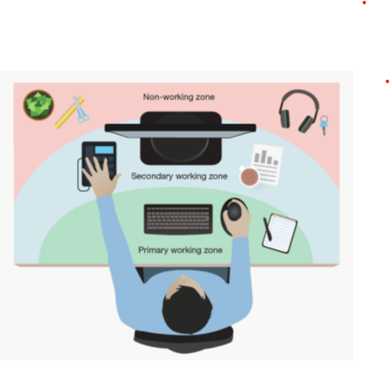 |  | Bring frequently used items within easy reach so that you are not twisting your torso to reach them. All equipment should be within an arms reach.  You should try to work in the primary working zone on your desk which is the immediate front edge of the desk where your keyboard is placed in order to avoid overstretching.  If you need to move your equipment but the cables for the equipment are not long enough to enable you to make the necessary adjustments, contact ICT for assistance.
Can you change activities so as to avoid prolonged or continuous use of DSE? |  | Intersperse tasks throughout the day so that you are getting a different range of movement and are not constantly sitting in a prolonged static sitting position.  Vary between both sitting and standing when working at your desk, e.g. try standing when taking phone calls or simply stand and have a stretch of your spine to release tension from your muscles. Take regular breaks away from the desk throughout the day to get sufficient body movement and good blood circulation by undertaking non-screen based work such as filing or photocopying.
Is there enough room to change body position and vary your range of movements when carrying out your tasks? |  | Space is needed immediately surrounding your workstation to enable you to be able to to move and stretch. If there is restricted space, consider reorganising the environment layout and remove any obstructions.
Are there any obstructions underneath the desk? |  | Remove any obstructions from under the desk, this would include the management of any trailing cables to ensure there is sufficient space to move your legs and feet.
Is the workstation area free of tripping hazards? |  | Ensure handbags, boxes etc. are stored out of the way.
Is the lighting suitable e.g. not too bright or too dim to work comfortably? |  | Consider shading or repositioning light sources or provide local lighting e.g. desk lamps (but make sure lights do not cause glare by reflecting off walls or other surfaces). Consider removal of tubes from ceiling lights. Contact Facilities Management to arrange this.
Does the air feel comfortable? |  | Circulate fresh air if possible by opening windows where appropriate, using fans, air conditioning etc. Consider a humidifier if discomfort is severe.
Are levels of heat comfortable? |  | Can heating be better controlled? More ventilation or air conditioning may be required if there is a lot of electronic equipment in the room. Consider moving user away from the heat source.
Training and Information  Has the user received training in arranging the workstation to minimise health risks and the correct working posture? |  | Complete the DSE e-learning package which can be found on DELTA.
Has the user read the various DSE related guidance documents? |  | Refer to the health and safety A-Z list of guidance on KNET/KELSI.

Additional Information
Outline any particular issues / medical issues which might affect how you are working at your computer as this information will highlight any special considerations that will need to be undertaken by your manager. Include any information where you are either awaiting a medical appointment or procedure to be undertaken.

