FINANCE

FMS6 PROCEDURE NOTE – No 43

VAT Returns – VAT Tolerances Correction

Reviewed November 2016

Please note that this is a brief procedure note not a training document.

Check VAT Actual and VAT Memo Amounts on the VAT Full Report – as referred to in FMS6 Procedure Note 42 Stage 2.

For VAT codes where VAT is paid, ie, VAT codes G and H, two types of VAT amount will be given for each invoice processed during the month:

 | VAT Actual £ - | the total VAT paid for the invoice posted to FMS6
 | VAT Memo £ - | the VAT automatically calculated by FMS6 for each line of the invoice

You must check the subtotals for VAT codes G and H to ensure that both the VAT Actual & VAT Memo amounts agree (a difference of 20p or less is acceptable as this allows for penny variances on individual invoices).

Please note - Where there is a large volume of transactions, it is possible that the 20p difference will be exceeded on the VAT code totals, but will not be due to an individual entry, it will be due to penny variances on a number of invoices. This is most likely to apply to Secondary Schools. If this is the case please contact Schools Financial Services before you continue any further.

If not continue as detailed below

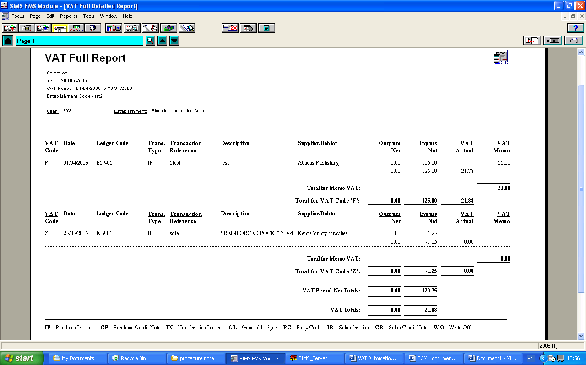
A difference of 21p or more for each VAT code total must be investigated and corrected. Please check the individual entries on the VAT code to identify the error. (ie, individual VAT Actual and VAT Memo amounts differ by more than 20p). You will then need to look at the original documentation, for example, the invoice or credit note and identify why there is a difference.

Example

An invoice for books and videos has been received as follows:

 | £ | VAT | VAT
 |  | % | £
Books | 50.00 | 0.0 | 0.00
DVDs | 50.00 | 20.0 | 10.00
Net Amount | 100.00
VAT payable | 10.00
Total Invoice | 110.00

The invoice appears on the VAT Full Report on VAT Code H as follows:

 | Inputs Net | VAT Actual | VAT Memo
Books | 50.00 |  | 10.00
DVDs | 50.00 |  | 10.00
Total Invoice | 100.00 | 10.00 | 20.00

The difference has occurred because the charge for the books has been input to FMS6 on VAT Code H but no VAT was payable for the books. The invoice should have been input on two VAT lines, £50 for DVDs to VAT Code H and £50 for books to VAT code Z.

Please refer to the VAT Manual for information on the correct VAT categories. This can be found on Kelsi (Schools’ Finance - Policy and Guidance – VAT and Income Tax)

To correct this invoice you will need to raise a credit note and reverse the original entries exactly as they were processed. The credit note must have the same date as the original invoice (this will ensure that the entries appear in the same VAT period). A non-order invoice should then be raised charging the items to the correct VAT codes.

Corrections must not be made using the cash book journal route as the entries will be posted to the following VAT period.

Once the correcting entries have been posted, recheck the VAT Full Report ensuring that the VAT Actual & VAT Memo totals are correct. Return to Procedure Note 42 ‘VAT Returns - VAT Automation for FMS6 Schools’ Stage 3.

Should you have any difficulties with this procedure note please contact Schools Financial Services on 03000 415 415

