

Appendix 5

Advice for Statutory Needs Assessment from Educational Psychology
for
Name of child (DOB)

This form is to be completed and returned to the SEN EHC Assessment Officer within 6 weeks of the request being received (Letter 2).

Please note that all the information on this form will be copied to parents (for under 16s), the young person and all agencies directly involved in the education of the child or young person.

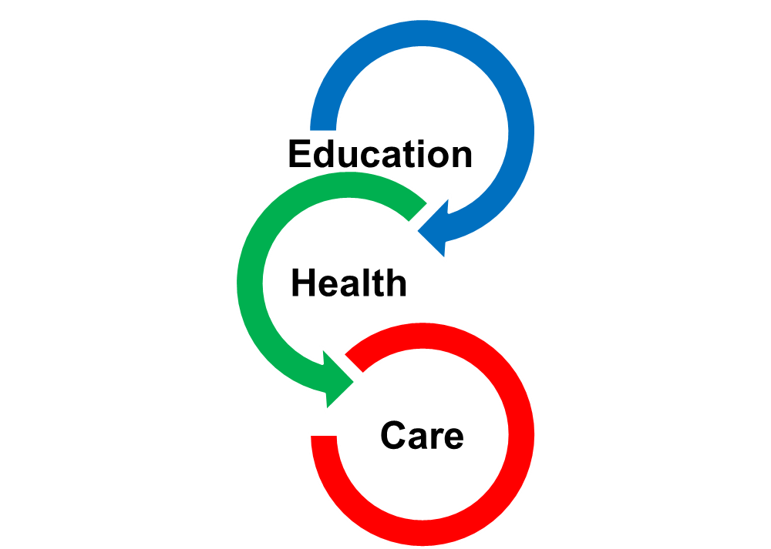

- Child/Young Person’s Personal Details
Full name |  |  | Date of EP Report
Date of Birth |  |  | Current year group
Chronological age at assessment
Gender
Child in Care | Yes/No | Name of Local Authority |  | N/A
English as an additional language | Yes/No | If ‘Yes’ what is the home language?  Is a translator required? |  | N/A
Ethnicity
Address
School / College / Setting Name and Address
Parent/person with parental responsibility
Relationship
Address (if different from above)
Contact Details | Telephone:
Details of any parental requirements to support engagement or communication | e.g. accessibility, intervener, interpreter

- Current Understanding of Needs

- Information Sources for Advice
- Views, Hopes and Aspirations
Child/Young Person’s View
Parents/Carers’ View and Aspirations
Has an Appendix 1 (voice of the parent) been completed?
What aspirations do you have for the medium/ long-term and what do you hope their life will look like after they leave education?
Other views/ background

- Current Situation, Needs, Outcomes and Provision
Communication and Interaction
(In EYFS this would be covered through Communication & Language)
What is going well?
Needs (What are the barriers to learning?)
Suggested medium-term outcome/s (e.g. to the end of this key stage)
Provision to meet identified needs
Kent’s Mainstream Core Standards (https://www.kelsi.org.uk/special-education-needs/inclusion/the-mainstream-core-standards) should be used for all CYP in Kent. Please detail below any key strategies that are particularly supportive for the CYP.
Special Educational Provision
Provision Description  This details support and interventions for Millie’s special educational needs. | For provisions that are an intervention:  - Who will deliver this?  - What is the frequency and duration?  - Anticipated end point of intervention/when to be reviewed (e.g. based on outcomes, frequency and duration or set year group etc)
Cognition and Learning
(In EYFS this would be covered through Literacy, Maths, Understanding of the world & Expressive arts and design)
What is going well?
Needs (What are the barriers to learning?)
Suggested medium-term outcome/s (e.g. to the end of this key stage)
Provision to meet identified needs
Kent’s Mainstream Core Standards (https://www.kelsi.org.uk/special-education-needs/inclusion/the-mainstream-core-standards) should be used for all CYP in Kent. Please detail below any key strategies that are particularly supportive for the CYP.
Special Educational Provision
Provision Description  This details support and interventions for Millie’s special educational needs. | For provisions that are an intervention:  - Who will deliver this?  - What is the frequency and duration?  - Anticipated end point of intervention/when to be reviewed (e.g. based on outcomes, frequency and duration or set year group etc)
Social, Emotional and Mental Health
(In EYFS this would be covered through Personal, Social and Emotional development)
What is going well?
Needs (What are the barriers to learning?)
Provision to meet identified needs
Kent’s Mainstream Core Standards (https://www.kelsi.org.uk/special-education-needs/inclusion/the-mainstream-core-standards) should be used for all CYP in Kent. Please detail below any key strategies that are particularly supportive for the CYP.
Special Educational Provision
Key Provision Description  This details support and interventions for Millie’s special educational needs. | For provisions that are an intervention:  - Who will deliver this?  - What is the frequency and duration?  - Anticipated end point of intervention/when to be reviewed (e.g. based on outcomes, frequency and duration or set year group etc)
Physical and Sensory
(In EYFS this would be covered through Physical Development)
What is going well?
Needs (What are the barriers to learning?)
Suggested medium-term outcome/s (e.g. to the end of this key stage)
Provision to meet identified needs
Kent’s Mainstream Core Standards (https://www.kelsi.org.uk/special-education-needs/inclusion/the-mainstream-core-standards) should be used for all CYP in Kent. Please detail below any key strategies that are particularly supportive for the CYP.
Special Educational Provision
Key Provision Description  This details support and interventions for Millie’s special educational needs. | For provisions that are an intervention:  - Who will deliver this?  - What is the frequency and duration?  - Anticipated end point of intervention/when to be reviewed (e.g. based on outcomes, frequency and duration or set year group etc)

- Assessment Results

7. Person/s Completing this Report
Name(s)
Job Title(s)
Health Care Professions Council Registration(s)
Signature(s)
Email
Work Address
Postcode
Telephone Number
Date of Report
No of Pages
Word Count
Cc | SEN, Electronic Child File

Please view our Educational Psychology privacy notice for details about how we process confidential information in compliance with GDPR.

