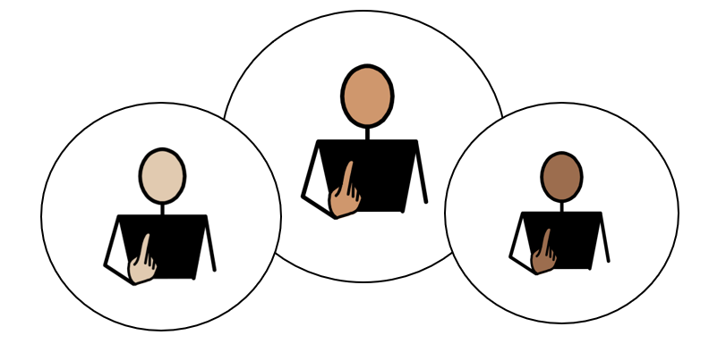
All About Me

Appendix 1A: Pathway 4 (Post-16)
Voice of the Young Person

This form is all about you. It helps the people who support you understand:
- what you are good at
- what you enjoy
- how you like to communicate
- what helps you learn and feel happy
- anything that could be better for you
You can complete this form on a computer, or you can print it out and write on it.
If you would like help, an adult can read the questions, write or type your answers, or help you complete a little bit at a time.
The examples on each page are just ideas to help you think about your answers. You do not have to choose them. Use the grey boxes to tell us what you think.
✅ Tick any boxes that sound like you.
✍️ Use the grey spaces to add your own comments, ideas, and feelings.
My views should be used to inform my Annual Review Meeting, Outcomes, and Provision.

1. About Me
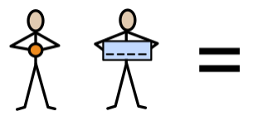  My Name is: | Tap or click here and type my name
My school or setting is called:  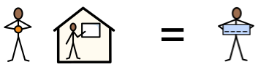 | Tap or click here and type my school or setting
Date this form was completed: Click or tap to enter a date.

The name of the person helping me complete this form is: | Tap or click here and type their name
They know me because: | Tap or click here and type how they know me

2. How my views were gathered
☐ My views were captured by completing this form and through observations and discussions with me, my parent(s)/carer(s), and relevant professionals.

☐ I was able to take part in developing my Education, Health and Care Plan by sharing my wishes and aspirations with my parent(s)/carer(s) and the professionals working with me.

☐ I am not able to express my views directly at this time. My views have been shared by adults who know me well, including my teacher and parent/carer.

3. Picture, drawing, or photo of me

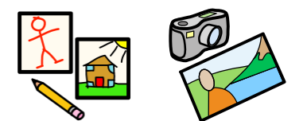
Add a picture, drawing, or photo here if you would like.



4. My aspirations and next steps

What sort of work would you like to do? 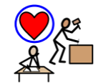
(It’s ok to say you are not sure)

What skills or training would you need?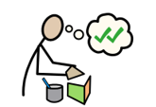

My Future: My hopes for education and work (My short-term aspirations)
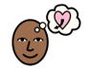
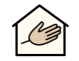 |  |  | 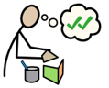 | 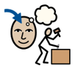
Social Care (day services)  ☐ | Progress from a level 1 course to a level 2 course  ☐ | Progress from a level 2 course to a level 3 course  ☐ | Access a supported internship  ☐ | Access an apprenticeship  ☐

My Future: My hopes for education and work (My short-term aspirations)
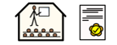 | 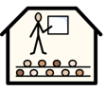 |  | 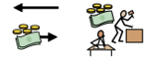 | 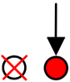
Gain my A-Levels  ☐ | Go to University  ☐ | Access voluntary employment  ☐ | Access paid employment  ☐ | Other  ☐

Tap or click here and type any comments

My Independence: I am working towards independence, by:
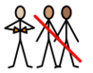
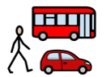 | 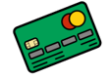 | 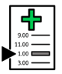 | 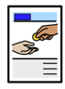 | 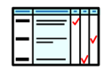 | 
Travelling to chosen places independently  ☐ | Managing my money  ☐ | Knowing how to make my own medical appointments  (doctor / dentist etc.)  ☐ | Managing bills  (e.g. mobile phone)  ☐ | Completing forms and other documents  ☐ | Preparing my own food  ☐

My Independence: I am working towards independence, by:
 |  | 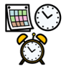 | 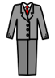 | 
Feeling confident placing orders at a café or restaurant  ☐ | Understanding how to claim my benefits E.g. PIP  ☐ | Managing my own time  ☐ | Knowing how to present myself at an interview  ☐ | Knowing how to complete basic household tasks  ☐ | Buying my own groceries at the local shop  ☐

Tap or click here and type any comments:

My Community: Outside of my school, or setting, I enjoy:
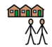
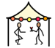 | 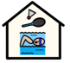 | 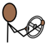 | 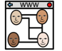 | 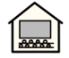 | 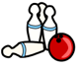
Festivals  ☐ | Sports Club  ☐ | Learning to drive  ☐ | Social Media  ☐ | Cinema  ☐ | Bowling  ☐

My Community: Outside of my school, or setting, I enjoy:
 |  | 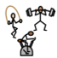 | 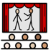
Gaming  ☐ | Escape Rooms  ☐ | The gym  ☐ | Theatre  ☐

Tap or click here and type any comments:

My Quality of Life: Things that are good, in my life at school, college or setting:

 | 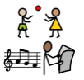 | 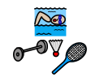 | 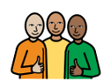 | 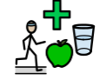 | 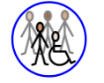
I have a comfortable and safe place to live  ☐ | I have daily activities which I enjoy  ☐ | I am involved in a community  ☐ | I have a trusted support network  ☐ | I have a healthy lifestyle  ☐ | I have a social life I feel happy with  ☐

Do you know how to find out about things to do, within the community? | Would you like help to take part in activities, within the community?
Yes ☐ No ☐ | Yes ☐ No ☐

My Voice: How I communicate best:
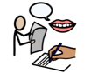
 | 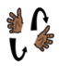 | 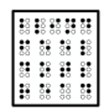 | 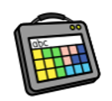 |  |  | 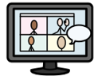
Talking  ☐ | Signing  ☐ | Reading Braille  ☐ | Augmentative Communication Aid  ☐ | Email  ☐ | Texting  ☐ | Virtual Platform  ☐

Tap or click here and type any comments:

My Voice: How I communicate best:
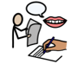
Who listens to me, at home?  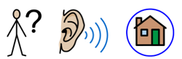 | Tap or click here and type any comments
Who listens to me, at my school, or in my setting?  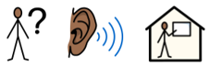 | Tap or click here and type any comments

My Support: Adults can help me, by:
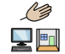
 |  |  | 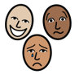 | 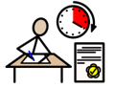 | 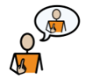
Reading my communication passport  ☐ | Teaching me how to write key notes, to help with my main lesson  ☐ | Providing alternative methods of recording  ☐ | Providing regular emotional check-ins and check-outs, to resolve issues and monitor my wellbeing  ☐ | Providing me with exam access arrangements  ☐ | Understanding the specific challenges, I face, and helping me advocate for myself  ☐

My Learning: The best way for me to learn, is:
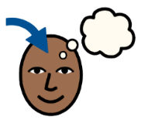
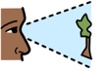 |  | 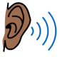 | 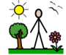 | 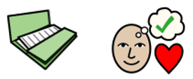 |  | 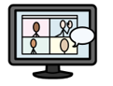
Visual  ☐ | Kinaesthetic  (practical, hands-on)  ☐ | Auditory  ☐ | Outdoor  ☐ | Project based  ☐ | Watching Videos  ☐ | Online learning platforms  ☐

Tap or click here and type any comments:

My Health: To keep myself healthy, I:
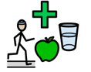
 | 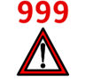 | 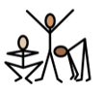 | 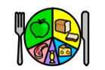 | 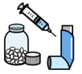
Keep my screen-time within healthy limits  ☐ | Know how to call 999/111 to look after myself, or someone else  ☐ | Stay physically active  ☐ | Try to eat a variety of foods  ☐ | Take prescribed medication according to the prescription  ☐ | Attend health appointments, such as GP, dentist, and opticians  ☐

My Health: To keep myself healthy, I:
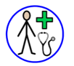 | 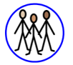 | 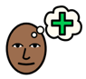 | 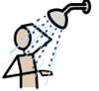 | 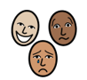
Know when I need to see a GP and what the GP can help me with  ☐ | Understand relationships, including sexual relationships  ☐ | Know how to access support for mental  health and wellbeing  ☐ | Manage my personal hygiene (wash daily, wear deodorant, brush teeth, etc.)  ☐ | Understand about masking and burn-out, and how to be kind to myself  ☐

My Safety: Adults can teach me to keep safe, by helping me to:

 |  | 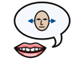 | 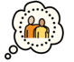 | 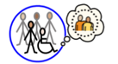
Supporting me to engage with services which support me (e.g., Therapies, Social Worker, etc)  ☐ | Teaching me the differences between healthy and unhealthy relationships  ☐ | Enabling me to understand my rights, and have confidence to say no to things I don’t feel comfortable with  ☐ | Ensuring that I have a trusted adult I can talk to about things which worry me  (parents, carers, setting staff)  ☐ | Teaching me how to stay safe out in the community  ☐

My Safety: Adults can teach me to keep safe, by helping me to:
 | 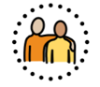 |  | 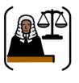 | 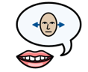
Understand the facts, so I can make informed choices about smoking, drugs and alcohol  ☐ | Keep myself safe in sexual relationships  ☐ | Understand that some people may try to exploit or groom me; how to recognise this, and what to do if this happens  ☐ | Understand what is right and wrong in the community, and the Law  ☐ | Have confidence to say no to things I don’t feel comfortable with, and understand that I am entitled to change my mind  ☐

I have been included in my Annual Review meeting:

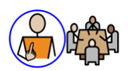

Please select Not Applicable if their annual review meeting has not been held yet meeting (the annual review meeting is held within a year after the EHCP of its first issue or from the date of the last review).

Not Applicable  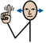 | Yes   | No  
☐ | ☐ | ☐

