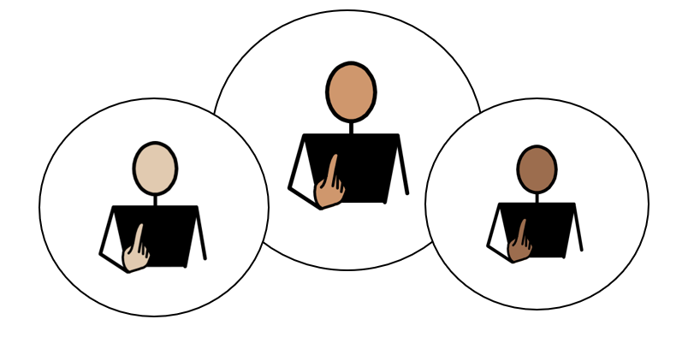
All about Me

Appendix 1A: Pathway 4 (Post-16)
Voice of the Young Person
We use our Children’s and Young People’s Outcome Framework, below, to make sure that the support provided for you is having a positive impact on your life.
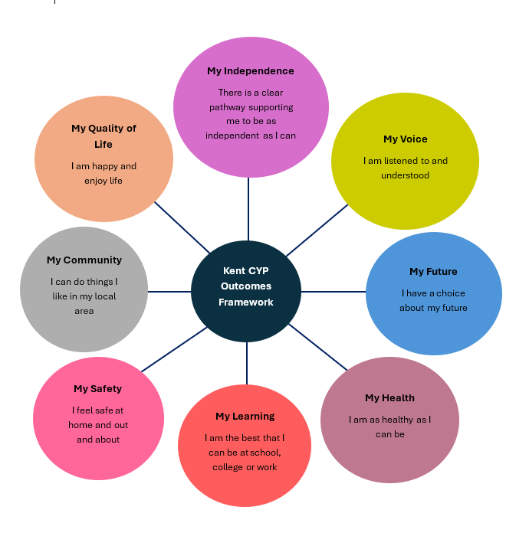

This is your chance to tell everyone supporting you what is going well, and what needs to change, in order to help you reach your full potential. The following questions will help us to understand more about you, and your views about your life.

This form can be printed off, to add your own ideas and thoughts in the blank grey boxes, if you would like. An adult can read for you, and /or write your answers for you, if you would like help; and you can break it down into smaller parts, if you don’t want to complete it all at once. Alternatively, this form can be completed electronically, using the text boxes to add typed comments and /or selecting thoughts and views using the tick boxes provided.

Please use the information gathered through Pupil Voice to inform the Annual Review Meeting in terms of Outcomes and Provision.

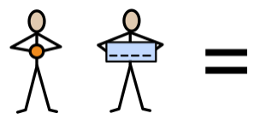
My name is:
Click or tap here to enter text.

Click or tap here to enter text.

My school/setting is called:
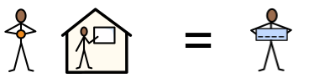

This information was provided by:
Please select the relevant statement below to represent how the child’s views were gathered to complete Appendix 1A:

Child/ Young Person’s views were captured by completion of this form and through observations and discussions with the child, their parent(s), carer(s) and relevant professionals. | ☐
The Child/Young Person’s was able to take part in developing their Education, Health and Care Plan (EHCP) by contributing their wishes and aspirations with their parents (s) and the professionals working with them. | ☐
Due to their severe and complex needs, the child/young person is unable to express their views directly. Therefore, their views have been provided by the child’s teacher and parent/carer. | ☐

Date of completed form:
Click or tap to enter a date.


Photo of me (optional):

My aspirations (goals) for the future:
My
Future

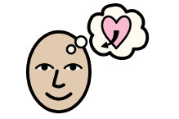

My hopes for education and work (My short-term aspirations)
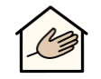 |  |  | 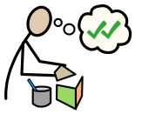 | 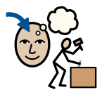
Social Care (day services)  ☐ | Progress from a level 1 course to a level 2 course  ☐ | Progress from a level 2 course to a level 3 course  ☐ | Access a supported internship  ☐ | Access an apprenticeship  ☐
  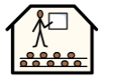 | 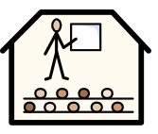 | 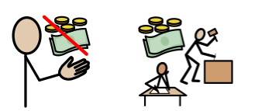 | 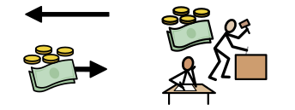 | 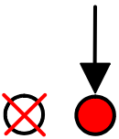
Gain my A-Levels  ☐ | Go to University  ☐ | Access voluntary employment  ☐ | Access paid employment  ☐ | Other  ☐
My aspirations (goals) for the future:
My
Future

What sort of work would you like to do? | 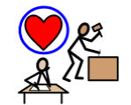 | Comments:  Comments:
What skills or training would you need? | 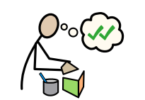
Who would you like to live with, in the future; and where? |  | Comments:
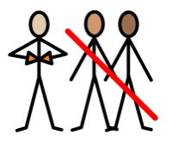
I am working towards Independence, by:
My Independence

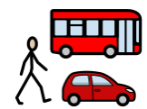 | 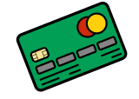 | 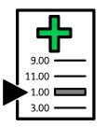 | 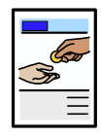 | 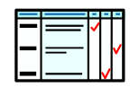 | 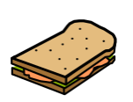
Travelling to chosen places independently  ☐ | Managing my money  ☐ | Knowing how to make my own medical appointments  (doctor / dentist etc.)  ☐ | Managing bills  (e.g. mobile phone)  ☐ | Completing forms and other documents  ☐ | Preparing my own food  ☐
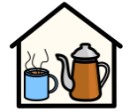 |  | 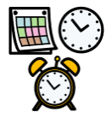 | 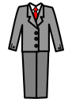 |  | 
Feeling confident placing orders at a café or restaurant  ☐ | Understanding how to claim my benefits E.g. PIP  ☐ | Managing my own time  ☐ | Knowing how to present myself at an interview  ☐ | Knowing how to complete basic household tasks  ☐ | Buying my own groceries at the local shop  ☐
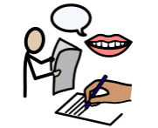
How I communicate best:
My
Voice

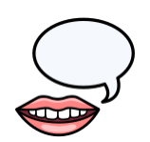 | 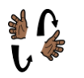 | 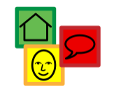 | 
Talking  ☐ | Signing  ☐ | Using Symbols  ☐ | Augmentative Communication Aid  ☐
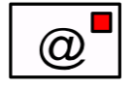 | 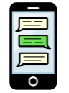 | 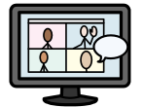 | 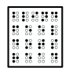
Email  ☐ | Texting  ☐ | Virtual Platform  ☐ | Reading Braille  ☐

Communication:
My
Voice

Who listens to me, at home?  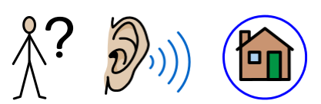 | Comments:
Who listens to me, at my school, or in my setting?  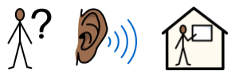 | Comments:

To keep myself healthy, I:
My
Health

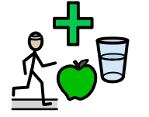

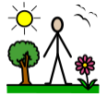 | 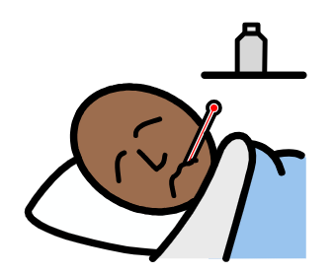 |  | 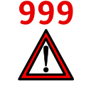 | 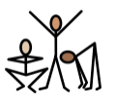
Spend time outside each day  ☐ | Tell someone when I feel unwell  ☐ | Keep my screen-time within healthy limits  ☐ | Know how to call 999/111 to look after myself, or someone else  ☐ | Stay physically active  ☐
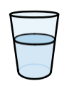 | 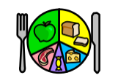 | 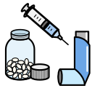 |  | 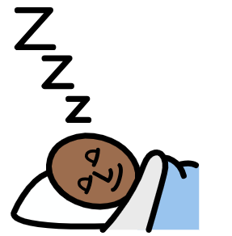
Stay hydrated  ☐ | Try to eat a variety of foods  ☐ | Take prescribed medication according to the prescription  ☐ | Attend health appointments, such as GP, dentist, and opticians  ☐ | Understand and ensure I have the amount of sleep I need  ☐
To keep myself healthy, I:
My
Health

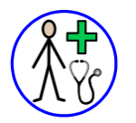 | 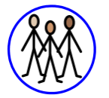 | 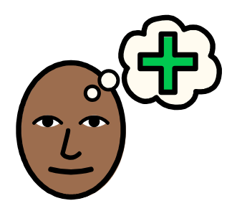 | 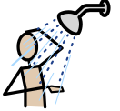 | 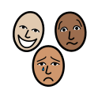
Know when I need to see a GP and what the GP can help me with  ☐ | Understand relationships, including sexual relationships  ☐ | Know how to access support for mental  health and wellbeing  ☐ | Manage my personal hygiene (wash daily, wear deodorant, brush teeth, etc.)  ☐ | Understand about masking and burn-out, and how to be kind to myself  ☐
Comments:

The best way for me to learn, is:
My Learning

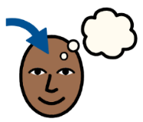
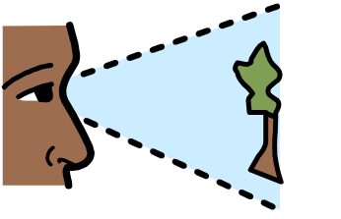 | 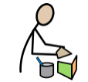 | 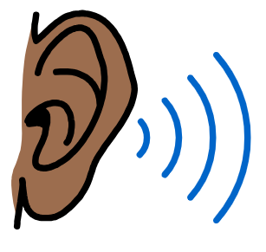 | 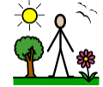 | 
Visual  ☐ | Kinaesthetic (practical, hands-on, doing things)  ☐ | Auditory  ☐ | Out-door  ☐ | Project-based  ☐
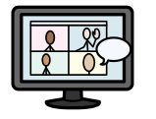 | 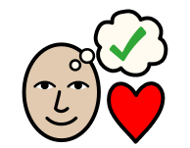 |  |  | 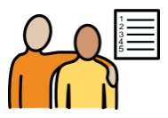
Via online learning platforms  ☐ | Special interest-based  ☐ | Watching Videos  ☐ | Life Skills-based  ☐ | Working towards and achieving my EHCP outcomes  ☐
Adults can help me, by:
My
Support

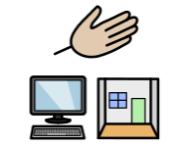

 |  |  | 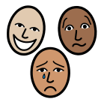
Reading my communication passport  ☐ | Preparing me for change  ☐ | Providing alternative methods of recording  ☐ | Providing regular emotional check-ins and check-outs, to resolve issues and monitor my wellbeing  ☐
 | 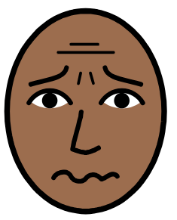 | 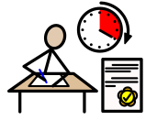 | 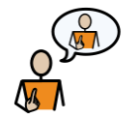
Teaching me how to write key notes, to help with my main lesson  ☐ | Ensuring I recognise when I am feeling stressed or anxious and know what I can do  ☐ | Providing me with exam access arrangements  ☐ | Understanding the specific challenges, I face, and helping me advocate for myself  ☐

I feel safe at school, college or in my setting:
My
Safety

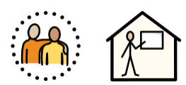

 |  | 
Yes  ☐ | No  ☐ | Unsure  ☐
Comments:

Keeping myself safe:
My
Safety

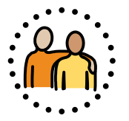

Who can help me at home?   | 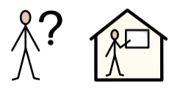  Who can help me at school?
Comments: | Comments:

I would like, adults to help me stay safe, by teaching me to:
My
Safety

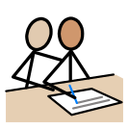 | 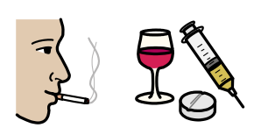 |  | 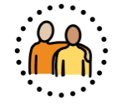
Engage with the services that support me (e.g., Youth Support, Therapies, Social Worker, etc.)  ☐ | Understand the facts, so I can make informed choices about smoking, drugs and alcohol  ☐ | Understand and identify the differences between healthy and unhealthy relationships  ☐ | Keep myself safe in sexual relationships  ☐
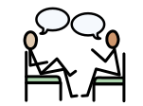 | 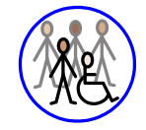 | 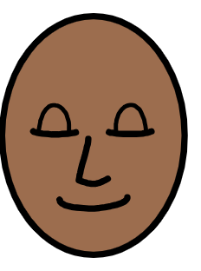 | 
Know that I have a trusted adult I can speak to outside my home, if I have worries about relationships at home  ☐ | Know that I have a social life I feel happy with, so I don’t feel isolated  ☐ | Use strategies to cope with different emotions, other than verbal or physical aggression  ☐ | Understand that some people may try to exploit or groom me; how to recognise this, and what to do if this happens  ☐
I would like, adults to help me stay safe, by teaching me to:
My
Safety

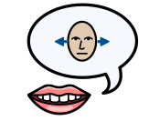 | 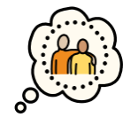 | 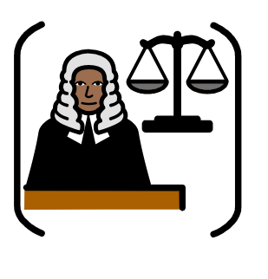
Have confidence to say no to things I don’t feel comfortable with, and understand that I am entitled to change my mind  ☐ | That I have a trusted adult I can talk to about things that worry me  (parents, carers, setting staff)  ☐ | Understand what is right and wrong in the community, and the Law  ☐
Comments:

Outside of my school or my setting, I enjoy:
My
Community

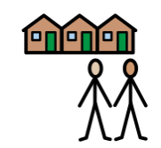

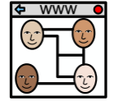 | 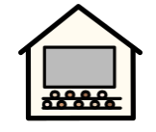 | 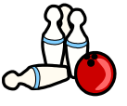
Social Media  ☐ | Cinema  ☐ | Bowling  ☐
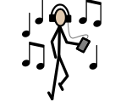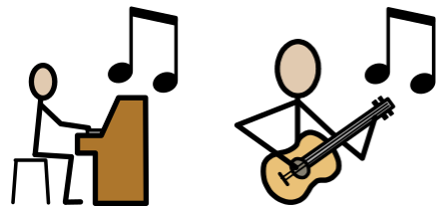 | 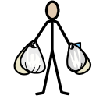 | 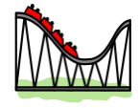
Listening to / Playing Music  ☐ | Shopping  ☐ | Theme Parks  ☐
Comments:

Outside of my school or my setting, I enjoy:
My
Community

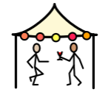 | 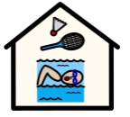 | 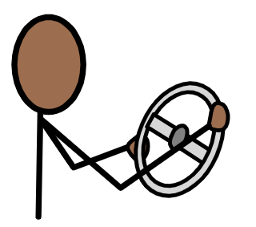 | 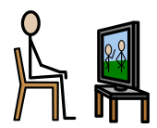
Festivals  ☐ | Sports Club  ☐ | Learning to drive  ☐ | Watching TV  ☐
 | 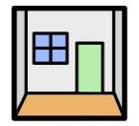 | 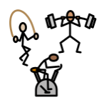 | 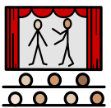
Gaming  ☐ | Escape Rooms  ☐ | The gym  ☐ | Theatre  ☐

Do you know how to find out about things to do, within the community? | Would you like help to take part in activities, within the community?
Yes ☐ No ☐ | Yes ☐ No ☐
Things that are good, in my life at school, college or setting:
My Quality of Life



 | 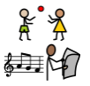 | 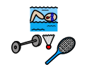 | 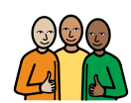 | 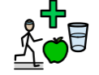 | 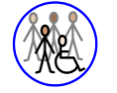
I have a comfortable and safe place to live  ☐ | I have daily activities which I enjoy  ☐ | I am involved in a community  ☐ | I have a trusted support network  ☐ | I have a healthy lifestyle  ☐ | I have a social life I feel happy with  ☐
At home, I am happy, with:
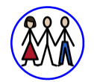 | 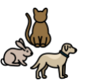 | 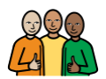
My family  ☐ | My pets  ☐ | My close friends  ☐

At my school or setting, overall:


My Setting: |   Yes  Yes |   No  No |   I don’t know
My Future – I have a choice about my future.  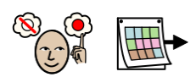 | ☐ | ☐ | ☐
My Independence - I have the right support to enable me to be as independent as I can be.  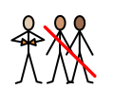 | ☐ | ☐ | ☐
My Voice - I feel listened to.  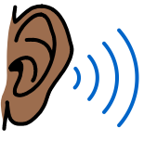 | ☐ | ☐ | ☐
My Health – I have the right health support to enable me to be as healthy as I can be.  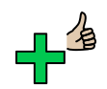 | ☐ | ☐ | ☐
My Learning/Support - I feel I have the right amount of support in my setting.  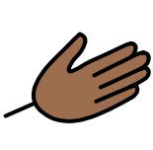 | ☐ | ☐ | ☐
My Safety - I feel safe.  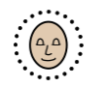 | ☐ | ☐ | ☐
My Quality of Life- I am happy and enjoy life. | ☐ | ☐ | ☐
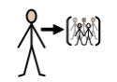  My Community - I have a sense of belonging. | ☐ | ☐ | ☐

Not Applicable  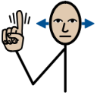 | Yes   | No   | Not Sure
☐ | ☐ | ☐ | ☐
I have been included in my Annual Review meeting:
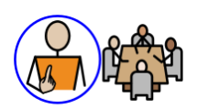

Please select Not Applicable if their annual review meeting has not been held yet meeting (the annual review meeting is held within a year after the EHCP of its first issue or from the date of the last review).
Anything else:
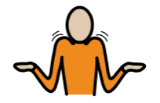

Comments:

