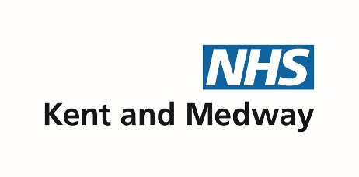

Guidance for health professionals to complete Health Advice Template

This guidance sits alongside the health template which is completed for the Statutory EHC Needs Assessment conducted by Kent County Council

Please note: the health advice needs to be completed within 6 weeks of receiving the request.

The form is to be completed and returned to the SEN area office.

Please note that all the information on the template will be shared with the child /young person and/or
Parents. The final EHCP will be shared with all agencies involved with the child .

Child/Young Person’s personal details
Child / Young Person Personal Details

All domains of the demographic information need to be completed accurately.

Child/Young Person’s personal details
Forename: |  |  |  |  | Surname:
DOB: |  |  | Gender at birth: |  | Male/Female | NHS Number:
Which gender does the child/young person identify with if different from above?
Or Is the child/young person in process of changing gender? Yes/No
Home Address:
Tel No: |  | Email:
Parent/carer name: |  |  |  |  |  | Preferred Contact No.
GP name & address |  |  |  |  |  | GP Phone number:

Views and Aspirations

Child’s / young person’s views, interests, aspirations | If CYP is unable to communicate due to age or need, parent’s/carer’s views, interests, aspirations
It’s important that the child / young person’s aspirations for the future are considered when documenting the outcomes related to their health needs  There should be a golden thread from aspirations to outcomes  Reference:  https://councilfordisabledchildren.org.uk/help-resources/resources/amys-education-health-and-care-plan-ehcp-resource  Aspirations are not outcomes. Services are not responsible for long-term aspirations in the same way that they are for outcomes.  As part of your assessment or appointment the health professional will be building a rapport and asking about the CYP, family, school, their interests etc. This could be articulated within your report writing to assist with completing this information.  As a child/young person gets older, and particularly as they move towards adulthood, what were aspirations at an earlier stage may become achievable outcomes (longer-term aspiration). | Some CYP will find it difficult to express or communicate their aspirations so parents/carers are able to report on their behalf.  Schools and other agencies will undertake a more thorough exploration of the views and aspirations of the CYP for this process if this information cannot be obtained during the health appointment/assessment.
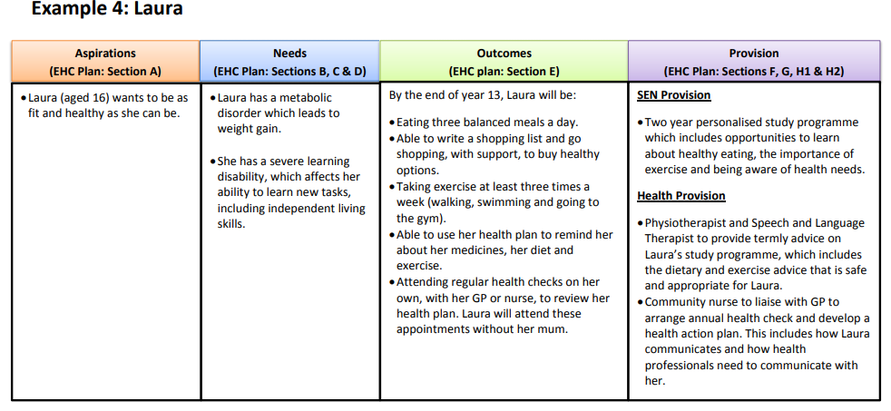

Child / young person’s health history including medical diagnoses
A brief description of the CYP health journey / history
Some history would not be relevant to the EHCP assessment process therefore use your professional integrity to ascertain a clear rationale for not including the information. An example might be their sexual health contacts, minor injuries or family health history.
Please list the medical conditions, illnesses and any diagnosis on separate lines.

Health Needs, Outcome/s and Provision
Health outcome/s

Outcomes are not a description of a service being provided, but a benefit or difference made to an individual as a result of an intervention.
Outcomes will usually set out what needs to be achieved by the end of a phase or stage of education. Outcomes should be written in a way that helps children and young people towards the achievement of their aspirations.
Outcomes should be specific, measurable, achievable, realistic and time bound (SMART), as well as challenging and be based on high expectations of what a child or young person can achieve.
Long term outcome (i.e. over an educational Key stage)
Short term outcomes are steps towards achieving the long term outcomes (this could be over one year or a shorter period): This will be updated at an annual review of the EHCP.

Resources:
Case Example
By the end of year 8, Harry will be confident in attending the dentist by attending his 6 monthly dental checks regularly.

By the end of year 8, Harry will be able to walk himself to school every day.

By the end of year 8, Harry will be able to recognise symptoms of a ‘hypo’ (low blood sugar) and be able to administer his medication without assistance.

By the end of year 11, Harry will to be able to manage his type I diabetes independently, including the management of medication and healthy dietary choices.

Strengths
What can the child/young person do well and what has he/she achieved

Needs and how these impact on the child/young person
The EHC plan must specify any health needs identified through the EHC needs assessment that relate to the learning difficulty or disability that results in a child or young person having SEN.
Consider all of the following, include all known diagnoses related to this child/young person:
- What does the child/young person find difficult?
- How do the child/young person’s health needs impact on learning and day to day activities?
- Does the child have any prescribed medication and what impact is the treatment ‘having / likely to have’ on the child, i.e. will this medication have an effect on the child’s ability to learn as expected
- Ongoing treatment other than prescribed medication for example use of special diets.

Case example
Harry has a diagnosis of High Functioning Autism which impacts on his communication and interaction with others

Harry has a diagnosis of moderate-severe anxiety which is managed with a small dose of anxiety medication. If Harry becomes anxious outside of his home, he may become withdrawn, vacant, trembling excessively and/or sweaty/clammy, tearful, and he may also attempt to leave his surroundings.

Provision to meet needs  Provision should be detailed and specific and should normally be quantified, for example, in terms of the type of support and who will provide it . This is completed in the columns on the right.  Indicate to which need/outcome the provision relates to.  This may include specialist support, treatment or therapies, nursing, equipment.  If the child/young person has an individual Health Care Plan this should be included.  Frequency of review at your clinic/planned future involvement from your clinic  If a young person has a learning disability and is over 14 years, an annual health check is documented.  It should be clear how the provision will support achievement of the outcomes, including the health needs to be met and the outcomes to be achieved through provision secured through a personal (health) budget | Who will provide this:  e.g. Education  Health provider / specialist | How Often:  e.g. Twice a week for 30 minutes | How/when this will be reviewed  Short term reviews can be added – but it would not be expected that the provision detailed on the plan would be changed more often than annually.
Please add additional rows to explain clearly each additional health provision, who will provide this, how often it will be delivered, and how/when this will be reviewed | Who will provide this: | How Often: | How/when this will be reviewed
Case example  Harry will work with the CAMHS team to manage his emotional health and undertake a block of cognitive behaviour therapy.  Harry is seen for review (including medication) by the CAMHS consultant.  Please refer to Harry’s individual health care plan for medications and doses. | Psychologist at CAMHS  CAMHS Psychiatric Consultant | One hour session every week for 6 weeks  Six monthly review | This is discussed and reviewed at the end of the 6 week block  Reviewed at each appointment
Harry to register with an ‘autism friendly’ dental practice.  Harry’s appointment to be scheduled at a quiet time. | Training for dental practices provided by CCG | Support for Harry from dental practice at each visit | Review with Dentist, Harry and his parent after two attendances.
Harry is seen for review by the children’s diabetes nurse.  Harry is seen by the consultant for review of his diabetes and medications.  Please refer to Harry’s individual health care plan for medications and doses, including any emergency medications. A ‘hypo’ is considered a medical emergency and needs intervention as soon as possible. | Children Diabetes service KCHFT  Paediatric Services EKHUFT  Children Diabetes service KCHFT | This will be three monthly  This will be six monthly  Annually or changed as treatment requires | Nurses will visit Harry at school, at home or in clinic every 3 months  Harry will attend an outpatient clinic  Reviewed with Harry and his parents following his Consultant appointments

Other information
Please provide any additional relevant evidence or advice
Professionals should, wherever possible, include individual health care plans with shorter term regimes and targets.
Medication regimes and how they might impact the CYP could be added here

Lead Health Professional(s) involved with the Child/Young Person
Name |  | Role | Contact Details: (Email / telephone)
 |  |  | Other consultants involved with the child/young person including speciality teams, contact details and date last seen
 |  |  | “
 |  |  | “
 |  |  | “

Contact(s) completing this report
Name(s) in caps: | Name of person completing the form
Designation/Job title: | of person completing the form
Telephone No: |  | Email: | Mandatory field
Work Address: | of person completing the form
Signature: | of person completing the form |  |  | Date:

Return document to relevant email addresses as per table below.

Please return completed Appendix together with all supporting reports to:
SendAssessmentTeam@kent.gov.uk and copy in kmicb.kmsendhco@nhs.net

