Kentchoices Briefing Autumn 2018

This briefing covers:
- The Education People
- Kentchoices application process
- Tracking
- Useful information to support post 16 progression

The Education People
We have been telling you all that education services will be moving across to a new company for some time. This took place on the 1st September. We are now part of The Education People, the new one-stop shop for education services, supporting the full age range from early years to young adults. Our mission is to support early years and childcare settings, schools and colleges, to improve learning, wellbeing and children’s development in Kent and beyond.

The support you receive from us will remain the same.

Kentchoices
As usual we will be using the kentchoices website to provide course information and to facilitate applications to post 16 providers. We do this to help with the tracking of the September guarantee – if a student makes their application and receives an offer through the system we can upload this information into our database. This means we can focus our resources on those that need it.

We will not be doing Autumn briefings as there was good attendance at the Summer ones. If you need support, especially if you are new to post, please contact Jackie Lovell (details below)

Note:
- Last year the average number of applications made per learner was 1.4, which was the same as the previous year. (We always get asked this, so we thought we’d let you know.
- Please note that UCAS sometimes sends out emails containing information that conflicts with what is said by KCC. Please prioritise information received directly from KCC.
- This will be our last year of using UCAS Progress as UCAS is shutting down the software. We are in the process of procuring a replacement.

Kentchoices timetable
- Return the kentchoices proforma stating how the school wishes to use the site to prospectusmail01@theeducationpeople.org – ASAP.
- Usernames and passwords available now, go to Learners – learners not logged on (no letters will be sent to schools this year).
- Update offer and set up the system to receive applications. Ensure you update your “Before you apply” message to ensure you receive good quality applications. This is your opportunity to tell students what they can apply for and how to do it – by 1st October 2018. The earlier you do this, the more likely we will be able to support you.
- Launch and letters arrive directly to students – 29th October 2018
- Learners to return to the website and accept offers – March 2019
- Schools can see if they are learners first, second or third choice as long as offers have been made and accepted through the system – March 2019.
Help
- For help with managing your offer, processing applications and anything else to do with using the website, please refer to the manual. There is also a PowerPoint for schools to use to train their learners on using the system. All support documents are available at: http://www.kelsi.org.uk/skills-and-employability/kentchoices4u
- To get help with anything to do with UCAS progress please contact Jackie Lovell prospectusmail01@theeducationpeople.org Tel: 03000 416401
Tracking young peoples’ destinations – a statutory duty
To ensure that schools are clear about the tracking data they are required to send the local authority to meet the statutory duty to track all academic age year 12 and 13 young people, a summary of tracking requirements from schools is below and available from Kelsi at
www.kelsi.org.uk/running-a-school/data-and-reporting/management-information/tracking-young-people

The summary provides information on:
- what data is required from schools and the deadlines;
- which service to send it to and the appropriate secure transfer method;
- what schools can expect from the local authority and
- how the data is used.

If you have any questions regarding any of the information in the summary please contact:

Skills and Employability Service (Helen.Whitcher@theeducationpeople.org , 03000 418830, Management Information – Trackingyp@kent.gov.uk

Young People’s Participation Officers (YPPOs)

YPPOs are the office based link to schools, colleges, training providers. Contact them for day to day issues relating to tracking, destinations and September Guarantee.
- Helen Whitcher– West/North helen.whitcher@theeducationpeople.org
- Meryl Marshall - East Meryl.Marshall@theeducationpeople.org
- Rob Chapple - South Robin.Chapple@ theeducationpeople.org

The Skills and Employability Service moved in to the Education People (TEP) from 1st September 2018, the responsibility for tracking young people also transferred under contract with KCC. The only change you will notice on an operational level is the new email address, which still has the capacity to send secure emails. The YPPO who covers your area will be in touch shortly to ensure that this simple email process is explained to you.

Action required now
The tracking process will identify young people who are NEET, but in some cases there could be a delay. If you are worried about any young person you think is either NEET or is in danger of becoming NEET, don’t wait, let us know immediately and we will follow up. Information on these individuals should go direct to the YPPO (otherwise known as trackers) who covers your area.

Summary of school tracking responsibilities 2018/19
Action | Data collection method | KCC deadline | School deadline | Data Transfer method | Responsible KCC Service | How data supports schools and young people
Sixth form Enrolment data | - School complete Post 16 Enrolment Template  - Information returned to KCC using Perspective Lite |  | 14th September | Perspective Lite | Management Information | Data used to provide Destination and Activity Survey reports for individual schools in January
Yr 11 and Yr12 Leaver data.  Information you hold on young people who have left your school in 2018 after Yr 11 and Yr 12 | - KCC provide schools with a prepopulated template of their Year 11 and Year 12 leavers who do not appear on any school or college enrolment lists  - Schools add destination information to the template  - Information returned to KCC by secure email | 14th October | ASAP or 31st October | New secure email | Skills & Employability Service soon to be part of Education People
Intended Destination  What your current Year 11 Age intend to do in September. | - Schools collect data from Year 11 learners  - Schools complete Intended Destination template  - Information returned to KCC using Perspective Lite |  | 31st January | Perspective Lite | Management Information | Used in schools to identify Year 11s who may need support with post 16 transition.
September Guarantee  Information on offers you have made to internal and external applicants for current year 11 age and year 12 age | - Schools make offers to Year 11 learners through UCASprogress – data collected centrally by KCC  - Offers made by schools to: Year 11 learners outside UCASprogress and all Year 12 learners collected on a September Guarantee template  - Information sent to KCC using Perspective Lite  - Final return of offers made by your school |  | 29th March  31st March  30th April | UCASprogr  Perspective Lite | Management Information | Used in schools and NEET to EET meetings to identify post 16 provision for young people without a September Guarantee offer
September Guarantee (2)  Information you hold on students in Year 11 and 12 with no recorded offers | - KCC to provide schools with lists of young people without a recorded offer via secure email  - Schools to provide intelligence they have via secure email | 7th June | 28th June | New secure email | Skills & Employability Service (Education People) | As above
Leavers and Joiners  Year 9 or above who have left or joined your school in the relevant month | - Schools complete leaver and joiner template each month  - Information returned KCC using Perspective Lite |  | Last day of each month | Perspective Lite | Management Information | Used to identify young people who need support from KCC Services

Optional support – we continuously try to stay in touch with NEETs and contact ‘Not Knowns’ so we can support them. Young people in many cases stay in touch with their schools or have siblings at the same school. In addition to the data requests above, we may ask for further information at limited times throughout the year. This is optional and dependant on your time demands. | Mid – January and other limited ad hoc requests
Key points:
- Always use latest templates for data returns, these include fields to capture phone numbers and are available from:
www.kelsi.org.uk/running-a-school/data-and-reporting/management-information/tracking-young-people
- Data returns need to be sent to the appropriate service: light blue to the Skills and Employability Service (soon to be part of Education People) using new secure email (Egress is no longer available) and dark blue to Management Information using Perspective Lite.
- Further Information from: The Education People (Helen.Whitcher@theeducationpeople.org, 03000 418830, Management Information – Trackingyp@kent.gov.uk

Post 16 Progression

NEET Support
- If you require help with supporting potential NEETS and any other issues regarding NEETs, please contact your local Young Person’s Participation Officer.
- If you have any information about young people who have become NEET, please contact your local Young Person’s Progression Officer.

Options for leaners not suitable for/struggling with sixth form/college
If you have learners who fall into this category, please refer them to the Ready To Work Kent website www.readytoworkkent.co.uk. It is very quick and easy to register and apply for courses.

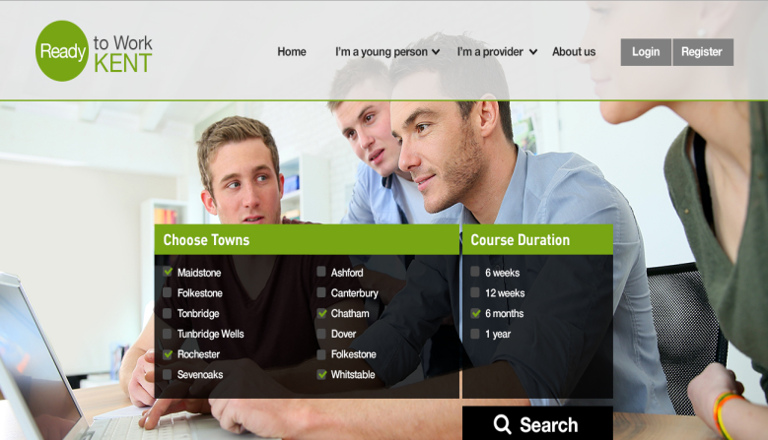

ReadyToWorkKent contains information on:
- Work Experience programmes
- Engagement/Mentoring programmes
- SEND programmes
- District specific traineeships /apprenticeship vacancies
- Employability Courses
- NEET programmes
- Training providers

Apprenticeships
For those interested in apprenticeships there is the ApprenticeKent website www.apprenticekent.com. The website contains information about apprenticeships and advertises vacancies. This year there will be a series of events to support young people interested in apprentices. Information on these can be found on the website.

Kent Supported Employment
Kent Supported Employment supports people with disabilities to have the same chance to gain and sustain employment as non-disabled people. They do this by providing the correct professional help and support so that both the employer and employee have a positive experience of employment. Referral to Kent Supported Employment is via KCC Social Care. Please speak to your care manager/social worker if you have one, or alternatively you can contact us direct for more information if you do not have a care manager/social worker on: 03000 410781 or via email at: kentsupportedemployment@theeducationpeople.org
Kent Supported Employment can also deliver the Supported Employment element of a Supported Internship for young people aged between 16-24yrs with an EHC Plan who are attending school or linking with an Training Provider who deliver Supported Internships.
For more information regarding Kent Supported Employment please contact:
03000 410781 or email: kentsupportedemployment@theeducationpeople.org
www.theeducationpeople.org

