

DSE - Adjusting your office chair guidance.

For further advice contact [healthandsafety@kent.gov.uk](mailto:healthandsafety@kent.gov.uk) or call 03000 418456

**Points to remember:**

Your chair height is the most important factor to sitting correctly at your workstation when using a computer. You must adjust the chair height to ensure that your elbows are parallel with the top of the desk and at right angles to the floor.

Always support your feet if you are unable to rest them flat on the floor once you have adjusted the chair height.

Ensure your natural eye-line rests within the top third of the screen.

Keep the things you use all of the time e.g. keyboard, mouse and telephone close to you, to avoid overstretching.

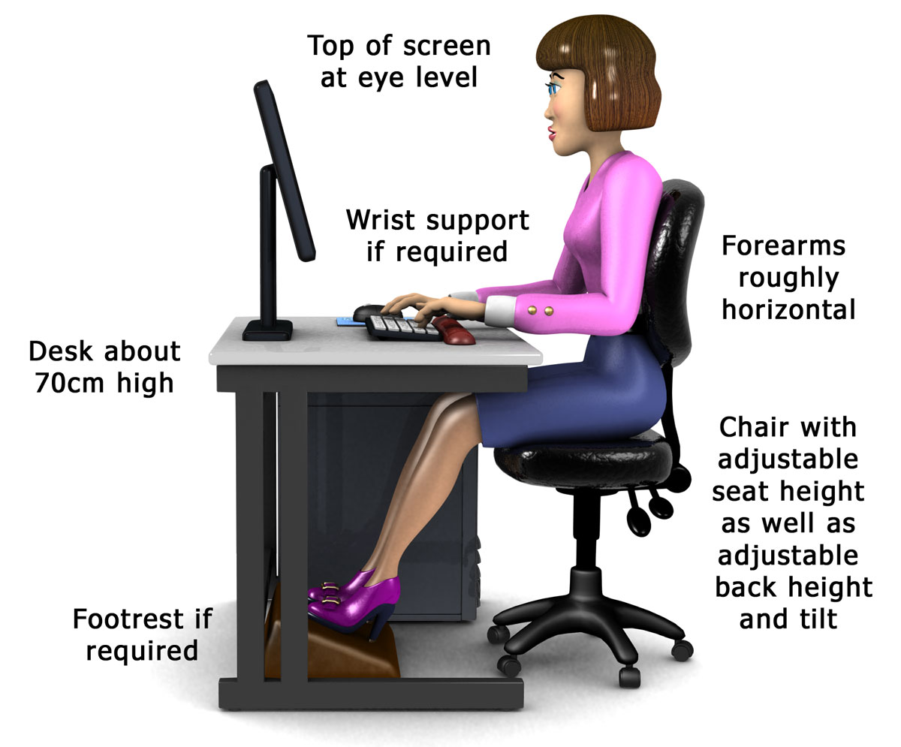

**Eyes rest within the top third of screen**

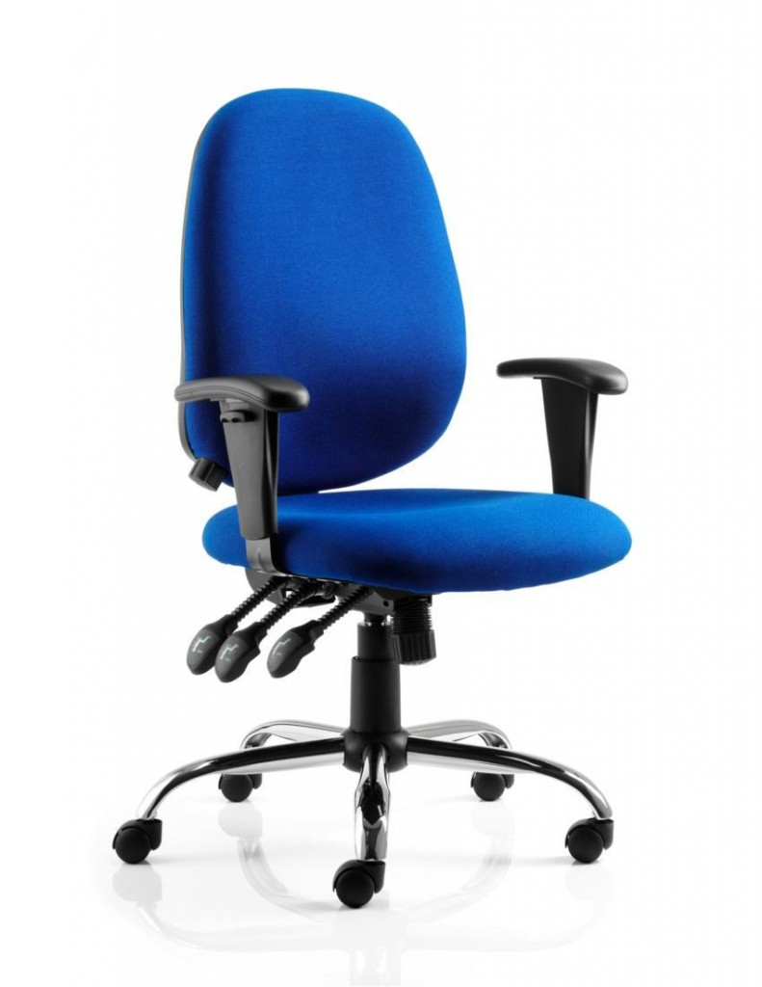

**Adjustable armrests. Always ensure when resting your arms on the armrests, your shoulders are low and relaxed**

**Ensure the lumbar curve fits into the small of your back.**

**Lift to adjust seat height**

**Lift to adjust back angle**

**Lift to adjust seat angle**

**Chair back height can usually be adjusted either by a large cog at the base of the chair or can be ratcheted up by lifting the chair back at its base.**