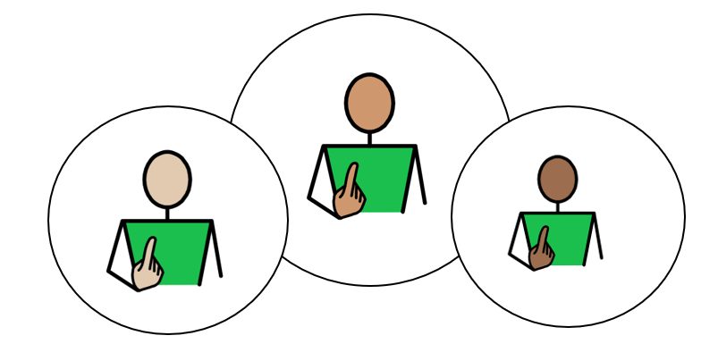
All About Me

Appendix 1A: Pathway 3
Voice of the Child/Young Person

This form is all about you. It helps the people who support you understand:
- what you are good at
- what you enjoy
- how you like to communicate
- what helps you learn and feel happy
- anything that could be better for you
You can complete this form on a computer, or you can print it out and write on it.
If you would like help, an adult can read the questions, write or type your answers, or help you complete a little bit at a time.
The examples on each page are just ideas to help you think about your answers. You do not have to choose them. Use the grey boxes to tell us what you think.
✅ Tick any boxes that sound like you.
✍️ Use the grey spaces to add your own comments, ideas, and feelings.
My views should be used to inform my Annual Review Meeting, Outcomes, and Provision.

1. About Me
My Name is: | Tap or click here and type my name
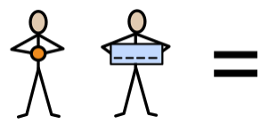  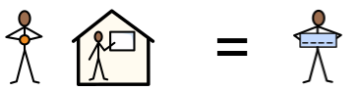  My school or setting is called: | Tap or click here and type my school or setting
Date this form was completed: Click or tap to enter a date.

The name of the person helping me complete this form is: | Tap or click here and type their name
They know me because: | Tap or click here and type how they know me

2. How my views were gathered
☐ My views were captured by completing this form and through observations and discussions with me, my parent(s)/carer(s), and relevant professionals.

☐ I was able to take part in developing my Education, Health and Care Plan by sharing my wishes and aspirations with my parent(s)/carer(s) and the professionals working with me.

☐ I am not able to express my views directly at this time. My views have been shared by adults who know me well, including my teacher and parent/carer.

3. Picture, drawing, or photo of me

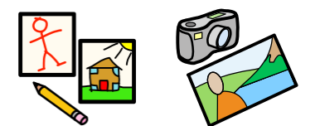
Add a picture, drawing, or photo here if you would like.



4. My aspirations and next steps

This year, I want to get better at: 

When I grow up, I would like to be: 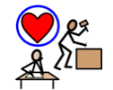

4. My aspirations and next steps

What sort of work would you like to do? 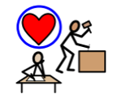
(It’s ok to say you are not sure)

What skills or training would you need?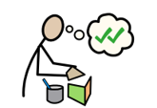

My Independence: I am working towards independence, by:
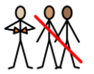
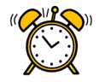 | 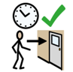 | 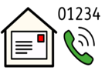 |  | 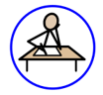 | 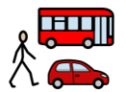 | 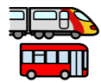
Learning how to use / set an alarm clock  ☐ | Getting to my lessons on time, independently  ☐ | Knowing my telephone number and address  ☐ | Recognising when I need help, and being able to ask for it, appropriately  ☐ | Completing homework tasks and handing them in on time, without reminders  ☐ | Travelling to and from school, independently  ☐ | Learning to use public transport, with support  ☐

My Independence: I am working towards independence, by:
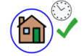 | 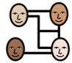 | 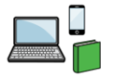 | 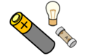 | 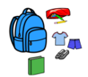
Returning home by an agreed set time  ☐ | Making plans with friends, and carrying them out, independently  ☐ | Taking responsibility for my own equipment  (e.g., laptop, phone, school equipment, books, etc.)  ☐ | Taking responsibility for household jobs  (e.g., changing batteries or light bulbs, tidying my bedroom)  ☐ | Having my equipment ready for school, without reminders  (e.g., PE kit, ingredients for cooking, etc)  ☐

My Community: Outside of my school, or setting, I enjoy:
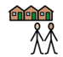
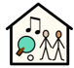 | 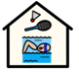 | 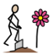 |  |  | 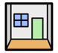 | 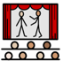
Youth Club  ☐ | Sports Club  ☐ | Community Projects  ☐ | Playing Football  ☐ | Playing Video Games  ☐ | Escape Rooms  ☐ | Theatre  ☐

Do you know how to find out about things to do, within the community? |  |  |  | Would you like help to take part in activities, within the community?
Yes ☐ No ☐ |  |  |  | Yes ☐ No ☐
My Community: Outside of my school, or setting, I enjoy:
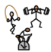 | 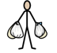 | 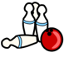 | 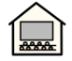 |  | 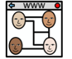 | 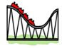 | 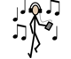
The Gym  ☐ | Shopping  ☐ | Bowling  ☐ | Cinema  ☐ |  | Social Media  ☐ | Theme Parks  ☐ | Listening to Music  ☐

Tap or click here and type any comments

My Quality of Life: I feel good when:

 | 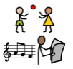 | 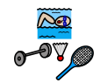 | 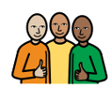 | 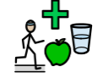 | 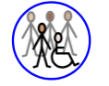
I have a comfortable and safe place to live  ☐ | I have daily activities which I enjoy  ☐ | I am involved in a community  ☐ | I have a trusted support network  ☐ | I have a healthy lifestyle  ☐ | I have a social life I feel happy with  ☐

Tap or click here and type any comments

My Voice: How I communicate best:
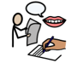
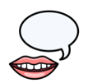 | 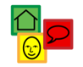 | 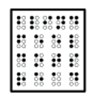 | 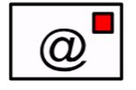 | 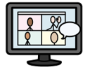 | 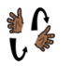
Talking  ☐ | Using Symbols  ☐ | Braille  ☐ | Email  ☐ | Virtual Platform  ☐ | Signing  ☐

Tap or click here and type any comments

My Voice: How I communicate best:
Who listens to me, at home?  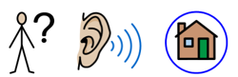 | Tap or click here and type any comments
Who listens to me, at my school, or in my setting?  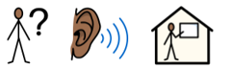 | Tap or click here and type any comments

My Support: Adults can help me, by giving me:
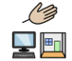
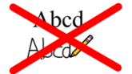 |  |  | 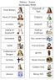
Minimising tasks which require copying form the board, providing copies of PowerPoints or resources to highlight/ annotate where possible  ☐ | Providing me with preparation for change (e.g. a supply teacher or room change)  ☐ | Providing alternative methods of recording  ☐ | Providing me with subject specific, visual word vocabulary banks  ☐

My Support: Adults can help me, by giving me:
 | 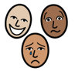 | 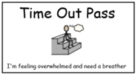 | 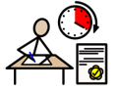
Reading my communication passport  ☐ | Providing regular emotional check-ins with a key adult, to resolve issues and monitor my wellbeing  ☐ | Providing me with an exit card and safe space to access, if I am feeling anxious or overwhelmed  ☐ | Providing me with exam access arrangements  ☐

Tap or click here and type any comments

My Learning: The best way for me to learn, is:
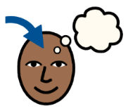
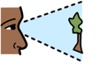 | 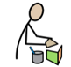 | 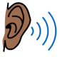 | 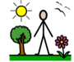 | 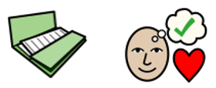 |  | 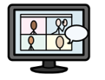
Visual  ☐ | Kinaesthetic  (practical, hands-on)  ☐ | Auditory  ☐ | Outdoor  ☐ | Project based  ☐ | Watching Videos  ☐ | Online learning platforms  ☐

Tap or click here and type any comments

My Health: To keep myself healthy, I:
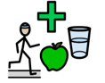
 | 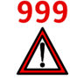 | 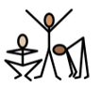 | 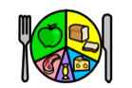 |  | 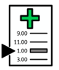
Keep my screen-time within healthy limits  ☐ | Know how to call 999/111 to look after myself, or someone else  ☐ | Stay physically active  ☐ | Try to eat a variety of foods  ☐ | Take prescribed medication according to the prescription  ☐ | Attend health appointments, such as GP, dentist, and opticians  ☐

My Health: To keep myself healthy, I:
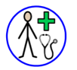 | 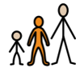 | 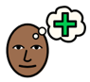 | 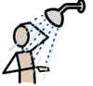
Know when I need to see a GP, and know what the GP can help me with  ☐ | Understand what puberty is, and the changes to male and female bodies  ☐ | Know how to access support for mental  health and wellbeing  ☐ | Manage my personal hygiene (wash daily, wear deodorant, brush teeth, etc.)  ☐

Tap or click here and type any comments

My Safety: Adults can teach me to keep safe, by helping me to:
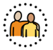
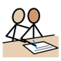 |  | 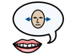 | 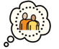 | 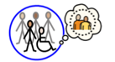 | 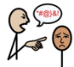 | 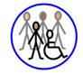
Supporting me to engage with services which support me (e.g., Therapies, Social Worker, etc)  ☐ | Teaching me the differences between healthy and unhealthy relationships  ☐ | Enabling me to understand my rights, and have confidence to say no to things I don’t feel comfortable with  ☐ | Ensuring that I have a trusted adult I can talk to about things which worry me  (parents, carers, setting staff)  ☐ | Teaching me how to stay safe out in the community  ☐ | Teaching me what to do if I think I am being bullied  ☐ | Enabling me to have a social life I feel happy with, so I don’t feel isolated  ☐

I have been included in my Annual Review meeting:

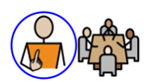

Please select Not Applicable if their Annual Review meeting has not been held yet meeting (the Annual Review meeting is held within a year after the EHCP of its first issue or from the date of the last Review).

Not Applicable  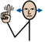 | Yes   | No  
☐ | ☐ | ☐

