

**Schools Financial Services**

*It all adds up to a great service, flexibility and peace of mind*



**Schools Financial Services**

**Academy Funding Template 2017/18 – Input Guidance**

**Academy Funding Template 2017/18 - Input Guidance**

Contents

‘Contents’ Tab 3

‘Home Tab 3

‘Early Years’ Tab 4

Early Years Funding 4

Early Years Pupil Premium (EYPP) 5

‘High Needs Mainstream’ Tab 6

‘Specialist Resourced Provision’ Tab 7

‘Growth Funding’ Tab 8

‘SRP Rates’ Tab 9

**IMPORTANT INFORMATION**

The purpose of this document is to provide guidance to Academies in Kent when filling out the Kelsi Academy Funding Template 2017/18. *This template gives details of funding allocations that are the* ***responsibility of the Local Authority******(LA) to fund directly****.*

This funding relates to a budget allocation for the financial year April 2017 to March 2018. An academy’s financial year runs for the period September to August. Please read the Contents information to check with period each of the tabs relates to.

Estimates have been included on individual tabs where it has been reasonable to do so.

**Academy Funding Template 2017/18 - Input Guidance**

At the bottom of the spreadsheet there are a number of tabs.



# ‘Contents’ Tab

This tab is for information only and provides details about the purpose of each of the other tabs within the template and hyperlinks to them.

# ‘Home Tab

On the ‘Home Tab select the Academy DfE number in cell F11 at the top of the sheet. The number can either be typed in directly or selected using the drop-down menu.



# ‘**Early Years’ Tab**

## Early Years Funding

This tab provides an Early Years Budget Estimation for 2017/18.

If the school has Early Years Funding (Nursery), the calculation of the school’s hourly rate will be shown near the top of the sheet, made up of a base rate, a Qualified Teacher Supplement and a Disadvantage Supplement.

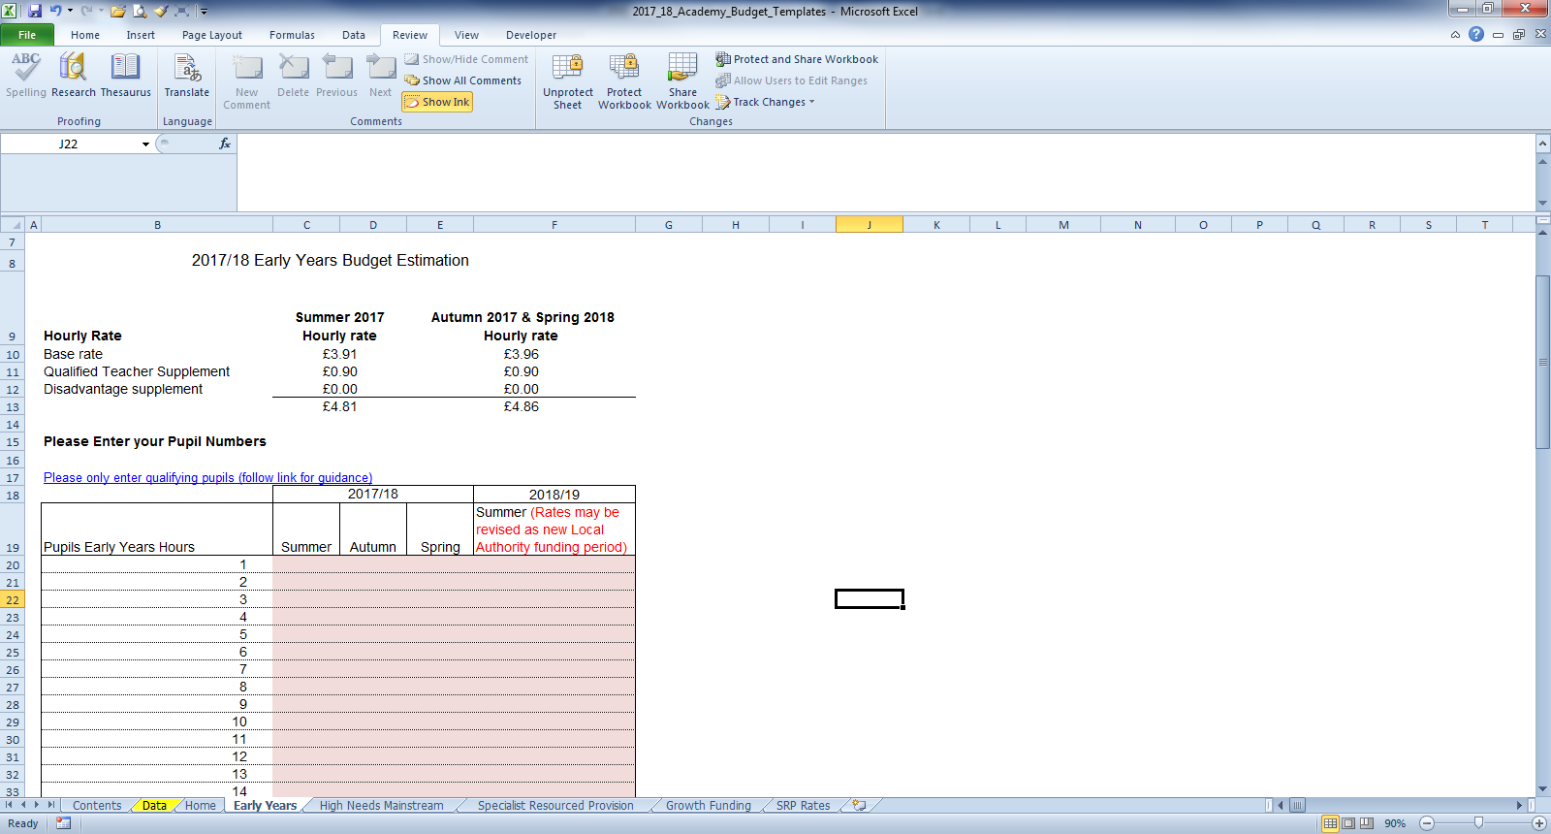

Enter Early Years pupil numbers in the pink-shaded cells in the table below by putting the number of pupils against the number of Early Years Hours that they attend school for each term.

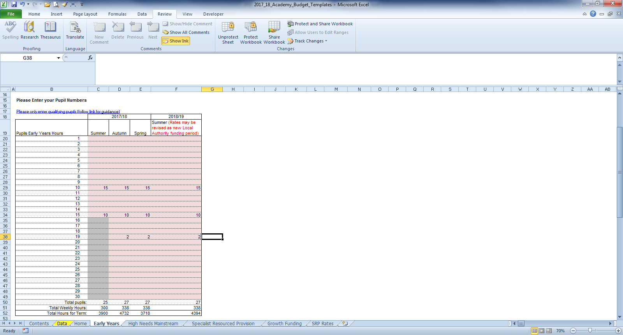

Follow the link in row 17 for guidance on determining eligibility for Free Early Education for 3 to 4 year olds and what constitutes a qualifying pupil.

Below this section, a summary table will provide a Total 2017/18 Financial Year Estimated Budget figure in cell F59 and the Total 2017/18 Academic Year Estimated Budget figure in cell F61.

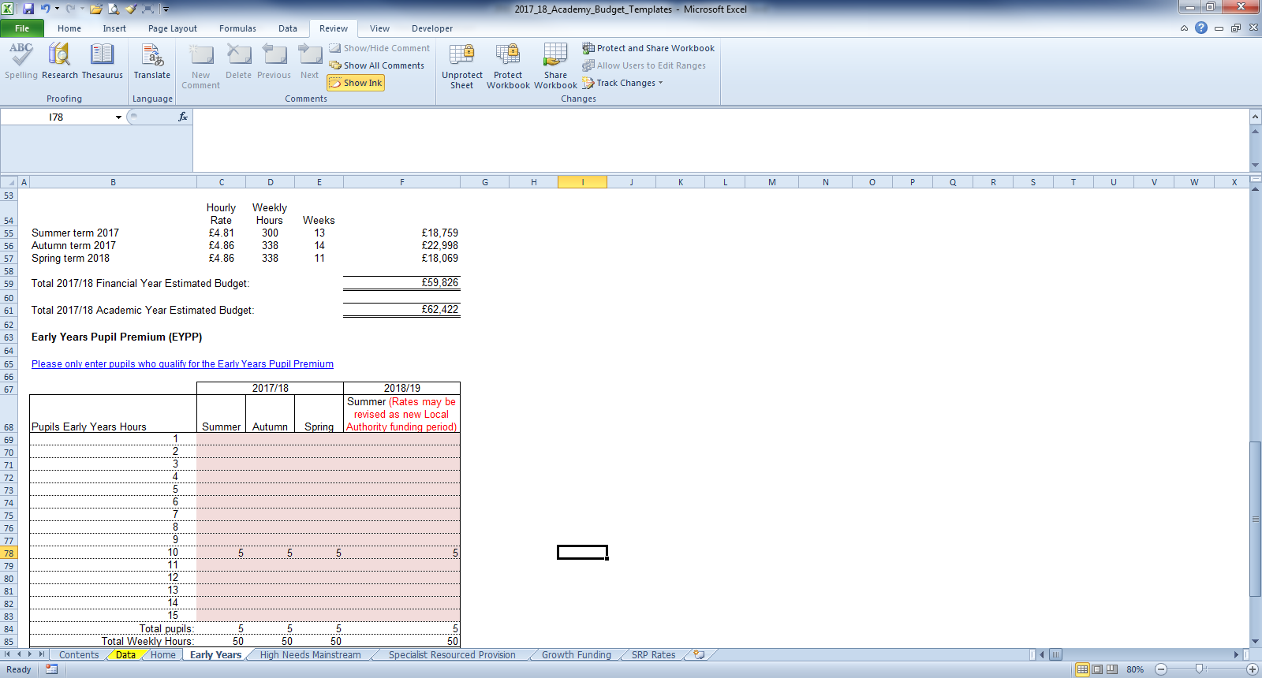

## 

## Early Years Pupil Premium (EYPP)

Lower down the sheet there is a similar table to fill out for EYPP, and a link to relevant guidance on row 65.

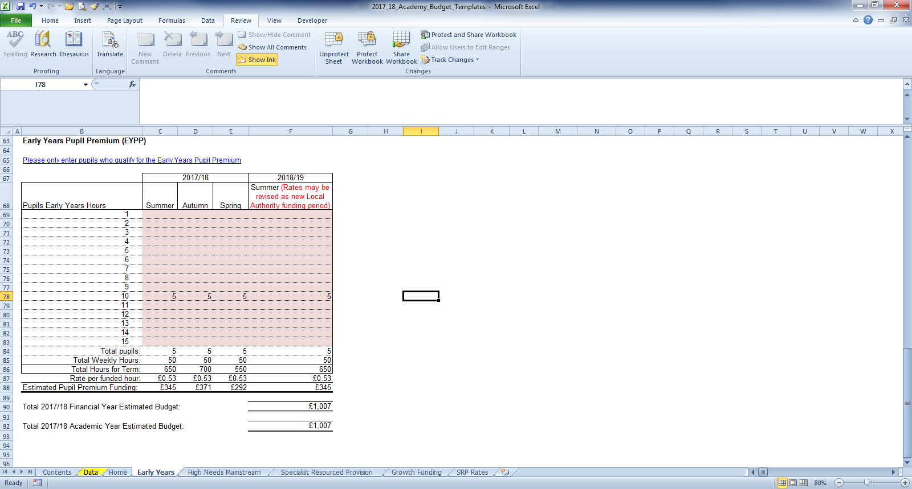

Fill the table out by entering the number of pupils against their weekly hours for each term. A Total 2017/18 Financial Year Estimated Budget figure in cell F90 and the Total 2017/18 Academic Year Estimated Budget figure in cell F92.

# ‘High Needs Mainstream’ Tab

In order to calculate an estimate of Funding for Year One, Academies with High Needs Mainstream pupils will need to enter pupil data on this tab.

When entering data on this tab it may be useful to refer to [this](https://shareweb.kent.gov.uk/Documents/KELSI/Finance/High%20Needs%20Consultation%20vfinal.pdf) consultation document.

The tables to the right of the pupil data will then populate with any Element 3 top up funding, Notional SEN budget top up funding & Post 16 Element 2 funding.

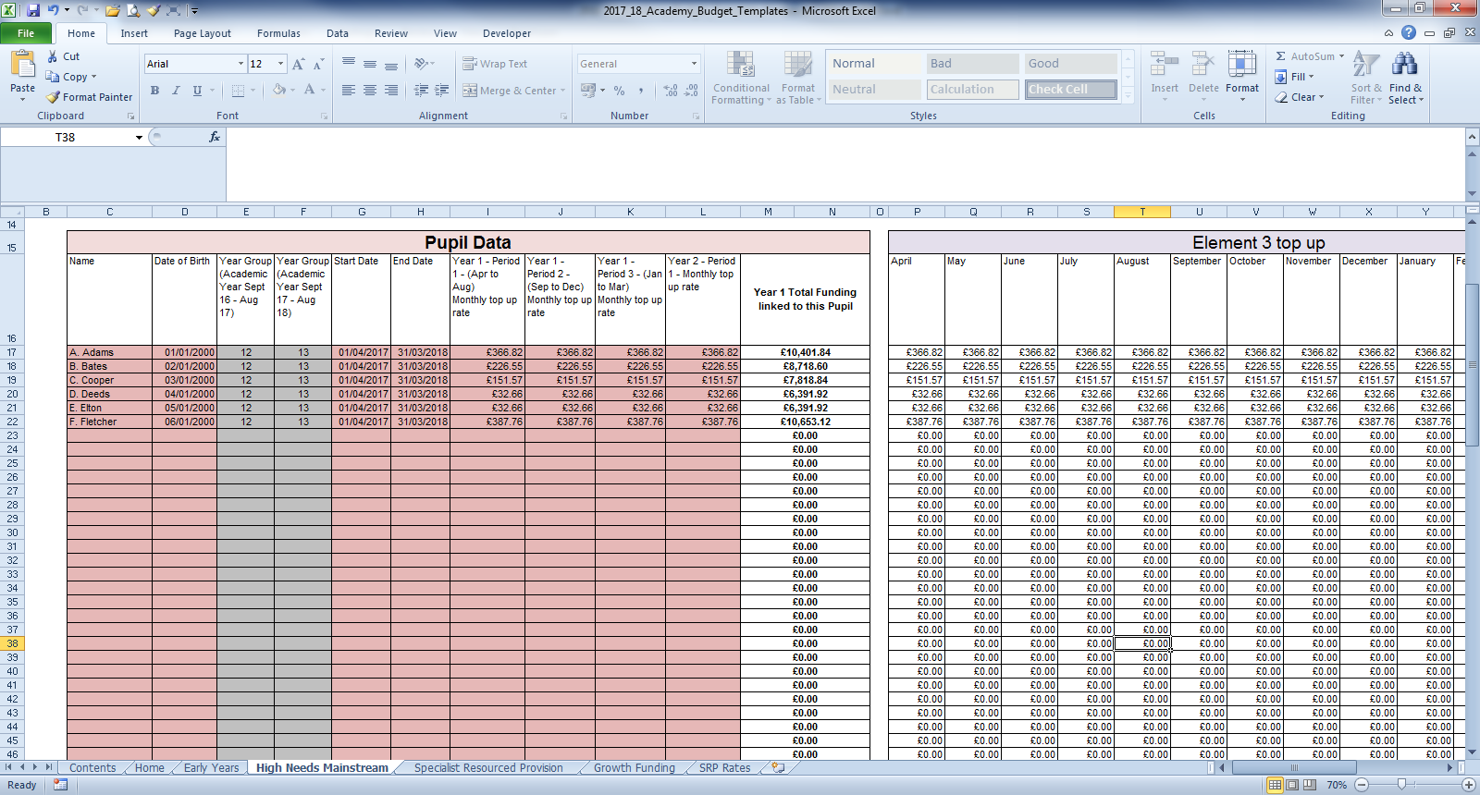

1) Enter the pupil names in Column C and dates of birth in Column D.

**N.B. Date of Birth MUST be entered for the funding to be calculated correctly.** When estimating future years budgets when a DOB may not be known use a fictitious date but ensure that it accurately reflects whether the pupil is Pre or Post 16

2) Input the placement Start date – this should not precede the 1st of September. The appropriate funding end date should be input being mindful that funding is reassessed annually.

3) In the columns for Year 1 Period 1, 2 and 3,( I,J and K) and the column for Year 2* Period 1,(L) enter the monthly top up rates. Monthly top up rates appear in the confirmation letters received by SENCOs, sent out by the SEN resources team.

*Note - Year 2 financial year is required to calculate the estimated funding for the Academy academic year

This estimated calculated funding is broken down in the tables to the right, between Element 3 top up and Notional SEN budget top up and Post 16 Element 2, with total in cells AB83, AP85, BD83 and BW85 respectively.

At the top of the sheet, above the Element 3 top up table, the workings for the Notional SEN budget top up rate are shown.

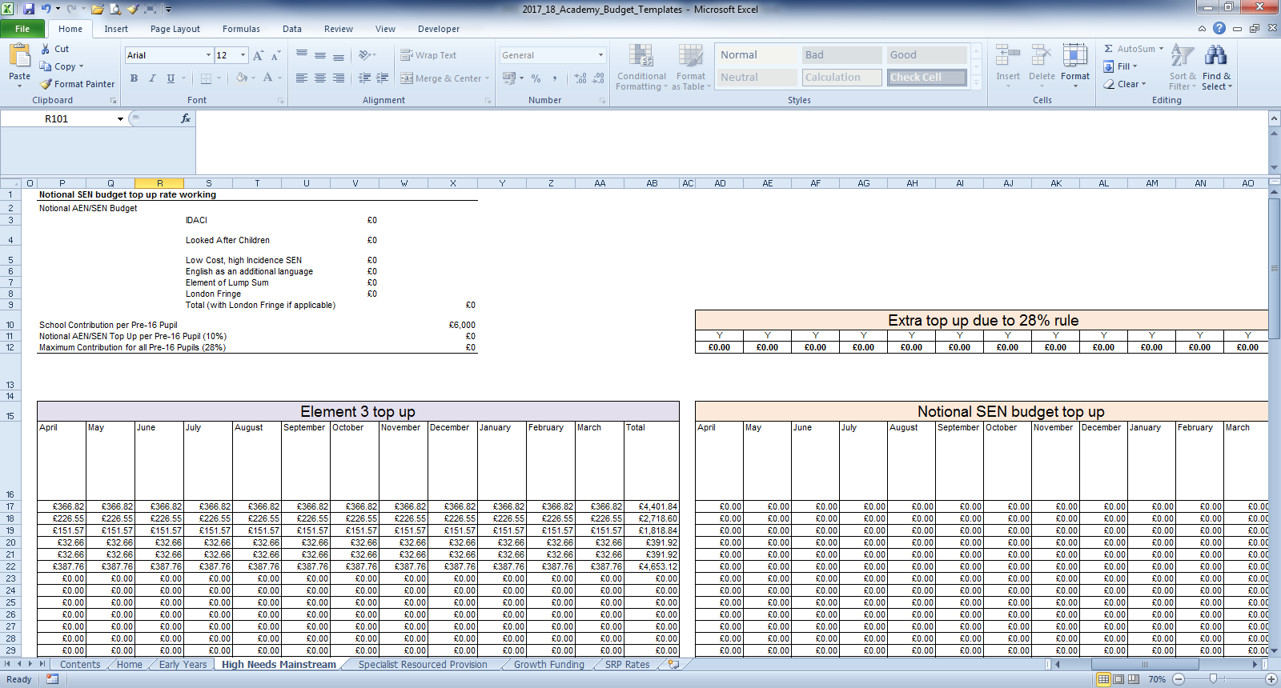

To the right of the Notional SEN budget top up table, there is another table that shows any Extra top up due to the 28% rule

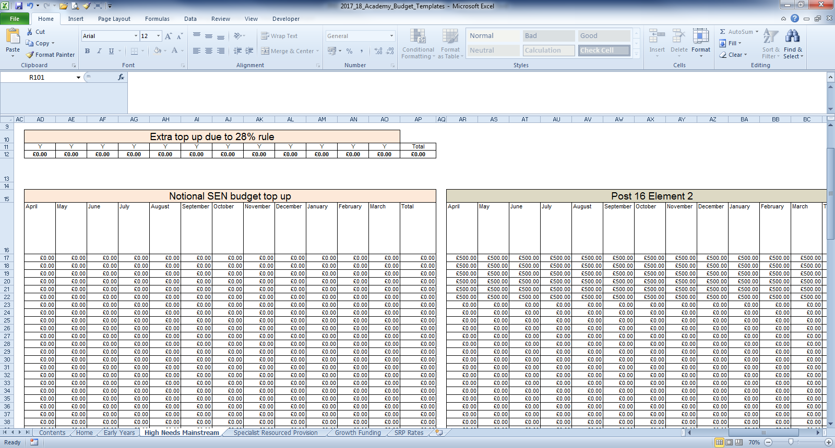

# ‘Specialist Resourced Provision’ Tab

Funding on this tab is only calculated for the Financial Year (1/4 – 31/3) – refer to contents tab. Funding is paid one month in arrears (lagged) ie

A pupil above commissioned place numbers starts in September. The excess commission funding for the month of September and the excess top up will be paid in October. By typing the actual start and end dates into this template it will demonstrate when funding shall be received NOT the month it relates to, therefore a start date of September will only demonstrate funding for 6 months of the year on this spreadsheet. This can be used to calculate an estimate of the full year.

Academies with Specially Resourced Provisions (SRPs) will need to enter data for those pupils in the pink–shaded cells in the Element 3 input table on this tab.

1) In column I, the drop down menu can be used to select the correct designation for each pupil (only 3 academies have two SRPs so the majority will use ‘designation 1’).

2) In column J the pupil Surname is entered, Forename in column K and Date of Birth (D.O.B) in column L.

3) Columns M and N will then use the DOB figure to auto-populate with a Pre or Post 16 indicator for the summer and winter terms.

4) Placement start and end dates (column O and P) should be entered. The table will then calculate any Place Plus funding for High Needs Pupils in the Resourced Provision for the period entered, bearing in mind the lagged funding explained above.

1) Pre-16 Excess pupil numbers appear in column C, with the funding in Column D.

2) Post-16 Excess pupil numbers are shown in Column E, with the associated funding in column F.

3) Total monthly funding then appears in Column G, with an total in cell G61.

# ‘Growth Funding’ Tab

The Growth Funding Estimator on this tab calculates Rising Roll Funding.

1) In cell E24 enter the number of pupils in Year R on the October 2016 census.

3) A total figure for the year will appear in cell E28.

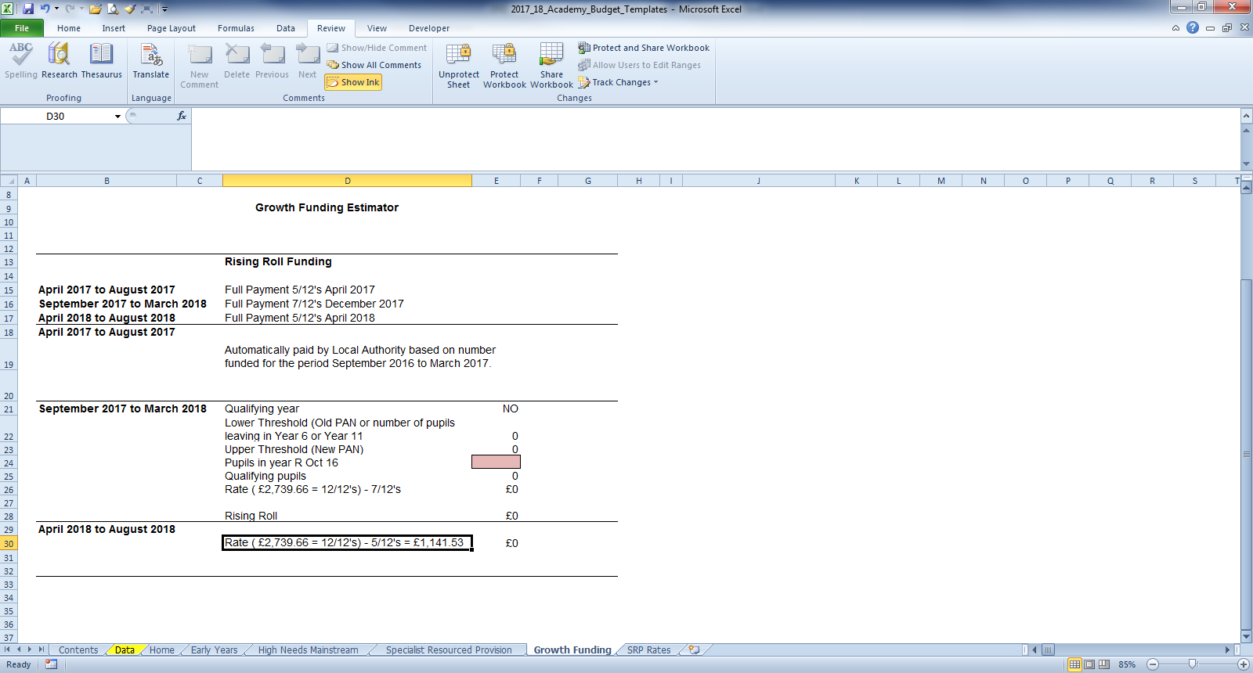

# ‘SRP Rates’ Tab

This tab is for information only and explains how SRP rates have been calculated for each of the eligible schools. No data needs to be entered onto this sheet.