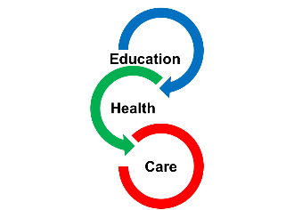

Voice of Child and Family for Education, Health and Care Plan needs assessment

Name of child/young person

Picture/Drawing or photo (optional)

Personal Details of child/young person
Last Name: |  | First name
Preferred Name |  | DOB
Gender: |  | Religion:
Language used at Home (Is an interpreter needed?) |  | Preferred way of communicating (e.g. signing)
Child Looked After? | Yes/No | If yes, to which Local Authority
Address
Current School or setting |  | National Curriculum Year |  | Unique Pupil Reference (UPN):
Parent/Carer 1
Parent/Carer contact details | Phone: | Email:
Address (if different from above)
Parent/Carer 2
Parent/Carer contact details | Phone: | Email:
Address (if different from above)
GP Name and Contact details |  | Child/Young Person’s NHS number

Section A
The Views, interests and aspirations of the child and their parents or of the young person

My aspirations for the future (what do I want to do in the future?)

What really matters to me?

What am I good at? - My Strengths and Skills:

How best to communicate with me:

How best to support me:

How I like to learn:

History about my Education, Health and Care:

This information was provided by: -

Background information and the family’s views

Our views about what is working well. What needs to stay the same and what needs to change.

Our hopes for our child/young person and in the future.

