A Parent/Carer Guide to High Needs Funding |  |  | Easy Read
 |  | High Needs Funding is money that schools can apply for to help them to support your child.
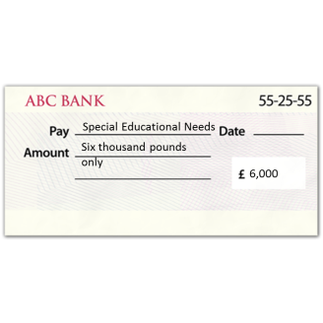 |  | Schools are expected to spend up to £6,000 on each pupil with special educational needs each year.
If the school needs more than this the Kent County Council is required to top this up.

This is called High Needs Funding

 |  | This is for children in mainstream schools and sixth form (including free schools and academies).
 |  | It is for children with a high level of special education needs.
 |  | The school will work with you and your child to put the right educational support in place.
 |  | To do this the school needs to apply for High Needs Funding.
 |  | To apply the school will need your written consent
 |  | If the funding is agreed you will be told by the school.
The funding is agreed for up to three years.

The support your child needs will be reviewed three times during the school year.

 |  | Schools can ask Kent County Council for more funding after seeing whether the help is working.
 |  | There is a different system for Further Education Colleges and Post-16 alternative registered educational providers.

