

**INCLUSION SUPPORT SERVICE KENT**

Accredited trainers

for Stonewall

**Equipping staff to tackle**

**homophobic, biphobic and**

**transphobic bullying in primary schools**

Stonewall

**Train the**

**Trainer**

**For primary schools**

**THURSDAY 19TH NOVEMBER**

**9.30 to 4.30**

Tudor Park Hotel, Bearsted Road, Maidstone, Kent ME14 4NQ

£150 + VAT

Discount: £120 + VAT

for faith schools, rural schools, schools with 40% + of FSM, schools with 50% + Minority Ethnic

+

Ongoing support though Stonewall’s School Champion programme

+

Resources

Lunch Provided

**FEEDBACK**

**90% felt more confident tackling HBT bullying and would recommend Train the Trainer to others.**

**“Without a doubt the most**

**helpful training I have attended in 17 years of teaching!”**

**“One of the best and most**

**informative training courses I've ever been to – well worth it!**

**Inspired!”**

*Feedback from Train the Trainer courses in 2014-15*

Homophobic, biphobic and transphobic (HBT) bullying is widespread in primary schools. **Almost half** of primary school teachers say pupils in their school experience homophobic bullying and **seven in ten** hear homophobic language – phrases like ‘that’s so gay’ – from pupils. **Nine in ten** teachers say they want to tackle the problem, but lack the training or support to do so.

*Statistics from ‘The Teachers’ Report (2014)’*

Stonewall’s **Train the Trainer courses** give Inclusion, Pastoral, Anti-bullying and PSHE leads the knowledge, tools and confidence to train colleagues on tackling HBT bullying and celebrating difference, as well as meeting the requirement of the new Ofsted inspection framework. Participating schools become members of Stonewall’s **School Champions programme.**

**Homophobic, biphobic and transphobic bullying is widespread in Britain’s primary schools, affecting hundreds of thousands of young people each year.**

**Research conducted by the University of Cambridge highlights the detrimental**

**impact this has on attendance, attainment and mental health and wellbeing.**

**Course objectives:**

* Learn practical strategies to train staff in your school on tackling homophobic, biphobic and transphobic (HBT) bullying and language (including phrases like ‘that’s so gay’) and celebrating difference in an age-appropriate way.
* Gain an overview of the current state of HBT bullying and its impact on pupil achievement and school performance.
* Help you meet legal and Ofsted requirements under the new inspection framework and on promoting British values.
* Create an action plan for your school.
* Be inspired by best practice from other schools.

**Participating schools receive Stonewall School Champions membership for a year, with a range of benefits including:**

* An extensive pack of Stonewall’s acclaimed Different Families resources for primary schools, including posters, curriculum guides, DVDs and learning activities for pupils and staff.
* Ongoing support, guidance and benchmarking from a dedicated point of contact at Stonewall, as well as help implementing your action plan.
* Free access to best-practice twilight seminars on issues from E-Safety to SEN.
* Exclusive use of the School Champions logo and the opportunity to apply for Stonewall’s Bronze, Silver and Gold School Champions Awards.

**Inclusion Support Service Kent can offer further support to schools, including:**

* Support with an inclusive curriculum and resources.
* Advice on supporting LGBT, minority ethnic, EAL and GRT pupils within your schools.
* Training and development to meet the Ofsted requirements in regard to equality, including British Values, SMSC and Prevent.
* Signposting to support agencies and advice for individual pupils and their families.

**To book a place, please contact**: [Kent CPD Online -](https://www.kentcpdonline.org.uk/cpd/default.asp?sid=) Schools training courses

**For more information contact:**

Gillie Heath, ISSK Manager [gillie.heath@kent.gov.uk](mailto:gillie.heath@kent.gov.uk) 03000 417093

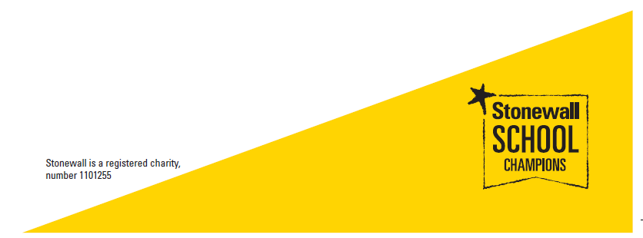

Amanda Maloney, ISSK Business Support [amanda.maloney@kent.gov.uk](mailto:amanda.maloney@kent.gov.uk)

03000 417320