Statutory Assessment Process

Guidance on writing
Appendices 1 and 1a

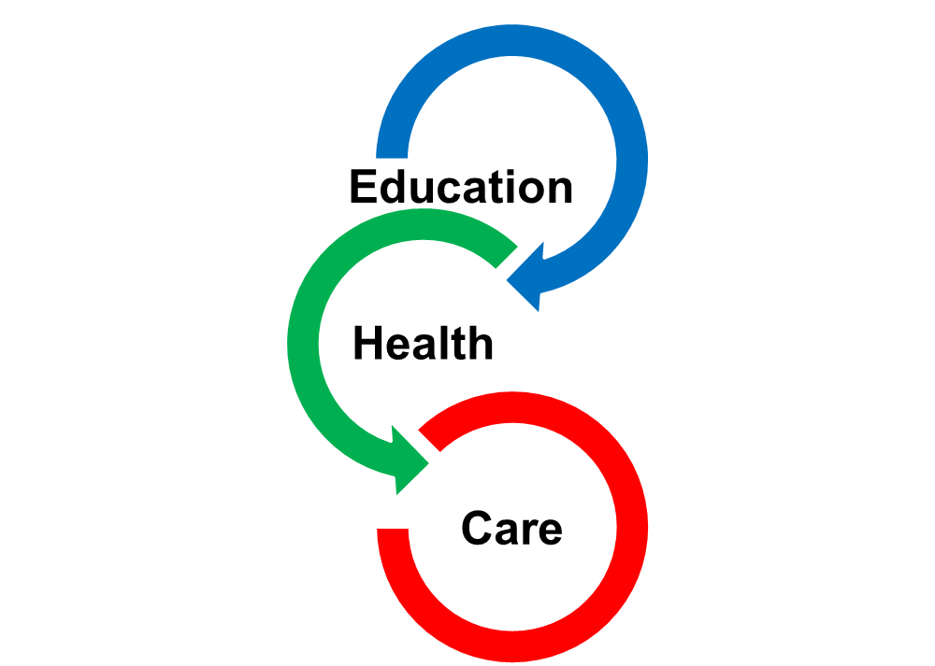

Please provide all the information asked for to the best of your ability. Your SEN officer can help you with any queries that you may have.
Section 1.
When telling us about you/your child and your/their needs please include some of your/their ‘story’. This is the only time you will be asked to write this down as part of the Statutory Assessment process so please make sure you include everything that is important for other professionals to know about you/your child.
Section 2 and 3.
Please tell us about the things that you/your child are/is good at and enjoy doing. Also tell us about the things that are harder for you/your child than for other children/young people of a similar age and about those that you/your child need help to do.
Section 4.
Please tell us here about what you hope for the future. Some will have a very clear idea about what they want to do in the future – be a nurse or a crane driver - others will have less of an idea and may say they want to live and work independently. This section is for hopes and dreams; nobody will expect you/your child to always feel the same and people’s dreams and hopes for the future will often change as they grow older.
Section 5.
Every educational setting has a legal obligation to use their best endeavours to meet the needs of children and young people with SEND. This means taking ‘relevant and purposeful’ action to support you or your child. It is important that you are aware of the provision in place to support you or your child. The LA will need to see the evidence from the educational setting about the individualised and personalised provision they have put in place for you or your child.
Section 9.14 of the SEND Code of Practice makes clear that
“In considering whether an EHC needs assessment is necessary, the local authority should consider whether there is evidence that despite the early years provider, school or post-16 institution having taken relevant and purposeful action to identify, assess and meet the special educational needs of the child or young person, the child or young person has not made expected progress”.
Where there is no evidence of purposeful and relevant action, a SA will not be necessary; however, the LA will ask the educational setting to put appropriate provision in place for your child to enable them to make progress towards achieving their agreed outcomes.

Section 6.
We can learn a lot about you/your child from understanding what you/they enjoy at pre-school, school or college. This information will help to determine what types of support might work best.
Section 7 and 8.
Please tell us about how well you think you/your child is doing at nursery/school/college. Please tell us any information you feel has not been covered in the comments boxes.
Section 9.
This section is where you tell us about the Outcomes we all agree you/your child will work towards over the next few years. Outcomes are very important. They are a step along the way to what you hope and dream for your/your child’s future. They usually cover a phase or stage of education. They should be something that is important to you/your child and they should be written so that everyone that needs to can understand them. For instance, for a child who wants to be able to work in the future, they may need to be able to travel on a bus. An Outcome would be –
- by the end of secondary school I will be able to travel on the bus on my own so that I can go shopping with my friends
For someone who wants to be a nurse they will need to be able to communicate well with strangers so an Outcome might be –
- by the time I leave Primary school I will be able to share my ideas with my friends so that I can work as part of a team in class.
We would suggest you try not to have more than 3 or 4 Outcomes to ensure they ae achievable. Outcomes will be reviewed at each in-year meeting and at Annual Review when agreed changes can be made.
Section 10 and 11.
Barriers to achieving these Outcomes need to be removed wherever possible so it is important that you tell us what these barriers are and share your ideas and experience with us about how these can be overcome.
The questions in the Social Care and Health sections are fairly clear. Please make sure that you share your full medical information with us, in particular, you need to tell us if you are currently awaiting a diagnosis of something, for instance, ASD.
Section 12.
Please inform us of anything that has had an impact on you/your child. This might include things like several house moves in a short period of time or the death of a close relative.

