Change from Kent Scheme Pay scales to Kent Range
1st June 2011

Introduction:
Following the abolition of the School Support Staff Negotiating Body and discussion with the Trade Unions the current Kent Scheme Salaries for Schools is to be brought into line with the rest of KCC. Therefore, with effect from 1st June 2011 the Kent Scheme will change from an incremental pay scale to one with minimum and maximum points within each grade (KR2 to KR15). Progression through the grade will be by a percentage increase based on performance.

New starters should normally be placed on the minimum point of the Kent Range for the relevant grade but from 1 June 2011 it will possible to award those with relevant previous experience anywhere within the grade providing that there is a business case to support this. This would also apply to anyone who is promoted or re-graded but you must ensure that that they receive a minimum pay rise of 2.5%.

People starting between April and October 2011 will be eligible for a TCP (Total Contribution Pay) Assessment in April 2012. Anyone starting on or after 2nd October 2011 will not receive a TCP assessment rating until April 2013 but they should still be part of the TCP processes and have their targets set and monitored.

Transition:
Undertake the TCP review and apply to the TCP rating for 1st April 2011 to the Kent Scheme Pay scales as published in the Kent Scheme Newsletter (for Schools) dated April 2010. This will give you a cash value on the old Kent Scheme salary scale. This should then be translated to a cash value in the new Range for that grade with effect from 1June 2011.

For example someone is paid on point 15 within Kent Scheme Grade 5 (KS5) for the year 2009/2010 the current value is £17,140.

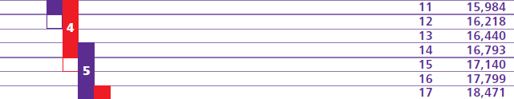
They receive a “Good” TCP rating and so for April 2011 they would move to point 16 in KS5, current value £17,799.
NB: for schools using SIMS.Net Personnel:
Apply any incremental progression from 1.4.11 on the Kent Scheme Service Term in the usual way. Then you will need to end the current contract on 31 May 2011 and set up the new contract with the Kent Range Service Term and pay scale from 1 June 2011.
If you buy a service from EiS you will find more detailed information in their Information Notice.
From June 2011 they would move to the cash value of £17,799, which is within Grade KR5.
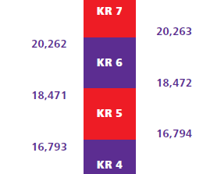

£17,799

In subsequent years, depending on the level of TCP rating, the individual would progress up Grade KR5 based on the percentage increase of the TCP rating. When they reach the top of the Grade they would receive a one off lump sum payment equivalent to the percentage increase.

Total Contribution Pay (TCP) ratings are also changing with effect from 1st April 2011 but they will not be applied to staff until April 2012. They move from 5 ratings to 4.

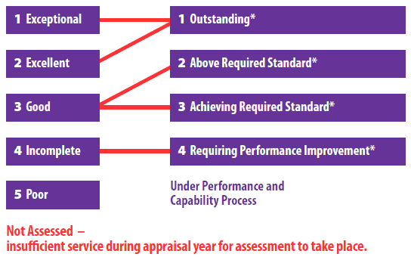
*New Contribution Levels

More information about the changes to the TCP process can be found in the TCP Guidebook and the Contribution Levels note on Kent Trust Web.

Communication:
Please ensure that all staff within the school that are paid on Kent Scheme Terms and Conditions are made aware of this change to their terms and conditions of employment.

It is important that individuals affected by this collective agreement are given information about this change and we advise you to give them a copy of the 2011 Kent Scheme Newsletter once it has been published. A copy of this will be published in a future E-Bulletin and some hard copies will be sent to all schools.

Please note that Voluntary Controlled and Community schools must implement these changes. KCC would encourage Voluntary Aided and Foundation Schools to also adopt these new terms and conditions.

If VA & F schools do not adopt the changes the school would need to establish the current Kent Scheme provisions (i.e. pre 1 June 2011) as the terms and conditions you will continue to apply and to rename these as the “Name of School* Terms and Conditions to avoid any confusion. These terms and conditions would then need to be maintained by the school and any further changes, including future pay awards, would need to be determined by the school through your own local consultation and bargaining mechanisms. Maintenance of an incremental pay scale will be the responsibility of the school and notification will be required to your personnel and payroll provider, on an ongoing basis, of any changes made to your terms and conditions of employment.

Please remember to inform your payroll provider of these changes.

