

Communities of Schools
Operational Guidance

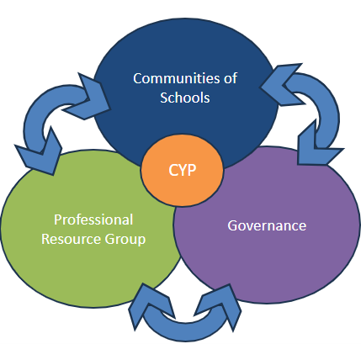

September 2026
Version 1.0
Table of Contents
Introduction 4
i. Operational Summary 6
ii. Guide to Using the Full Document 9
1. About this Guidance 10
Section 1 Mandatory Operational Standards 10
1.1 Purpose of the Guidance 10
1.2 How to use this Guidance 10
1.3 Scope and Applicability 11
1.4 Intended Outcomes 11
2. Strategic, Policy and Legislative Context 12
Section 2 Mandatory Operational Standards 12
2.1 Kent’s Countywide Approach to Inclusive Education (CATIE) 12
2.2 The Locality Model for School Inclusion 12
2.3 Local Area Partnership Accountability 14
2.4 National Policy and Statutory Duties 14
3. Financial Context 15
3.1 High Needs Funding Block (HNFB) National Guidance 15
3.2 HNF in Kent 17
3.3 Notional SEN Budget 18
3.4 The Inclusive Mainstream Fund 19
4. Governance Framework 22
Section 4 Mandatory Operational Standards 22
5. Roles and Responsibilities 27
Section 5 Mandatory Operational Standards 27
6. CoS Operational Process and Procedures 32
Section 6 Mandatory Operational Standards 32
6.1 What Starts the CoS Process 32
6.2 Preparation and Pre-Meeting 33
6.3 CoS Meeting and Decision-Making 37
6.4 Recording, Submission and Payment 38
6.5 Implementation and Impact Review 38
6.6 Timescales 39
6.7 Funding Amendments 39
6.8 Exceptions 39
7. Standards, Equity and Escalation 42
Section 7 Mandatory Operational Standards 42
7.1 Principles and Core Standards for Practice 42
7.2 Decision-Making and Funding Standards 43
7.3 Equity, Equality, and Inclusion 44
7.4 Reasonable Adjustments and Accessibility 44
7.5 Escalation, Intervention and Accountability 44
8. Communication 46
Section 8 Mandatory Operational Standards 46
8.1 Stakeholders – Who Needs to Be Informed? 46
8.2 Methods and Timing of Communications 47
8.3 Professional Standards in Correspondence and Conduct 47
8.4 Expectations for Written Communication (including digital) 48
8.5 Expectations for Verbal Communication (including digital) 48
8.6 Review and Continuous Improvement 49
9. Monitoring, Assurance, Data Management and Review 50
Section 9 Mandatory Operational Standards 50
9.1 Monitoring and Assurance Context 50
9.2 What Is Monitored 50
9.3 Sources of Evidence and Data 51
9.4 Quality Assurance and Moderation Framework 51
9.5 Assurance Cycle and Frequency 53
9.6 Records, Information Governance and Data Protection 53
9.7 Review, Learning and Continuous Improvement 54
9.8 Accountability and Intervention 54
10. Related Documents, Links and Key Contacts 56
Section 10 Mandatory Operational Standards 56
10.1 Statutory and National Guidance 56
10.2 Local Forms, Guides and Resource 57
10.3 Key Contacts for Advice and Support 57
10.4 Version Control and Currency 57

Introduction
Kent Communities of Schools (CoS) were established in September 2025 following engagement spanning four years, between Kent County Council (KCC), school leaders and wider stakeholders, including a public consultation on the development of inclusive practice within mainstream schools across Kent.

The Countywide Approach To Inclusive Education 2023 – 2028 (CATIE) sets out a commitment to a school-led approach to inclusion, strengthened through inclusive leadership, peer moderation, collaborative working and the sharing of effective practice. CoS provides the operational framework through which these commitments are delivered at community level.

The model has been developed in partnership with the sector and is founded on the principle that school leaders are well placed, and bound by their own professional standards, to make informed decisions about the needs of children and young people within their local communities. CoS supports collaborative decision-making, peer support, constructive challenge and shared responsibility for improving outcomes for children and young people across Kent.

The agreed principles of the school-led system were endorsed by the sector in April 2023 and underpin all aspects of community working, decision-making and governance within the CoS model.

CoS are expected to operate in accordance with the following principles:
- Commitment to meeting needs in the area and achieving best possible pupil outcomes
- Prioritising the greatest need (over individual school advocacy)
- Willingness to support and challenge (and be supported/challenged)
- Recognising impact of contextual factors not only levels of pupil need
- Active participation, even when you don’t have immediate need for support
- Effective use of all available budgets (delegated, devolved, community)
- Commitment to reducing reliance on additional resources wherever possible (so that these can be reallocated)
- Recognition of the need to respond to contingencies as they arise (and ensuring capacity available for this)
- Willingness to share good practice with and learn from other communities
- Commitment to equity and positive outcomes across the area and county as a whole

To support consistent implementation of the model, CoS participate in ongoing monitoring, moderation and review activity. This activity supports consistency of practice, informs continuous improvement and contributes to the effective use of available resources.

As part of its role in facilitating the SEND Reform Plan, KCC supports this approach through:
- School-led moderation processes that promote consistency, peer support, challenge and continuous improvement

- Support the national agenda for the strategic leadership role of SENCos within schools and trusts
- Provision of data and information to support local and countywide decision-making, strategic planning and evaluation of impact
- Opportunities for collaborative responses to shared local challenges, informed by evidence and professional consensus

i. Operational Summary
Communities of Schools (CoS) – What Kent Schools Need to Know
This summary provides a clear operational overview of how CoS operate and what is expected of Kent schools when participating in CoS decision-making. It should be read by all schools engaging with CoS support or funding.
This summary does not replace the full CoS Operational Guidance. It highlights the mandatory requirements that underpin all Kent CoS activity.

1. What CoS Are
CoS are school-led, locality-based decision-making forums established by Kent County Council to support inclusive mainstream practice through a more effective use of resources, with access to a proportion of pooled High Needs Funding (HNF). Through CoS:
- schools work collectively to respond to local patterns of need
- decisions are made locally, by schools, for schools
- professional advice informs decisions, but accountability for children’s outcomes remains with schools
- all decisions operate within a clear governance, assurance and statutory framework

2. What Kent Schools Must Do
All schools participating in CoS must comply with the following expectations.
Before making a CoS request, schools must:
✅ Use universal provision and quality-first teaching
✅ Use their Notional SEN Budget, Inclusive Mainstream Fund, and statutory funding appropriately, in line with the latest guidance
✅ Engage with the Professional Resource Group (PRG) and relevant Local Offer services where appropriate, as early intervention and implement as part of the Assess, Plan, Do, Review (APDR) cycle
✅ Define the problem to be solved and how solutions can be sought
✅ Consider sustainability and proportionality, including collective or shared solutions
Requests that do not meet these prerequisites should not be submitted.
When submitting a request, schools must:
✅ Complete the approved CoS request form in full and on time
✅ Submit requests at least 10 working days before the relevant CoS meeting
✅ Provide clear evidence of need and intended outcomes
✅ Focus on provision, support and impact
✅ Be open to professional challenge and alternative solutions
✅ Participate in discussion and collective decision-making, even where they are not the requesting school
Late, incomplete or poor-quality requests may be deferred or declined.
Where funding is agreed, schools must:
✅ Use funding only for the purpose approved
✅ Implement provision as agreed
✅ Monitor and review impact
✅ Provide feedback or impact information when requested
✅ Notify the Chair and KCC immediately if circumstances change (e.g. EHCP issued, pupil moves)
Failure to meet these expectations may result in funding being amended, stopped or recovered.
Where Advice and Guidance, or school to school support is agreed schools must:
- Enter into the agreement with an open mind and be non-judgemental
- Agree what is the required outcome
- Engage with peer review training should it be required
- Accept support and challenge in the manner in which it is intended
- Provide support and challenge in the manner in which it is intended
- Provide feedback about impact on children in accordance with the Outcomes Framework
- Consider if CoS funding can be used to develop capacity.

3. Purpose of Funding Allocated to CoS
CoS funding is designed to support timely, preventative and inclusive approaches. It is not an alternative to statutory funding routes or core school responsibilities.
CoS funding may be used to support:
✅ Targeted or specialist support to meet identified need
✅ Time-limited interventions with clear outcomes
✅ Group, cohort or community-wide provision
✅ Shared staffing, training or resources across schools
✅ Preventative support to reduce escalation to higher-cost provision
✅ Locally agreed solutions informed by professional advice
Funding decisions must always be:
- proportionate and evidence-based
- sustainable and value for money

CoS funding should not be used for:
✖ Provision already available through the PRG or Local Offer
✖ Routine staffing costs or core funding pressures
✖ Provision that should be met from Notional SEN Budget or Mainstream Inclusion Fund
✖ Support based solely on diagnosis without evidence of need
✖ Individual school interests that undermine community equity
✖ Health or social care provision
✖ Statutory assessment, EHCP processes or tribunal activity
Requests that duplicate existing entitlement or fail to demonstrate value for money will not be approved.

4. Non-Negotiables
The following rules apply without exception to all CoS activity.
PRG first
- PRG and Local Offer support should be considered before CoS funding is requested
No duplication
- CoS funding must not duplicate provision already available or commissioned elsewhere
- Schools must evidence how proposed support adds value beyond existing arrangements
Evidence matters
- Decisions are grounded in evidence of need, context and likely impact
- Requests must demonstrate why the support is necessary, proportionate and appropriate
Community equity over individual interest
- Decisions prioritise community need, not individual school advantage
- Collective responsibility is fundamental to the CoS model
Accountability remains with schools
- Schools remain accountable for:
- delivery of provision
- impact on children and young people
- use of funding in accordance with agreement

5. Decision-Making at CoS Meetings – What to Expect
At each CoS meeting:
- Schools participate in structured discussion and peer challenge
- Where consensus cannot be reached, the Independent Chair holds final authority
All decisions are:
- formally recorded
- accompanied by a clear rationale
- subject to review, moderation and assurance

6. Monitoring, Assurance and Learning
CoS operate within a clear assurance framework to ensure:
- equity of access
- consistency of decision-making
- lawful and appropriate use of public funds
- learning and continuous improvement
Assurance activity focuses on:
- patterns and trends
- improvement and calibration, not remaking decisions
- maintaining confidence in the integrity of the CoS model
Schools are expected to engage constructively with monitoring, moderation and feedback.

7. Key Message for Kent Schools
CoS are most effective when schools:
- engage early
- act collectively and take shared responsibility for outcomes
- are honest about need and capacity
- focus on practical, inclusive solutions
This summary should be used alongside the full Operational Guidance and approved templates.

ii. Guide to Using the Full Document
The full guidance supports a wide range of roles involved in Communities of Schools (CoS). The visual below highlights which sections are most relevant to different audiences. All participants are expected to be familiar with the principles, standards and requirements that apply to their role.

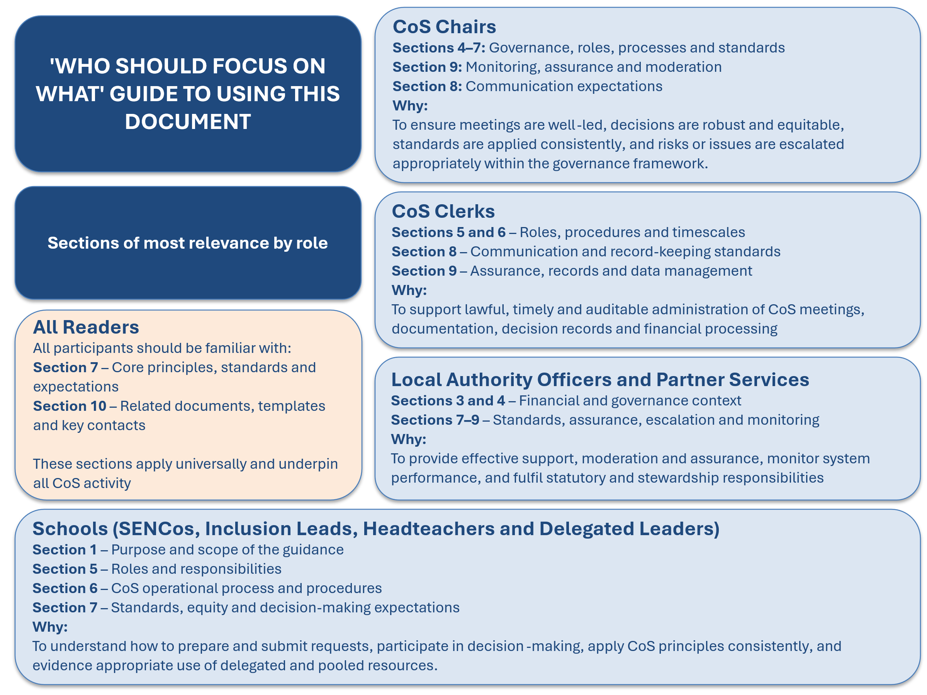Visual 1: Guide to using this document

1. About this Guidance
This Operational Guidance sets out how Communities of Schools (CoS) operate within Kent’s Locality Model for School Inclusion. It provides a clear, consistent framework for how schools, partners and Kent County Council (KCC) work together to meet the needs of children and young people with Special Educational Needs and/or Disabilities (SEND) within a mainstream, inclusive education system.

Section 1 Mandatory Operational Standards
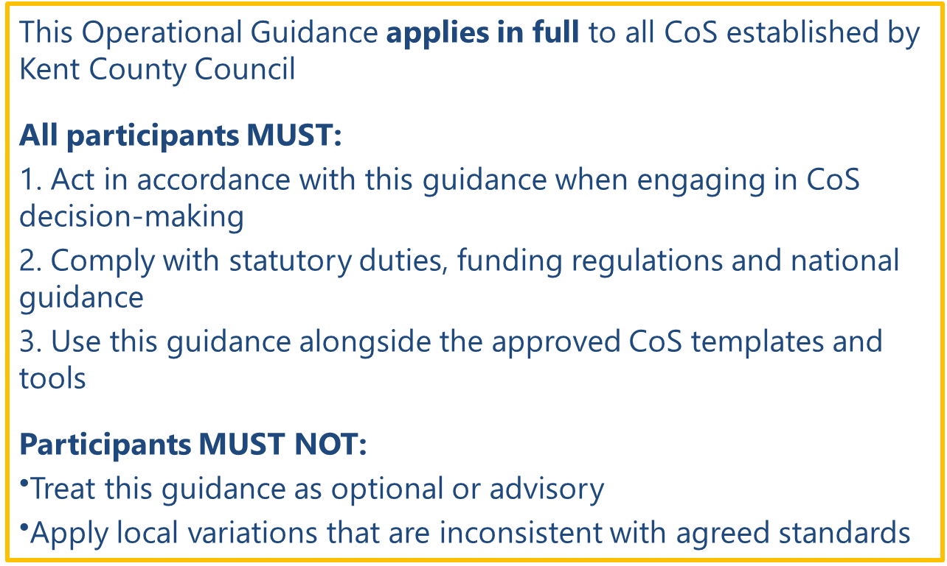
Visual 2: Section 1 Mandatory Operational Standards

1.1 Purpose of the Guidance
The purpose of this guidance is to provide operational clarity on the role, function and operation of CoS as a core mechanism for delivering school-led, locality-based inclusion across Kent. It does this by:
- establishing a shared understanding of the purpose and remit of CoS
- setting out agreed processes, expectations and governance arrangements
- clarifying the intended use of the PRG, early intervention and part of the Local Offer
- clarifying the intended use of pooled High Needs Funding (HNF)
- supporting lawful, transparent and evidence-based local decision-making

1.2 How to use this Guidance
Not all sections will be equally relevant to every reader. Schools engaging in CoS decision‑making should focus in particular on Sections 5–7 (Roles, Processes and Standards), while CoS Chairs and Clerks should also be familiar with Sections 4, 6 and 9 (Governance, Operational Procedures, and Monitoring and Assurance). Trust leaders and senior leaders should use the guidance to understand system expectations, accountability arrangements and how local decision‑making operates within a county‑wide assurance framework.

This guidance should be used alongside the approved CoS templates, forms and supporting documents listed in Section 10. It does not replace statutory duties, professional judgement or individual school responsibilities but provides a consistent framework within which local decisions must be made.

1.3 Scope and Applicability
This guidance applies to the operation and governance of all CoS established by KCC as part of the Locality Model for School Inclusion. It applies, in its entirety, to all those involved in, or supporting, CoS activity, including:
- mainstream primary and secondary schools
- CoS Chairs and Clerks
- representatives attending CoS meetings with delegated authority
- KCC officers responsible for SEND, funding, governance and system oversight
- services contributing through the PRG

This guidance does not apply to:
- special schools (except where providing advice or school to school support)
- nursery schools
- pupil referral units or alternative provision
- individual school decisions relating to delegated budgets or Notional SEN Funding
- direct funding allocated through Education, Health and Care Plans (EHCPs)
- statutory assessment or tribunal processes

1.4 Intended Outcomes
Through consistent implementation of this guidance, CoS are expected to contribute to:
- improved inclusion, participation, attainment and outcomes for children and young people with SEND
- greater equity of access to support and reduced variation in local practice and funding decisions
- improved experiences for local children, young people and families through clearer and more consistent decision‑making
- more timely, effective and sustainable use of a proportion of HNF through shared responsibility and pooled resources
- stronger collaboration, mutual accountability and trust between schools, the local authority and partners

These outcomes are underpinned by the equity and inclusion standards in Section 7

2. Strategic, Policy and Legislative Context
This section provides the statutory and policy framework that underpins the operational arrangements set out later in this guidance.

Section 2 Mandatory Operational Standards
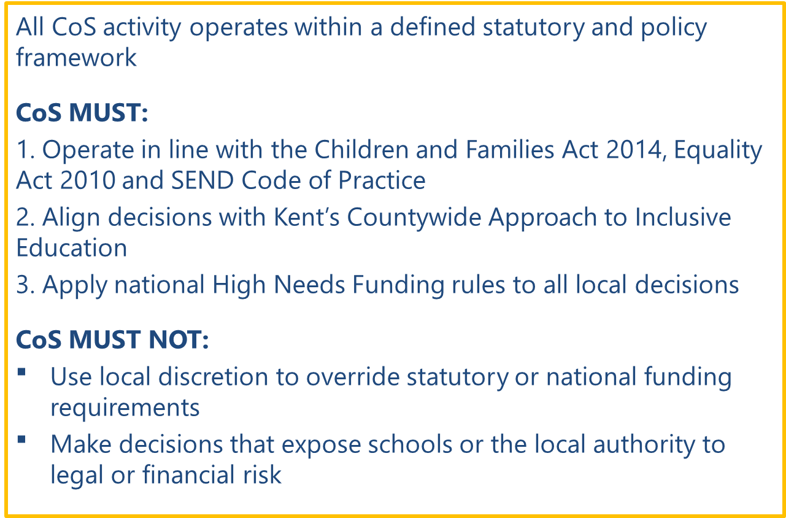
Visual 3: Section 2 Mandatory Operational Standards

2.1 Kent’s Countywide Approach to Inclusive Education (CATIE)
KCC adopted the Countywide Approach to Inclusive Education (CATIE) as agreed policy in 2023, setting out a long-term commitment to improving inclusion across mainstream education. Kent’s strategic intent is translated into clear, practical expectations for schools, CoS and partners in this guidance.

2.2 The Locality Model for School Inclusion
The Locality Model comprises three core components that support a system-level approach to inclusion that balances local flexibility with clear expectations and oversight:
- CoS are the primary delivery units for local collaboration, decision-making and effective use of resources
- PRG provides multi-disciplinary SEND expertise and early intervention support
- Governance ensures transparency, accountability and consistency across the county

^{Visual 4: CoS graphic}

Communities of Schools
CoS were organised broadly in line with NHS Primary Care Networks, creating defined geographic footprints with the intention of supporting improved joint working and more coherent commissioning of education, health, and care services. As of September 2025, there are 53 CoS covering all mainstream schools in Kent.

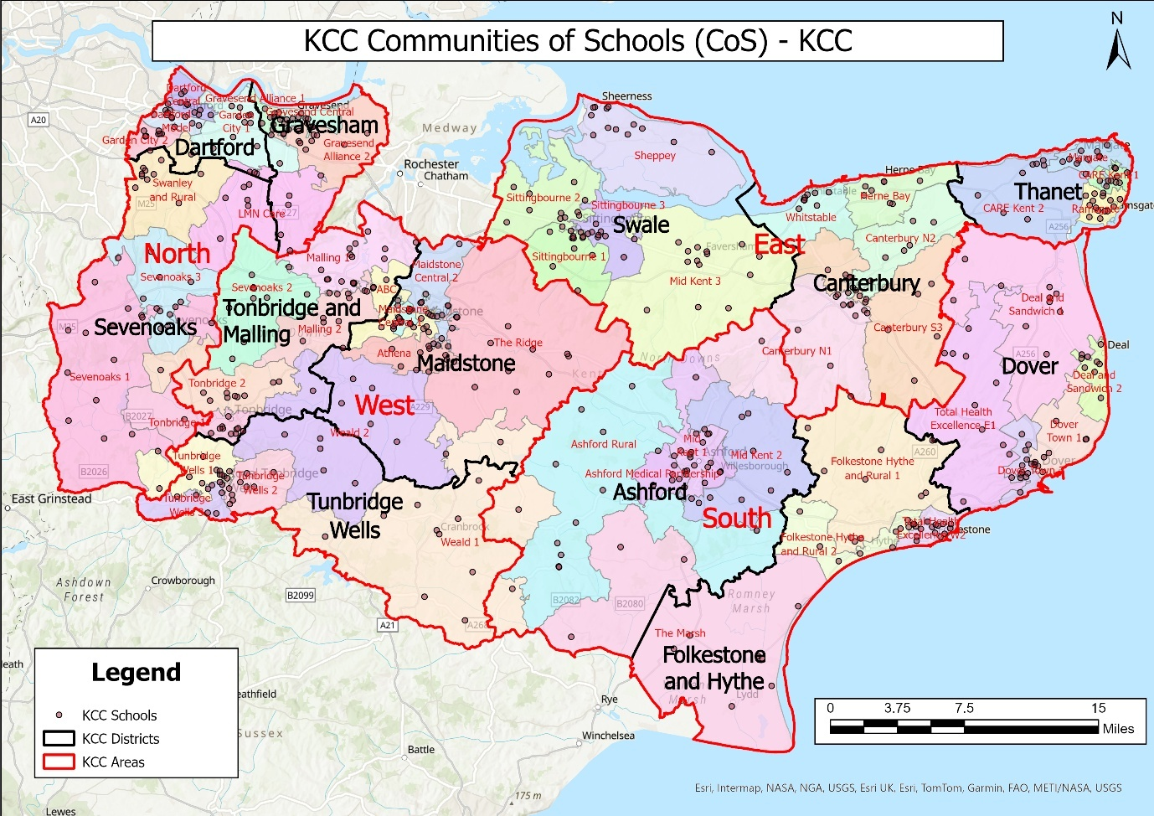
Visual 5: Kent Map showing District and community boundary lines and Kent Schools
Maps and further information on CoS is available on CoS - KELSI, for Kent, split by area and district, these are updated annually for the beginning of the academic year.

Professional Resource Group
The PRG is a multi-disciplinary arrangement comprising statutory and commissioned services from the education sector and health providers, and it is intended over time to include social care. It provides coordinated advice, consultation, and support to schools and CoS (children and families), enabling earlier intervention, strengthened inclusive practice and more effective responses to emerging need. The PRG operates as a shared resource for all schools and CoS, supporting improved inclusion and outcomes for children and young people.

The PRG forms an important component of Kent's Locality Model for School Inclusion. Engagement with PRG services is a local operational expectation intended to support early intervention and informed decision-making; however it does not constitute a statutory prerequisite for CoS consideration or funding decisions (see Section 6).

Core members are accessed by schools and CoS via a link practitioner model; contact details by school can be found at Professional Resource Group - KELSI.

Depending on the context of each CoS there may be links with third party, voluntary sector and other services that support schools, e.g. local church community groups, parent and SEN charities. These may not be core members of the PRG, but the team will be aware of them and signpost and work with them as needed for the benefit of the local community.

2.3 Local Area Partnership Accountability
The Locality Model operates within Kent’s Local Area Partnership, comprising education, health, and care organisations jointly responsible for the planning, commissioning, and delivery of SEND arrangements for children and young people living in Kent. The effectiveness of this partnership is evaluated through the Ofsted / Care Quality Commission (CQC) local area SEND inspection framework, which focuses on how well local partners work together to improve experiences and outcomes for children and young people with SEND.

2.4 National Policy and Statutory Duties
The work of CoS is underpinned by national legislation and statutory guidance, including:
- the Children and Families Act 2014, which establishes the presumption of mainstream education for most children and young people with SEND
- the Equality Act 2010, which places duties on schools to make reasonable adjustments for pupils with disabilities
- the SEND Code of Practice (2015), which sets expectations for early identification, graduated response and partnership working

Department for Education (DfE) HNF guidance further emphasises the importance of collaboration between schools and other providers to ensure provision is planned and sustained within available resources. CoS provide a practical mechanism for delivering this expectation locally within a clear statutory and policy framework.

3. Financial Context
This section sets out the national and local financial context within which CoS operate. While detailed financial arrangements are determined nationally and managed by the local authority, an understanding of this context is essential for schools participating in local decision-making through CoS.

3.1 High Needs Funding Block (HNFB) National Guidance
Local authorities are expected to develop funding arrangements through engagement with schools, colleges, parents, young people and Schools Forum.

The HNFB supports:
- children and young people aged 0–25 with complex SEND, generally those whose support costs exceed what can reasonably be met from mainstream funding
- children of compulsory school age in alternative provision who cannot attend mainstream or special schools (for example due to exclusion or medical needs)

Funding must be spent in accordance with:
- Dedicated Schools Grant (DSG) Conditions of Grant
- School and Early Years Finance (England) Regulations
- The SEND Code of Practice

High Needs National Funding Formula (NFF) 2026–27
For 2026–27, the high needs NFF is temporarily suspended by the DfE, instead local authorities high needs allocation is currently:
- based on its 2025–26 DSG high needs baseline
- adjusted for:
- annualised pay‑related funding (Core Schools Budget Grant elements)
- additional funding for special units and resourced provision
- import / export adjustment, reflecting cross‑border pupil placements

What the HNFB Is Made Up Of (National Guidance for Local Use)
Although allocated as a single block, HNF is typically deployed across three main areas.

A. Place Funding (Core Funding),
This is fixed, per‑place funding intended to provide baseline capacity. Typical rates:
- £10,000 per place for special schools, alternative provision and Pupil Referral Units
- £6,000 per place for mainstream schools and post‑16 providers with high needs places, SEN units and resourced provision (with some places funded at £10,000 depending on occupancy)
Place funding is not linked to individual pupils, is not withdrawn if places are temporarily unoccupied and supports sufficiency and stability of provision.

B. Top‑up Funding
Top‑up funding meets the additional costs of provision over and above place funding and mainstream contributions. The key principles are it’s:
- paid by the resident (commissioning) local authority
- usually associated with pupils identified as requiring high-needs provision, including many (but not exclusively those) with an EHCP
- should reflect the reasonable costs of meeting assessed needs and be fair, transparent and evidence-based
- must be fair and paid in a timely manner
Top-up funding can cover | Top-up funding can’t cover
Specialist teaching and support staff | Local authority SEND administration
Targeted interventions | Health or social care costs
Equipment / facilities to meet individual needs | Statutory SEN assessments
^{Table 1: Top-up funding}
C. High Needs Central Services
Local authorities may use part of the HNB to commission or deliver central SEND and inclusion services, including:
Central services spend can cover | Central services spend can’t cover
Specialist support services (e.g. SEMH) | Costs associated with local authority statutory SEND casework, including EHC assessment, planning and related legal processes
School to school and inclusion support to mainstream schools | Health and social care provision
Early intervention and prevention services
Collaboration between special and mainstream schools
Table 2: Central Services funding
Central services spend must be:
- permitted under Schedule 2 of the Finance Regulations
- declared through section 251 budget returns
- consulted on, and engaged with, through the Schools Funding Forum

How the HNFB Should Be Used
Core expectations from the DfE require local authorities to: | Explicit exclusions include:
Secure sufficient and suitable provision | Local authority SEND administration
Use funding to support:  - Stability of specialist provision  - A more inclusive mainstream system  - Reduced reliance on high-cost placements | Health or social care services
Co‑produce funding arrangements with:  - Schools and colleges  - Parents and young people  - Schools Funding Forum | Premises or staffing costs unrelated to education
The regulations explicitly allow HNF to be used to:
- Encourage mainstream inclusion
- Support collaboration between special and mainstream settings
Table 3: How HNFB should be used
Key Strategic Messages Emerging from DfE Guidance
The HNB is a tool to support SEND system reform. Emphasis is shifting toward:
- early intervention
- inclusive mainstream practice
- local planning of provision

For 2026-27, funding stability is prioritised while the system is re‑designed. The 2026-27 operational guide places increased emphasis on supporting mainstream inclusion and collaboration between mainstream and specialist provision. The regulations explicitly permit high-needs expenditure for these purposes.

3.2 HNF in Kent
Kent’s funding arrangements are set out here, and how these translate into expectations for mainstream schools and CoS within the Locality Model for School Inclusion. There is a stronger emphasis on inclusive mainstream provision, reduced reliance on individualised high-cost support where needs can be met earlier and locally, and greater consistency in how funding decisions are made across the county. These arrangements are designed to support early intervention, strengthen system capacity, and promote shared responsibility for inclusion.

For CoS, this means operating within a clearly defined framework that balances local decision-making with transparency, equity, and financial stewardship. Pooled resources are intended to support timely, preventative responses to need, informed by evidence and professional advice, while remaining aligned with statutory duties, national funding rules, and Kent’s CATIE. Schools are advised by the DfE to use all available resources in a more innovative way. This includes statutory funding, SEN notional budgets and the Inclusive Mainstream Fund. CoS funding allows schools the option to consider a ‘top-up’, where it may be required for a specific evidence-informed purpose, with clear intended improvements in children’s outcomes.

The system will work on a continuous improvement model which supports consistent practice across communities, enables robust monitoring of spend and impact, and provides assurance that public funding is being used appropriately to improve inclusion and outcomes for children and young people with SEND.

How Kent Funds Different Types of High Needs Provision
Mainstream Schools | Special Schools
Kent changed its mainstream high needs arrangements from September 2025, and these will remain in place until at least August 2027. HNF is now provided via:  - Specific allocations for EHCPs (direct payments from the local authority (LA) where the LA contribution exceeds £6,000), and  - CoS budgets (for SEN support and lower-cost EHCP provision)  Schools are expected to:  - Use their whole-school offer and CoS funding where LA contribution is below £6,000  - Only receive direct high needs payments where costs exceed that threshold | - Receive £10,000 per commissioned place, regardless of occupancy  - Top-up funding: Calculated through Kent-specific funding formula based on:  - Primary need type  - Pupil-led cost factors (staffing models, leadership, premises, catering)  - School-led lump sums distributed across commissioned places  - Funding rates are set per academic year but paid on a financial-year weighted average  - Minimum Funding Guarantee for special schools is 0%, meaning no school will receive less per pupil than in 2025–26
Specialist Resourced Provision (SRP) in Mainstream Schools | Alternative Provision (AP)
- SRP funding applies only where the SRP is named in the EHCP  - Funding consists of:  - mainstream core funding (or £4,000 for unfilled commissioned places)  - place funding, £6,000 per commissioned place  - top-up funding, paid monthly for actual pupils  - Commissioned places are agreed annually in the autumn  - If places are exceeded, core and place funding are paid on a pro-rata basis; funding is never clawed back below commissioned levels | - PRU places are planned at a county level, set at 0.42% of the secondary pupil population  - PRUs receive £10,000 per place  - PRUs receive top-up funding from devolved district budgets  - Kent also operates a £13m devolved fund to support PRUs provide devolved AP funding to non-selective secondary schools, allocated using:  - Pupil numbers  - Income Deprivation Affecting Children Index (IDACI)  - Looked After Children (LAC)  - English as an Additional Language (EAL)
Table 4: Kent funding by provision
Additional High Needs Related Features in Kent
- Special schools and PRUs receive a combined “legacy grant,” consolidating historic grants (pay, pensions, National Insurance Contributions)
- Special schools participate in pooled budgets, mirroring de-delegation arrangements in mainstream
- Kent centrally supports schools by recouping funding from other local authorities for out-of-county placements where schools opt in

CoS funding is not available for special schools, pupil referral units or alternative provision.

3.3 Notional SEN Budget
All mainstream schools are expected to meet the first £6,000 of additional SEN support per pupil from within their own resources, this expectation is referred to as the Notional SEN Budget.

The Notional SEN Budget:
- is not a separate or ring-fenced allocation, but forms part of a school’s mainstream delegated budget
- is indicative, used to illustrate the level of resource a school should reasonably contribute towards SEN support
- is funded through the Schools Block
- represents the expected contribution towards SEN support costs up to £6,000 per pupil, before additional HNF is considered

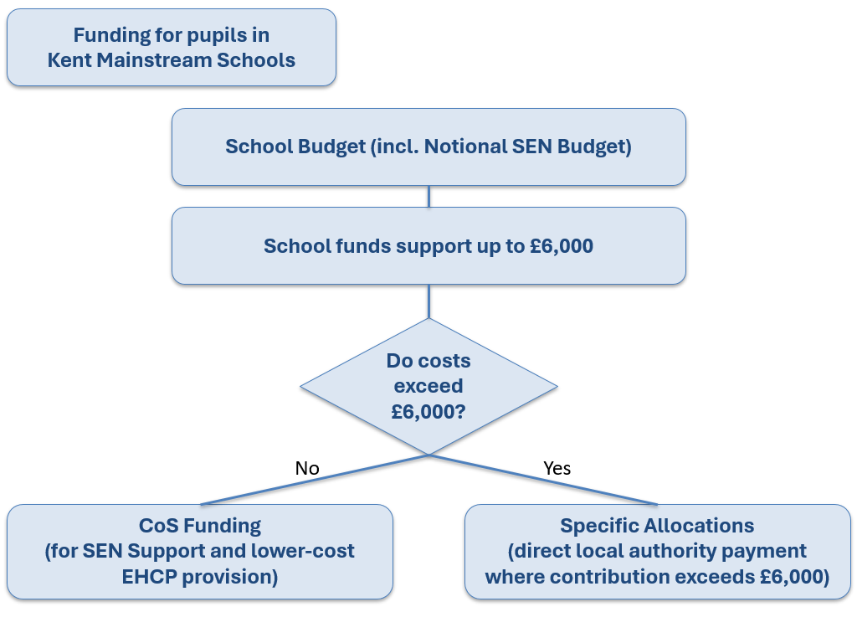
Visual 6: Kent Mainstream funding system flow chart

3.4 The Inclusive Mainstream Fund
The Inclusive Mainstream Fund is a significant investment by the DfE aimed at improving inclusion in mainstream education. It is part of a broader initiative to create a more inclusive education system, moving away from reliance on formal diagnosis and EHCPs. DfE guidance is available for the 2026-27 methodology.

The inclusive mainstream fund will help equip schools to improve the inclusivity of their universal practice, providing them with more resource to meaningfully embed inclusion and remove commonly occurring and predictable barriers to learning. This includes:
- investing in high quality, adaptive teaching
- inclusive pedagogy and decision-making
- creating safe, calm, and accessible learning environments

Schools will also be able to spend this funding on developing more targeted evidence-based support, such as specific group interventions for those that need them. It is recommended that schools allocate funding across 7 themes of activity to help deliver evidence-informed inclusive practice to children and young people. Schools are required to publish an Inclusion Strategy to demonstrate their commitment to inclusive practices. The fund is designed to empower schools to deliver for children and young people with SEND through evidence-informed practices and targeted support.
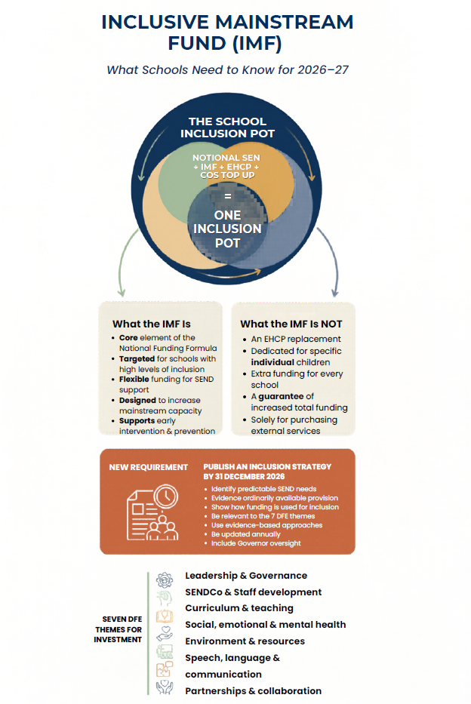
Visual 7: Inclusive Mainstream Fund

4. Governance Framework
The CoS model operates within a defined governance framework that ensures school-led decision-making, supported by professional advice, underpinned by clear assurance and system oversight. Governance arrangements are designed to promote consistency, transparency, equity, and alignment with countywide SEND and inclusion priorities.

Section 4 Mandatory Operational Standards
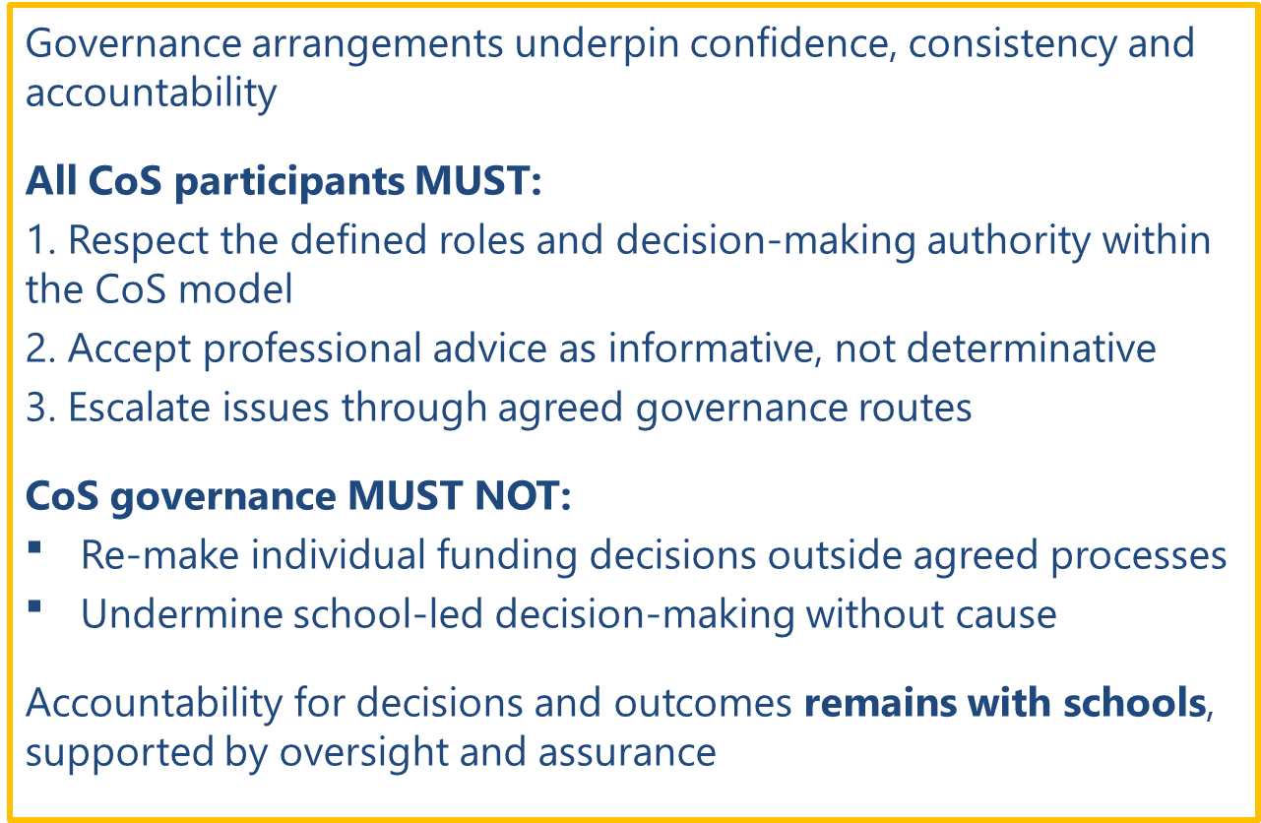
Visual 8: Section 4 Mandatory Operational Standards

Strategic and System-Level Governance (Oversight and Assurance)
KCC retains responsibility for ensuring that public funding is used appropriately to improve outcomes for children and young people with SEND.

The CoS model sits within the wider governance framework of the Children, Young People and Education (CYPE) Directorate. The following bodies provide strategic oversight, democratic accountability, and system assurance, but do not participate in individual CoS funding decisions:
- CYPE Cabinet Committee and KCC Scrutiny Committee
- SEND Partnership Board
- Schools Funding Forum (SFF)
- CYPE Divisional Management Team and Directorate Management Team

These groups receive information, monitor assurance, and consider escalation where required, ensuring that the operation of CoS remains compliant with statutory duties, funding regulations, and strategic priorities.

Operational Governance and System Assurance
The CoS Steering Group provides collective operational governance across communities. Its role is to:
- oversee the effective operation of the CoS model across all communities
- support consistency of practice and interpretation of guidance
- review themes, trends, and risks emerging from local decision-making
- identify areas requiring clarification, support, or further guidance
- act as a conduit between local CoS activity and system-level governance
The Steering Group does not replace local decision-making authority, responsibility for individual decisions remains with CoS.

Chairs Oversight
A Chairs Oversight Group meets three times each academic year (Terms 2, 4 and 6) to provide strategic oversight of the CoS model and advise on its ongoing development. Membership comprises one CoS Chair from each area quadrant, attending on a rotational basis. The group is supported by a Clerk, a SENCo/Inclusion Lead who is not a CoS Chair, and a SEN Area Coordinator who provides a direct link to the PRG. The supporting SENCo/Inclusion Lead remains consistent throughout the academic year.

The Chairs Oversight Group is responsible for:
- reviewing county-wide performance, outcomes and available data to inform strategic development of the model
- providing assurance that Communities of Schools are operating in accordance with the agreed principles, standards and expectations of community working
- identifying and addressing areas where practice is not aligned with agreed principles
- undertaking the first stage of the formal escalation process where disputes or complaints arise
- contributing to the governance and continuous development of the model to support improved outcomes for children and young people across Kent.

Community Level Decision-Making
CoS are the primary decision-making bodies within the model. Decisions must be made at community level and in accordance with the mandatory standards set out in Section 7.

Each community is supported by a CoS Chair, who is responsible for:
- facilitating professional discussion, constructive challenge, and collective decision-making
- ensuring that decisions are evidence-based and aligned with the agreed principles of CoS
- ensuring that decision-making processes and rationales are recorded clearly and consistently
- supporting local quality assurance arrangements and contributing to escalation processes where required.

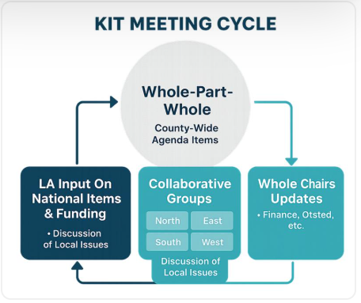
Visual 9: Kent CoS Meetings flow

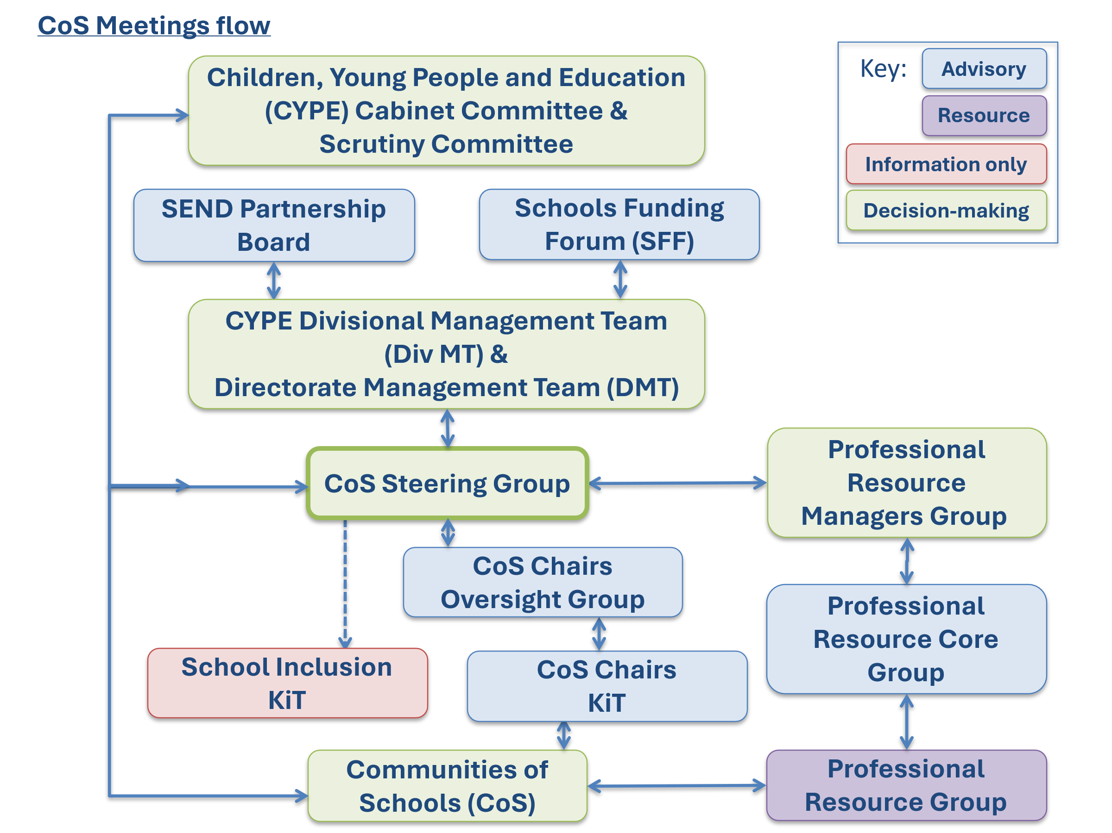
Visual 10: Kent CoS Meetings flow

The CoS Chairs’ Keeping in Touch (KiT) meeting provides a forum for Chairs to share intelligence, ensure alignment of practice, and support consistency across communities.

The School Inclusion KiT supports shared understanding of inclusive practice and expectations within the CoS model, reinforcing the link between funding decisions and inclusive, sustainable approaches.

Professional Advice and Resource Input
Professional advice and resource are provided through the PRG, the Professional Resource Managers Group, and the Professional Resource Core Group. These groups do not make funding decisions. Their function is to support informed local decision-making by providing professional insight on system demand and capacity, and feedback on system pressures and emerging trends.

Through this governance framework:
- decisions are made locally, by schools, for schools
- professional advice informs decision-making without removing school accountability
- assurance is embedded at community, operational, and system levels
- the CoS model remains fair, transparent, sustainable, and aligned with countywide priorities

Visual 11: Kent CoS Governance Framework aims

5. Roles and Responsibilities
This section sets out the roles, responsibilities, decision-making authority, escalation routes, and accountability within the CoS Locality Model. Clarity of roles is essential to ensure consistency, transparency, and effective use of HNF.

Section 5 Mandatory Operational Standards
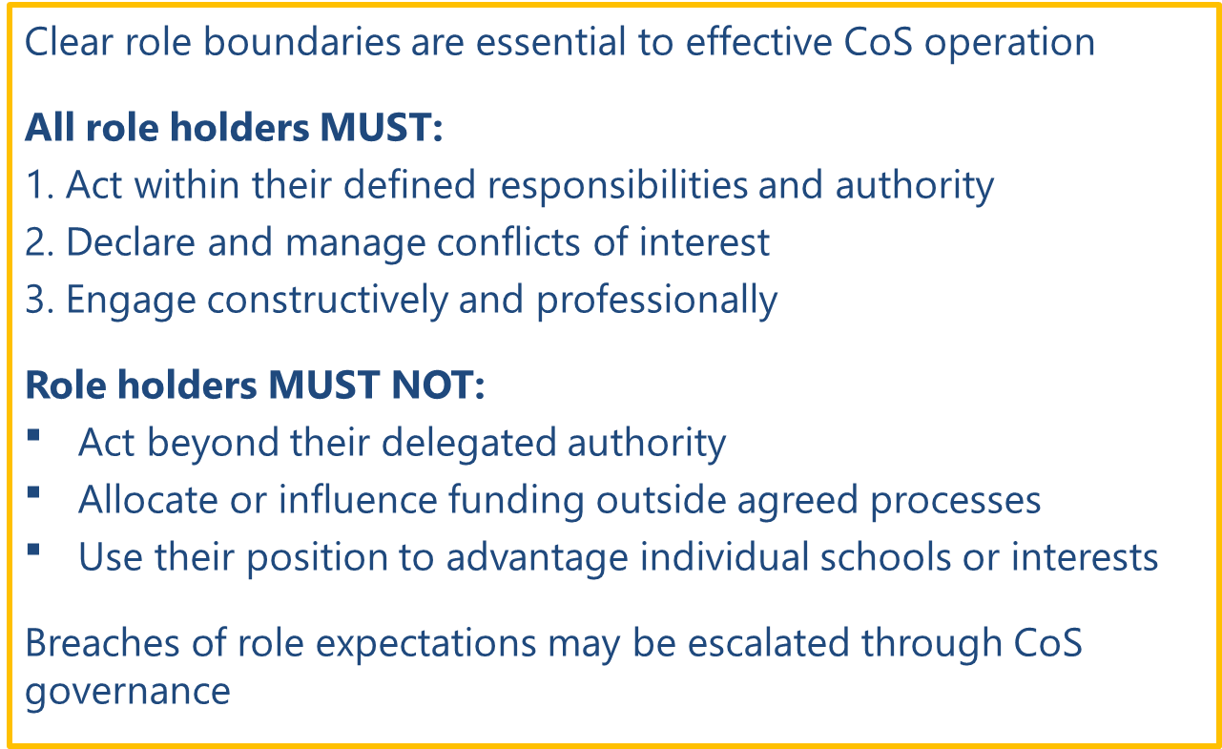
Visual 12: Section 5 Mandatory Operational Standards

Role, Role holders & accountability | Responsibilities | Decision-making authority & escalation
CoS Members (Schools)  Role holders:  • SENCo / Inclusion Lead (expected representative)  • Can be Headteacher or delegated senior leader (where appropriate and agreed locally)  Accountable:  • to the CoS for appropriate use of funding and delivery of agreed provision  • to the local authority for compliance with funding conditions and legal duties | Responsibilities:  • Attend CoS meetings and actively participate even when no request is being submitted  • Act in accordance with agreed CoS principles, prioritising CoS need over individual school interest  • Prepare and submit CoS request forms within agreed timescales, ensuring notional SEN funding and universal provision have been utilised first (where appropriate)  • Submit evidence-based, sustainable, and solution-focused requests  • Contribute to professional peer challenge, scrutiny of proposals, and shared problem-solving  • agree or disagree allocations of CoS support / funding  • Must act in accordance with the mandatory operational, decision-making and funding standards in Sections 6 and 7  • Implement agreed provision and use funding strictly for the purpose approved  • Provide timely feedback on impact, outcomes and use of funding | Decision-making:  • Participate in collective discussion and voting on funding decisions  Escalation:  • Safeguarding and welfare concerns must be escalated immediately via statutory routes and not within CoS processes  • Raise concerns about processes, decisions, or equity through the Chair in the first instance, follow CoS escalation process
CoS Chair (Independent)  Role holder:  • Independent Chair, appointed outside the CoS by KCC  Accountable:  • for the integrity, consistency, and value-for-money of CoS decisions  • to KCC CoS governance | Responsibilities:  • Complete induction process and paperwork (includes Memorandum of Understanding; Declaration of Interests and Code of Conduct forms)  • Chair meetings in line with agreed agendas and CoS principles  • Ensure meetings are solution-focused, equitable and evidence-led  • Confirm schools have considered whether PRG and Local Offer support may appropriately meet the identified need before CoS funding is agreed  • Lead and manage decision-making, ensuring clarity, challenge, and fairness (in the case of a tie or impasse in decision-making the Chair’s decision is final)  • Ensure conflicts of interest are declared and managed appropriately  • Ensure Clerk has the required information for financial processing  • Disseminate information from KCC governance to CoS members | Decision-making:  • Holds final decision-making authority where consensus cannot be reached  • Oversight that allocation of CoS budget is in line with agreed principles and available budget  Escalation:  • Escalate systemic, financial, or procedural risks through CoS escalation process  • Escalate unresolved disputes via CoS escalation process
CoS Steering Group  Role holder:  • Internal and external CoS stakeholders  Accountable:  • to KCC for ensuring operational consistency across CoS  • to KCC governance for coherent implementation of the Locality Model, including CoS | Responsibilities:  • Provide operational leadership, coordination, and oversight across CoS  • Support consistency of processes, documentation, and decision-making  • Identify themes, challenges, and improvement priorities emerging from CoS activity  • Facilitate peer support, shared learning, and problem-solving across CoS  • Ensure alignment between CoS practice, PRG activity, and countywide expectations  • Support Chairs and Clerks to implement guidance and maintain standards | Decision-making:  • Advisory and coordinating role; does not allocate CoS funding  • May recommend operational changes or clarifications to KCC  Escalation:  • Escalates systemic issues, risks, or inconsistencies via KCC CoS governance  • Receives escalations from Chairs where local resolution is not possible
CoS Clerk (Administrator)  Role holder:  • KCC-appointed Clerk  Accountability:  • Accountable to KCC for accuracy, timeliness, and data protection compliance | Responsibilities:  • Coordinate meeting schedules, agendas and papers in line with published timescales  • Maintain accurate records of discussion, rationale and decisions  • Ensure required information is submitted for financial processing  • Distribute minutes and decisions  • Collate information for regular and ad-hoc reporting  • Raise issues of non-attendance or procedural non-compliance to the Chair | Decision-making:  • Does not allocate CoS funding  Escalation:  • Escalate administrative or compliance issues to the Chair, KCC CoS governance, or line manager as appropriate
PRG  Role holders:  • Multi-agency professionals including local authority, health, and commissioned services  Accountable:  • to employing organisations and the local authority for service delivery and professional standards  • to schools for clarity and accessibility of support | Responsibilities:  • Provide expert advice, training, consultation and signposting to schools and CoS  • Support early intervention, capacity-building and inclusive practice  • Ensure clarity of service roles, access routes, and expectations  • Work collaboratively with CoS to support local needs | Decision-making:  • Advisory only; does not allocate CoS funding  Escalation:  • Raise capacity, demand, or systemic concerns with KCC commissioners and service leads
PRG Core Group  Role holder:  • PRG practitioners from statutory and commissioned services  Accountable:  • to their employing organisations for professional standards  • to the local authority for delivering agreed PRG functions | Responsibilities:  • Coordinate and prioritise PRG activity across CoS  • Review patterns of need emerging from CoS requests and school engagement  • Ensure PRG advice is consistent, timely, and aligned with Locality Model expectations  • Support early intervention and inclusive practice through joint planning  • Provide professional insight to inform CoS discussions | Decision-making:  • Advisory only; does not allocate CoS funding  • May agree internal PRG deployment or prioritisation  Escalation:  • Escalate capacity, demand, or service-level risks to PRG Managers Group  • Escalate systemic issues to KCC commissioners and service leads
PRG Operational Group  Role holder:  • Senior officers and managers from PRG services  Accountable:  • to KCC for oversight of PRG delivery  • for ensuring PRG capacity, quality, and alignment with CoS processes | Responsibilities:  • Provide strategic oversight of PRG operations across CoS  • Ensure PRG services are resourced, coordinated, and meeting demand  • Monitor service performance, capacity pressures, and delivery risks  • Align PRG practice with countywide priorities, CATIE, and Locality Model expectations  • Support consistent professional advice and early intervention across CoS  • Address escalated issues from PRG Core Groups or CoS Chairs | Decision-making:  • Operational decisions about PRG deployment, service priorities, and resource allocation  • Does not allocate CoS funding  Escalation:  • Escalate significant service risks, gaps, or systemic issues to KCC CoS governance  • Provide regular information to KCC CoS governance
KCC Officers (Inclusion, SEND and funding functions)  Role holders:  • SEND Officers  • HNF Officers  • Senior Managers / Heads of Service  Accountable:  • Accountable to KCC CoS governance | Responsibilities:  • Set and maintain the policy framework and operational guidance  • Allocate CoS budgets and manage the overall HNFB  • Ensure statutory compliance with SEND legislation and funding regulations  • Provide financial processing, assurance, and reporting  • Monitor consistency, equity, value for money and impact  • Intervene where systems or decisions are not operating effectively | Decision-making:  • Determines funding frameworks, thresholds, and CoS budgets  • Does not allocate CoS funding  • Retains decision-making authority for EHCP funding, tribunals, and cross-authority responsibilities  Escalation:  • Address risks escalated from CoS members, Chairs or Clerks  • Escalate significant risks upwards through KCC CoS governance
Democratic & Corporate services  Role holders:  • KCC CYPE Cabinet Committee / KCC Scrutiny Committee  • Elected Members with portfolio responsibility for CYPE  Accountable:  • for ensuring that CoS activity operates within the council’s democratic, legal and financial frameworks  • to the public for transparency, lawful decision-making and effective use of public funds  • for providing political oversight of the Locality Model and SEND system performance | Responsibilities:  • Provide democratic oversight of the Locality Model for School Inclusion, including CoS activity, through scheduled reporting and scrutiny  • Receive and consider reports on SEND, inclusion performance, HNF, and system pressures  • Ensure that CoS arrangements align with statutory duties, corporate priorities, and financial regulations  • Offer political challenge, assurance and direction where risks, inequities or system issues are identified  • Support transparency and public accountability by scrutinising decisions, performance data, and financial stewardship  • Call in decisions or request further information where governance concerns arise | Decision-making:  • Does not allocate CoS funding but holds overarching authority for:  – approving or endorsing strategic SEND and inclusion policies  – receiving formal reports on CoS performance, risks and financial management – ensuring the Locality Model operates within statutory / corporate requirements  Escalation:  • Receive escalations from senior officers where systemic, financial, or legal risks are identified  • May request additional scrutiny, investigation or reporting where concerns arise  • Scrutiny Committee may call in decisions relating to CoS or the Locality Model to ensure transparency and accountability
Table 5: CoS Roles and Responsibilities

6. CoS Operational Process and Procedures
This section sets out the end-to-end operational process for how needs are identified, resources are requested, decisions are made, funding is allocated, and impact is reviewed within the CoS model. All participants must follow this process to ensure consistency, transparency, and lawful use of HNF.

Section 6 Mandatory Operational Standards
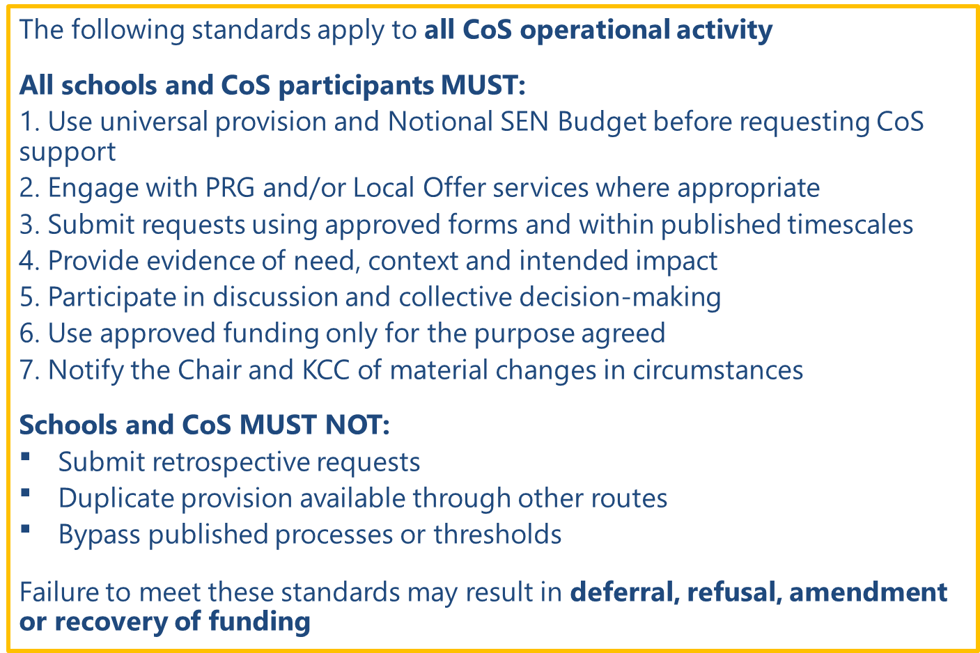
Visual 13: Section 6 Mandatory Operational Standards

6.1 What Starts the CoS Process
The CoS operational process is triggered when one or more of the following apply:
- a school identifies that a group of children (or a child) requires additional provision beyond:
  - universal provision
  - the school’s Notional SEN Budget, and
  - the Inclusive Mainstream Fund
- a group of schools identifies a shared or emerging local need that can be addressed collectively (e.g. pooled provision, training, or specialist input)
- a change in circumstance occurs that affects provision sustainability (e.g. increased complexity, cohort change, staffing pressures)

Before a request is made:
- schools should consider and, where appropriate, engage with PRG and Local Offer support in line with Kent's Locality Model for School Inclusion
- where PRG or Local Offer support has not been accessed, schools should explain how available support has been considered
- where an EHCP needs assessment request has not been agreed, schools should consult with their linked Special Educational Needs Inclusion Advisor (SENIA), Educational Psychologist (EP), or other relevant link practitioner to explore available support before submitting a request to the CoS
- requests should not duplicate provision available through PRG or Local Offer services

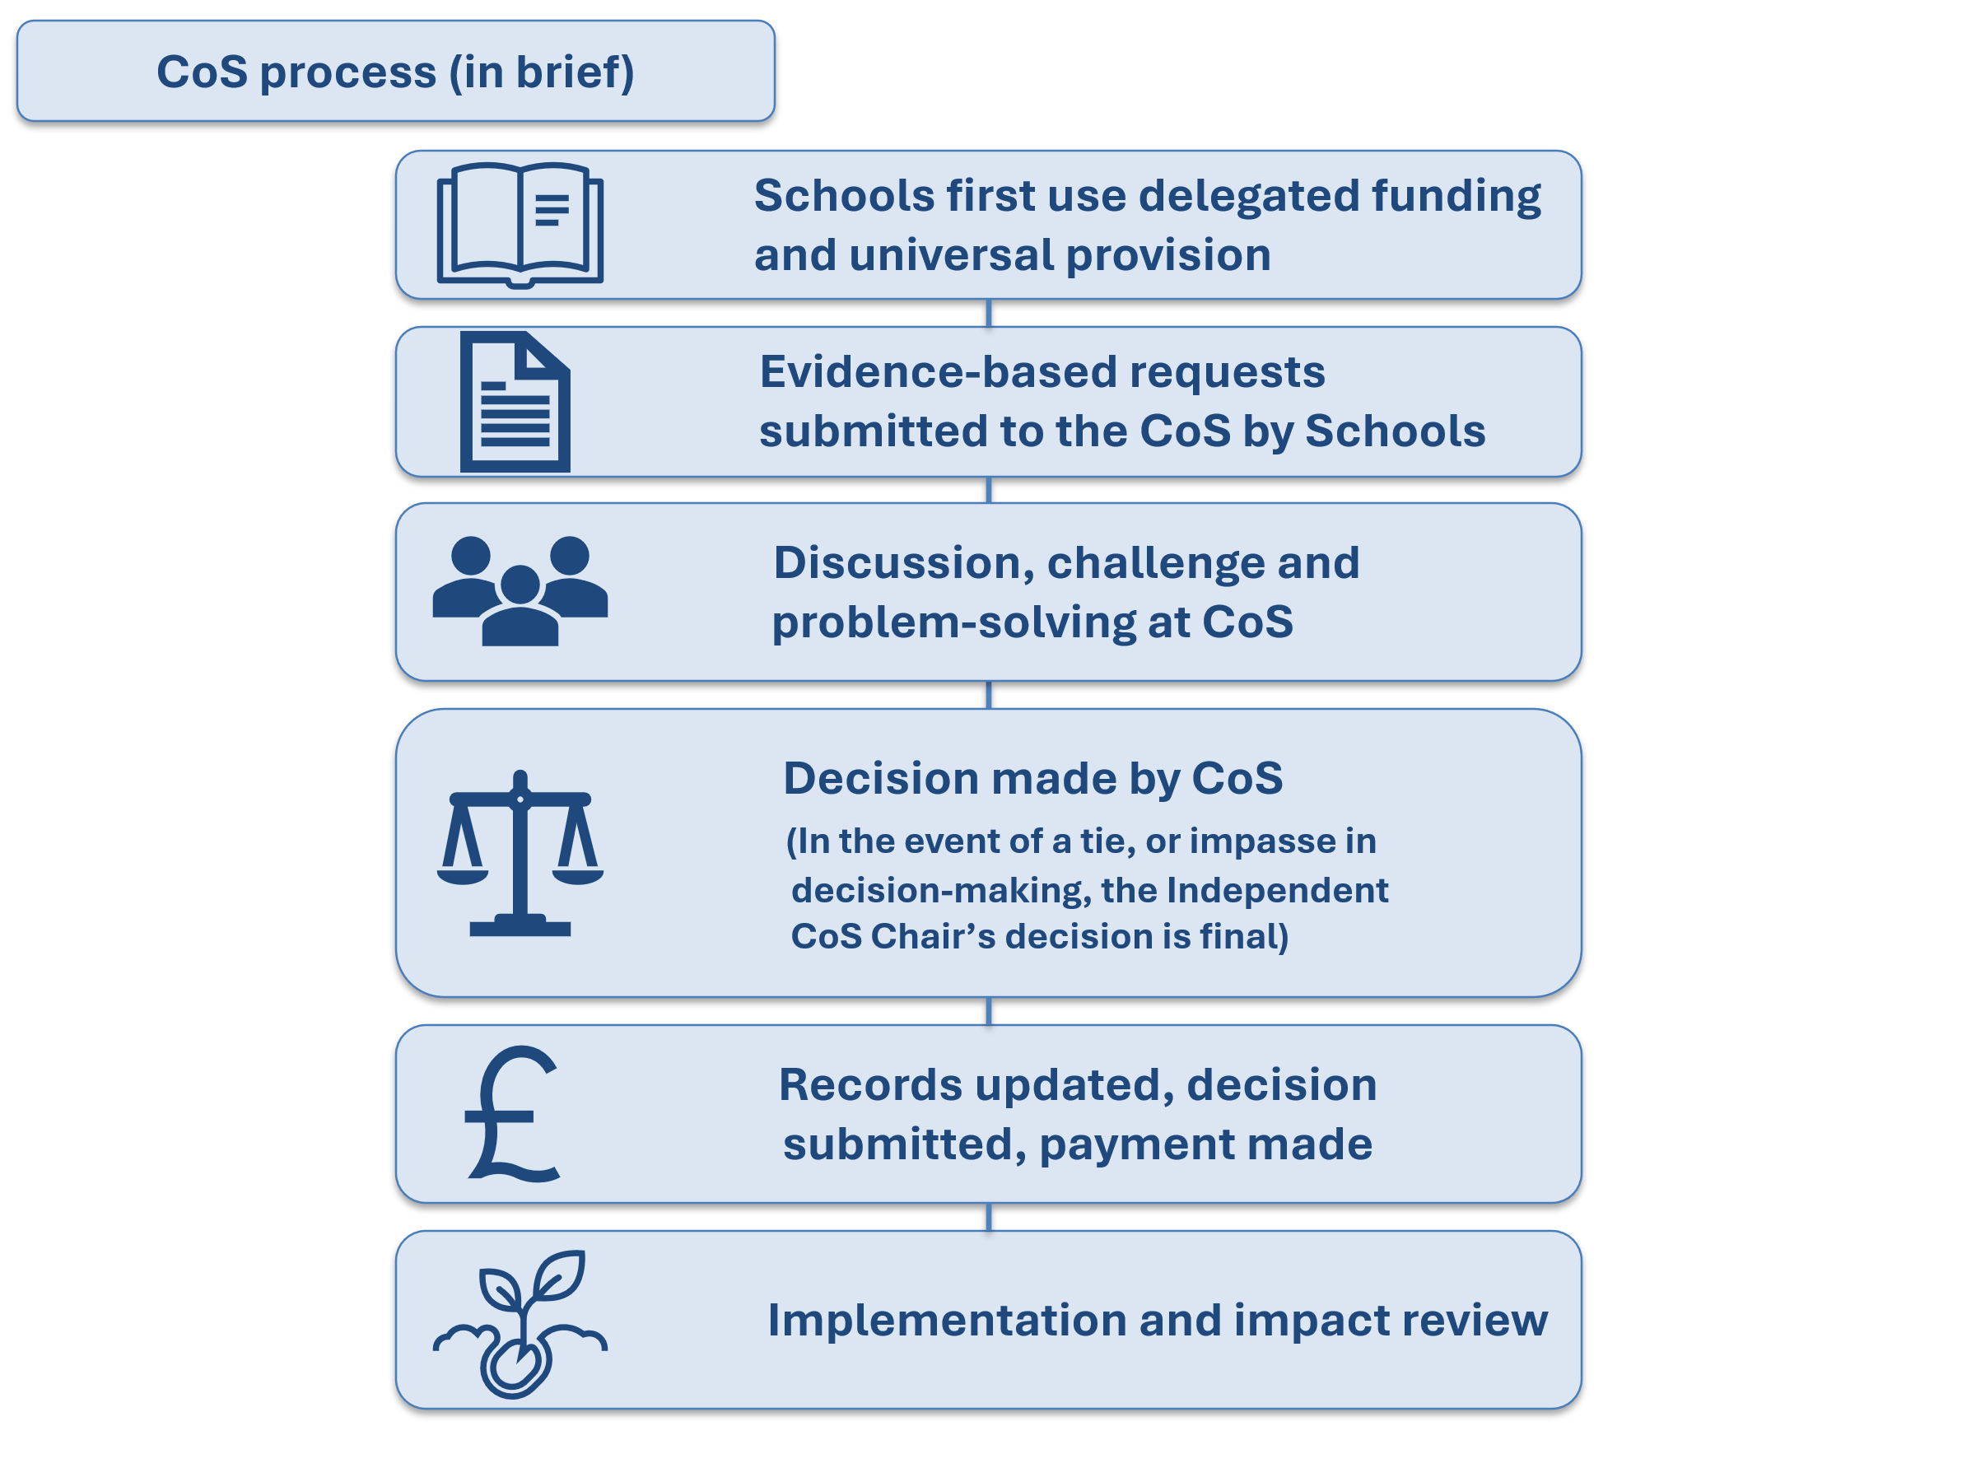 Visual 14: Overview CoS process flow

6.2 Preparation and Pre-Meeting
Actions by Schools (Requesting Schools)
Schools must:
- review current provision and confirm that:
- universal strategies and quality first teaching are in place
- notional SEN funding has been appropriately used
- consider sustainability and proportionality of the proposed support
- complete the online CoS request form, ensuring the:
- request is evidence-based
- intended outcomes are clear
- request focuses on provision rather than diagnosis
- submit the form at least 10 working days before the scheduled CoS meeting (Failure to meet submission deadline may result in the request being deferred to a later meeting)

Completing the CoS request form
A CoS request form can be completed for:
- An individual (in exceptional circumstances, e.g. new arrival, child in crisis)
- Small groups
- Whole cohorts (year groups or whole school)
- Groups of schools (within the CoS)
- Whole CoS
- Groups of CoS (locally based)

The CoS request form asks for minimal information to be entered by schools to keep bureaucracy low, for local authority audit purposes however, pupil names are collected. For information governance purposes the pupil details collected are visible only to KCC staff; not CoS Chairs or participants. The form has space for schools to enter up to 10 pupil details, with an email provided (hnf@kent.gov.uk) for schools to send the additional information to if the request exceeds this number of pupils. The following table details KCC requirements for pupil information.

CoS request form for | Pupil Detail Section | Additional Action Required
An individual | Add all information | None
Small groups | Add all information | If less than 10 pupils: None  If more than 10 pupils: Email all additional information to hnf@kent.gov.uk
Whole cohorts | Add one pupil from cohort | Add the cohort information to ‘What problem are you trying to solve?’ on the Request Details section  e.g. Year 4 or whole school
Groups of schools | Follow relevant prompt for individual / small group / whole cohort | Follow relevant prompt for individual / small group / whole cohort  AND  Add the other schools to ‘What problem are you trying to solve?’ on the Request Details section
Whole CoS | Follow relevant prompt for individual / small group / whole cohort | Follow relevant prompt for individual / small group / whole cohort  AND  State it’s a whole CoS request to ‘What problem are you trying to solve?’ on the Request Details section
Groups of CoS | Follow relevant prompt for individual / small group / whole cohort | Follow relevant prompt for individual / small group / whole cohort  AND  State which CoS involved to ‘What problem are you trying to solve?’ on the Request Details section
Table 6: Pupil information required
Group requests
Before completing a form for group requests, you will need to decide how you and the other schools need to be paid:
- one lead school to receive all the funds (one beneficiary) (who will pay for the resource on behalf of all beneficiaries)
- individual schools to each receive a share of the funds (multiple beneficiaries) (whether equal or pre-agreed differing allocations)

Group request examples:
- A group of schools have some small groups of pupils that would benefit from a joint provision, and one lead school will pay for this.

One ‘lead’ school completes a CoS request form (follow the process for ‘small groups’) add information of the pupils from their school who will benefit onto the form and via email if more than 10 AND add the other school details to the ‘What problem are you trying to solve?’ on the Request Details section.
- A whole CoS have some individuals that would benefit from the same provision and want all schools to receive funds to pay for this.

All schools complete a CoS request form (follow the process for ‘individuals’ or ‘small groups’) add information of the pupil / s from their school who will benefit onto the form (and via email if more than 10) AND state it’s a whole CoS request to the ‘What problem are you trying to solve?’ on the Request Details section.

Visual 15: group request example Visual 16: group request example

- A group of CoS have whole cohorts of pupils that would benefit from a joint provision, and one lead school will pay for this.

One ‘lead’ school completes a CoS request form (follow the process for ‘whole cohorts’) add information for one pupil from their school who will benefit onto the form AND state which other CoS are involved to the ‘What problem are you trying to solve?’ on the Request Details section.

Visual 17: group request example

Date entry – accuracy is vital

When completing the CoS request form selecting the appropriate funding start and end dates affect how your payment is made.

The expectation is:
- dates entered should broadly align with the anticipated cash outlay (if the school is making a one-off payment, KCC will pay as a lump sum, if schools will be making payments over a period, KCC will fund similarly)

- end dates for funding agreed would not normally be expected to run beyond 31 August of the academic year in which they’ve been approved, however, communities can commit to funding beyond this date, but where funding spans two academic years, the funding will be apportioned over the two academic years as appropriate, with the new academic year proportion being paid from the new year’s budget

Funding Detail | Example Start Date | Example End date | Explanatory Notes
Financial resource up to £1,000 | 05.09.26 | 05.09.26 | The start and end dates should match; this will ensure the payment is made in one lump sum
Financial resource greater than £1,000  (not including staffing) | 05.09.26 | 05.09.26 | Use the same dates if a lump sum payment is necessary, e.g. funds are for a one-off purchase
 | 01.09.26 | 30.11.26 | If funds are for costs which will be paid in instalments by the school e.g. a subscription, enter the date at the end of the period / month this will run to  (the example given is for a 3-month subscription starting in Sep 26)
Financial resource greater than £1,000 (including staffing) | 01.09.26 | 31.03.27 | Always use the end date of the month the staff are to be employed until (within the current academic year). e.g. staff employed for:  Term 1 & 2 - use end date 31.12.25  Term 3 & 4 - use end date 31.03.26  Term 5 & 6 - use end date 31.08.26  (The example given is for a member of staff employed for a 4-Term involvement / resource input)
^{Table 7:} How dates entered on the CoS request form should be determined

Quality of Requests
Requests must be sufficiently evidenced and clearly focused on the problem to be solved.

Where a school submits repeated requests that do not meet the required standard, the CoS Chair may:
- request additional work or clarification before the item is scheduled
- require engagement with PRG or other support before resubmission
- pause progression of new requests while quality concerns are addressed

This approach supports schools to improve the quality and effectiveness of requests over time. Good Practice examples of completed CoS request forms can be found in Section 10

Actions by Chair and Clerk (Pre-Meeting)
The Chair and Clerk must:
- schedule requests on the agenda to ensure:
- all requests are valid (e.g. they do not ask for resource available from the PRG, they are not from a special school, pupil referral unit or alternative provision)
- all requests can be heard
- adequate time is allocated for discussion
- issue agenda and papers at least 5 working days before the meeting

6.3 CoS Meeting and Decision-Making
Meeting Requirements
- each school must send a representative, ideally the school SENCo or Inclusion Lead (there is no quorum for a CoS meeting, the Chair holds authority to decide if there is not enough representation for decision-making)
- to have a vote on how the CoS budget is spent your school must have representation at each meeting (or registered prior assent or dissent to the Chair if you are unavoidably absent, the Chair has final discretion in this instance)
- meetings operate on a solution-focused approach and collective responsibility
- discussions must prioritise community need over individual school interest
- if a meeting is cancelled it should be re-booked at the earliest opportunity by the Chair and Clerk
- if a meeting cannot be re-booked it is the Chair’s responsibility to communicate alternative process for submitted requests that were on the agenda

Structured Discussion and Challenge
For each request, the Chair must ensure that:
- discussion must apply the decision‑making standards in Section 7
- members are given opportunity for clarification and constructive challenge
- PRG resources and Local Offer support have been considered where appropriate, and the CoS can clearly identify the additional value that CoS funding would provide

Decision Points and Thresholds
Decisions must be taken as follows:
- requests are voted on by CoS members present
- decisions are based on a majority vote
- where consensus cannot be reached, the Chair has final decision-making authority
- adhering to the standards set out in Section 7

6.4 Recording, Submission and Payment
Post-Meeting Actions
Following discussion the Clerk must:
- record decisions and rationale clearly in the minutes
- complete the CoS section of the request form within 3 working days of the meeting, submitting to KCC
- seek Chair approval for minutes and decisions made
- circulate minutes to all members within 5 working days of the meeting

Payment and Funding Arrangements
- payments are made subject to schools’ advance cycles (if the clerk’s completion of the approval is made by the last working day of the month, payment should be received by school in the following month’s advance)
- funding must be used solely for the agreed purpose
- funding must be used to support pupils who are on roll and attending school during the academic year in which the request is submitted, or pupils who are known to be transferring into the setting as part of a phase transfer. Where an agreed allocation spans more than one academic year, the funding will be apportioned between the current CoS budget and the budget for the subsequent academic year
- where circumstances change see 6.7 (Funding Amendments), (e.g. EHCP funding is agreed)

6.5 Implementation and Impact Review
School Responsibilities
Schools must:
- implement provision as agreed
- monitor impact against intended outcomes
- provide feedback and evidence for impact evaluation when requested

Where a school does not provide proportionate impact evidence when requested, the CoS Chair may:
- seek clarification or additional information
- defer further requests from that school until assurance is received
- escalate concerns through agreed CoS governance routes if non-compliance persists

6.6 Timescales
The following standards apply to CoS processes, failure to meet these standards must be addressed, and escalated when necessary.

Activity | Standard
Submission of CoS request form by schools | ≥ 10 working days before meeting
Agenda and papers issued by clerks | ≥ 5 working days before meeting
Clerks complete CoS section of form and submit to KCC | Within 3 working days
Clerks circulate minutes and decisions to CoS | Within 5 working days
KCC Payment processing (subject to advances) | Target: within 30 working days of clerks submission
Table 8: CoS processing timescales
Where a school or CoS participant repeatedly fails to meet agreed timescales or process requirements, the CoS Chair may:
- defer consideration of requests
- require additional preparation or support before resubmission
- escalate concerns through CoS governance where non-compliance is sustained

6.7 Funding Amendments
It may be necessary on occasion for payments which have been approved and paid, or in the course of regular payments, need to be returned to the CoS budget. This could be in the event of:
- a child moving to a school in another CoS area
- a child receiving a new EHCP with a specific allocation
- a child’s circumstances changing whilst in receipt of CoS funding

In the event of any of these scenarios the school in receipt of CoS funding must notify the Clerk immediately. These funds can then be claimed back from the school, or stopped from future payments, bringing the funds back into the CoS budget.

6.8 Exceptions
In exceptional circumstances, where funding is required urgently and a CoS meeting is not scheduled within a timeframe that would enable the pupil's needs to be met, a request may be considered outside of the standard process. The school must submit the usual CoS request form and email the CoS Clerk and Chair, quoting the case reference number and setting out the reasons why an exceptional decision is required. Any request for consideration outside the standard process will be at the discretion of the Chair and is subject to the timing of the school advance. This route is intended only for unforeseen, unusual or emergency situations and should not be used as an alternative to the normal CoS funding process.
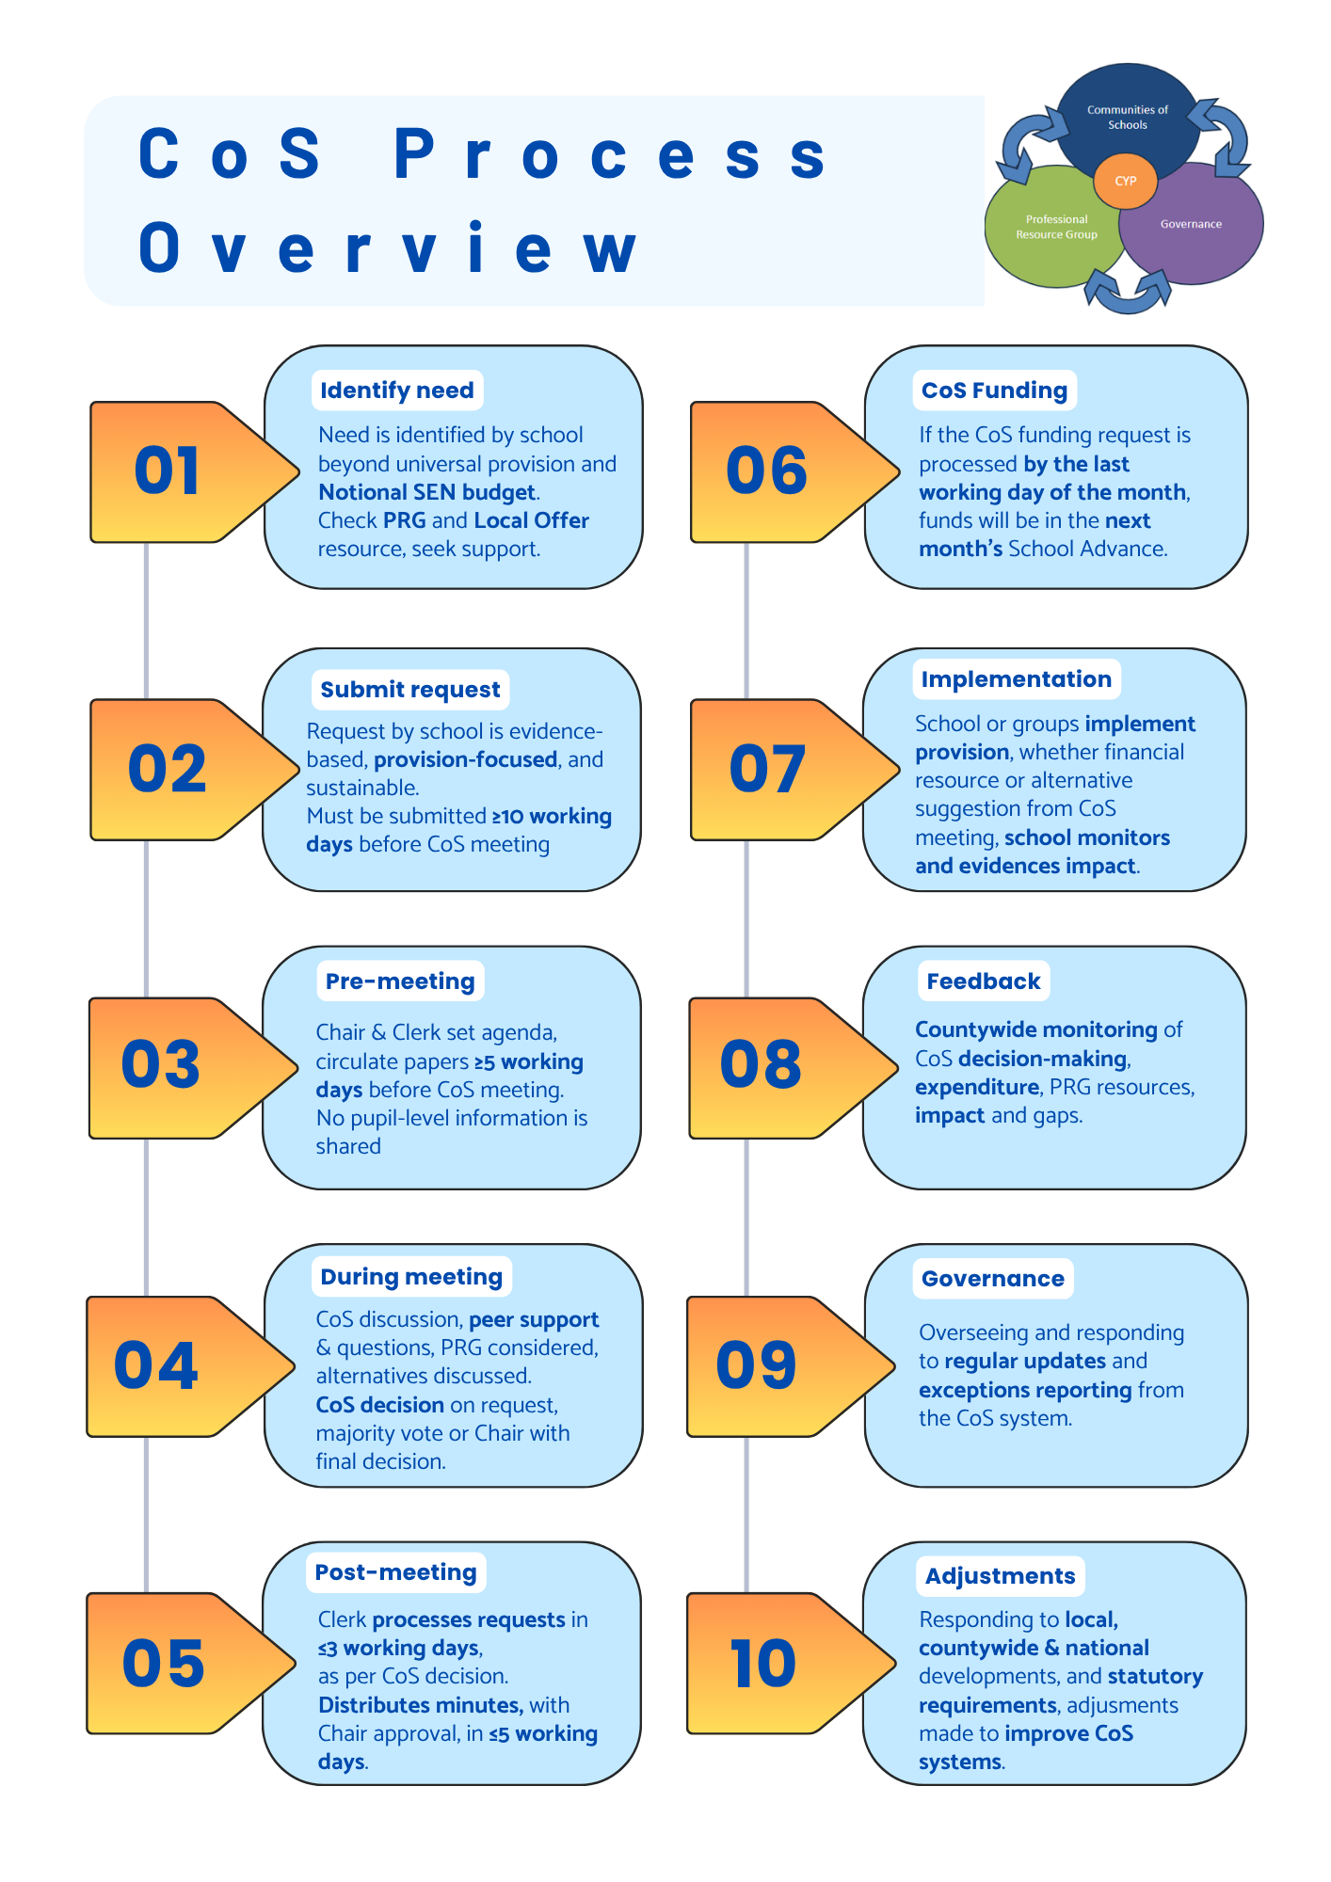Visual 18: Overview CoS process flow

7. Standards, Equity and Escalation
This section sets out the mandatory standards and expectations that apply to all decision-making within CoS. These standards ensure that professional trust and local decision-making operate within a clear framework of accountability and assurance, consistent with the expectations of the Ofsted / CQC Local Area SEND Inspection Framework.

KCC retains overall responsibility for statutory compliance, financial stewardship and system assurance and may provide proportionate challenge, support or intervention where practice does not align with agreed standards or requirements.

Section 7 Mandatory Operational Standards
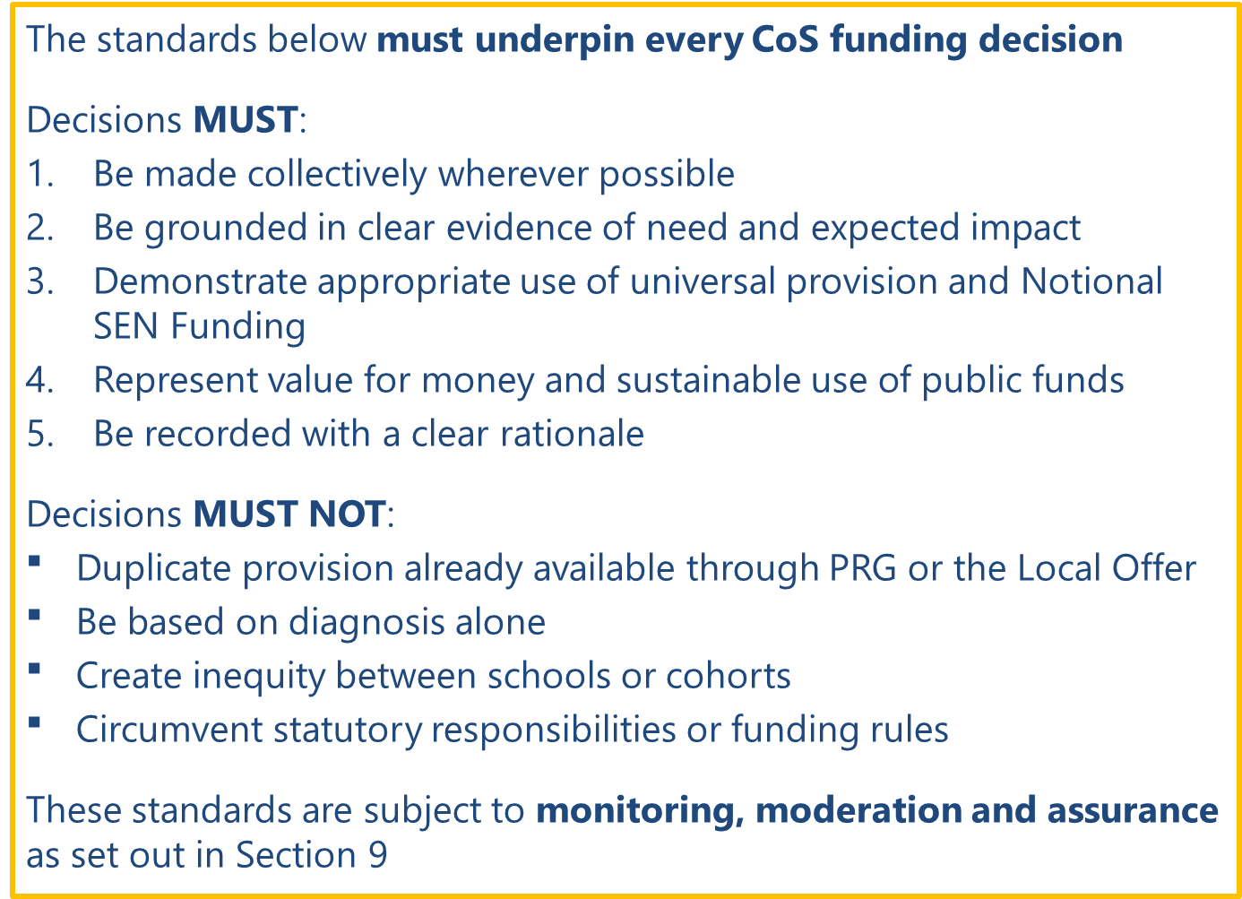
Visual 19: Section 7 Mandatory Operational Standards

7.1 Principles and Core Standards for Practice
The principles underpinning CoS are mandatory and apply to all schools, trusts and individuals participating in the CoS model. Adherence to these principles is expected at all times and is monitored through established accountability, assurance and moderation arrangements. The principles, agreed in April 2023, are:

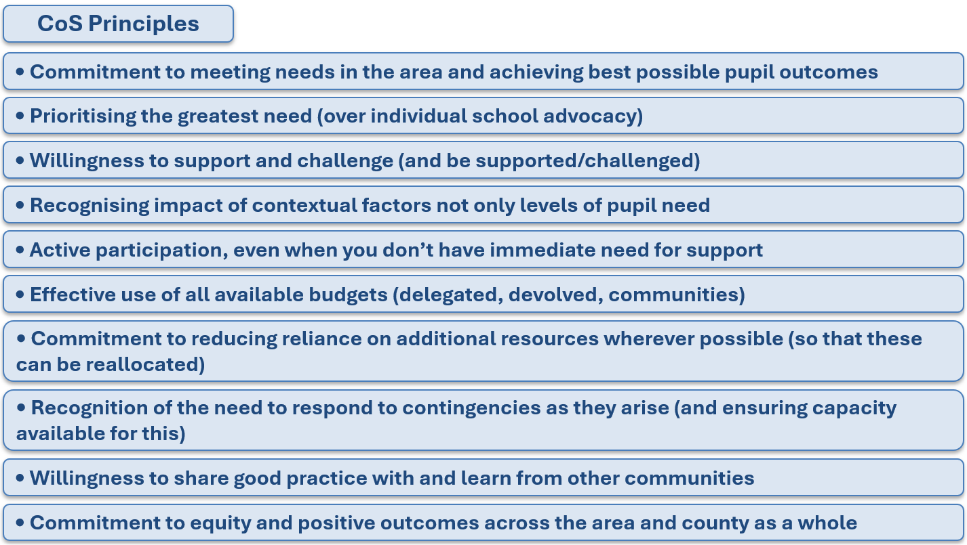
Visual 20: Kent CoS Principles, April 2023

CoS operate on the basis of professional trust, collaborative working and shared responsibility. Participants are expected to engage openly, share information honestly, apply agreed principles consistently and contribute constructively to collective problem-solving and professional challenge. Trust within the system is sustained through transparent decision-making, consistent application of standards and demonstrable impact.

Multi-Academy Trusts (MATs) play a critical role in the CoS model and are expected to act as equal system partners in line with national policy expectations. Trusts must support effective collaboration within local CoS, ensure trust-level practice aligns with community principles and processes, and balance organisational interests with collective responsibility for inclusion and outcomes.

All CoS activity must be underpinned by consistent standards that apply to decision-making, use of funding, partnership working and evaluation of impact. All participants must act in accordance with the agreed principles and Code of Conduct (in 10.2 Local Forms, Guides and Resource), demonstrating integrity, transparency and collective accountability for both decisions taken and outcomes achieved. Decisions relating to the allocation and use of CoS funding must comply with the decision-making and funding standards set out in this section and are subject to the quality assurance and moderation arrangements described later in this guidance.

7.2 Decision-Making and Funding Standards
Funding and resource decisions must:
- be made collectively wherever possible
- be grounded in clear evidence of need and expected impact
- demonstrate appropriate use of universal provision and Notional SEN Funding
- be proportionate and time-limited where appropriate
- focus on provision and outcomes rather than diagnosis
- represent value for money and sustainable use of HNF
- remain within the available CoS budget
See Section 6.1 for mandatory prerequisites to submitting a request.

Decisions must not:
- be influenced by individual school interest at the expense of community equity
- create avoidable dependency or unsustainable models of support

Where these standards are not met, decisions may be deferred, declined or conditioned, in line with the assurance arrangements set out in Section 9.

7.3 Equity, Equality, and Inclusion
The CoS model is underpinned by a clear commitment to equity, inclusive practice, and compliance with equality duties. Equity is not about identical provision, but about fair access to appropriate support based on need, context, and cumulative impact across the community. Decision-making must:
- take account of protected characteristics under the Equality Act 2010
- consider patterns of disadvantage, exclusion, or unequal access
- avoid assumptions based on diagnosis, background, or prior attainment
- actively support inclusive mainstream practice as the default

CoS must demonstrate a commitment to equitable access to support and positive outcomes for children and young people with SEND across the area and county as a whole, reducing unwarranted variation and strengthening consistency over time.

7.4 Reasonable Adjustments and Accessibility
Adjustments should be proportionate, evidence-led and reviewed over time. Reasonable adjustments must be considered and applied to ensure that children and young people with SEND can:
- access education on an equitable basis
- participate meaningfully in school life
- benefit from provision agreed or funded through CoS decisions
Accessibility must also be reflected in CoS processes themselves, including:
- flexible meeting arrangements where required
- clear, jargon-free documentation
- reasonable adjustments for staff participation and communication needs

7.5 Escalation, Intervention and Accountability
Safeguarding and welfare concerns must always be managed through existing statutory safeguarding procedures and must not be raised, discussed or progressed through CoS mechanisms.

Escalation may be considered where there is evidence of:
- persistent non-compliance with agreed CoS processes
- repeated failure to provide required information, evidence or assurance
- sustained inequity or inconsistency in local decision-making
- ineffective use of funding resulting in limited demonstrable impact
- breakdown in professional relationships that affects the effective operation of the community

The CoS model operates on principles of professional trust, collaboration and collective accountability. Participation in the model is voluntary, and all parties are expected to engage constructively, act in accordance with agreed principles and seek resolution of concerns at the earliest opportunity. It is expected that any issues are resolved within the community in line with professional standards.

Where a conflict of interest, unresolved dispute, or other significant professional concern cannot be addressed through local discussion, the following escalation process applies.

Stage 1. Referral to the Chairs Oversight Group
Concerns that cannot be resolved in the meeting should be referred to the Chairs Oversight Group via the Clerk and the CoS Chair. Where the concern relates to the Chair, any member of the community may request that the Clerk makes the referral. An email should be sent to the Clerk detailing:
- Email subject line: CoS Escalation
- The nature of the issue, including the FS-Case number if directly relating to a request

The Chairs Oversight Group will consider the issue, review the available information and provide advice and recommendations to support resolution.

Stage 2. Referral to the CoS Steering Group
Where resolution is not achieved through Stage 1, the matter may be escalated to the CoS Steering Group by the Clerk, in consultation with the CoS Chair and/or the school or trust involved, via the CoS Operations Manager, or nominated KCC representative, (via localitymodel@kent.gov.uk). The Steering Group will consider the matter at the next available meeting and determine any actions required to support resolution.

Stage 3. KCC complaints procedure
Where the matter remains unresolved following consideration by the CoS Steering Group, it may be progressed through the Kent County Council complaints procedure in accordance with the relevant corporate process. See section 10.

Escalation, intervention and continuous improvement operate in line with the assurance framework set out in Section 9.

8. Communication
Effective communication is essential to the success of the CoS model. This section sets out who must be informed, how and when communication occurs, and the standards expected in all digital, written and verbal communication. All communication within the CoS system must be clear, timely, accurate and professional. It is expected that all professionals involved engage with the appropriate communication channels to keep their knowledge current and ensure that decisions are made accordingly.

Section 8 Mandatory Operational Standards
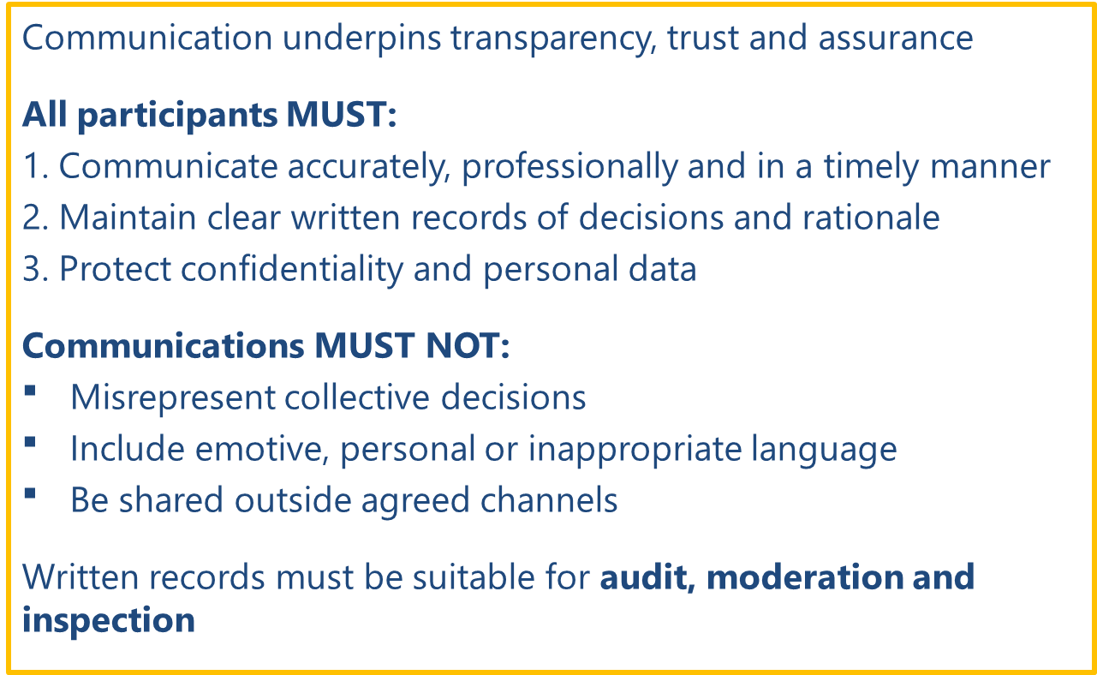
Visual 21: Section 8 Mandatory Operational Standards

8.1 Stakeholders – Who Needs to Be Informed?
Communication within the CoS model involves the following key stakeholders:
Core Stakeholders
The following must be informed as a minimum (where relevant):
- Schools within the CoS
  - SENCos / Inclusion Leads
  - Senior leaders with delegated decision-making authority
- CoS Chairs
- CoS Clerks
- Local authority officers (SEND, HNF and commissioning teams)
- PRG services, where advice, support, or capacity is relevant

Wider Stakeholders (where appropriate)
Depending on context, communication may also involve:
- Special schools and School to School services supporting CoS
- Health and care colleagues contributing outside PRG arrangements
- Governing bodies
- Governance and partnership forums (e.g. Schools’ Funding Forum, SEND Partnership Board)

Communication with parents / carers does not sit within CoS decision-making processes and remains the responsibility of individual schools, in line with statutory duties.

8.2 Methods and Timing of Communications
Routine and Planned
The following communication must occur routinely:
Communication | Method | Standard
CoS meeting dates | Email / calendar invite | Planned and shared in advance
Agendas and papers | Written (electronic) | ≥ 5 working days before meetings
Decisions and minutes | Written record | Within 5 working days of meetings
Funding approvals | Written record (minutes) | Following submission to KCC
Progress reports | Written (electronic) | Following moderation timetable
Table 9: CoS routine communications

Decision and Outcome
Communication should enable schools to understand both what was decided and why.
- All funding decisions must be clearly communicated to CoS members through formal minutes
- Decisions must include rationale, not just outcomes
- Where funding is not approved, the reason must be recorded and communicated clearly

Escalation and Issue
Where issues arise relating to:
- process compliance
- funding concerns
- capacity or sustainability risks
- disagreements or disputes
The issue must be communicated promptly to the CoS Chair in the first instance. If onward escalation is required, communication must follow agreed escalation routes and be digitally documented.

8.3 Professional Standards in Correspondence and Conduct
All participants in the CoS system are expected to uphold high professional standards, including their digital, written and verbal communications.
Conduct Expectations
CoS participants must:
- adhere to the CoS Code of Conduct
- act with integrity, impartiality, and transparency
- respect confidentiality and data protection requirements
- declare conflicts of interest promptly
- engage constructively, even where views differ

Tone and Representation
Professional communication is critical to maintaining trust between schools, the local authority, and partners. When communicating on behalf of the CoS:
- individuals must not represent personal views as collective decisions
- external communication must accurately reflect agreed outcomes
- Chairs and Clerks must ensure consistency of messaging across communications

8.4 Expectations for Written Communication (including digital)
Standards for Written Communication
All written communication must:
- be factual, objective and clearly written
- be sufficiently detailed to explain what was decided, why, by whom and on what basis
- be free from emotive language, personal opinion or speculation
- focus on provision, outcomes, and impact rather than individual opinion
- be understandable to an external reviewer or inspector, suitable for audit and moderation

Written communication must not:
- contain emotive, inflammatory, or personalised language
- name individual children or include identifiable personal data outside approved systems
- undermine collective decision-making or agreed principles

Required Written Records
Written records must provide a clear narrative of how decisions were reached. The following must be produced and retained:
- CoS request forms
- Agendas and papers
- Meeting minutes and attendance records
- Decision rationales and voting outcomes
- Conflict of interest declarations
- Formal correspondence relating to approvals, refusals, or escalations
- Funding and payment records: retained within LA finance systems

Schools must also retain appropriate internal records evidencing:
- implementation of agreed provision
- monitoring and review of impact
- use of funding in line with approved purposes

8.5 Expectations for Verbal Communication (including digital)
Verbal discussions must be accurately reflected in written records to ensure transparency and auditability. Verbal communication within CoS meetings and related discussions must:
- be respectful, collaborative, and solution-focused
- allow equitable participation from all members
- be grounded in evidence and community context

Chairs must ensure that:
- discussion remains focused on agreed agenda items
- individual school advocacy does not override community need
- disagreement is managed professionally and constructively

8.6 Review and Continuous Improvement
Improvements to communication processes should be made where clarity, consistency, or confidence can be strengthened. Communication arrangements and effectiveness will be reviewed through:
- feedback from Chairs and CoS members
- moderation and quality assurance activity
- governance reporting and oversight

9. Monitoring, Assurance, Data Management and Review
This section explains how monitoring, assurance and review are embedded across the CoS model. These arrangements support KCC in meeting its statutory duties and provide confidence to schools, partners and inspectors that the CoS model is operating as designed, in line with the Ofsted / CQC Local Area SEND Inspection Framework.

Section 9 Mandatory Operational Standards
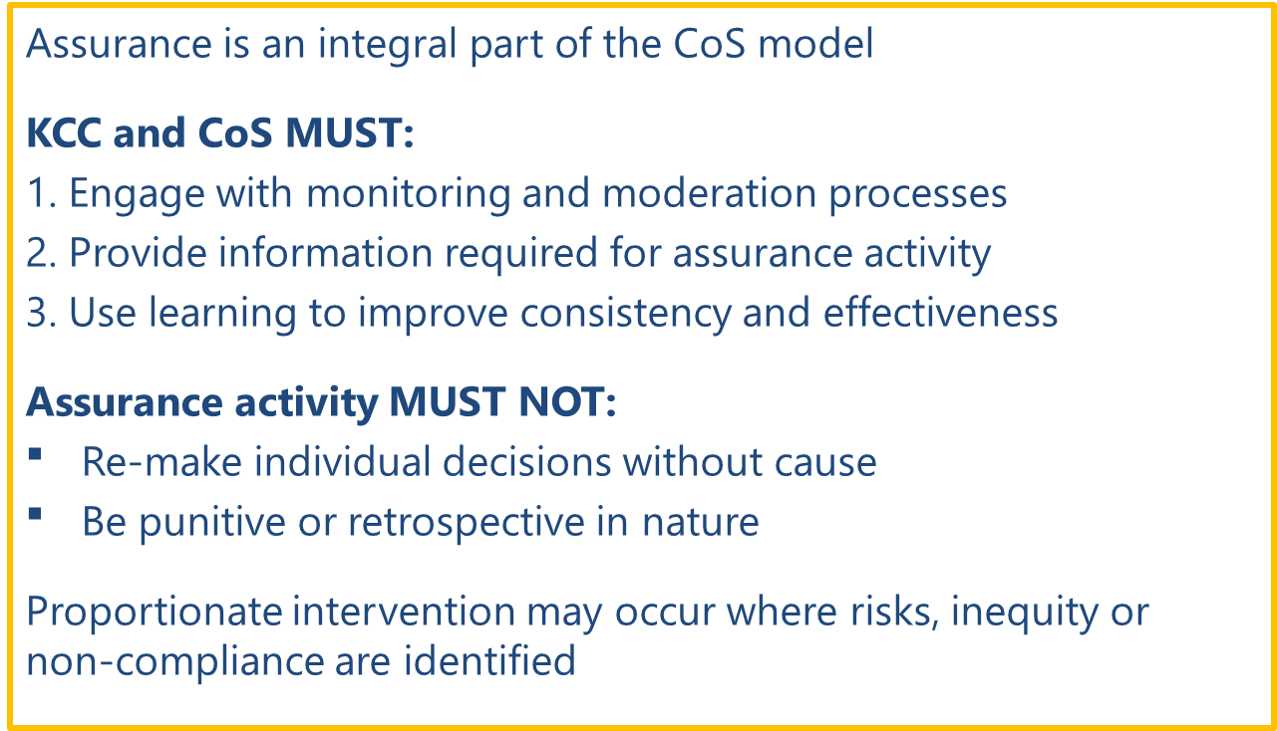
Visual 22: Section 9 Mandatory Operational Standards

9.1 Monitoring and Assurance Context
Monitoring and assurance arrangements ensure that CoS operate lawfully, equitably and effectively, and that pooled HNF is used as intended to improve inclusion and outcomes for children and young people with SEND. This section sets out:
- what is monitored
- how assurance is provided
- how data and records are managed and
- how learning informs review and continuous improvement

9.2 What Is Monitored
Monitoring activity is proportionate and purposeful, focused on systems and impact rather than individual case changes. KCC, working with CoS Chairs and governance partners, will monitor:
- consistency and equity of decision-making across communities
- compliance with agreed CoS operational processes and timescales
- patterns of requests, approvals, refusals and amendments
- sustainability and value for money of funded provision
- alignment with agreed CoS Principles and decision-making standards
- evidence of impact on inclusion, access and outcomes (where available)

Monitoring enables the system to identify:
- effective practice to be shared
- unwarranted variation requiring calibration or support
- emerging risks or pressure points
- where clarification, guidance, or intervention may be required

Monitoring Impact of Funded Provision
Monitoring activity considers not only process compliance and financial stewardship, but the impact of CoS-funded provision. As a minimum, impact monitoring focuses on whether agreed provision has been implemented as intended and whether it has contributed to improved inclusion, access and participation for children and young people with SEND.

Schools may be asked to provide proportionate impact information as part of routine assurance activity. This may include evidence relating to attendance, engagement, inclusion, reductions in escalation or exclusions, or other outcomes relevant to the purpose of the funding. Impact information is reviewed through community-level assurance and county-level moderation to inform learning, support consistency and identify where further action or refinement may be required.

9.3 Sources of Evidence and Data
Data is used to inform learning and assurance, not to replace local professional decision-making. Assurance draws on multiple sources to build a rounded and credible picture of practice. These include:
- CoS request forms (approved, declined and amended)
- meeting agendas, attendance records and minutes
- recorded decision rationales and voting outcomes
- funding and payment records held within LA finance systems
- impact and review information provided by schools
- moderation findings and thematic reviews
- locality and county-level performance data (where available)
- issues escalated through Chairs or governance routes

9.4 Quality Assurance and Moderation Framework
Quality assurance operates at connected levels, supporting consistency while preserving local accountability.
System-Level Assurance
System-level assurance brings together learning from community and county activity to:
- identify system-wide trends, risks and pressures
- monitor alignment with CoS Principles
- inform refinement of guidance, templates and training
- support reporting to governance and partnership forums
Community-Level Assurance
Community-level assurance is a core expectation, within each CoS, assurance is primarily achieved through:
- professional peer challenge and solution-focused discussion
- consistent application of agreed decision-making questions
- clear recording of rationale, conditions and adaptations
- periodic review of patterns of decisions and spend

The moderation process, developed by school leaders, provides information for oversight and governance of the model. This provides assurance to the system that the model is operating in line with agreed principles. Where there is evidence through moderation that community activity is not in line with agreed principles, the structure in the system promotes peer support and challenge and provides advice and guidance on how this can improve.

County-Level Moderation
Moderation is developmental and improvement-focused. It does not remake local decisions or rank communities. The local authority undertakes proportionate moderation to:
- review robustness and consistency of processes,
- understand variation across communities,
- identify strengths, learning and areas for development,
support calibration and shared understanding.

Assurance Roles Within the CoS System
The following roles contribute directly to assurance within the CoS model
CoS Chairs
Chairs play a critical role in frontline assurance by:
  - ensuring agreed decision-making standards and principles are applied consistently
  - facilitating robust professional challenge and recorded rationale
  - reviewing patterns of decisions and spend within the community
  - escalating concerns regarding equity, sustainability or process compliance where required
CoS Steering Group
The Steering Group provides collective operational assurance by:
  - reviewing themes and issues emerging across communities
  - supporting consistency of practice and interpretation,
  - identifying areas for clarification, guidance or training
  - acting as a conduit between local practice and system-level governance
Professional Resource Group (PRG)
The PRG contributes assurance intelligence by:
  - identifying patterns of need, demand and service pressure
  - providing feedback on the effectiveness and impact of advice and interventions
  - informing system learning about emerging trends and capacity issues
  - supporting alignment between professional advice, CoS decisions and system priorities
Together, these roles ensure that assurance is embedded at community, operational and system levels, rather than being an isolated or retrospective activity.

9.5 Assurance Cycle and Frequency
Assurance activity within the CoS model operates through a planned, cyclical framework, combining routine monitoring with proportionate moderation and thematic review. This ensures that assurance is consistent, transparent and focused on learning and improvement rather than retrospective compliance.

Assurance activity takes place at the following frequency:
- Ongoing / meeting-level assurance: Operates continuously through CoS meetings, professional peer challenge, and Chair oversight of decision-making, ensuring that agreed standards and principles are applied consistently at the point of decision.
- Termly moderation and review: The system undertakes moderation activity three times over the academic year, drawing on CoS documentation, decision patterns and funding data to:
  - check consistency and equity across communities
  - identify variation, strengths and emerging risks
  - support calibration and shared understanding
- Targeted thematic reviews (as required): Where monitoring or moderation identifies recurring themes, pressure points or system risks (e.g. specific types of provision, cohort need, or funding patterns), the system may undertake focused thematic reviews to inform corrective action or system improvement as advised through the Chairs Oversight Group or CoS steering group.
- Annual assurance and reporting cycle: Annual analysis of CoS activity contributes to system-level assurance, informing:
  - reporting to governance and partnership forums
  - refinement of guidance, templates and training
  - strategic planning for inclusion and HNF

This cyclical model ensures that assurance activity is predictable, proportionate and effective, supporting continuous improvement and inspection readiness.

9.6 Records, Information Governance and Data Protection
Accurate, timely and well-managed records are essential to transparency, audit and inspection readiness. All CoS participants must ensure that records are:
- clear, factual and sufficiently detailed to explain what was decided and why
- suitable for moderation, audit and external scrutiny
- consistent with the standards set out in Section 8 (Communication)

All CoS activity must comply with data protection legislation, including General Data Protection Regulations (GDPR). This includes:
- collecting only necessary personal data
- processing information lawfully, fairly and securely
- limiting pupil-identifiable information to approved systems and sections
- anonymising pupil information in discussions and minutes wherever possible
- sharing data strictly on a need-to-know basis

Any breach of confidentiality must be reported and managed in line with KCC policy.

9.7 Review, Learning and Continuous Improvement
The CoS model is underpinned by a commitment to continuous improvement. Information gathered through monitoring, moderation and assurance activity is used to:
- strengthen consistency and equity of practice across CoS
- improve the quality of requests and decision-making
- enhance sustainability and impact of funded provision
- build confidence and capability across communities

Continuous improvement activity is informed by:
- feedback from CoS Chairs, Clerks and schools
- findings from moderation activity and thematic reviews
- analysis of decision-making patterns and outcome data, where available
- shared learning across CoS

Monitoring, moderation and quality assurance activities form part of the model's assurance framework and are used to inform the ongoing development of policy, practice and guidance. Emerging themes, trends and areas for development are reviewed through the governance structure, including the CoS Steering Group, to support continuous improvement across the system.

Assurance activity may result in:
- Clarification of expectations and standards.
- Targeted support for individual communities or schools.
- Identification and dissemination of effective practice.
- Revisions to guidance, templates, processes or training materials.

Learning arising from assurance activity is communicated through established governance and communication channels, including CoS Chairs, Steering Group updates and routine communications.

The impact of changes implemented as a result of assurance activity is considered through subsequent monitoring and moderation cycles, ensuring that improvement activity remains evidence-informed and responsive to identified need.

9.8 Accountability and Intervention
KCC retains overall responsibility for statutory compliance, financial stewardship and system assurance. Where monitoring or moderation identifies concerns relating to:
- compliance with agreed processes
- equity, value for money or sustainability
- weak or unsustained impact
- misalignment with CoS Principles

Local Authority Oversight of Pooled High Needs Funding
KCC retains overall accountability for the stewardship and lawful use of pooled HNF operated through CoS. The local authority monitors pooled HNF at system level by:
- reviewing aggregate spend, commitments and forecasts by community
- analysing variation in funding patterns and decision-making
- assessing sustainability and value for money over time
- triangulating financial data with moderation findings and impact information

Evidence from monitoring and moderation informs reporting to relevant governance and partnership forums, including the Schools’ Funding Forum and SEND Partnership Board. This provides transparency, challenge and assurance that pooled HNF is being used appropriately to support inclusive practice and improved outcomes.

Where monitoring or moderation identifies risks, concerns or inconsistency, KCC will respond in a proportionate and evidence-led way. This may include clarification, targeted support or escalation through agreed governance arrangements where necessary. Any intervention is transparent, improvement-focused and designed to maintain the balance between professional trust and clear accountability that underpins the CoS model.

10. Related Documents, Links and Key Contacts
This section brings together the key statutory guidance, local operational documents, templates and contact details that support the effective operation of CoS. All participants are expected to use the most up-to-date versions when carrying out their roles.

Section 10 Mandatory Operational Standards
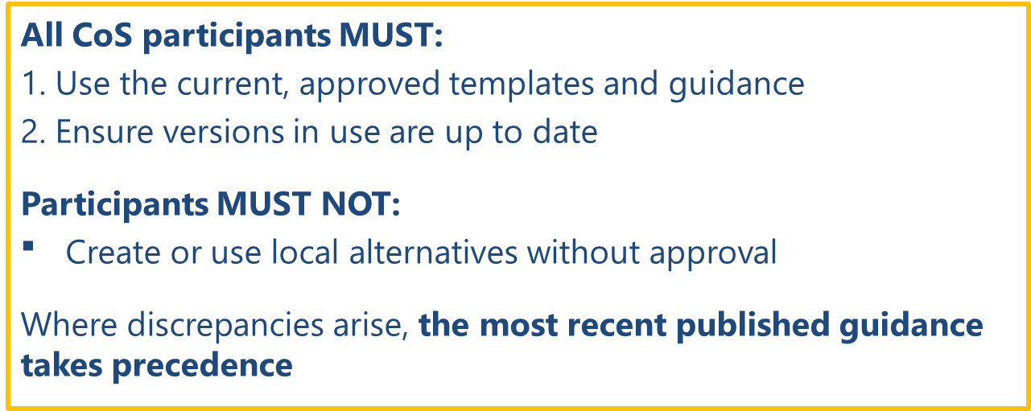
Visual 23: Section 10 Mandatory Operational Standards

10.1 Statutory and National Guidance
Statutory and National Guidance
The following statutory and national guidance underpins the CoS model and must inform decision-making and practice:
- SEND Code of Practice (2015)
Statutory guidance for education, health and care provision for children and young people aged 0–25 with SEND
- Children and Families Act 2014
Legislative framework establishing duties relating to SEND, including the presumption of mainstream education
- Equality Act 2010
Legal duties relating to reasonable adjustments, non-discrimination and accessibility
- DfE High Needs Funding Operational Guidance
National rules governing the use and management of High Needs Funding in mainstream and specialist provision.
- Ofsted / CQC Local Area SEND Inspection Framework
The framework against which joint SEND arrangements are evaluated.

10.2 Local Forms, Guides and Resource
Only approved templates and tools must be used, to ensure consistency, auditability and inspection readiness. The following documents support consistent delivery of the CoS model across Kent:
- Countywide Approach to Inclusive Education (CATIE) (Kent inclusion strategy)
- CoS Agenda Template (completed by Clerks in collaboration with the Chair)
- CoS Code of Conduct (completed by Chairs with CoS participants)
- CoS Declaration of Interests Form (completed by Chairs, updated with changes)
- CoS Minutes Template (completed by Clerks, approved by Chair)
- CoS Operational Guidance (this guidance)
- CoS Request Form (completed by mainstream schools)
- Kent Continuum of Need and Provision (guide for all education provision and stakeholders in Kent)
- Kent Notional Budget Guidance (guide for education providers / stakeholders)
- Kent School Budget Guidance 2026-27 (guide for education providers / stakeholders)
- KCC Complaints

10.3 Key Contacts for Advice and Support
- CoS operational queries: cosadmin@kent.gov.uk
- (New) EHCP funding queries: hnf@kent.gov.uk
- Locality Model strategic queries: (including for CoS, PRG, governance) localitymodel@kent.gov.uk
- PRG Link Practitioner details: Professional Resource Group - KELSI
- School Advance and CoS Overview Statement queries: schoolfunding@kent.gov.uk

10.4 Version Control and Currency
- Links and references will be reviewed as part of the annual update process
- Out-of-date or superseded documents must not be used
- Where discrepancies arise, the latest published national or local authority guidance takes precedence

This is so the local authority has an audit trail for pupils who have benefitted from HNF
As a minimum, if the Clerk processes the CoS section by the last working day of the month, schools will receive funding from the following month advance.

