Health contacts for Schools/Education/SENCOs when requesting Health Advice for Annual Review: Children and Young People Aged 0–18 Years
In Kent and Medway, a comprehensive array of health services is available to support children and young people.
Acute Services:
- Consultant Paediatricians
- London Hospitals
- Support for Complex Health Issues
Community Paediatric Services:
- Community Paediatricians (managing developmental disorders)
Children’s Therapies:
- Physiotherapy
- Speech and Language Therapy
      - Occupational Therapy
Other Children’s Services:
- Health Visiting
      - School Nurses/Public Health Nursing
      - Children’s Community Nursing
      - Looked After Children Services
- Special Schools Nursing
- Bladder & Bowel Services
Mental Health Services:
(CYPMHS) Children and Young Peoples Mental Health Service
- Support for mental health concerns including stress, low mood, depression, anxiety, self-harm, and challenging behaviours
- Eating Disorders
- ADHD Pathway
- ASD Pathway
A contact list has been developed to accompany the parents' health information form and SENCO guidance. This resource is intended to enhance understanding of health service involvement, with particular emphasis on therapies, paediatricians, and mental health services, as these are often engaged in providing long-term care and support for children and young people.

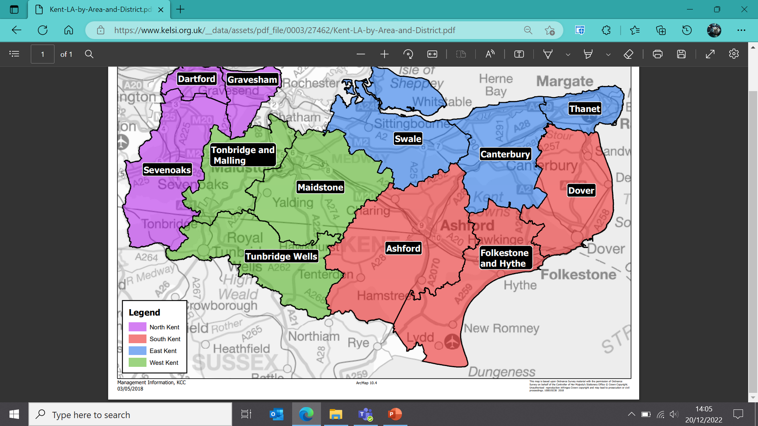

South (Ashford, Folkestone & Hythe, Dover)

Community Paediatric Services:
Community Paediatricians
Ashford & surrounding kentchft.childhealthsek@nhs.net
Deal, Dover & surrounding
Folkestone & surrounding
Therapies
Ashford & surrounding kentchft.cyptherapyashford@nhs.net
Deal, Dover & surrounding kentchft.cyptherapydover@nhs.net
Folkestone & surrounding kentchft.cyptherapyfolkestone@nhs.net

Mental Health Services including: (Kent & Medway Mental Health Trust)
Ashford & South Kent Coast kmbusinesssupport@nelft.nhs.uk
Children and Young Peoples Mental health service (CYPMHS)
Mental Health Support Teams (MHST)
Emotional Wellbeing Team (EWT)
All Age Eating Disorders (AAED)
Learning Disability (LD)
Autism Assessment Team (AAT)

North (Dartford, Gravesham & Sevenoaks)

Community Paediatric Services:
Community Paediatricians kcht.communitypaediatrics@nhs.net
Therapies kentchft.ct-nwkentsenadmin@nhs.net
Mental Health Services, including ADHD 11+. (Kent & Medway Mental Health Trust)
Dartford, Twistleton. kmbusinesssupport@nelft.nhs.uk
Children and Young Peoples Mental health service (CYPMHS)
Mental Health Support Teams (MHST)
Emotional Wellbeing Team (EWT)
All Age Eating Disorders (AAED)
Learning Disability (LD)
Autism Assessment Team (AAT)

East (Canterbury and Thanet)
Community Paediatric Services:
Community Paediatricians
Canterbury & Swale (Faversham) kentchft.childhealthsek@nhs.net
Margate & surrounding

Therapies (Kent Community)
Canterbury & Swale (Faversham) kentchft.ehcp-childrenstherapies-east@nhs.net
Margate & surrounding

Mental Health Services including: (Kent & Medway Mental Health Trust)
Thanet & Canterbury kmbusinesssupport@nelft.nhs.uk Children and Young Peoples Mental health service (CYPMHS)
Mental Health Support Teams (MHST)
Emotional Wellbeing Team (EWT)
All Age Eating Disorders (AAED)
Learning Disability (LD)
Autism Assessment Team (AAT)

West (Maidstone, Tonbridge & Malling, Tunbridge Wells)

Community Paediatric Services:
Community Paediatricians (Kent Community) kcht.communitypaediatrics@nhs.net
Therapies (Kent Community) kentchft.ctwestkent@nhs.net

Mental Health Services: (Kent & Medway Mental Health Trust)
Maidstone & Tunbridge Wells kmbusinesssupport@nelft.nhs.uk
Children and Young Peoples Mental health service (CYPMHS) Mental Health Support Teams (MHST)
Emotional Wellbeing Team (EWT)
All Age Eating Disorders (AAED)
Learning Disability (LD)
Autism Assessment Team (AAT)

Medway
Community Paediatric services:
Community Paediatricians
Medway medch.ehcp@nhs.net
Therapies:
Medway medch.ehcp@nhs.net

Mental Health Services including: (Kent & Medway Mental Health Trust)
Medway Young Peoples Wellbeing Service (MYPWS)
Mental Health Support Teams (MHST) and kmbusinesssupport@nelft.nhs.uk
Emotional Wellbeing Team (EWT)
All Age Eating Disorders (AAED)
Learning Disability (LD)
Autism Assessment Team (AAT)

Swale
Community Paediatric Services:
Community Paediatricians
Swale Community Paediatrics (Medway Foundation NHS Trust, MFT) medch.ehcp@nhs.net
Therapies:
Rural Swale (Kent Community): kentchft.cteast-admin@nhs.net
Swale (not including Faversham) medch.ehcp@nhs.net

Mental Health Services including: (Kent & Medway Mental Health Trust)
Swale kmbusinesssupport@nelft.nhs.uk
Children and Young Peoples Mental health service (CYPMHS)
Mental Health Support Teams (MHST) and
Emotional Wellbeing Team (EWT)
All Age Eating Disorders (AAED)
Learning Disability (LD) and
Autism Assessment Team (AAT)

Local Providers:

East Kent Hospitals University NHS Foundation Trust (EKHUFT)
Kent Community Health NHS Foundation Trust (KCHFT)
Medway NHS Foundation Trust (MFT)
Maidstone and Tunbridge Wells NHS (MTW)
Dartford and Gravesham NHS Trust (DGH)
Kent and Medway Mental Health Trust
NHS Kent and Medway Integrated Care Board (NHS K&M).

