**South East Region Information Pack for Managing Scarlet Fever in Education and Childcare Settings**

|  |
| --- |
| *Produced by UKHSA SE Region*  *Version 03.00 October 2023*  *Review Date October 2024* |

Contents

**Introduction** 3

**When and How to Contact UKHSA Health Protection Team** 3

**Scarlet Fever** 3

Signs and Symptoms of Scarlet Fever 3

Exclusion 3

Contacts of Scarlet Fever 3

Outbreak of Scarlet Fever 3

Pregnant Women and Clinically Vulnerable 4

**Other Group A Streptococcus Infections** 4

**Invasive Group A Streptococcus (iGAS)** 4

**Residential Settings** 4

**Useful Resources** 5

**Scarlet Fever Outbreak Action Card** 6

**Summary Flow Chart of Advice Letters to be Sent to Parents/Carers/Staff in the Event of a Scarlet Fever Outbreak** 7

**Template Letter One** 8

**Template Letter Two** 9

**Fact Sheet for Education Settings and Parents/Carers about Group A Streptococcus (GAS) and Scarlet Fever.** 11

**Handwashing Poster** 13

**Handwashing Poster (Young Children)** 14

# **Introduction**

This pack sets out the actions education settings should take in response to cases of Scarlet Fever in the setting. It also covers information about other Group A Streptococcus (GAS) infections and exclusion advice for them. Scarlet Fever and other infections circulate at higher levels during winter and spring.

# **When and How to Contact UKHSA Health Protection Team**

Please follow the guidance set out in this pack and only contact the South East Health Protection Team on [se.acuteresponse@ukhsa.gov.uk](mailto:se.acuteresponse@ukhsa.gov.uk) or 0344 225 3861 **if** you have an outbreak of scarlet fever (see definition below) **and** any of the following apply:

* + You have two or more cases of chickenpox or clinically diagnosed flu in the class that has scarlet fever at the same time. This is because infection with scarlet fever and either chickenpox **or** flu at the same time can result in more serious illness.
  + You are a special needs setting with many clinically vulnerable individuals.
  + The outbreak continues for over 3 weeks, despite taking steps to control it **and** you are concerned that case numbers are still rising.
  + Any child or staff member is admitted to hospital with a GAS infection (or there is a death).

# **Scarlet Fever**

## Signs and Symptoms of Scarlet Fever

Scarlet fever is a common childhood infection caused by *Streptococcus pyogenes* or Group A Streptococcus (GAS). It is not usually serious but should be treated with antibiotics. The early symptoms of scarlet fever include sore throat, headache, fever, nausea, and vomiting. After 12 to 48 hours, the characteristic red, pinhead rash develops, typically first appearing on the chest and stomach, then rapidly spreading to other parts of the body, and giving the skin a sandpaper-like texture. On white skin the rash looks pink or red. On brown and black skin, it might be harder to see a change in colour, but you can still feel the sandpaper-like texture of the rash and see the raised bumps.

Scarlet fever is generally a clinical diagnosis and swabbing is not always undertaken. If a parent reports that their child has been diagnosed by the GP or other clinician as having scarlet fever, then that is considered a case without the need for a swab result.

## Exclusion

**Children and adults with suspected scarlet fever should be excluded from nursery / education setting / work until 24 hours after the commencement of appropriate antibiotic treatment.**

## Contacts of Scarlet Fever

Contacts of Scarlet Fever cases (including siblings or household members) who are well and do not have symptoms **do not** require antibiotics and can continue to attend the setting. They should seek treatment if they develop symptoms.

## Outbreak of Scarlet Fever

**An outbreak of Scarlet Fever is defined as two or more cases in a class or specific close mixing group that occurs within a 10-day period.** There are several actions that need to be taken in the event of a Scarlet Fever outbreak in the setting. These are detailed in the action card on page 6. **There are no actions required for a single case of Scarlet Fever**. If an outbreak in a defined class or group is continuing beyond 2 weeks, please review your infection control measures. **Single cases in different classes or groups do not constitute an outbreak**.

## Pregnant Women and Clinically Vulnerable

There is no increased risk of complications for pregnant women but if you are concerned, please discuss with your midwife.

It is important to note that special educational needs are not the same as clinical vulnerability. Most people with SEN, ASN or disabilities will not require any additional health protection measures.

If, during an outbreak, anyone in the setting has an underlying condition which affects their immune system or specific clinical vulnerabilities, they should seek advice from their GP or clinical team.

# **Other Group A Streptococcus Infections**

The same bacteria which cause scarlet fever can also cause a range of other types of infection such as skin infections (impetigo) and severe sore throat (pharyngitis). The actions that are relevant for these infections are detailed below.

* **Impetigo:** This is a bacterial skin infection that mainly affects infants and young children. It is very infectious, and the sores can develop anywhere on the body but tend to occur as reddish sores on the face, especially around the nose and mouth and on hands and feet. After about a week, the sores burst and leave golden brown crusts. It can sometimes be painful and itchy.
  + **Action: Exclude the individual from the setting until all lesions (sores or blisters) are crusted over or until 48 hours after commencing antibiotic treatment.**
* **Pharyngitis (sore throat):** No specific actions required by the setting for sore throats (and many sore throats are caused by viruses). However, individuals may be diagnosed with Group A Strep or other bacterial causes of pharyngitis and prescribed antibiotics.
  + **Action: If anyone is prescribed antibiotics for a sore throat, they should stay away from the setting for at least 24 hours after starting antibiotic treatment.**

# **Invasive Group A Strep****tococcus (iGAS)**

In very rare cases, the bacteria can get into the bloodstream and cause an illness called invasive Group A strep (iGAS). Whilst still very uncommon, there was an increase in iGAS cases last winter, particularly in children under 10 years old. It is very rare for children with scarlet fever to develop iGAS infection. However, it is important that parents and carers understand the signs and symptoms of invasive disease and seek medical attention promptly. This is why we ask the settings to send out advice letters when there is an outbreak of Scarlet Fever in the setting. Co-infection with certain viruses is a risk factor for severe disease. Therefore, there is a different advice letter if flu is circulating in the setting with a Scarlet Fever outbreak and additional caution is required if an individual has recently had chicken pox.

Clinicians have a duty to notify the Health Protection Team of all cases of invasive Group A Streptococcus (iGAS). In this situation we may contact the relevant setting, complete a risk assessment, and recommend further actions.

# **Residential Settings**

Additional considerations may be needed for residential or secure settings. Further information can be found at [Specific settings and populations: additional health protection considerations - GOV.UK (www.gov.uk)](https://www.gov.uk/government/publications/health-protection-in-schools-and-other-childcare-facilities/specific-educational-settings-and-populations-additional-health-protection-considerations#residential-settings). If a child cannot go home to recover, then they should be kept away from others as much as possible for the exclusion periods above.

# **Useful Resources**

[NHS – Scarlet Fever](https://www.nhs.uk/conditions/scarlet-fever/)

[Scarlet fever: symptoms, diagnosis and treatment](https://www.gov.uk/government/publications/scarlet-fever-symptoms-diagnosis-treatment)

[Management of scarlet fever outbreaks in schools (publishing.service.gov.uk)](https://assets.publishing.service.gov.uk/government/uploads/system/uploads/attachment_data/file/1110540/Guidelines_for_the_public_health_management_of_scarlet_fever_outbreaks.pdf)

[Health protection in education and childcare settings](https://www.gov.uk/government/publications/health-protection-in-schools-and-other-childcare-facilities/managing-specific-infectious-diseases-a-to-z)

[Hand hygiene resources for schools](http://www.e-bug.eu/)

[Preventing Infections in Childcare - Online Course - FutureLearn](https://www.futurelearn.com/courses/preventing-and-managing-infections-in-childcare-and-pre-school-settings)

# **Scarlet Fever Outbreak Action Card**

**An outbreak of Scarlet Fever is defined as two or more cases in a class or specific close mixing group that occurs within a 10-day period.**

|  |  |
| --- | --- |
| **Key Actions** | |
| **Exclusion** | Children and adults with suspected scarlet fever should be excluded from nursery / school / work until 24 hours after the commencement of appropriate antibiotic treatment.  Contacts of Scarlet Fever cases (including siblings or household members) who are well and do not have symptoms do not require antibiotics and can continue to attend the setting. They should seek treatment if they become symptomatic. |
| **Communication** | 2 or more cases of Scarlet Fever in a class or specific group within 10 days – send relevant information letter to parents/carers/staff (see flow chart on page 7):   1. Two or more cases of scarlet fever in a class – send template letter one and fact sheet to affected class(es) 2. Two or more cases of scarlet fever and at least two cases of chickenpox in a class within a 10-day period – send template letter one and fact sheet to affected class(es) 3. Two or more cases of scarlet fever and at least two cases of clinically diagnosed flu in a class within a 10-day period – send template letter two and the factsheet to affected class(es)   The fact sheet (FAQ) can be sent to parents and staff in the wider school community in any of the above scenarios. |
| **Closures** | It is not necessary to close the school, unless there are operational reasons such as significant staff absence, which would be a decision for the school in conjunction with the relevant Local Authority. There is no requirement to cancel extra-curricular activities or visits. |
| **Infection Control Advice for Limiting Transmission** | |
| **Hand and respiratory hygiene** | * Children should be supervised and/or encouraged to wash their hand regularly and paper towels or hand dryers should be used for drying hands (wastepaper bin provided for disposal of towels) * Remind staff to wash their hands throughout the day. Hand washing needs to be done after changing nappies and helping children use the toilet. * Hand washing with liquid soap and warm water preferred over alcohol gel. * Encourage good respiratory hygiene (using and disposing of tissues). * [Home (e-bug.eu)](https://www.e-bug.eu/) has a range of educational resources for ages 3-16 to learn about microbes, infection prevention and control, antibiotics and vaccination. |
| **Cleaning and disinfection** | * Daily cleaning using standard cleaning products such as detergents and bleach (Hypochlorite at 1000 ppm of available chlorine) for equipment, hard surfaces, hard toys, and sleep mats is an important part of reducing transmission. Single use cloths or paper towels should be used for cleaning. Soft toys should be machine washed. * Carpets and soft furnishings should be vacuumed daily. * Frequently touched surfaces such as taps, toilet flush handles, and door handles, should be cleaned regularly throughout the day. * Complete a deep clean at end of outbreak (at least 10 days with no new cases in the defined group). Carpets and rugs should be cleaned with a washer-extractor. Curtains, soft furnishing covers and all linen should be removed, and washed at the hottest compatible temperature. Soft furnishings without removable covers should be steam cleaned. This could be done during an evening, weekend or over the school holidays. |
| **Broken Skin** | * Make sure that all cuts, scrapes, and wounds are cleaned and covered. This also applies to bites. This is because breaching the skin barrier provides a portal of entry for the organism. |

# **Summary Flow Chart of Advice Letters to be Sent to Parents/Carers/Staff in the Event of a Scarlet Fever Outbreak**

Two or more cases of Scarlet Fever in a class or specific group plus at least 2 cases of clinically diagnosed flu within 10 days.

Two or more cases of Scarlet Fever in a class or specific group plus at least 2 cases of chicken pox within 10 days. period

Two or more cases of Scarlet Fever in a class or specific group within 10 days.

Send **template letter one** **and fact sheet** to affected class(es)/group

Send **template letter one** **and fact sheet** to affected class(es)/group **AND contact the Health Protection Team**

Send **template letter two and fact sheet** to affected class(es)/group **AND contact the Health Protection Team**

Send fact sheet about Scarlet Fever and iGAS to wider school community if you wish

Implement infection control advice in the setting as per action card on page 6

**Remember:**

* No specific actions required by the setting for other Group A Strep infections such as sore throats (and many sore throats are caused by viruses). However, if anyone is prescribed antibiotics for a sore throat, they should stay away from the setting for at least 24 hours after starting antibiotic treatment.
* Impetigo - Exclude the individual from the setting until all lesions (sores or blisters) are crusted over or until 48 hours after commencing antibiotic treatment
* An outbreak of Scarlet Fever can be declared over when 10 days have passed without any new cases in the group.
* Please only contact the South East Health Protection Team on 0344 225 3861 or [se.acuteresponse@ukhsa.gov.uk](mailto:se.acuteresponse@ukhsa.gov.uk) for advice if you have a scarlet fever outbreak **and** any of the following apply:
  + You have two or more cases of chickenpox or clinically diagnosed flu in the class that has scarlet fever at the same time. This is because infection with scarlet fever and either chickenpox or flu at the same time can result in more serious illness.
  + You are a special needs school with many clinically vulnerable individuals.
  + The outbreak continues for over 3 weeks, despite taking steps to control it and you are concerned that case numbers are still rising.
  + Any child or staff member is admitted to hospital with a Group A Strep (GAS) infection (or there is a death).
* Clinicians have a duty to notify the Health Protection Team of all cases of invasive Group A Streptococcus (iGAS). In this situation we may contact the relevant school, complete a risk assessment, and recommend further actions.

# **Template Letter One**

TO BE USED WHEN THERE ARE TWO OR MORE CASES OF SCARLET FEVER IN A CLASS OR DEFINED GROUP EITHER WITH OR WITHOUT CHICKENPOX CASES.

Please amend highlighted sections

Dear parent/guardian/staff member

We have been informed that a small number of children in class/group have been diagnosed with suspected or confirmed scarlet fever.

Although scarlet fever is usually a mild illness, it should be treated with antibiotics to minimise the risk of complications and reduce the spread to others. The symptoms of scarlet fever include a sore throat, headache, fever, nausea, and vomiting. This is followed by a fine rash which typically first appears on the chest and stomach, rapidly spreading to other parts of the body. On white skin the rash looks pink or red. On brown and black skin it might be harder to see a change in colour, but you can still feel the sandpaper-like texture of the rash and see the raised bumps. The face can be flushed red but pale around the mouth.

If you think you, or your child, have scarlet fever:

* see your GP (please remember to take this letter with you) or contact NHS 111 as soon as possible
* make sure that your child takes the full course of any antibiotics prescribed by the doctor.
* Stay at home, away from nursery, education, or work until at least 24 hours after starting the antibiotic treatment, to avoid spreading the infection.

The infection causing scarlet fever (group A streptococcal infection) also causes sore throats (strep throat), mild fever and minor skin infections (for example, impetigo). If someone in your family has any of these symptoms in the next 30 days, we advise that you take them (along with this letter) to see their GP. Their GP can arrange for them to be tested if necessary and then treated with antibiotics if the GP thinks they have a group A streptococcal infection. If the GP thinks that the person has group A streptococcal infection, they will need to remain off work, education or nursery for 24 hours following the start of the antibiotics.

**Complications**

Rarely, children with scarlet fever or other mild GAS infections can develop more serious infections. Children who have had chickenpox recently are more likely to develop more serious infection. Parents and carers should remain vigilant for symptoms such as a persistent high temperature, skin infection and joint pain and swelling. If you are concerned for any reason, please seek medical assistance immediately.

If your child has an underlying condition which affects their immune system, you should contact your GP or hospital doctor to discuss whether any additional measures are needed.

You can find more information in on scarlet fever symptoms, diagnosis and treatment at <https://www.gov.uk/government/publications/scarlet-fever-symptoms-diagnosis-treatment>.

Yours sincerely

Authors Name

# **Template Letter Two**

TO BE USED WHEN TWO OR MORE CASES OF SCARLET FEVER AND AT LEAST TWO CASES OF CLINICALLY DIAGNOSED FLU WITHIN A 10 DAY PERIOD WITHIN A SPECIFIC CLASS OR GROUP

Amend highlighted sections

Dear parent/guardian/staff

We have been informed that a number of children in class/group have been diagnosed with suspected or confirmed scarlet fever and/or influenza. Where both diseases are circulating at the same time there is a slightly increased risk of more serious infection.

**Influenza**

Most children will have a mild illness and will recover at home without needing treatment. Children with flu-like symptoms – fever (38°C or greater), cough, sore throat, runny nose, or headache – should stay home until they are free of a fever and well enough to attend.

The children's flu vaccine is offered as a yearly nasal spray to children aged between 2 and 16 to help protect them against flu. The nasal spray flu vaccine will help protect against flu and the infection will also be less able to spread from them to their family, carers, and the wider population.

**Children with a complex medical history**

It is important that you seek advice from your GP if your child has a complex medical history (such as asthma or immunosuppression), which potentially increases their risk of severe disease if they get flu and they have not received this season’s flu vaccine more than 14 days ago. Your GP will advise if they require prompt preventative antiviral prophylaxis. In addition, if your child has a complex medical history and develops any flu-like symptoms your GP can advise whether they should receive antiviral treatment.

**Scarlet fever**

Scarlet fever is also a mild childhood illness but unlike influenza, it requires antibiotic treatment. Symptoms include a sore throat, headache, fever, nausea, and vomiting, followed by a fine rash which typically first appears on the chest and stomach, rapidly spreading to other parts of the body. On white skin the rash looks pink or red. On brown and black skin it might be harder to see a change in colour, but you can still feel the sandpaper-like texture of the rash and see the raised bumps. The face can be flushed red but pale around the mouth. As the rash fades, the skin on the fingertips, toes and groin area can peel.

If you think you, or your child, have scarlet fever:

* see your GP (please remember to take this letter with you) or contact NHS 111 as soon as possible
* make sure that your child takes the full course of any antibiotics prescribed by the doctor.
* Stay at home, away from nursery, education, or work until at least 24 hours after starting the antibiotic treatment, to avoid spreading the infection.

The infection causing scarlet fever (group A streptococcal infection) also causes sore throats (strep throat), mild fever and minor skin infections (for example, impetigo). If someone in your family has any of these symptoms in the next 30 days, we advise that you take them (along with this letter) to see their GP. Their GP can arrange for the person to be tested if necessary and then treated with antibiotics if the GP thinks they have a group A streptococcal infection. If the GP thinks that the person has group A streptococcal infection, the person will need to

remain off work, education or nursery for 24 hours following the start of the antibiotics.

**Complications**

Rarely, children with scarlet fever or other mild GAS infections can develop more serious infections. Children who have recently had influenza or chicken pox are more at risk of developing serious infection. Parents and carers should remain vigilant for symptoms such as a persistent high fever, skin infection and joint redness, pain or swelling. If you are concerned for any reason, please seek medical assistance immediately.

If your child has an underlying condition which affects their immune system, you should contact your GP or hospital doctor to discuss whether any additional measures are needed.

You can find more information in on scarlet fever symptoms, diagnosis and treatment at <https://www.gov.uk/government/publications/scarlet-fever-symptoms-diagnosis-treatment>.

More information about flu can be found at <https://www.nhs.uk/conditions/flu/>.

Yours sincerely

Authors Name



# **Fact Sheet for Education Settings and Parents/Carers about Group A Streptococcus (GAS) and Scarlet Fever.**

**What is Group A Streptococcus?**

Group A Streptococcus or *Streptococcus pyogenes* is a bacterium that can be found in the throat and on the skin. People may carry it and have no symptoms of illness or may develop infection.

**How is it spread?**

Group A Streptococcus survives in throats and on skin for long enough to allow easy spread between people through sneezing and skin contact. People who are currently carrying the bacteria in the throat or on the skin may have symptoms of illness or they may have no symptoms and feel fine. In both cases, these bacteria can be passed on to others.

**What kinds of illnesses are caused by Group A Streptococcus?**

Most Group A Streptococcus illnesses are relatively mild, with symptoms including a sore throat ("strep throat"), scarlet fever or a skin infection such as impetigo. However, on rare occasions, these bacteria can cause other severe and sometimes life-threatening diseases.

Although scarlet fever is usually a mild illness, it should be treated with antibiotics to minimise the risk of complications and reduce the spread to others. Children should **stay at home until at least 24 hours after starting the antibiotic treatment** to avoid spreading the infection.

The **symptoms** of scarlet fever include a sore throat, headache, fever, nausea, and vomiting. This is followed by a fine red rash which typically first appears on the chest and stomach, rapidly spreading to other parts of the body. On white skin the rash looks pink or red. On brown and black skin, it might be harder to see a change in colour, but you can still feel the sandpaper-like texture of the rash and see the raised bumps. The face can be flushed red but pale around the mouth. As the rash fades, the skin on the fingertips, toes and groin area can peel.

Children who have had **chickenpox** or **influenza (‘flu)** recently are more likely to develop more serious infection during an outbreak of scarlet fever and so parents should remain vigilant for symptoms such as a persistent high fever, cellulitis (skin infection) and arthritis (joint pain and swelling). If you are concerned for any reason, please seek medical assistance immediately.

**What is invasive Group A Streptococcal (iGAS) disease?**

The same bacteria which cause scarlet fever can also cause a range of other types of infection such as skin infections (impetigo) and sore throat. In very rare cases, the bacteria can get into the bloodstream and cause an illness called invasive group A strep (iGAS). Whilst still very uncommon, there has been an increase in iGAS cases this year, particularly in children under 10 years old. It is very rare for children with scarlet fever to develop iGAS infection.

As a parent, you should trust your own judgement.

Contact NHS 111 or your GP if:

* your child is getting worse
* your child is feeding or eating much less than normal
* your child has had a dry nappy for 12 hours or more or shows other signs of dehydration
* your baby is under 3 months and has a temperature of 38C, or is older than 3 months and has a temperature of 39C or higher
* your baby feels hotter than usual when you touch their back or chest, or feels sweaty
* your child is very tired or irritable

Call 999 or go to A&E if:

* your child is having difficulty breathing – you may notice grunting noises or their tummy sucking under their ribs
* there are pauses when your child breathes
* your child’s skin, tongue or lips are blue
* your child is floppy and will not wake up or stay awake

**Do contacts of a case of scarlet fever require antibiotics?**

Contacts of Scarlet Fever cases (including siblings or household members) who are well and do not have symptoms **do not** require antibiotics and can continue to attend the setting. They should seek treatment if they develop symptoms.

There is no increased risk of complications for pregnant women but if you are concerned, please discuss with your midwife.

If anyone has an underlying condition which affects their immune system or specific clinical vulnerabilities, they should seek advice from their GP or clinical team.

**What else can I do to prevent my child from becoming unwell?**

Because Group A Streptococcal disease is spread through coughing, sneezing and skin contact, it is important to have good hand hygiene and catch coughs and sneezes in tissues and throw these away. If you are unwell, stay at home and seek medical advice. This will all help limit the spread of other infections, which are common this time of year.

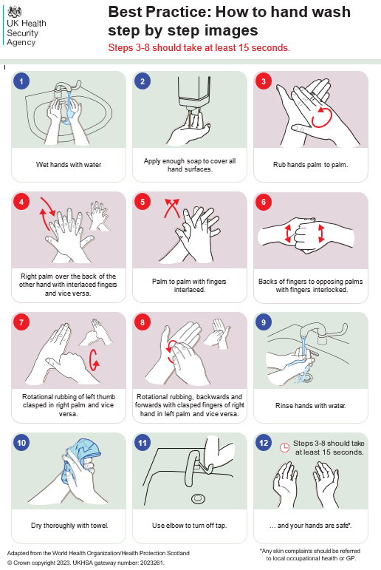

[UKHSA handwashing advice (england.nhs.uk)](https://www.england.nhs.uk/wp-content/uploads/2022/09/nipc-manual-appendix-1-handwashing.pdf)

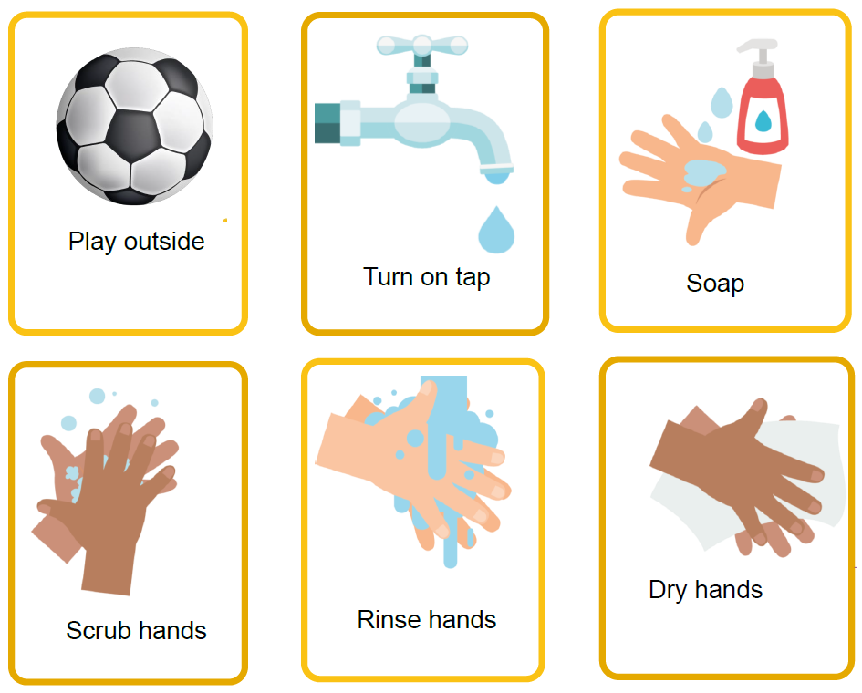

[Hand Hygiene (e-bug.eu)](https://www.e-bug.eu/ey-hand-hygiene)