Kent School
Public Health Service
Secondary School Partnership Agreement

School Name:
District:
Date:
Present:

Information at a glance | Page
School Public Health Service roles and responsibilities  - Context and background of the School Public Health Service  - The School Public Health Service  - Scope of the School Public Health Service | 3  3  4
Partnership Agreement (for signature)  - School Public Health Service Responsibilities  - School Responsibilities | 5  6
School Public Health Service Intervention Framework | 7
School specific sessions | 8
Partner Services | 9
Feedback sheet | 10
Contact details for School Public Health Service | 11
Appendix 1 – Template letter re. Lancaster Questionnaire | 12
Appendix 2 – Letter re. DBS checks for KCHFT School Public Health Service staff visiting schools | 13

Context

KCHFT was commissioned from 1st April 2017 to provide Primary and Secondary School Public Health Services (5-19years) and Targeted Emotional Health and Wellbeing Services (EHWBS). The service includes children in mainstream school, special school, alternate curriculum units or home educated.

Three key themes strongly influenced the new service design:

- The School Public Health Service and the range of services offered needs to be more visible in schools and the community. This could be through activities that raise awareness of the range of services provided, as well as clarity regarding the role of the school (public health) nurse.

- Services need to be more accessible for children, young people, parents/guardians and schools. In particular, this applies to communication and improved dialogue.
- There needs to be a willingness to work together with stakeholders on further developing services in schools, from our school health staff and school staff, to parents, young people and primary care services. There is a real opportunity to co-create sustainable, innovative school
health services based on the needs of the local population.

The School Public Health Service (SPHS)

The School Public Health Service is staffed with a range of practitioners ensuring a
multi-skilled team. This includes; Public Health Assistants, Assistant Practitioners, School Staff Nurses and School Nurses who focus on delivering a high quality, responsive, public health service to the whole school community. The School Public Health Service is available 8:00 to 18:00 5 days a week, 52 weeks a year (excluding public holidays).

We have a dedicated team of Administrators who are based in the Single Point of Access at Foster Street in Maidstone who deal with all referrals and telephone calls into the service. The referrals are triaged by qualified clinicians who assess the level of need and assign to a practitioner for intervention or support
as required.

Referrals can be made directly by parents/ carers, young people themselves or by partner agencies, using the online referral form which can be accessed via the link below:

www.kentcht.nhs.uk/forms/school- health-service-referral-form/
(Online referral form)

Contact no: 0300 123 4496

Scope of the SPHS

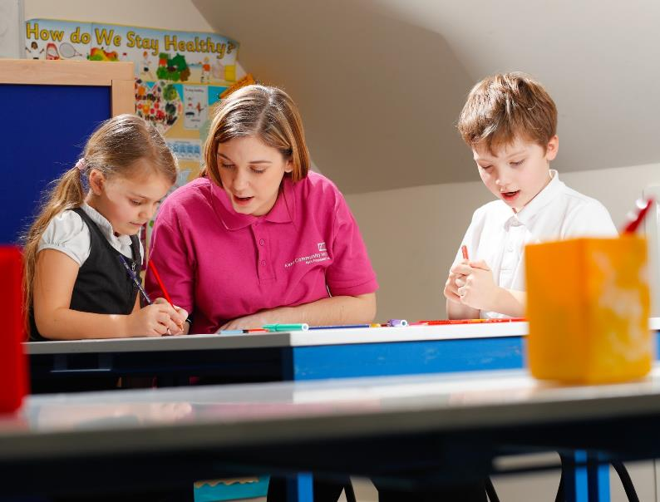
Our teams work hard to improve the general health and wellbeing of children, young people and their families to support children to get the best start in life.

The teams are led by school nurses who are qualified nurses, with specialist training in public health. They are supported by school staff nurses, assistant practitioners, public health assistants and an administration team.

The SPHS aims to provide a named school nurse for each secondary school. It is important for the named school nurse to be visible and well known to children and young people, their parents and school staff.

As a public sector organisation delivering a contract commissioned by NHS England we provide assurance under contract to NHSE that our staff our appropriately trained, qualified and checked (DBS). It is not appropriate for our staff to carry or present their certificates to a third party.

All our staff carry photo ID badges and attend scheduled appointments.

This partnership agreement will ensure that children and young people in schools receive the best possible outcomes as outlined in the 5-19 Healthy Child Programme (Department of Health, 2009).

The School Public Health Service are responsible for the following:

- Provide contact details of named School Public Health Service staff for each school

- Share data ( individual and community level) to support planning and service delivery in accordance with GDPR, for example school health profiles (see appendix 2)

- The School Public Health Service will ensure that all staff have up to date enhanced DBS clearance. All Kent Community Health NHS Foundation Trust staff have enhanced child & adult DBS clearance. All staff are issued with a photo ID badge which will be worn at all times (see appendix 3)

- Liaise with an identified member of school staff to plan the roll out of the Lancaster questionnaires for year 10 pupils (this is most likely to be Dec-April each year)

- Attend every drop in session as agreed, and attempt to find cover if unable to attend.

- Working within professional and ethical guidelines and be accountable for their practice, in accordance with KCHFT policies (Kent Community Health NHS Foundation Trust and NMC guidance

- Be visible, through regular visits from school public health team (as agreed at the beginning of the school year), and through the distribution of promotional materials to be displayed in schools.

- Be accessible and confidential through improved communication (centralised and direct emails, more time spent in schools through mobile working), online presence and centralised contact system

- Coordinate with a named member of school staff to plan all SPHS activities, including regular visits during the school term

- Provide end of year activity reports to schools and highlight relevant information (where school has taken part in The Lancaster Model)

- Deliver health promotion sessions based on needs of the school using the School Health profile (as agreed at the beginning of the academic year)

- The School Public Health service will support schools to engage with the HeadStart toolkit, promoting resilience across the whole school community and supporting staff to feel confident in having resilience based conversations.

- The School Public Health Service has a statutory responsibility to be involved with any child or young person, who is subject to a safeguarding plan, where a referral has been received into the service for an unmet health need. We will work in partnership with the school/referring agency to meet the needs of the child/young person and will share information appropriately.

Additional activities by prior agreement:
- Deliver Health Needs Training sessions to school staff on Allergies, Asthma, Eczema & Epilepsy (dates and timings agreed at the beginning of the school year)

- Attend parent’s evenings and school assemblies when appropriate, agreed in advance. It is the responsibility of the school to request SPHS attendance at any event and we would recommend giving at least a term’s notice.

The School is responsible for the following:

- Identify a named member of staff who will liaise with the School Public Health Service.

- Share data at an individual and community level to support planning and service delivery in accordance with GDPR (see appendix 2)

- Actively promote the completion of The Lancaster Model Health Questionnaires in Year 10 (by pupils) and work in partnership with the School Public Health Service named lead to help increase the uptake of this programme (see appendix 1)

- Provide a confidential space for 1 to 1 consultations taking place at school, which is a safe environment for lone working purposes and accessible for students

- A person of appropriate seniority should be present at all Individual Health Care Planning meetings and is responsible for sharing information with other senior staff as appropriate
- Send appropriate staff to Health Needs Training as advised by named school nurse.

- Provision of I.T equipment to be set up and ready to use for any training sessions/ events.

- Request for a School Public Health Service representative to attend new parents evening/transition events to be negotiated at least half a term in advance. If this level of notice is not given, we cannot guarantee that we will be able to provide a member of staff to attend.

- Each school will register on the HeadStart website. Schools will familiarise themselves with the HeadStart project, engage with the toolkit and promote a culture of resilience within their school community.

- Where a child has an identified health need, and there is a safeguarding concern, the school will share relevant information with the School Public Health Service in a timely manner.

Name of School……………………………………………………….....................................................................

District & Postcode…………………………………………………......................................................................

Headteacher/Designated lead……………………………….............................................................................

ChairofGovernors……………………………………………………....................................................................

Primary School Designated Health Lead......................................................................................................

Date………………………………………………………………………….............................................................

Service intervention framework
The service has interventions which are targeted at varying levels of need. The diagram below sets out the school health offer within a four-level framework

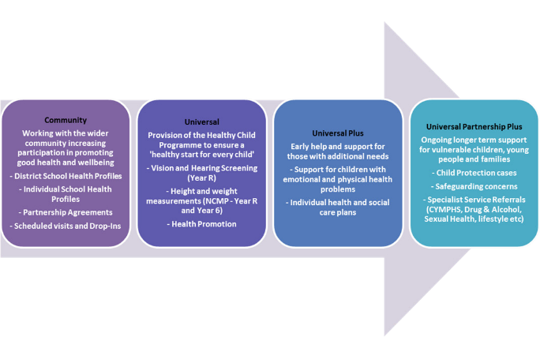

School specific sessions

- Targeted interventions can be undertaken for a range of health needs including emotional wellbeing, and referral on to specialist services where necessary.

- Packages of care (Tier 1 eg. Behaviour, bed wetting, bullying, bereavement, healthy eating and lifestyle, emotional health and wellbeing including anxiety, stress, depression, self-harm and anger management, sexual health, drug and alcohol misuse, sleep, complex needs) are offered where identified to be appropriate through assessment.

- The School Public Health Service can support the development and review of Health Care Plans for children with long or short term conditions and Education, Health and Care (EHC) plans as required.

- Assessments will be offered to young people in year 10 using the Lancaster model which is an early identification and preventative model to assess strengths and needs and risks. The purpose of the Lancaster is to provide the opportunity to discuss concerns and aspirations; assess physical health, growth & development; assess any mental or emotional issues; and identify any needs which require progressive (targeted) interventions. The questionnaires have been formulated to provide early intervention alerts by utilising research, government targets and public health priorities to enable the identification of individual pupils who may require a targeted intervention, support or information please visit: http://www.thelancastermodel.co.uk

- Training awareness sessions can be facilitated to support school staff to manage children/ young people with long term health needs such as anaphylaxis, epilepsy and asthma.

- ChatHealth – The School Public Health Service offer young people a confidential text messaging service. It is available all year round Monday – Friday. An ‘out of hours’ response provides further contact information if young people make a contact outside of the service being open.

- A confidential drop-in service can be offered which will be run within the School by a School Nurse or School Staff Nurse. This will be at a mutually agreed time. The room needs to be fully accessible by young people throughout this period of time.

- The School Public Health Service offer attendance at Market place events in Year 9 to support with key public health issues for young people in relation to healthy lifestyle & risk taking behaviours.

Partner services

CHATTS - The School Public Health Service have subcontracted CHATTS to provide therapeutic and counselling services to children/young people who require a targeted emotional health and wellbeing service.

NELFT - North East London Foundation Trust (NELFT) are co-located with the School Public Health Service to work in partnership. NELFT was commissioned from 1st September 2017 to provide an integrated Children and Young People’s Emotional Health and Mental Health Services (CYPMHS).
www.nelft.nhs.uk/services-kent-children- young-peoples-mental-health

HeadStart Kent - HeadStart Kent is a lottery
funded project for 10 to 16 year olds and their
families which offers to promote improved resilience, by developing the child/young person’s knowledge and lifelong skills to maximise their own and their peers’ emotional health and wellbeing in ways which work for them.
www.headstartkent.org.uk/

The Kent Immunisation Team offer
- The Human Papilloma Virus (HPV) vaccination which protects against Cervical Cancer and Genital Warts. This is currently offered to girls only but as next year will be offered to boys. We give this in Year 8, and will offer a catch up to those in Year 9 if missed in year 8.
- Meningococcal disease strains A, C, W, Y (MenACWY) Currently being offered to young people in years 9 and 10
- Diphtheria Tetanus and Polio (Td/IPV) Offered at the same time as MenACWY in years 9 and 10.

They also provide catch up clinics for any child or young person up to 19 years who are not up to date with their routine childhood immunisations

Contact details for the Immunisation Team are as follows:
Telephone: 0300 123 5205
Email: kchft.cyp-immunisationteam@nhs.net

Feedback

The School Public Health Service is continually striving to improve the service to ensure the best outcomes for children, young people and their families. We are keen to hear what we are doing well and what we could do better. The following link can be shared with anyone who has had contact with the service for them to provide feedback:

https://www.kentcht.nhs.uk/help-us/ways-to- get-involved/your-feedback/

We are also very keen to hear from partner agencies such as schools. We would be grateful if you could complete a feedback survey today.

To ensure effective feedback in a timely manner, we would appreciate your ideas as to the best method of gaining feedback. We will them look to develop methods to regularly gather feedback to inform service development:

Please select
Online Survey
Paper-based feedback form
Face to face meeting
Telephone survey
Other

Contact details

School Public Health Team

Phone: 0300 123 4496

Email: www.kentcht.nhs.uk/school-health

Kent Youth Health website: www.kentyouthhealth.nhs.uk

Cathie Burton | Head of School Public Health and Immunisation Service | cburton3@nhs.net | 01233 667870
Linda Starkie | Area Clinical Manager North West Kent | linda.starkie@nhs.net | 07825 104645
Imelda O’Connell | Area Clinical Manager South East | ioconnell@nhs.net | 07770 700699
Michele Ellis | Team Co-ordinator, Dartford, Gravesham, Swanley and Sevenoaks | m.ellis2@nhs.net | 07391 860956
Jean Ravenna | Team Co-ordinator, Tonbridge & Malling,  Tunbridge Wells and Maidstone | jeanravenna@nhs.net | 07795 256891
Allison Leigh | Team Co-ordinator,  Thanet, Swale and Canterbury | allison.leigh@nhs.net | 07557 663368
Christine Beer | Team Co-ordinator,  Dover, Shepway and Ashford | chrisbeer@nhs.net | 07946 171122
Alison Watkins | Team Co-ordinator for Single Point of Access | awatkins@nhs.net | 07392 864008

Appendix 1

Template letter re. Year 10 Lancaster Questionnaire

Dear colleague,

We would be grateful if you can support our young people health and wellbeing reviews by forwarding the below email to parents and carers of young people in Year 10. This questionnaire is only for this year group and so does not need to be sent to parents and carers of other years.

Many thanks for your help and support,

Cathie Burton
Head of School Public Health and Immunisation Service

Dear Parent/Carer
KENT COMMUNITY HEALTH NHS FOUNDATION TRUST SCHOOL PUBLIC HEALTH SERVICE
In line with government policy, the School Health Service offers the opportunity for your child to have a full health assessment and ask for help, support and information when it is needed.
To achieve this, your child will be involved in completing a simple secure online questionnaire about their health, wellbeing and lifestyle choices and behaviour. Although anonymous information may be shared, (for example information about lifestyle choices and behaviour) with other agencies to improve services, all personal information collected from this questionnaire will be treated as confidential and held securely to meet with data protection requirements.
After the questionnaire has been completed, the School Health Team may arrange to see your child if needed or if your child has requested it.
As your child progresses through his/her school career he/she will be asked to complete a further health questionnaire in year 13.
Details about the information we collect from you, what we do with it and how it may be shared can be found in the leaflet: What happens to personal information held about you? Which you can find online: www.kentcht.nhs.uk/personalinfo
Yours faithfully

www.kentyouthhealth.nhs.uk

Appendix 2
Template letter

Dear Head teacher / Chair of Governors

Disclosure & Barring Service Checks for Kent Community Health NHS Foundation Trust Staff Visiting Schools

Ofsted Guidance on DBS checks for visiting staff states:

‘For visiting staff who do have unsupervised regular access to children and young people – such as educational psychologists, social workers, supply teachers, trainee teachers, nurses, sports coaches, MOD personnel and inspectors – their ‘providing’ organisation (for example, the supply agency, the university, primary care trust, local authority and so on) should request the check. It is sufficient, for schools and colleges to seek written confirmation that appropriate checks, including DBS checks have been carried out and by whom – most commonly the relevant human resources department (it is not necessary to specify a named individual) – and to confirm the identity of these visitors.’

To help you comply with this guidance, this letter is confirmation that Kent Community Health NHS Foundation Trust HR Department obtains the following checks for all centrally employed staff who may as part of their jobs have unsupervised contact with children & young people on a regular basis:
  - Enhanced DBS disclosure with barred list check
  - 2 References
  - Medical Clearance
  - Eligibility to work in the UK.

Employees of the KCHFT School Public Health Service do not commence employment in posts with regular unsupervised contact with children until all satisfactory clearances have been received.

All KCHFT School Public Health Service employees are issued with identification badges and will show these upon their visit to your school.

This letter should be retained with your single central record for Ofsted purposes.

Should you require further information please contact:

Cathie Burton
Head of School Public Health and Immunisation Service cburton3@nhs.net

Version: Draft v1
Date of publication: March 2019

