Introduction
Blood borne viruses - principles of infection prevention and control
Produced by Public Health

Kent County Council (KCC) is required to assess, address and minimise any risks to the health, safety and welfare of staff, service users, contractors and anyone else affected by their actions, which includes prevention of infection. The council also has a general public health obligation to prevent the spread of infectious diseases and conditions.

Infection is always present somewhere in the community or health care setting. The objective of infection control is to prevent its transmission to new hosts and new environments. This is done by the application of effective measures to control and prevent the spreads of infection.

Infection Prevention and Control is also an issue of health and safety. It comes under the remit of the health and safety at work Act 1974. The health and safety at work act came into force on 31 July 1974.

Therefore application of the principles of infection prevention and control is a fundamental part of effective health and social care. Infection prevention and control principles and practices are very much part of Public Health within the community setting.

Public Health has been defined as:-

“The science and art of preventing disease, prolonging life and promoting health through the organised efforts of society.”
(Acheson, 1996)

This is a guidance document and KCC staff must follow local policies, using local documentation where appropriate.
General Principles of Infection Prevention and Control

The general principles of infection prevention and control are based on the use of practices and procedures that prevent or reduce the likelihood of infection being transmitted and by an understanding of fundamental microbial organism behaviour

How infection is spread
The spread of infection is caused by a ‘chain’ of events. Breaking the ‘chain’ involves interrupting one or more events in the ‘chain’. This can be achieved in three ways, through:

- control of sources of bacteria
- prevention of transmission
- maximising an individual’s immunity

The two most important contributory factors are people and the environment.

People
The keys are an individual’s vulnerability to the organism that will decide whether they will develop an infection (immune status), attitude and knowledge and commitment to personnel hygiene.

Environment
The environment includes equipment as well as fixtures and fittings. It is important that everything is kept clean and dry.

The chain of infection

There are a number of interconnecting factors that come together, resulting in an individual acquiring an infection. Figure 1 below demonstrates how they link together and the practices that are required to help break the chain.

Source or causative agent
The chain begins with an invading organism, which may be viral, bacterial, fungal or other. Specific reactions vary depending on the type of invading organism. Certain bacteria are described as normal flora or commensals they live on the skin or mucous membranes and become part of the body’s defences against disease. Other organisms colonise the individual (host), which means they invade a host but do not necessarily cause a reaction i.e. an infection. The hosts own immune system overcomes them.

Reservoir
A reservoir is the environment in which organisms are found. For example, soil is a reservoir for tetanus and animals are the reservoir for brucellosis. Infections most often arise from contact with infected or colonised people.

Mode of escape
Organisms may exit through the various body systems for example respiratory tract, or through skin lesions. Additionally organisms may escape from the host by means of insect bites, etc.

Mode of transmission
An infecting organism is only threatening if it finds a host having escaped from its reservoir. The mode of transmission may be by
- direct contact-that is animal bite or droplet spray
- indirectly, that is transmitted via an intermediate vehicle, such as infected food, water or body fluids.
- or environmentally on dirty equipment. The most common major mode of transmission is directly by person to person contact with the most common vehicle is the hands.

Portal of entry
The portal of entry to some extent mirrors the mode of escape. The most common mode of entry is via broken skin i.e. a leg ulcer, cuts and lacerations, the gastro intestinal tract (oral- faecal e.g. salmonella), respiratory, e.g. chest infections, genitourinary tract e.g. HIV, Blood e.g. Hepatitis B&C

Susceptible Host
The presence of an infectious agent does not necessarily produce disease. Illness following entry of infection into the body will depend on many factors. These factors include gender, age, general physical, mental and emotional health, the health and susceptibility of the host’s immune system.

Figure 1
CHAIN OF INFECTION
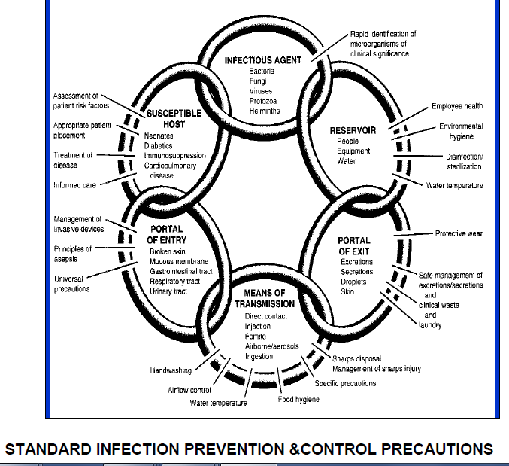

Universal Precautions is a policy developed in 1990 as a vital tool in the prevention of the spread of blood borne viruses and although this guide was originally aimed at the protection against infection with blood borne viruses, however this guide translates well for the prevention, control and the spread of all infection. They have now been updated and are now known as Standard Infection Prevention and Control Precautions.

Aspects of Hygiene

Handwashing
Hands are a major vehicle in the transmission of infection. Hand washing is the single most important measure in infection control. Hands should be washed with liquid soap and water after general patient contact or handling potentially contaminated articles. Thorough handwashing and careful drying on soft quality disposable paper towels is essential to remove the majority of resident and transient organisms. All rings and jewellery, wristwatches etc. should be removed prior to working in a client/work area and to washing. Rings may harbour infection and wrist watches reduce and prevent thorough washing from wrist to elbow. Clothing should be removed to enable” bare below the elbow”.

Any visible injury should be covered with a waterproof occlusive dressing (renewed as and when necessary) before attending a patient. Individuals with dermatitis and eczema should seek advice from their Occupational Health or their General Practitioner for advice as frequent handwashing can exacerbate the conditions. These conditions are not an excuse not to wash hands. Hands should be washed:

- before contact with a susceptible person or site
- after contact with body secretions/excretions including your own
- after handling contaminated laundry/equipment
- prior to administration of care
- prior to serving meals and drinks
- after removing articles of protective clothing, for example masks, gloves or aprons
- at the beginning and end of a span of duty
- any duty which involves close contact with a person

Studies have shown that handwashing techniques are often inadequate. It should be remembered that the surfaces of the hand consist of the palm, dorsum and areas between the fingers. All surfaces should be included to remove bacteria and dirt effectively.
The essentials requirements for good hand washing are:

- liquid soap
- hot or warm running water
- friction
- thorough drying
- disposable towels of hot air dryer
- foot operated bin for disposal of paper towel hands

Only soap and hot or warm water and/or alcohol based hand disinfection preparations are required for medium or low risk procedures. For high risk procedures, such as prior to minor surgery, a further hand decontamination may be carried out prior to wearing sterile gloves using an antibacterial agent. Scrubbing hands is generally not recommended as it debrides the skin. Soft bristle brushes may be required for ensuring nails are clean. If brushes are used, a sterile brush should be used on each occasion. It is possible to obtain commercially packed brushes. They should never be left on a sink for multi-use. Drying the hands thoroughly on soft quality disposable towels is an essential component of the washing process.

Hand washing technique

Always use liquid soap
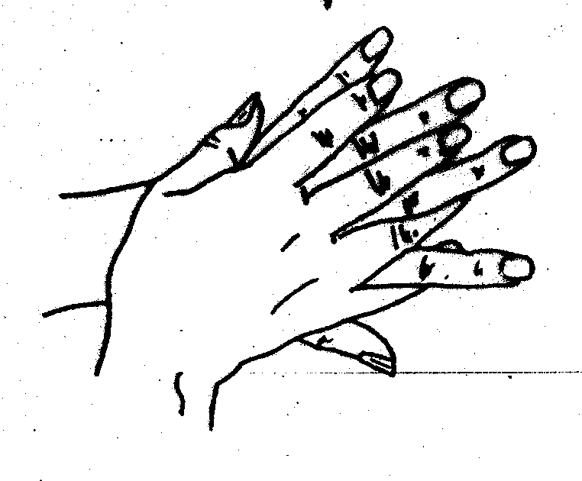

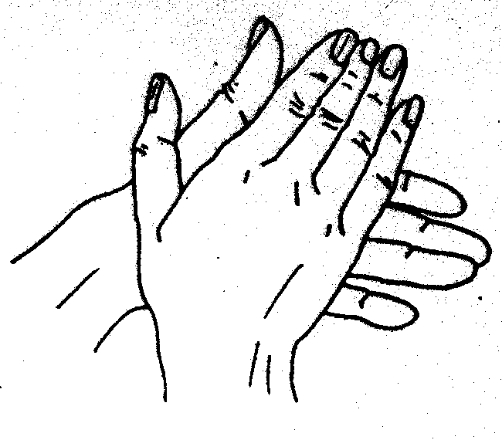

1. Rub palm to palm 2. Rub backs of both hands
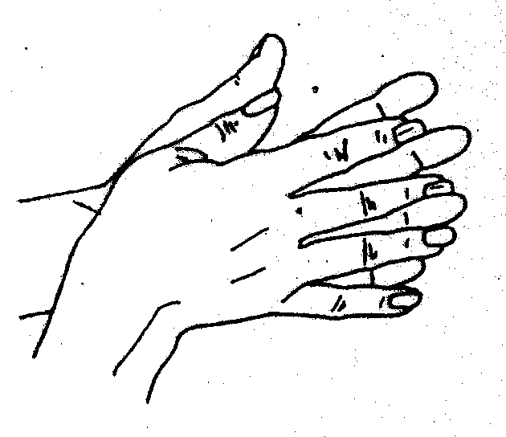
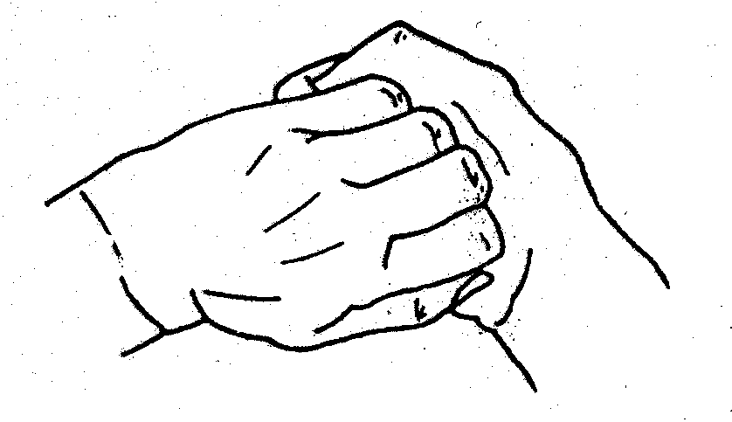

3. Rub palm to palm with fingers 4. Rub backs of fingers (interlocked)
(interlaced)
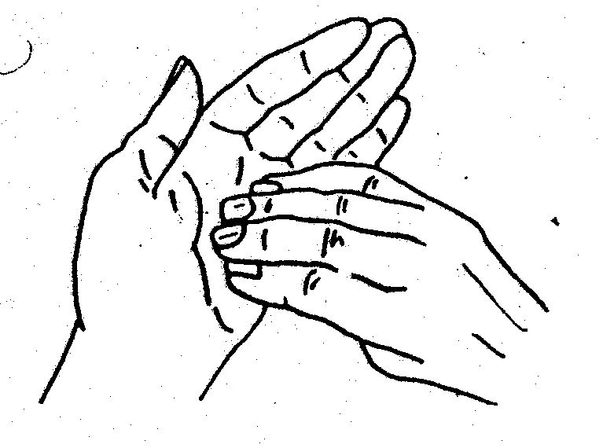

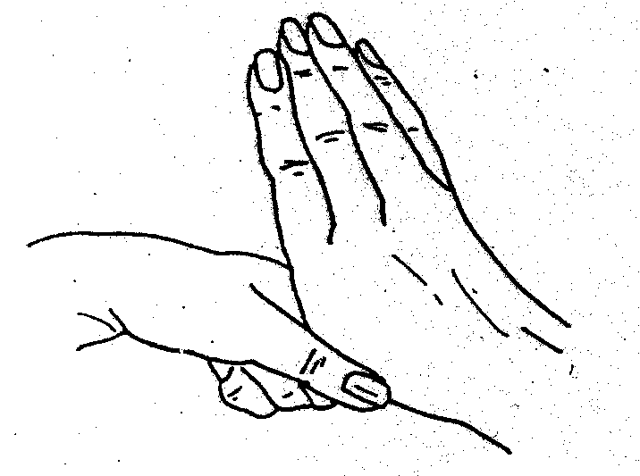

5. Rub all parts of both hands
6. Rub both palms with finger tips
The above should take 15-20 seconds

7. Rinse hands under clean warm running water (15-20 seconds)
8. Dry thoroughly on a clean dry paper towel. (15 -20 seconds)
9. Wipe taps with paper hand towel and discard in foot operated bin

Apply hand lotion (not from a communal pot)

Use the same 6-step technique when using alcohol gel. Alcohol gel should not routinely be used in place of hand washing. On occasions when Soap and water is not available and alcohol gel is, used hands should be washed with soap and water at the earliest opportunity.

Alcohol gel is not effective if hands are visible dirty or if clients have Clostridium
Difficile or winter vomiting disease

This technique is based on a procedure described by G.A.J.Ayliffe et al. (1978)

Protective clothing
Where there is a risk of splashing, single use disposable plastic aprons must be worn. They must also be worn when having direct contact with patients / clients and when disposing of clinical waste or substances which have been in contact with an infectious disease. Seamless single use disposable gloves, for example non latex or vinyl should be used when dealing with all blood or body fluids. Where there is a risk of aerosol spray or danger of flying contaminated debris or blood splashes, eye protection must be worn.

Laundry
In the event of paper towels not being available, any linen used should be changed at least daily and washed with detergent and water at a temperature of at least 71°C (158°F). Care should be taken to segregate soiled linen and wash separately. Washing agents suitable for low temperatures should be used at the appropriate concentration as recommended by the manufacturer.

Disposal of Waste/Clinical /Hazardous Waste Management

Due to legislative changes that include Hazardous Waste (England and Wales) Regulations 2005 and the lists of Waste regulations 2005 (which introduce the European Waste Catalogue Codes), there have been substantial changes in the way that waste is defined. Although clinical waste is still defined in the Controlled Waste Regulations 1992, however, as a consequence of the Hazardous Waste regulations 2005, any waste that is deemed to be infectious or hazardous is considered to be hazardous waste and must be consigned for disposal at suitably licensed facilities.

The Hazardous Waste Regulations 2005 define Infectious waste as “substances containing viable micro-organisms or their toxins which are known or reliably believed to cause infection in man or other living organisms.”

All those working in areas where clinical/hazardous waste and general waste arise must adopt safe working practices, since failure to do so may result in the establishment being in breach of its statutory obligations as regulated by the environment agency under the Environment Protection Act, section 34 Duty of Care requirements.

The generator (the provider of health care) waste has a duty of care to ensure waste is correctly segregated, sealed and stored at the point of origin before collection for incineration or land fill. Personal protective clothing must always be worn when handling waste.

Different classes of waste must be segregated and discarded into colour-coded containers. It is the responsibility of the waste generator to dispose to segregate the waste safely and appropriately e.g. no flowers or newspapers in the hazardous waste container.

The collection of waste should be arranged through a licensed disposal contractor using licensed carriers to transport the waste to licensed treatment/disposal plants only.

Clinical Waste
When generated on health care premises or as a result of health care, the following must be disposed of in orange bags:

- soiled surgical dressings, swabs and all other contaminated waste from treatment areas
- material other than linen from cases of infectious disease
- all human tissues (whether infected or not) and tissues from laboratories, and all related swabs and dressings
- tampons and used sanitary towels; where possible these should be disposed of separately in dedicated sanibins

NB Orange bags must not be placed in second orange bag. All bags must be securely tied using the ‘swan neck’ technique and labelled with the place of origin and date of disposal.

The above regulations require clinical waste that is generated as a result of health care in an individual's home to be disposed of in orange bags. The “Duty of Care” and safe disposal is considered to be the responsibility of the provider of the health care. This requires clinical waste to be collected from each home by a collection service. Waste should be segregated at the point of origin.

Handling of Clinical Waste
- Personal Protective Clothing must always be worn when handling clinical waste
- clinical waste should be correctly bagged in orange bags of 225 gauge to prevent spillage
- clinical waste bags should be used in a holder or container with a foot-operated lid and, so far as is reasonably practicable, out of the reach of children
- clinical waste bags should only be filled to 2/3 full
- clinical waste bags are securely sealed with coded tape at the point of use
- cags are not re-used
- clinical waste is not decanted into other bags but remains in the original bag, regardless of volume (less than 2/3 full)
- the exterior of the clinical waste bag is uncontaminated and seals are secure.
- bags MUST be secured indicating originating area/dept
- nappies should be disposed of in nappy sani-bins in designated centres.

Clinical waste bins must not be put into toilets in centres, where there is a clinical waste collection the parent or carer may place the used nappy in an orange bag. It is the clinicians responsibility to oversee the procedure and to ensure that the 3/4 orange bag/s is sealed and placed in the secure locked collection area at the end of their session.

In all other circumstances nappies must be taken home for disposal by parents/carer.

Sharps
Discarded syringes, needles, cartridges, small items or broken glass and any other sharp instruments must be put in the approved sharps container. (See Safe disposal of discarded needles and syringes guidance).

Non-Clinical Waste
Other general waste (e.g. food waste) should be disposed of in black bags or recycled. All other materials if not contaminated or food waste should be disposed of into recycling bags which are then “sorted” at the refuse centre.

Any “domestic” glass or sharp plastic is to be packaged into an empty carton and placed in the recycling bin.

Storage of Clinical Waste
Clinical waste should be removed daily to the clinical waste store and then from point of generation as frequently as circumstances demand, and at least weekly. Whilst awaiting collection of bulk amounts, waste should be:

- stored in correctly coded bags, with bags of each colour code kept separate.
- situated in a separate area of adequate size related to the frequency of collection which displays a biohazard sign
- sited on a well-drained, impervious hard standing floor, which must be washed down at frequent intervals
- kept secure from unauthorised persons, entry by animals and free from infestation
- accessible to collection vehicles

Transport of Clinical Waste
The transport of clinical waste off-site for eventual disposal is dealt with specifically in the environmental legislation. Close liaison between producers and registered contractors is essential.

An identified employee of the premises needs to sign a consignment note to confirm that the clinical waste has been collected by the authorised waste collection service. This is retained on the premises for two years.
A safe system of work includes:

- written evidence of what is contained within the waste
- all handlers have received training in the handling of waste
- all vehicles are licensed to carry waste
- handlers are provided with protective clothing
- an emergency telephone number of the transport company is provided in the event of an accident
- it should be checked that the contractor is registered to transport waste
- staff must not carry clinical waste unless it is transported in a “red community box” and then disposed of appropriately at their designated base

Control of the environment

General cleaning
Some micro-organisms can survive in the environment for long periods and are more likely to spread if dust is allowed to collect. Unless otherwise indicated, washing with hot soapy water and thorough drying will suffice in the majority of cases.

Toilets and sluices often provide the warm, moist, ill lit and badly ventilated conditions which aid bacterial growth. Sinks, basins, sluices etc. must be clean and well maintained.

Problems with the water supply or waste services of these items must be reported and appropriate action taken immediately.

Furniture, fixture and fittings should have accessible and easy to clean surface which are impervious to spillage. Toilets should have lids to avoid the spread of aerosols into the environment when being flushed.

All health, social and multi-use premises should be cleaned to NHS standards which require the use of colour coded mops, buckets and cloths for use in specific areas. This is best practice in any environment.

Floors and Wall Surfaces
Where the work surface is impervious (that is, not wood) there is no need to cover it with impervious disposable coverings.

Effective cleaning and disinfection are greatly aided and simplified by a strict system of zoning. In practice, this means defining the areas which may be contaminated during procedures; only these areas need to be cleaned and disinfected between tasks. A room can, as a result, be cleaned rapidly. In addition, between sessions, all work surfaces, including those apparently uncontaminated, should be thoroughly cleaned and disinfected. The aim of the cleaning and disinfection process is to reduce the microbial load below the minimum infective dose. Cleaning is achieved by applying a detergent liquid to the surface and physically wiping the area clean with a generous application of elbow grease! The surface can then if required be disinfected with a suitably virucidal disinfectant which will kill or inhibit most microbes.

Kitchens
Kitchens are potential sources of food poisoning. Careful attention to food hygiene and processing at all stages of preparation is vital. Policies and protocols must recognise current legislation

Sinks
- Should be accessible
- Lever taps promote good hygiene by encouraging a non-touch technique after washing hands. Elbow operated mixer taps or sensor taps are preferable
- Bar soaps should not be used as they can harbour bacteria if left in a pool of water. Soap dispensers are advisable
- Disposable paper hand towels in a dispenser should be available for hand drying
- Disposable cloths should be used for cleaning purposes
- Sinks that are used for hand washing should not be used for any other purpose especially washing or storing used instruments and disposing of urine
- Plugs should not be used when washing hands

Infection Prevention & Control and Cleaning
National Colour Coding
Red |  | Blue
Green |  | Yellow

Based on the National Colour-Coding System for the British Institute of Cleaning Science
Red | = | Bathrooms, washrooms, shower, toilets, basins and bathroom floors
Blue | = | General areas including multi use areas, departments, offices and basins in public areas
Green | = | Catering departments, kitchen areas and food service areas
Yellow | = | Isolation areas
Cleaning Procedures

1. The aim of a colour coding system is to prevent cross contamination. Work from the cleanest area to the dirtiest area.
2. Colour coding for hygiene should form part of staff induction and continuous training programme.
3. A minority of people are colour blind in one or more colours. Some individuals may not know this and colour identification testing should form part of any induction training.
4. Always use two colours within the washroom/ sanitary area.
5. The colour-coding system must relate to all cleaning equipment, cloths and gloves

Sterilisation and disinfection

Decontamination
Decontamination – covers methods of cleaning, disinfection and sterilisation for the removal of microbial contamination from equipment

- Cleaning – removes some vegetative microbe’s bacteria, viruses and fungi.
- Disinfection – reduces vegetative microbes but may exclude bacterial spores.
- Sterilisation – achieves complete destruction of micro-organisms and their spores and all living matter

Bacteriostatic agent - prevents microbes from multiplying but may not destroy them.
Cleaning
Cleaning is a process, which physically removes contamination but does not necessarily destroy microorganisms. The reduction of microbial contamination cannot be defined and will depend upon many factors including the efficiency of the cleaning process and the initial bio-burden.

Sterilisation
Most infectious agents are susceptible to heat. Whenever possible, equipment should be sterilised by conventional procedures employing moist or dry heat. The highest sterilising temperature compatible with the equipment should be used. Manufacturers’ instructions for effective and safe use of steam and hot air sterilisers should be followed.

Disinfection
Where items cannot be sterilised, it will be necessary to employ methods of chemical disinfection. The use of chemical disinfectant is restricted by many factors, including their variable effects on different micro-organisms, reduced efficiency in the presence of organic matter and susceptibility to deterioration during storage. It is therefore recommended that chemical disinfection only be undertaken in the absence of a satisfactory alternative. Further advice on suitable methods of sterilisation and disinfection of equipment may be given by contacting the local infection control team.

Single Use Items
Single use items are extremely abundant. When using disposable items, health and social care professionals must be very clear whether the product they are using is designated, single use only, single patient use or single session use.

These items have a product licence indicating use and should not be recycled or reused (Consumer Protection Act 1987).

Routine Equipment Decontamination
All equipment e.g. zimmer frames must be either single use or appropriately decontaminated between each client use. Where necessary, cleaning of all equipment must be done as per manufacturer’s instructions by a trained operator and in suitable dedicated areas. Instruments should be stored dry.

Single Patient Use equipment must only be used as stated by manufacturer’s instructions.

Infection Control in the Legal Context

The Law
Health and Social Care Act 2008 with its code of practice implements a comprehensive Infection Prevention and Reduction strategy. The Health and Social Care Act 2008 has the Care Quality Commission as the regulatory body for Health and Social Care Services in England.

All health and social care providers are required to register with the Care Quality Commission from April 2010. The registered providers need to demonstrate that they are meeting the requirements in order to be registered. Additionally, the Care Quality Commission need to be assured that the community health and social care service premises continue to meet them to remain registered. This will provide satisfaction to all patients and clients that their treatment/care meets the essential requirements for Infection Prevention and Control

Infection prevention and control is an issue of health and safety. It also comes within the remit of the Health and Safety at Work Act.

The Health and Safety at Work Act came into force on 1 April 1974. It is still the essential reference point when considering health and safety at work.

The Act’s basic objective is to establish a simple, strong and unified system of protecting people at work. It should work through joint consultation and co-operation between the employer and employees. The Health and Safety at Work Act applies throughout England, Scotland and Wales. Employees also have a duty under the Act to take care of themselves and, by their actions, other workers, neither should they interfere nor misuse anything provided to protect their health, safety or welfare. They must co-operate with their employers.

References-
Acheson D 1988 Public Health in England. HMSO, London
-Ayliffe G.A.J et al. (1978) A test for ‘hygienic, hand disinfection’. Journal of Clinical
Pathology 31
Caddow.P. (1994) Applied Microbiology
Health and Safety Executive (1992 Personal protective equipment at work: guidance on regulations, London HMSO
NHS National Patient safety Agency. (2007) The national specifications for cleanliness in the NHS: a framework for setting and measuring performance outcomes
Royal college of Nursing (2000) Good practice in Infection Control RCN
Royal college of Nursing (1995) Infection Control in Hospitals RCN DH (2008) Health and Social care Act and its code of practice

