Winter Planning Guidance for Schools in Kent

“Schools should, wherever possible, stay open in severe weather. They play a key role in their communities and by staying open help both their pupils and parents.”
– Department for Education

Every winter brings the possibility of snow and ice. Extreme bad weather can cause widespread and prolonged disruption. Schools are often affected and it can be difficult to maintain an education service.

This guidance provides advice for headteachers about the risks that schools may face, some preventative strategies and advice on how to communicate a school closure to parents, stakeholders and the Local Authority.

The aim of the guidance is to be a useful touchstone and offer reassurance that acting reasonably and applying sound risk assessment principles will enable headteachers to determine risks and to confidently make the best decisions for schools.

This guidance is split into the following sections:
- Preparing for severe snow and ice – short and long term actions
- School staff
- Risk assessment/management
- Communication with parents and staff
- The Kent Closures Website
- Appendix 1: Useful Websites
- Appendix 2: Example Newsletter to Parents
- Appendix 3: Risk Assessment Template

As a fundamental principle, every effort must be made to keep schools open, even if only limited numbers of pupils can attend. However, there will be circumstances where schools may have to close due to unavoidable circumstances. Those circumstances being that it is no longer safe for staff or pupils to be onsite. The cancellation of public transport or the inability to run a normal timetable due to staff absences are not considered unavoidable circumstances.

The government has stressed the importance of schools remaining open, wherever possible, as closures have a knock on effect on parents/carers who are key workers in other areas of the public sector, e.g. Health Services, thus undermining crucial service delivery. The overriding principle is, therefore, for schools to remain open to the maximum degree possible, as is consistent with health and safety requirements, even if it is not possible to run a full timetable.

Preparing for Severe Snow and Ice
There are long and short term actions you can take that will increase your ability to remain open during times of severe snow and ice.

Long term – consider these actions well in advance of winter weather:

- Develop a written school policy for extreme snow and icy conditions and ensure it is fully communicated to staff and parents/carers. (See Appendix 2: Example Newsletter to Parents).
- Ensure stocks of salt/grit/sand are adequate for the time of year and foreseeable weather.
- Consider alternative local suppliers of road salt, such as your Parish Council. Please remember salt stocks should be sourced well in advance of winter, not days before predicted snow because transporting salt may be inhibited by bad weather.
- Pre‐identify the outdoor areas used by pedestrians most likely to be affected by ice, for example: ‐ building entrances, pedestrian walkways, shortcuts, sloped areas and areas constantly in the shade or wet.
- Ensure water, boiler and heating systems are regularly maintained.
- Inspect windows and exterior doors for draughts. Consider repairs and draught‐proofing.
- Check that pipes are appropriately lagged.
- Consider making arrangements with a contractor to clear the school site (as supermarkets do) and possibly work with other schools to share the service.
- Talk to local community groups that may be able to support during heavy snow and ice.
- Perhaps put agreements in place with staff in advance of severe weather.

Short term – consider these actions days before forecasted severe snow and ice:

- Regularly check weather forecasts via news and websites. Take action whenever freezing temperatures are forecast. A designated member of staff could regularly monitor the following sites:
  - BBC Weather http://www.bbc.co.uk/weather
  - Met Office http://www.metoffice.gov.uk
- Leave heating on a low setting overnight.
- Where curtains and blinds are fitted consider closing them at night to retain heat.
- Close doors between areas of differing temperatures.
- To enable proper circulation of warm air consider keeping radiators clear of obstruction.
- Put procedures in place to prevent any icy surface forming and/or to keep pedestrians off the slippery surface.
- Use grit or similar on areas prone to being slippery in frosty/icy conditions.
  - Gritting should be carried out when frost, ice and snow is forecast or when walkways are likely to be damp or wet and the ground temperatures are at, or below freezing.
  - The best time is early evening before the frost settles, if this is possible (or additional salt is required), use it early in the morning before people arrive. Salt doesn’t work instantly, it needs sufficient time to dissolve into the moisture on the ground. Please remember, if you grit when it is raining heavily the salt will be washed away causing a problem if the rain then turns to snow.
- Cover walkways e.g. by an arbour high enough for people to walk through or use an insulating material on smaller areas overnight.
- Divert pedestrians to less slippery walkways and barrier off existing ones.
- Consider plans to restrict the movement of pupils and staff around the school grounds.
- Remember it is not always necessary to clear the car park of snow as it can be taken out of use until such time as it is safe to be used. Staff can make alternative parking arrangements providing it is safe to do so.
- Try to ensure access points into buildings have the means for people to wipe off water, snow or ice from their shoes.

School Staff
Please remember you cannot direct a member of staff to drive in severe weather. However the expectation is that staff will make every effort to attend school during severe snow and ice except in the most extreme cases where they can demonstrate a high degree of risk or by virtue of distance or terrain and absence of transport that it’s simply not possible for them to attend.

- The headteacher should be aware of the location of their staff and be able to communicate with them to determine attendance.
- Ask staff what alternative arrangements they intend to make to get to work: walk, bus, train, car sharing.
- Please also consider planning for staff such as county clearance/gritting plans/routes etc (information about planned gritting routes can be found on:
http://webapps.kent.gov.uk/KCC.MyNearestGIS.Web.Sites.Public/Default.aspx?lyrs=35&xmin=510905&xmax=671095&ymin=91716&ymax=191284&bg=_osColour
- If possible, arrange for staff to accommodate each other locally in severe conditions if returning home is impossible.
- An agreement may be reached for certain staff not to be expected until later in the morning or to be released early.

Risk Assessment/Management
Risk management and assessment aims to help schools identify potential risks in advance of severe snow and ice and ensure appropriate control measures are implemented. It also assists headteachers in making the right decision on the day by adopting an approach that is grounded in common sense and being proportionate.

“‘The decision whether to close must however, be for headteachers as they know their schools and surrounding areas. They should use common sense in assessing the risks and keep their schools open.”
– Department for Education

The decision to close or restrict attendance should be taken by the headteacher of the school or in their absence by the most senior member of the teaching staff available and after the completion of a suitable and sufficient risk assessment (see Appendix 3: Risk Assessment Template).

The following should be considered and management systems put in place:

- Is the school building accessible?
  - Are pedestrian routes on the school grounds passable?
  - Is there means to clear these routes e.g. salt/grit?
  - Can priority be made in respect to slopes, steps or ramps or can these areas be restricted from use?
  - Outside metal staircases should also be avoided unless appropriately treated.
- Can the headteacher ensure enough teaching and/or supervisory staff to operate safely?
  - The emphasis would be to operate safely, not whether a full or normal curriculum could be followed.
  - There are no supervisor ratios for non‐teaching periods. Internal management should decide staffing numbers depending on risk and by considering the type of pupils (age, behaviour, disabilities) and the type of activity they are doing.
- Is the school appropriately heated?
  - Is there enough fuel for the day?
- Are water systems working appropriately?
- Is it possible to restrict outside play to limit the snow/ice becoming compacted and therefore more dangerous.

It is vital a risk assessment is completed prior to the decision being taken to close, in order to ensure all the safety issues have been considered and control measures implemented. It will also serve as evidence should justification be needed to defend the school closure.

During each day headteachers will want to review their risk assessment. It is expected that a school will remain open until normal time for the end of the school day. However if the revised risk assessment indicates that circumstances have changed to such an extent that the headteacher believes conditions are now unsafe, early closure may be necessary. In such circumstances the school should register their closure online at (see ‘Communication with Parents and Staff’).

A school must never close completely unless the headteacher is certain that no child will present his/herself. A member of school staff must remain on site in case any students or staff arrive at the school after it has announced it is closed. Arrangements must always be made for the security of children and parental consent must be sought if sending them home.

If you have any questions about completing a risk assessment, please contact Kent County Council’s Health and Safety Unit on 03000 418456.

Communication with Parents and Staff

It is vital that parents and staff are made aware of the school’s closure as early as possible. Please

also consider any onsite stakeholders that may also be affected if the school is closed, e.g. Adult

Education classes etc.

Communication with parents in advance of severe snow/ice

You may already do this but consider communicating with parents in advance of severe snow and ice via a school newsletter to aid preparation and ensure they know how to find out if the school is closed. (See Appendix 2: Example Newsletter to Parents).

- Re‐iterate the advice from the Department of Education about schools remaining open (see page 1).
- Remind parents about the preparations the school will be undertaking to ensure the school remains open for as long as possible.
- Remind parents they can go online to see if their school is closed www.kentclosures.co.uk
- The Kent Closures website will also display closures for a number of services including libraries, nurseries and Children’s Centres.
- Remind parents they can hear about school closures by listening to KMFM, BBC Radio Kent and Heart FM.
- They can also visit www.kent.gov.uk/winter for more information about salting routes, KCC, services affected, travel issues etc.
- Suggest parents may want to sign up for the SMS or email alerts on www.kentclosures.co.uk
- Please be aware there is a charge for SMS alerts (not for emails).

Suggest visiting the BBC or gov.uk websites for home learning resources to support children’s learning while the school is closed (see Appendix 1: Useful Websites).

The Kent Closures Website
After the decision has been made to close or partially close the school you will want to communicate that closure to parents and staff as soon as possible.

The Kent Closures website allows a school representative to log in (with a school specific password) and change the ‘status’ of the school to ‘open’, ‘closed’ or ‘partially closed’. The information will then be displayed on the website for parents and staff. In addition, when the status of a school is changed the information is shared with Kent radio stations so the closures can be broadcast.

Please also consider any onsite stakeholders that may be affected if the school is closed e.g. Adult Education classes etc. www.kentclosures.co.uk

Please note: this website is intended to display term time closures only, not times when the school is closed due to holidays.

Register with the Kent Closures Website
In advance of winter please register your school with the Kent Closures website to create your school password, which you will need to log your closure on the morning of severe snow/ice. This school specific password ensures the announcement of your school closure is secure. If you have problems registering please contact KCC Emergency Planning or your Area Schools Organisation Officer.

The local authority is required to maintain records of school closures. The Schools Closure website collates data on closure AND links in with local media outlets. It is therefore essential that you use it to inform your community and the wider authorities of closure; even if you have your own bespoke or corporate notification mechanism.

You can register by visiting www.kentclosures.co.uk and clicking the ‘Education service login’ button on the right hand side of the screen:

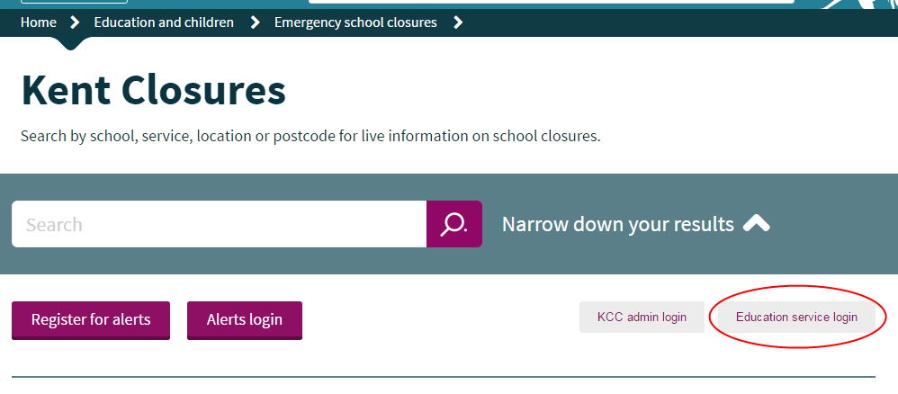

Here you can find your school using a drop down menu – select the town first and then the school, then click ‘Submit’:

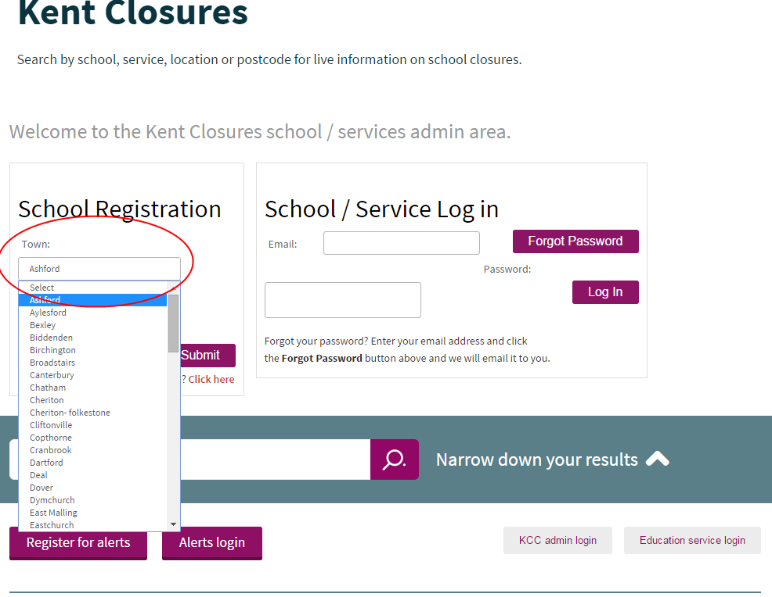

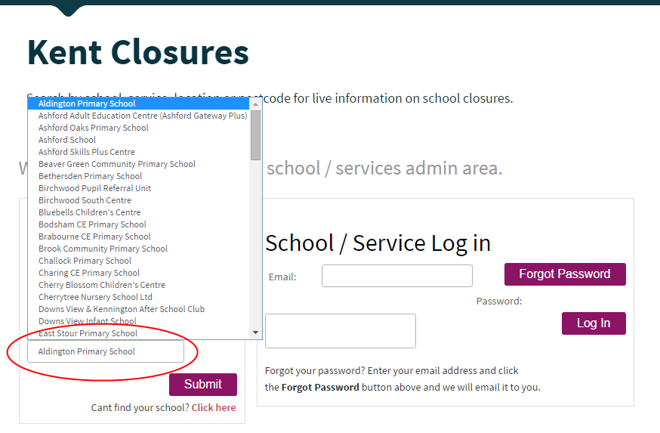
Once you click on your school you will be taken through to another page to confirm your registration. Simply confirm the address details of the school, complete your name/email and create a password (this will be needed to log your closure on the morning of severe weather).

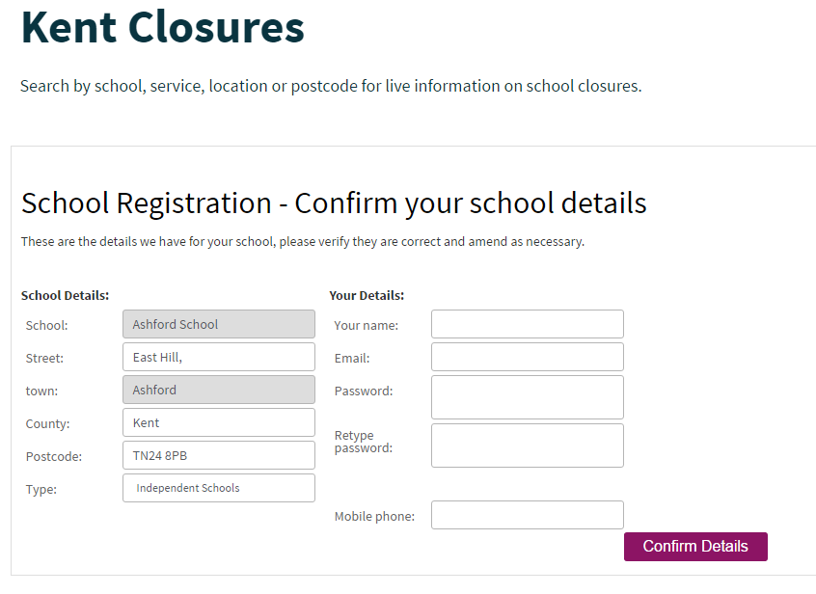

Once Digital Services have approved your registration (this could take a couple of days) you will then receive an email that requires you to click on a link to validate the email address. Once you have validated the email address please log into your account and initially set your status to ‘open’.

If you registered last year you can still use the same email address and password to log in this year.

If you don’t know if you registered last year, you can work out if you did by clicking on your school from the drop down menu. You may then receive a message on screen saying you’ve already registered. This means you registered last year and have already created your school specific password. If you don’t remember your password, click the original ‘Education service login’ button again and under ‘School / Service Log in’, type in the email address which was previously displayed in the onscreen message and click ‘forgot password’. A password reminder will then be sent to your registered email address.

If you need to change the email address that you originally registered with last year, email digital.services@kent.gov.uk with details of the new email address.

On the morning of severe snow/ice
Once the decision has been made to close your school, visit www.kentclosures.co.uk with your
password ready. Click the ‘Education service login’ button and log on using your school email address and password.

You will be asked to update your status to either ‘open’, ‘closed’ or ‘partially closed’. Your status will remain the same until you change it, so please remember to ‘re‐open’ your school if you do close it.

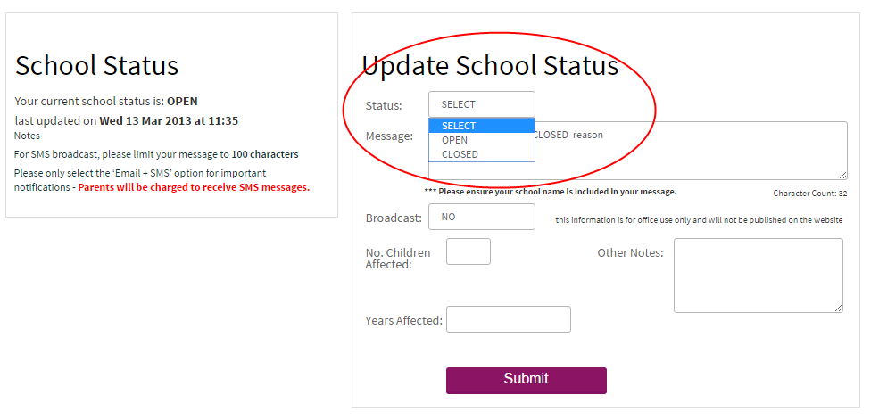
You will be asked the following:

- Message – there is a default message but you can change this and include further information if necessary e.g. cancellation of parents evening or the continuation of Year 10 exams etc.
- Approximate number of children affected.
- Year groups affected.

Within minutes this information will be displayed on the Kent Closures website. Kent radio stations will use this information to broadcast closures over the radio.

It is now no longer necessary for your school to call the radio stations and/or the Local Authority to announce the school closure. However, you can still speak to your Area Education Officer if you would like advice about whether to close or not.

If you cannot get online on the morning of severe snow/ice, you can call your Area Education Officer (AEO) or Area Schools Organisation Officer (ASOO) and they will note the necessary details and complete the online information for you. Their contact details are below:

Marisa White | Area Education Officer for East Kent | 03000 418794 | 07834 841560
Jane Wiles | Area Schools Organisation Officer, East Kent | 03000 418924
Jill Clinton | PA to Marisa White | 03000 410129
Ian Watts | Area Education Officer for North Kent | 03000 414302 | 07919 212062
David Hart | Area Schools Organisation Officer, North Kent | 03000 410195
Ann Drury | PA to Ian Watts | 03000 410157
David Adams | Area Education Officer for South Kent | 03000 414989 | 07740 184848
Lee Round | Area Schools Organisation Officer, South Kent | 03000 412309
Julie Hawkins | PA to David Adams | 03000 410199
Jared Nehra | Area Education Officer for West Kent | 03000 412209 | 07786 191476
Michelle Hamilton | Area Schools Organisation Officer, West Kent | 03000 412037
- vacant - | PA to Jared Nehra | 03000 412134

SMS Service
Parents and staff can register for alerts via email for free or SMS for a small charge on the Kent Closures website. This means that as soon as you change the status of your school on the Kent Closures website, the parents and staff who have registered will be notified via SMS or email.

Be Prepared
Before the winter and the chance of severe snow/ice, please ensure:

- A member(s) of staff has been nominated to carry out the process of logging into the Kent
Closures website and changing the status should the school need to close.
- The password has been kept secure but is easily accessible/known by the nominated person
- That www.kentclosures.co.uk is accessible or saved as a quick link on a school/home computer.
- The number for your AEO/ASOO is easily accessible/known should you be unable to get online.
- The name and contact number of the AEO is available should you require advice about
whether to close or not.`

Appendix 1: Useful Websites

Kent County Council | School closures, gritting routes | http://www.kent.gov.uk/winter
Kent Health and Safety Unit | Event Safety, First Aid and Lone Working | http://www.kelsi.org.uk/school_management/day-to-day_administration/health__safety.aspx
Highways Agency | Conditions on motorways and trunk roads | http://www.highways.gov.uk
BBC Road Traffic Advice for Kent | Traffic on Kent Roads | https://www.bbc.co.uk/travel/kent/incidents/road
Traveline | Public transport information for journeys within South and East England | http://www.travelinesoutheast.org.uk
Health and Safety Executive | Risk assessment/ management | http://www.hse.gov.uk/risk/index.htm

Appendix 2: Example Newsletter to Parents

Dear Parents and Carers,

Severe Snow/Ice Plan for Parents and Families

Every winter brings the possibility of snow and ice. Extreme bad weather can cause widespread and prolonged disruption. Schools are often affected and it can be difficult to maintain an education service.

As a fundamental principle every effort must be made to keep schools open, even if only limited numbers of pupils can attend. However schools may close due to ‘unavoidable’ circumstances. Those circumstances being that it is no longer safe for staff or pupils to be onsite.

We recognise that it is important our school remains open so parents are able to work and pupils can continue to learn. [Name of school] will make every effort to prepare for severe snow/ice this winter by [insert preparations e.g. gritting pathways, clearing access points etc].

How will we let you me know if the school is closed?
If we do experience severe snow/ice resulting in hazardous conditions, [our Headteacher] may have to take the decision to close the school. Once this decision has been made we will notify parents via the Kent Closures website. To determine whether [name of school] is open or closed please visit www.kentclosures.co.uk. Search for the school in the search box. The Kent Closures website can also be used to find out if other services in Kent are open or closed, such as nurseries, children’s centres and libraries. We also recommend parents sign up for SMS/Email alerts on the Kent Closures website. This service will send an SMS or email alert to let parents know if [name of school] is closed. Parents can also listen to KMFM, BBC Radio Kent or Heart FM to hear if the school has closed.

What can you do to help?
- Please visit www.kent.gov.uk/winter for more information about gritting routes and travel issues around Kent so you can plan your journey.
- Please approach the school from [detail a pre‐identified access into the school].
- Please can you provide a packed lunch from home in case school meals cannot be provided.
- Don’t forget suitable warm clothing – gloves, hats, scarves, wellies etc. or even a change of clothing.
- If you are a working parent or feel you may have a problem with a sudden earlier pick up, please could you put a back‐up plan in place with another family member or parent and inform the school. This will allow staff to leave earlier for their safety if weather dictates.

Many thanks for your support in helping [name of school] remain open during periods of severe snow/ice.

Appendix 3 Risk Assessment Template for Snow and Ice

In accordance with government policy every effort should be made to keep a school open and the closure of the school must be justified. In order to determine a decision, work through the following risk assessment. If your site has specific issues that are not listed, these should be added. Any pre‐planning controls not in place must be transferred to your action plan at the end.
This assessment should be carried out:
• Before any bad weather arrives ‐ make sure identified control measures are implemented; refer to your action plan at end
• At the time of the emergency ‐ consider and complete last header column
• After the event ‐ does the risk assessment need to be reviewed?

 | Are the following controlmeasures in place? | State what risks are involved and theconsequence of the risk | State which control measures are in place to reduce the risk | Are the controls in place?  (Pre‐Planning) |  | Are the controls in place?  (On the day)
 |  |  |  | Yes | No | Yes | No
1 | Is there enough salt/grit available on site to keep a clear path for safe access and egress around the school site? | Slip/Trip of pupils, staff, 3rd party visitors, causing a falling injury. | Maintain stocks of salt/grit.
 |  |  | Identify which walkways or areas need to be cleared to allow people to get around the premises safely.
 |  |  | Allocate a responsible person to monitor weather reports and grit/salt prior to snow/ice forming.
 |  |  | Reduce the movement of people around the premises.
 |  |  | Identify access specific routes and restrict movement to those routes.
2 | Is there an acceptable ratio of staff to pupils to attain adequate supervision? | Staff not being able to attend school, leaving pupils without adequate supervision, | Estimate how many staff members need to get in for the school to operate safely by identifying how many pupils could attend.
 |  |  | Identify how many staff would be safe to travel to work in severe conditions.

 |  |  | Inform staff to listen to Road Safety (AA) to see if the roads are safe to travel on. Remember: travelling to school is considered ‘essential travel’.
 |  |  | Devise a system where staff can report to headteacher by 7.45am and contact number given.
3 | Are there procedures in place for heating failure? | Unable to sufficiently heat school to the recommended minimum working temperature, causing staff and pupils to suffer from the cold. | Contact Property Service Desk to have emergency heaters delivered.
 |  |  | Consider only using the parts of the school that has heating.
 |  |  | Keep doors, curtains and blinds closed during the night to retain the heat.
4 | In the event of a closure, has it been identified which pupils are safe to be sent home? | Pupils unable to get into their homes, left stranded. | Identify which pupils have alternative arrangements if they were to be sent home.
 |  |  | Consider if enough staff can stay on site to supervise the pupils unable to return home, and that those staff will be able to get home at a later time.
5 | Will the school have adequate hygiene facilities? | Staff and pupils are unable to wash their hands, flush the toilets, or have access to drinking water. | Ensure that there is anti‐bacterial wash on site.
 |  |  | Reserve supplies of bottled water.
 |  |  | Consider if all toilets are operational or whether alternative toilets can be used.
6 | Would the school have provision for the pupils to cross the road safely? | Pupils involved in a vehicle collision. | Consider if the road patrol officer is able to get to the school.
 |  |  | Consider if alternative arrangements need to be made if the road patrol officer cannot get to the school.

All actions, where possible, should be completed before the bad weather arrives.

Action Plan
Pre‐planned controls measures that are not in  place: | Actions to be taken: | By Who: | Date Completed:

Completed By: | Position:
Signed: | Date of completion of risk assessment:

Review dates: | Signature:

Signature of Head: Date:

Signature of Chair of Governors: Date:

