

**Schools Financial Services**

*It all adds up to a great service, flexibility and peace of mind*



**Schools Financial Services**

**Primary and Secondary School Funding Template 2016-17 - Input Guidance**

**Primary and Secondary School Funding Template 2016-17 – Input Guidance**

Contents

‘Contents’ Tab 3

‘Year 1’ Tab 3

Formula Budget 2016/17 3

Estimated Pupil Premium (PP) (Based on Jan 2016 census figures) 5

Universal Infant Free School Meals (April to August 2016) 5

Universal Infant Free School Meals (September 2016 to March 2017 ESTIMATE) 6

De-Delegation (Funding delegated to schools which is recovered via the advances) 7

‘MFG’ Tab 7

‘Pupils’ Tab 7

‘Year 2’ Tab 8

2017/18 Budget Projection 8

Estimated Pupil Premium (PP) 9

UIFSM (ESTIMATE) 10

De-Delegation (Funding delegated to schools which is recovered via the advances) 11

‘Year 3’ Tab 11

‘Early Years’ Tab 12

Early Years Funding 12

Early Years Pupil Premium (EYPP) 13

‘High Needs Mainstream’ Tab 14

‘SRP Year 1’ Tab 15

‘SRP Year 2 & 3’ Tab 18

‘SRP Rates’ Tab 20

‘Growth Funding’ Tab 20

‘BPS Summary’ Tab 21

**Primary and Secondary School Funding Template 2016-17 - Input Guidance**

At the bottom of the spreadsheet there are a number of tabs.



# ‘Contents’ Tab

This tab is for information only and provides details about the purpose of each of the other tabs within the template and hyperlinks to them.

# ‘Year 1’ Tab

## Formula Budget 2016/17

On the ‘Year 1’ Tab select the school DfE number in cell G2 at the top of the sheet

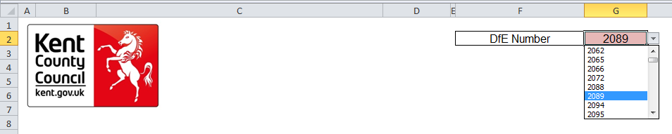

The number can either be typed in directly or selected using the drop-down menu.

1) Pupil numbers, rates and totals for Factors 1 to 12 will automatically populate in rows F, G and H.

2) A Formula Factors Total will be given in cell H33.

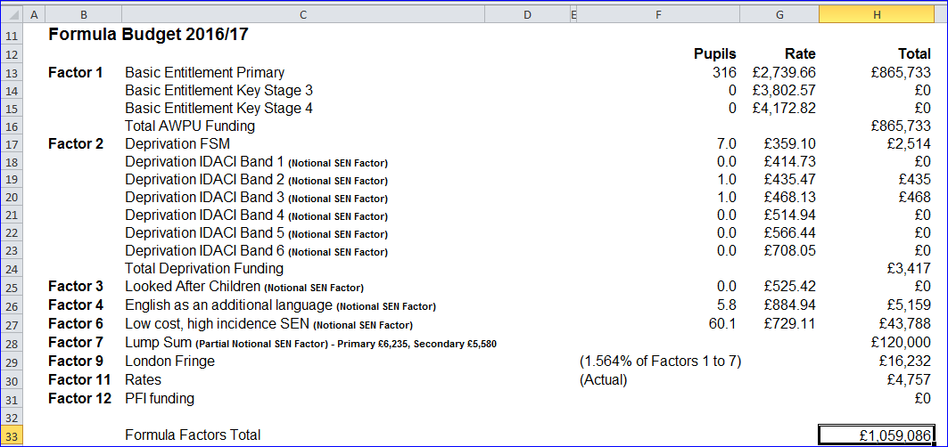

3) Below the Formula Factors Total, Estimated Growth Funding for 2016/17 will be shown in cell H35 if applicable to the school, driven by the data entered on the ‘Growth Funding’ Tab.

4) Minimum Funding Guarantee (MFG) amount will show in cell H37, with the calculation shown on the ‘MFG’ Tab.

5) The School Budget Share (SBS) for 2016/17 will be shown in cell H39.

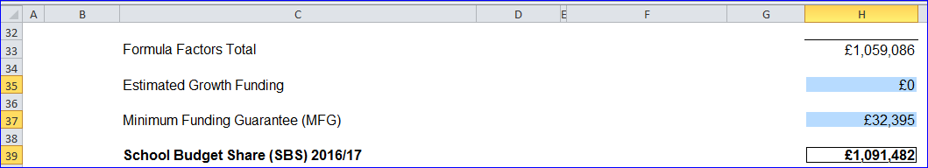

1) Below the 2016/17 SBS figure, any High Needs Mainstream funding will be shown in cells H41 to H43, split between Element 3 Top Up Funding, Notional SEN Top Up Funding and Element 2 Post-16 funding. These figures are driven by the data entered on the ‘High Needs Mainstream’ Tab, and a Total High Needs Mainstream Funding figure will show in cell H45.

7) Specialist Resource Provision (SRP) funding will be shown below in cells H47 to H50, split between Pre-16 Place Funding, Post-16 Place Funding, Excess Place Funding and Element 3 Top Up funding, with a Total High Needs SRP Funding figure for 2016/17 in cell H52. These figures are driven by the data entered on the ‘SRP Year 1’ Tab and the ‘SRP Year 2 & 3’ Tab.

8) Early Years Funding will show in cell H54, based on the data entered on the ‘Early Years’ Tab, if applicable.

9) In cell H56, the Post 16 allocation needs to be manually entered. These amounts are sent directly to schools from the EFA in February/March.

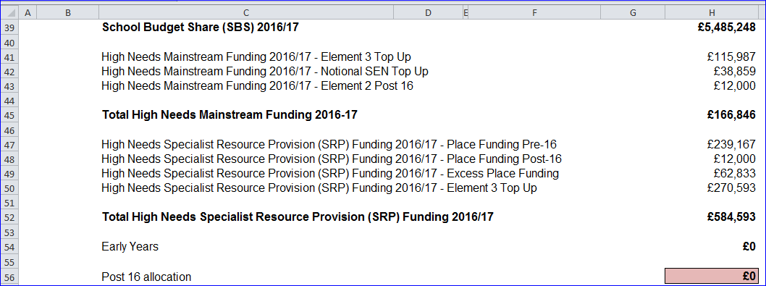

## Estimated Pupil Premium (PP) (Based on Jan 2016 census figures)

1) In cell F60 the number of units for Free School Meals Ever 6 Primary needs to be entered.

2) In cell F61 the number of units for Free School Meals Ever 6 Secondary needs to be entered.

3) In cell F62 the number of units for Adopted (Post-LAC) pupils needs to be entered.

4) In cell H63 a total funding figure for Children in Care (CiC) should be entered.

5) In cell F64 enter the number of units for Service Children Ever 6, based on the January census.

6) The figure for pupil premium for 3 & 4 year olds will automatically populate cell H65, based on the data entered on the ‘Early Years’ Tab.

7) A total estimated pupil premium will now show in cell H66.

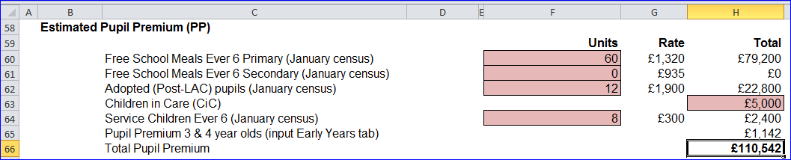

## Universal Infant Free School Meals (April to August 2016)

*Qualifying Pupils: Calculate this by using the number of pupils recorded as taking a meal and then* ***subtracting*** *those pupils taking a meal known to be eligible for FSM in the same censuses. (Refer to census data).*

1) In cell H73, enter the number of qualifying pupils in years 1 & 2 as per the October 2015 census.

2) In cell H74, enter the number of qualifying pupils in years 1 & 2 as per the January 2016 census.

3) In cell H75, enter the number of qualifying pupils in year R as per the October 2015 census.

4) In cell H76, enter the number of qualifying pupils in year R as per the January 2016 census.

5) A Remaining Allocation for 2015/16 academic year (April to August 2016) will show in cell H82 (based on 5/12ths of the Full Year Allocation for September 2015 to August 2016 in cell H75).

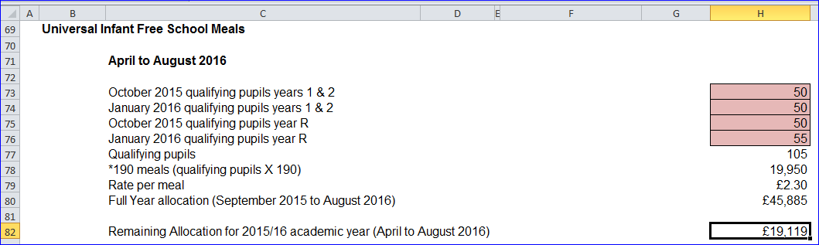

These figures are based on actual pupil numbers from the October 2015 and January 2016 census. In the next section, schools will need to enter estimated pupil numbers into cells H80 through H83 to give an estimated allocation for September to March 2017.

## Universal Infant Free School Meals (September 2016 to March 2017 ESTIMATE)

1) In cell H87 enter the estimated number of qualifying pupils in years 1 & 2 that are expected to be on roll in the October 2016 census.

2) In cell H88, enter the estimated number of qualifying pupils in years 1 & 2 for the January 2017 census.

3) In cell H89, enter the estimated number of qualifying pupils in year R as per expectations for the October 2016 census.

4) In cell H90, enter the number of qualifying pupils estimated to be in year R for the January 2017 census.

5) An Estimated Allocation for September to March will now appear in cell H96.

6) The Estimated total funding figure for the 2016/17 financial year will be shown in cell H99.

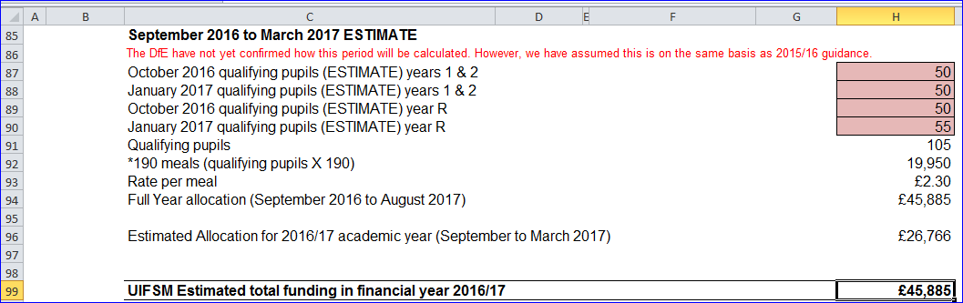

## De-Delegation (Funding delegated to schools which is recovered via the advances)

The figures for De-Delegation will automatically populate in the next section with a total in cell H113.

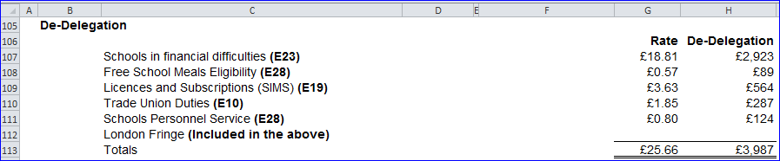

# ‘**MFG’ Tab**

This tab illustrates how the MFG figure in cell H37 of the ‘Year 1’ Tab has been calculated. No data needs to be entered on this tab.

# ‘Pupils’ Tab

The data entered on this tab feeds into the ‘Year 2’ Tab and ‘Year 3’ Tab.

1) On this tab you need to enter estimated Mainstream pupil numbers in the pink-shaded cells for each Year Group as at the October ’16 (row E) and October ’17 (Row F).

2) For October 2018, only estimated Reception pupil numbers (cell G7) are required to assist with calculating growth funding, if applicable to the school.

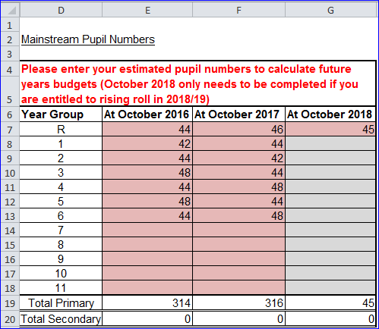

# ‘Year 2’ Tab

## 2017/18 Budget Projection

On the ‘Year 2’ Tab, Budget Projection figures for 2017/18 will appear in row E.

In cell E23 there is a drop down box for MFG reduction. The MFG options are 1.5%, 1%, 0.5% and 0%. (1.5% is most prudent but local knowledge should be used when making a selection.)

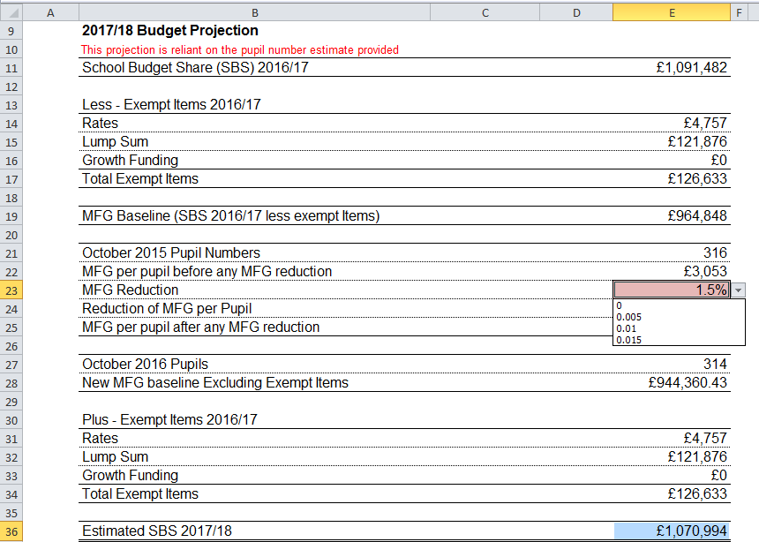

A total Estimated School Budget Share figure for 2017/18 will show in cell E36.

1) Below the 2017/18 SBS figure, any High Needs Mainstream funding will be shown in cells E38 to E40, split between Element 3 Top Up Funding, Notional SEN Top Up Funding and Element 2 Post-16 funding. These figures are driven by the data entered on the ‘High Needs Mainstream’ Tab, and a Total High Needs Mainstream Funding figure will show in cell E42.

2) SRP funding will be shown below, with Place Funding in cell E44 and Element 3 Top Up funding in cell E45. A Total High Needs SRP Funding figure for 2017/18 will show in cell E47. These figures are driven by the data entered on the the ‘SRP Year 2 & 3’ Tab.

3) Early Years Funding will show in cell E49, based on the data entered on the ‘Early Years’ Tab.

4) In cell E51, the Post 16 allocation needs to be manually entered. These amounts are sent directly to schools from the EFA in February/March.

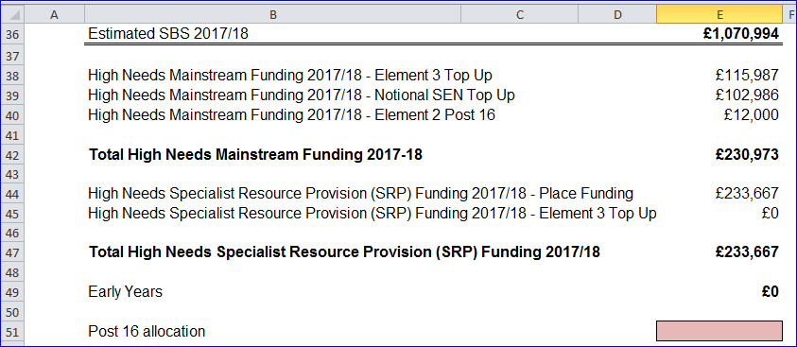

## Estimated Pupil Premium (PP)

Below the ‘2017/18 Budget Projection’ section, enter estimated pupil numbers again in order to calculate future years Estimated Pupil Premium (PP).

1) Estimated Free School Meals Ever 6 Primary numbers need to be entered into cell C55.

2) Estimated Free School Meals Ever 6 Secondary numbers need to be entered into cell C56.

3) In cell C57 enter estimated Adopted (Post-LAC) pupil numbers.

4) In cell E58 enter estimated total funding agreed for Children in Care (CiC)

5) Then in cell C59 the estimated number of Service Children Ever 6 should be entered.

6) A Pupil Premium 3 & 4 year olds total will show in cell E60, based on the data input into the ‘Early Years’ Tab.

7) A total estimated pupil premium figure will then be generated in cell E61.

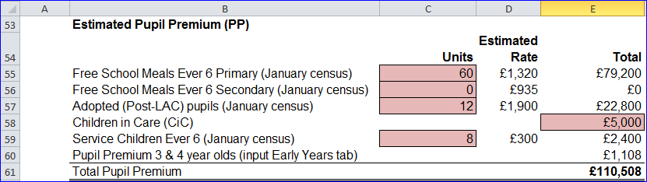

## UIFSM (ESTIMATE)

*Qualifying Pupils: Calculate this by using the number of pupils recorded as taking a meal and then* ***subtracting*** *those pupils taking a meal known to be eligible for FSM in the same censuses. (Refer to census data).*

1) In cell E72 enter the estimated number of qualifying pupils in years 1 & 2 for the October 2017 census.

2) In cell E73 enter the number of qualifying pupils in years 1 & 2 that are estimated to be on the January 2018 census.

3) In cell E74 enter the estimated number of qualifying pupils in year R as per expectations for the October 2017 census.

4) In cell E75 enter the number of qualifying pupils you estimate will be in year R for the January 2018 census.

5) The number of qualifying pupils will then automatically populate cell E76 and an Estimated Full Year Allocation (September 2017 to August 2018) will appear in cell E79.

6) An Estimated Allocation for the 2017/18 Academic Year (September to March 2018) will appear just below in cell E81 and a UIFSM Estimated Total Funding figure for the 2017/18 Financial Year will be shown in cell E83.

This UIFSM Estimated Total Funding figure is made up of the remaining payment in cell E68 (from the ‘Year 1’ Tab) which covers the April to August period, and the Estimated September to March allocation from cell E81. These figures are shown in green boxes overleaf for clarification.

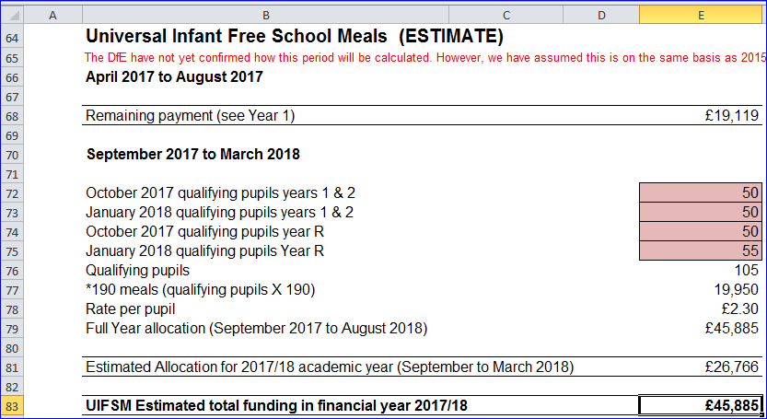

## De-Delegation (Funding delegated to schools which is recovered via the advances)

The figures for De-Delegation will automatically populate in the next section with a total in cell E96. 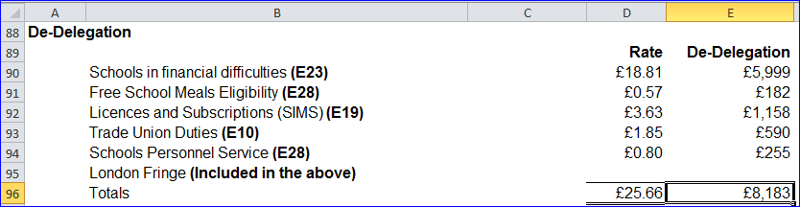

# ‘Year 3’ Tab

The ‘Year 3’ Tab provides a budget projection for 2018/19 and relies on the pupil number estimates provided on the ‘Pupils’ Tab.

It is set up in the same way as the ‘Year 2’ Tab with a School Budget Share section for 2018/19 at the top of the sheet, then an Estimated Pupil Premium (PP) section, a UIFSM section and De-delegation details at the bottom of the sheet.

The information required for this tab is very similar to the ‘Year 2’ Tab, however estimates should be updated to reflect Year 3 expectations.

# ‘**Early Years’ Tab**

## Early Years Funding

This tab provides an Early Years Budget Estimation for 2016/17.

If the school has Early Years Funding (Nursery), the calculation of the school’s hourly rate will be shown near the top of the sheet, made up of a base rate, a Qualified Teacher Supplement and a Disadvantage Supplement.

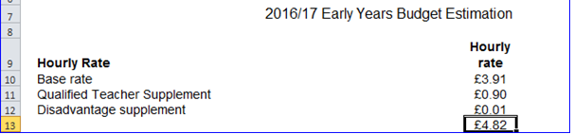

Enter Early Years pupil numbers in the pink-shaded cells in the table below by putting the number of pupils against the number of Early Years Hours that they attend school for each term (Summer/Autumn/Spring) for 2016/17, 2017/18 and 2018/19.

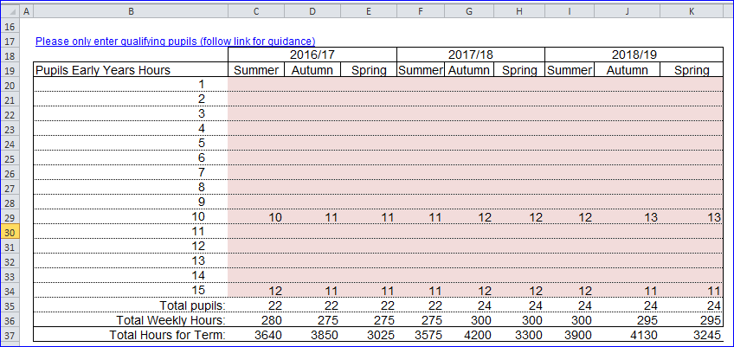

For guidance on determining eligibility for Free Early Education for 3 to 4 year olds and what constitutes a qualifying pupil, follow the link in Row 17.

## Early Years Pupil Premium (EYPP)

Lower down the sheet there is a similar table to fill out for EYPP, and a link to relevant guidance on row 54.

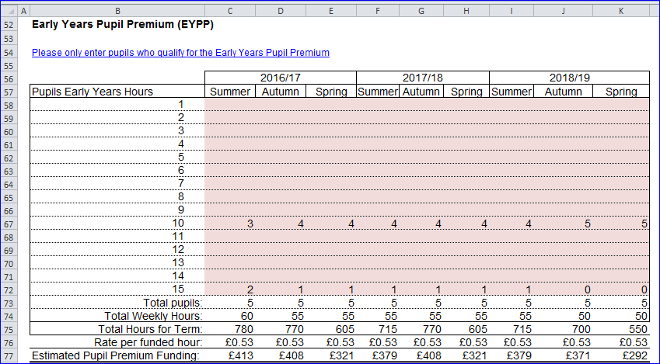

Populate the table by entering the number of pupils against their weekly hours for each term (Summer/Autumn/Spring) for 2016/17, 2017/18 and 2018/19.

# ‘High Needs Mainstream’ Tab

Schools with High Needs Mainstream pupils will need to enter pupil data on this tab. It feeds into the Year 1, Year 2 and Year 3 tabs in the High Needs Mainstream sections.

When entering data on this tab it may be useful to refer to [this](https://shareweb.kent.gov.uk/Documents/KELSI/Finance/High%20Needs%20Consultation%20vfinal.pdf) consultation document.

The tables to the right of the pupil data will then populate with any Element 3 top up funding, Notional SEN budget top up funding & Post 16 Element 2 funding, for the current year as well as years 2 and 3.

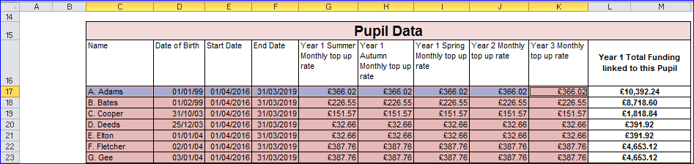

1) Enter the pupil names in Column C and their dates of birth in Column D.

**N.B. Date of Birth MUST be entered for the funding to be calculated correctly.** When estimating future years budgets when a DOB may not be known use a fictitious date but ensure that it accurately reflects whether the pupil is Pre or Post 16

2) Placement Start and End dates are already filled in, assuming the pupil will be at the school for all three financial years (Years 1, 2 and 3). These can be changed as necessary.

3) Enter the Year 1 Summer, Autumn and Spring Monthly top up rates in columns G, H and I respectively. Monthly top up rates appear in the confirmation letters received by SENCOs, sent out by the SEN resources team.

4) A year 2 monthly top up rate should be entered against each pupil in column J and a year 3 monthly top up rate should be entered against each pupil in column K.

It is prudent to initially forecast the same rates for each of the periods in Columns G to K and then update them as necessary.

At the bottom of this table in cell L/M83 the total funding linked to the pupils entered in the table will be shown.

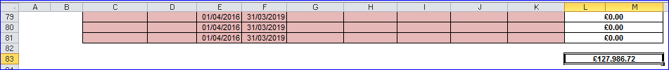

This figure is then broken down further in the tables to the right, between Element 3 top up and Notional SEN budget top up and Post 16 Element 2, with total in cells AA83, AO85 and BC83 respectively.

Further to the right, funding figures for 2017/18 and 2018/19 are also shown.

At the top of the sheet, above the Element 3 top up table, the workings for the Notional SEN budget top up rate are shown.

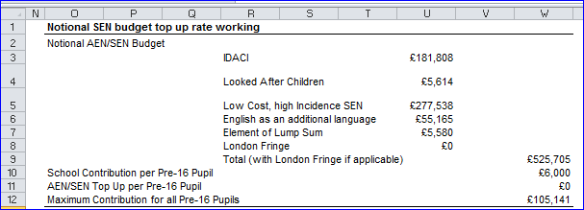

To the right of the Notional SEN budget top up table, there is another table that shows any Extra top up due to the 20% rule.



# ‘SRP Year 1’ Tab

Schools with Specialist Resourced Provisions (SRPs) will need to enter data for those pupils in the pink–shaded cells in the table on this tab.

1) In row I, the drop down menu can be used to select the correct designation for each pupil (only 3 schools have two SRPs so the majority will use ‘designation 1’).

2) In row J the pupil Surname is entered, Forename in row K and Date of Birth (D.O.B) in row L.

3) Columns M and N will then use the DOB figure to auto-populate with a Pre or Post 16 indicator for the summer and winter terms.

4) Placement start (row O) and end dates (row P) can be amended as necessary. The table will then automatically calculate any Place Plus funding for High Needs Pupils in Resourced Provision.

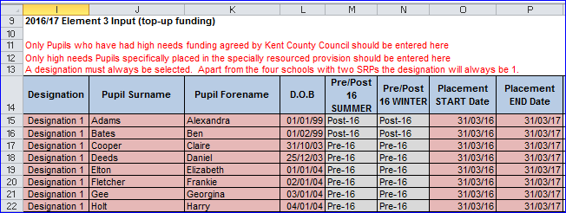

5) Based on the data entered in the table, a Pre 16 Element 1 Funding figure will appear in cell F18, and a figure for Element 2 in cell F22, and a Total figure in cell F24.

6) Post 16 Element 1 Funding is already included within the 16-19 allocation. A Post 16 Element 2 figure will appear in cell F35, and a Total figure in cell F37.

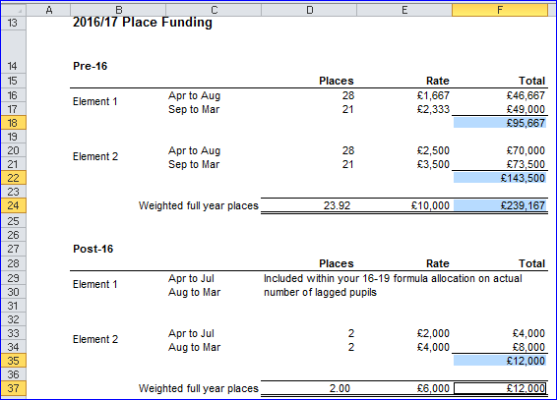

*Lagged pupil numbers: This is a count of the number of pupils participating at a school in the previous academic year.*

Excess Place Funding (the number of actual pupils above the agreed place numbers) will be shown in the table below.

1) Pre-16 Excess pupil numbers appear in column C, with the funding in Column D.

2) Post-16 Excess pupil numbers are shown in Column E, with the associated funding in column F.

3) Total monthly funding then appears in Column G, with an annual total in cell G61.

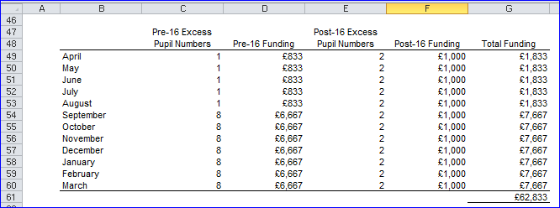

Below this there is an Element 3 Top-up Funding table, with an annual total in cell C79.

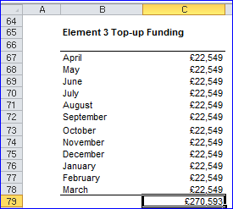

To the right of this is a Summary table, with Total 2016/17 SRP funding shown in cell G72 (which feeds through to the ‘Year 1’ Tab).

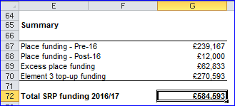

# ‘SRP Year 2 & 3’ Tab

Place Plus Funding for High Needs Pupils in Resourced Provision for Years 2 and 3 is generated by entering relevant information into the pink shaded cells on this tab.

1) Enter the agreed number of Pre-16 places in Designation 1 for the period April to August 2017 in cell D18. Enter estimated actual pupil numbers for that period in cell E18.

2) In cell G18 enter the agreed number of Pre-16 Designation 1 places for the period September to March 2018. Enter estimated actual pupil numbers for that period in cell H18.

3) Enter the agreed number of Post-16 places in Designation 1 for the period April to July 2017 in cell D19. Enter estimated actual pupil numbers for that period in cell E19.

4) In cell G19 enter the agreed number of Post-16 Designation 1 places for the period August to March 2018. Enter estimated actual pupil numbers for that period in cell H19.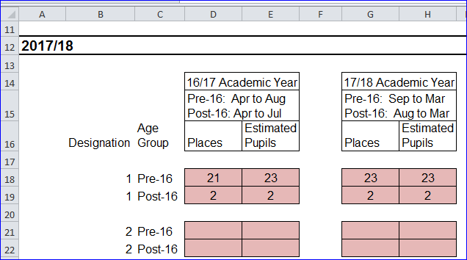

The same information needs to be entered in the cells below for Designation 2 pupils (only relevant for schools with more than one SRP).

The table to the right will then detail the funding due for the 2017/18 financial year, with a total funding figure in cell S24, which feeds into the ‘Year 2’ Tab.

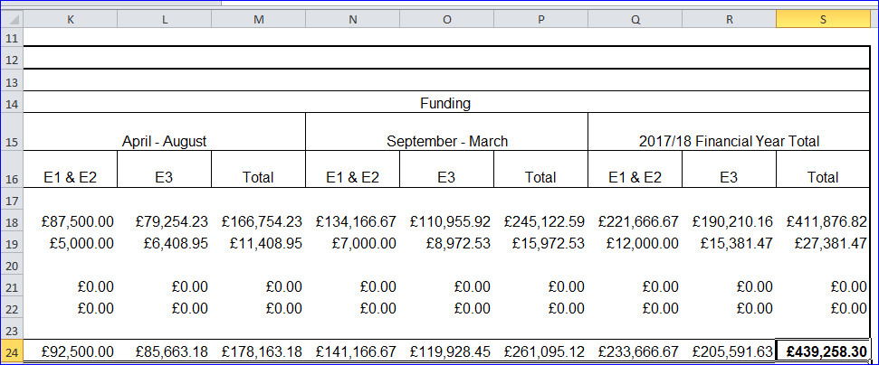

The same exercise needs to be carried out for the 2018/19 financial year, by populating the cells further down the sheet.

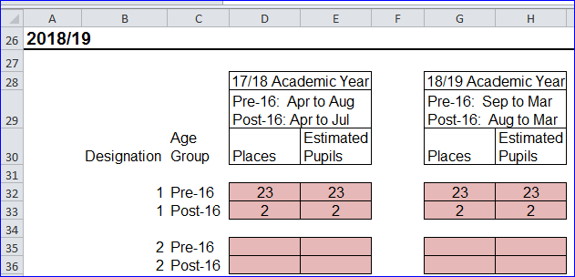

2018/19 funding will then be detailed with a total funding figure in cell S38 which feeds into the ‘Year 3’ Tab.

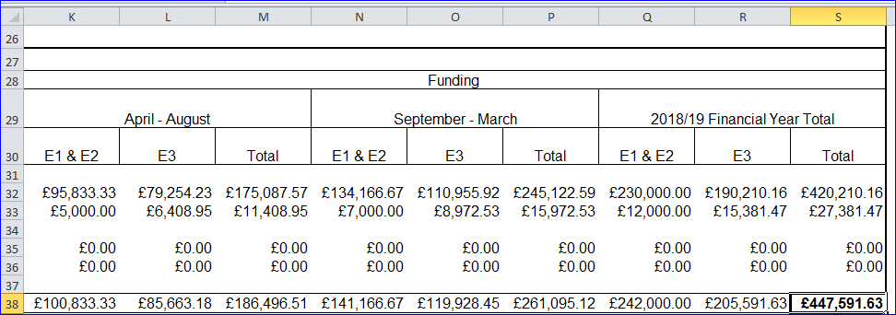

# ‘SRP Rates’ Tab

This tab is for information only and explains how SRP rates have been calculated for each of the eligible schools. No data needs to be entered onto this sheet.

# ‘Growth Funding’ Tab

The Growth Funding Estimator on this tab calculates Rising Roll Funding as well as Reorganisation Funding, if applicable. The rising roll estimation is based on the pupil number estimate provided on the ‘Pupils’ Tab. Schools eligible for Reorganisation Funding will receive email notification of any amounts due and can populate the pink shaded cells in row H with the relevant information.

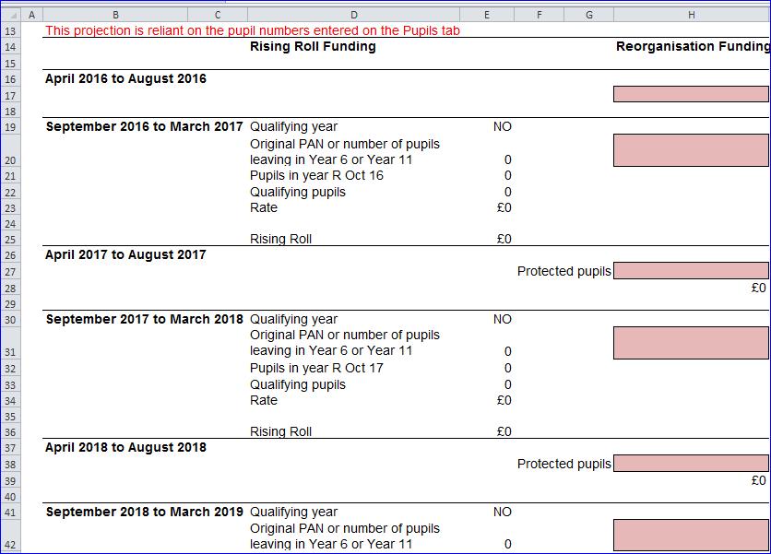

This data then feeds into a summary table further down the sheet, with a Total Actual Funding figure for Years 1, 2 and 3 in cells H52, H54 and H56 respectively.

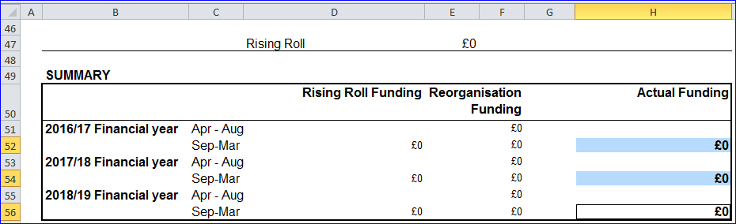

# ‘BPS Summary’ Tab

Once all the other tabs have been completed, this tab will summarise your funding by Ledger Code (I01, I02, I03, I05, I07 and I18) for Years 1, 2 and 3, with totals for each year in cells C29, D29 and E29.

De-delegation totals for each year will be shown in the cells below (C31, D31 and E31).

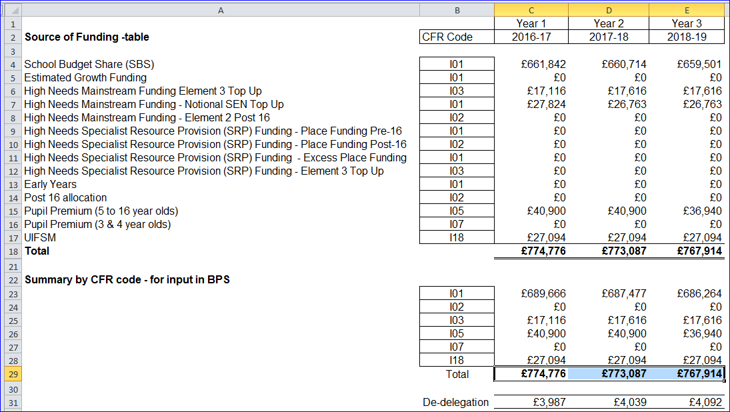

These figures can then be used to complete the first 3 years of the *5 Years Data tab* on the Budget Planning Software (BPS). Refer to the BPS guidance notes for further instructions on how to enter these figures on BPS.

**N.B.**

* The PE & Sports Grant will need to be accounted for within the I&E section on BPS as it is not included within the funding templates
* On the accounts package, a UIFSM year-end adjustment may need to be included in I18 (refer to closedown instructions on KELSI).